Hypothesized structural model
The hypothesized model demonstrated little fit: Chi-square (χ2) = 124.07, p < .001, df= 56, CMIN/DF = 2.216, AGFI= .921, NFI = .944, RFI= .908, IFI, .968, TLI= .948, CFI = .968, and RMSEA = .054.
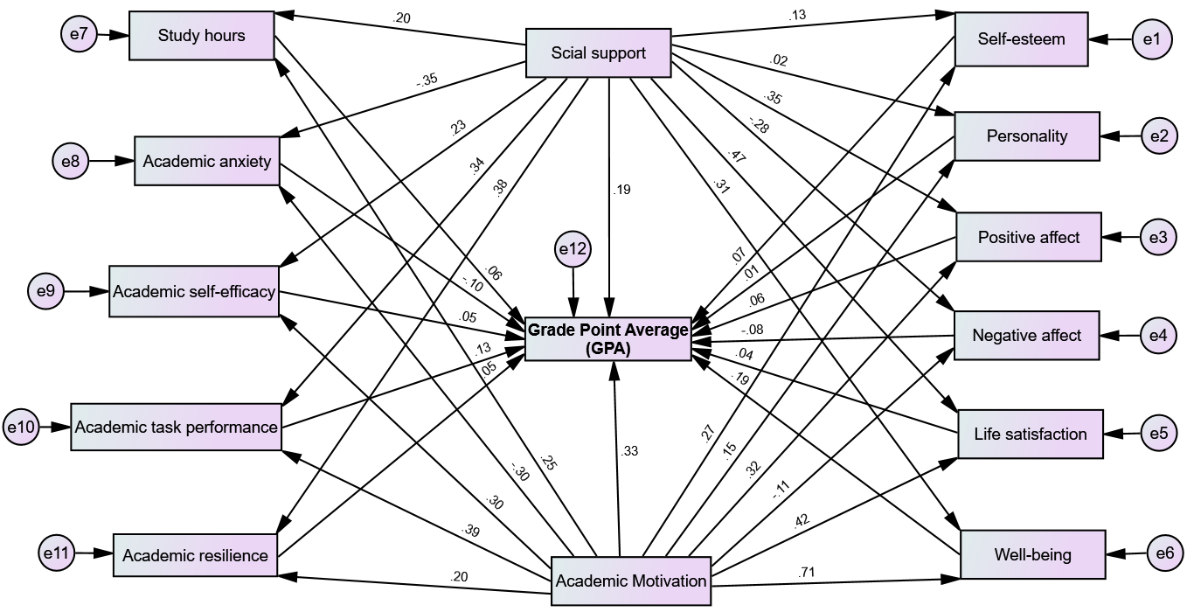
Figure 1a displays the initial, hypothesized structural model, which served as the baseline for our analysis. A priori, this model did not include a covariance path between academic anxiety and academic self-efficacy, nor between social support and academic motivation. These unmodeled relationships were later introduced to improve model fitness, based on our analysis and theoretical rationale.
Figure 1s, Baseline hypothesized structural model

Table 1s: Descriptive statistics and correlation matrix of GPA, academic, and non-academic factors
Variables | Observed range | n of items | 1 | 2 | 3 | 4 | 5 | 6 | 7 | 8 | 9 | 10 | 11 | 12 | 13 | 14
- GPA | 0-4 | 1 | 1
Academic factors
- Study hours | 1-5 | 1 | .375** | 1
- Academic anxiety | 1-4 | 11 | -.500** | -.182** | 1
- Academic self-efficacy | 1-5 | 5 | .420** | .141** | -.290** | 1
- Academic task performance | 1-6 | 7 | .584** | .305** | -.309** | .281** | 1
- Academic resilience | 1-7 | 6 | .422** | .147** | -.257** | .239** | .338** | 1
- Academic motivation | 1-7 | 14 | .734** | .311** | -.402** | .365** | .487** | .320** | 1
Nonacademic factors
- Social support | 1-7 | 12 | .604** | .274** | -.431** | .317** | .454** | .437** | .330** | 1
- Self-esteem | 1-4 | 10 | .334** | .090 | -.140** | .126** | .202** | .145** | .313** | .220** | 1
- Personality | 1-5 | 10 | .142** | .066 | -.093 | .086 | .114* | .071 | .152** | .068 | .061 | 1
- Positive affect | 1-5 | 10 | .495** | .233** | -.289** | .309** | .317** | .358** | .421** | .444** | .170** | .114* | 1
- Negative affect | 1-5 | 10 | -.299** | -.154** | .194** | -.085 | -.187** | -.075 | -.195** | -.309** | -.093 | -.049 | -.083 | 1
- Life satisfaction | 1-7 | 5 | .596** | .280** | -.363** | .353** | .416** | .333** | .538** | .569** | .278** | .126** | .376** | -.184** | 1
- Well-being | 0-5 | 5 | .747** | .336** | -.409** | .398** | .494** | .367** | .762** | .512** | .283** | .133** | .459** | -.203** | .557** | 1
Mean |  |  | 3.27 | 2.64 | 18.81 | 13.48 | 30.22 | 31.52 | 78.82 | 54.5 | 27.77 | 33.56 | 38.59 | 35.28 | 23.07 | 12.58
SD |  |  | 0.4 | 1.0 | 5.81 | 2.88 | 2.75 | 3.76 | 4.67 | 13.7 | 4.21 | 3.5 | 2.98 | 3.61 | 5.61 | 6.55
**. significant at the 0.01 level
*. significant at the 0.05 level

