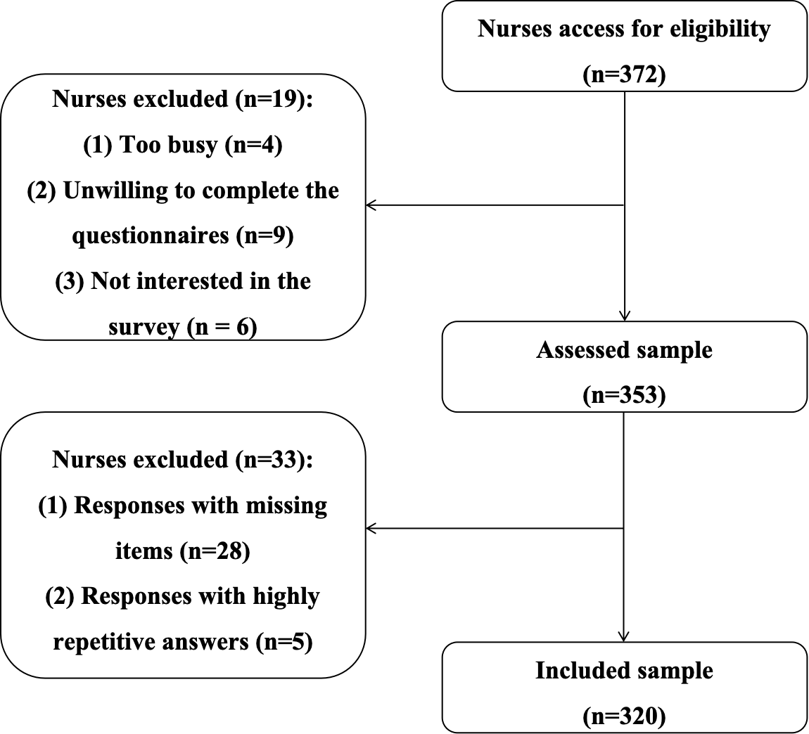
Figure S1 Flowchart of participants selection process.

To illustrate the current state and gaps of research on the topic of psychological resilience in nurses globally, we summarized 34 cross-sectional studies with resilience as the main dependent variable and extracted relevant information.

Table S1 Characteristics of currenting relative studies.
Author, year | Country | Study location | Resilience acssessment approach | Participants | Relative factors
Alameddine 2021(a) | Lebanon | Single-center | Total score | Nurses in referral center | Job satisfaction, turnover intentions, exposure to violence
Alameddine 2021(b) | Lebanon | Multi-center | Total score | Nurses | Burnout, intention to quit, perceived COVID-19 risk
Aljarboa 2022 | Saudi Arabia | Single-center | Total score | Nurses | Emotional intelligence
Alonazi 2023 | Saudi Arabia | Single-center | Total score | Mental health nurses | Professional quality of life
Balay-Odao 2020 | Saudi Arabia | Single-center | Total score | Nurses | Hospital Preparedness, depression, anxiety, stress
Baldassini Rodriguez 2022 | Italy | Multi-center | Total score | Nurses | Anxiety
Buntoro 2023 | Indonesia | Multi-center | Total score | Nurses | Depression, work duration
Cao 2019 | China | Multi-center | Total score | Haemodialysis nurses | Social support, empathy, work engagement
Cao 2020 | China | Multi-center | Total score | Haemodialysis nurses | Empathy, work engagement
Clark 2021 | USA | Multi-center | Total score | Emergency nurses | Moral Distress, workplace engagement
Foster 2020 | Australia | Multi-center | Total score | Mental health nurses | Psychological well-being, caring behaviours
Han 2023 | South Korea | Single-center | Total score | Nurses | Meaning in life, post-traumatic growth
Huang 2023 | China | Multi-center | Total score | Emergency nurses | Organizational support, workplace violence, cognitive reappraisal, self-efficacy
Jim´enez Fernandez ´ 2022 | Spain | Multi-center | Total score | Nurses | Acceptance, experiential avoidance, psychological inflexibility, burnout
Manomenidis 2019 | Greece | Multi-center | Total score | Nurses | Anxiety, depression, coping strategies
Meng 2023 | China | Single-center | Total score | Nurses | Work engagement, career identity, work-related quality of life
Table S1 (Continued)
Author, year | Country | Study location | Resilience acssessment approach | Participants | Relative factors
Salam 2023 | Lebanon | Multi-center | Total score | Nurses | Perceptions of transformational leadership
Sani 2020 | Iran | Single-center | Total score | Emergency nurse | Exposure to violence
Selvi 2023 | Turkey | Multi-center | Total score | Nurses | Work factors were related to authenticity
Sun 2022 | China | Multi-center | Total score | ICU nurses | Career calling, thriving, ethical leadership
Tabakakis 2019 | New Zealand | Multi-center | Total score | Nurses | Job performance, stress
Walpita 2020 | Sri Lanka | Multi-center | Total score | Nurses | Work performance
Xu 2020 | Spain | Single-center | Total score | Oncology nurses | Emotional labour
Xue 2022 | China | Multi-center | Total score | Nurses | Craftsmanship, career success
Yang 2018 | China | Multi-center | Total score | Transplant nurses | Burnout
Xu 2024 | China | Multi-center | LPA | Nurses | Work fatigue
Zhao 2024 | China | Multi-center | LPA | Nurses | Professional identity, psychological flexibility, growth mindset
Li 2025 | China | Multi-center | LPA | Nurses | Emotional regulation, sleep quality, coping style
Klingenberg I 2022 | Germany | Multi-center | LPA | Nurses | Stressors, coping, irritation, commitment
Chen 2024 | China | Multi-center | LPA | Emergency nurses | Workplace violence
Huang 2025 | China | Multi-center | LPA | Nurses | Empathy for pain
Chen 2024 | China | Single-center | LPA | Nurses | Compassion fatigue, coping style, stress
Chen 2025 | China | Multi-center | LPA | Nurses | Stress, coping style
Abbreviation: LPA = Latent profile analysis.

