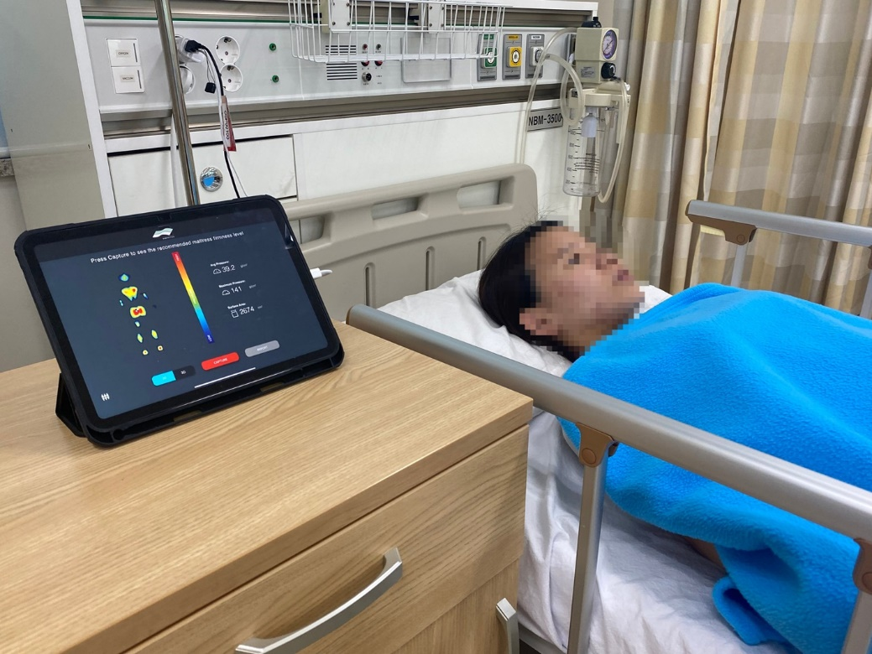
Supplementary Figure 1. Real-time pressure mapping system

