Additional file 2. Drawings used during analysing process
Content
Additional file 2. Drawings used during analysing process 1
Figure1 Drawing 1 2
Figure 2 Drawing 2 3
Figure 3 Drawing 3 4
Figure 4 Drawing 4 5
Figure 5 Drawing 5 5
Figure 6 Drawing 6 6

Several drawings used to interpret and combine codes into themes in step 3 - 5 of Reflexive Thematic Analysis

Figure1 Drawing 1
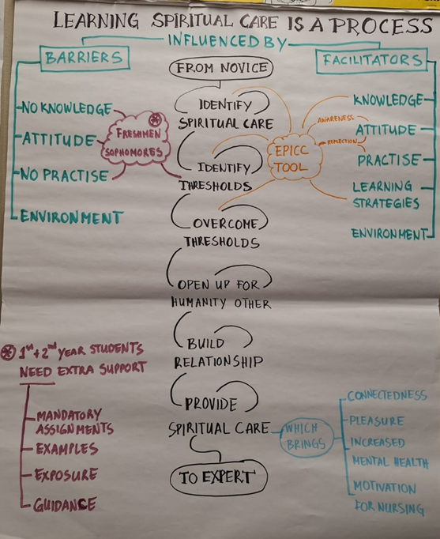

Figure 2 Drawing 2
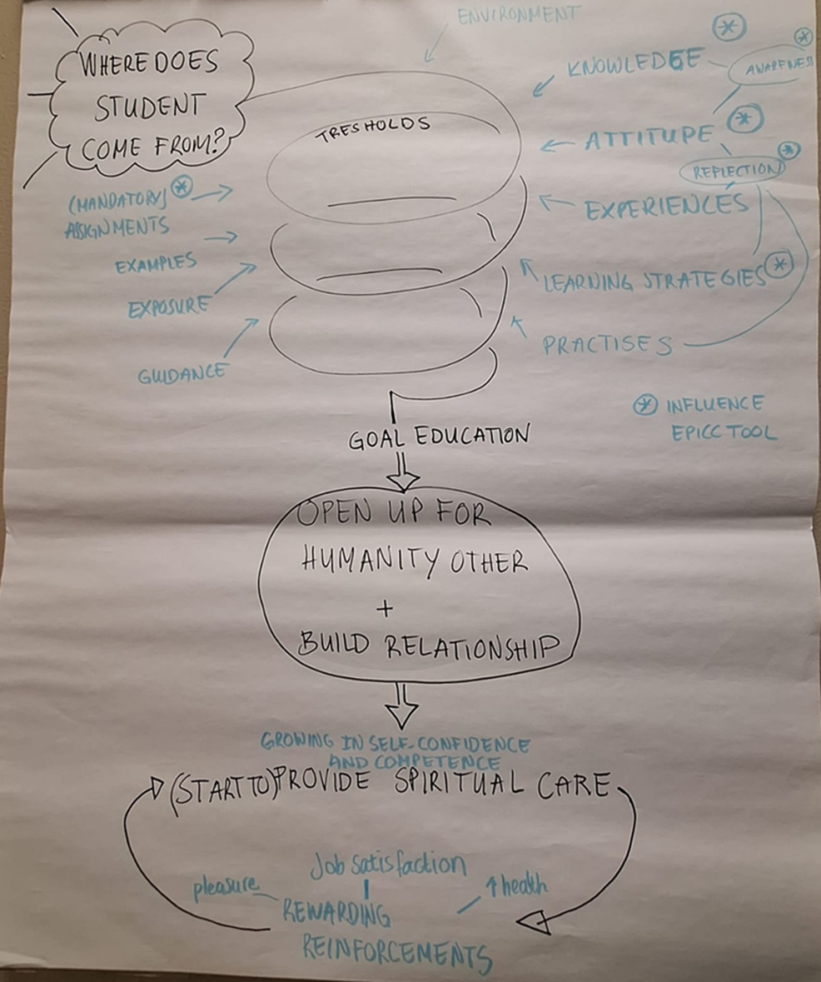

Figure 3 Drawing 3
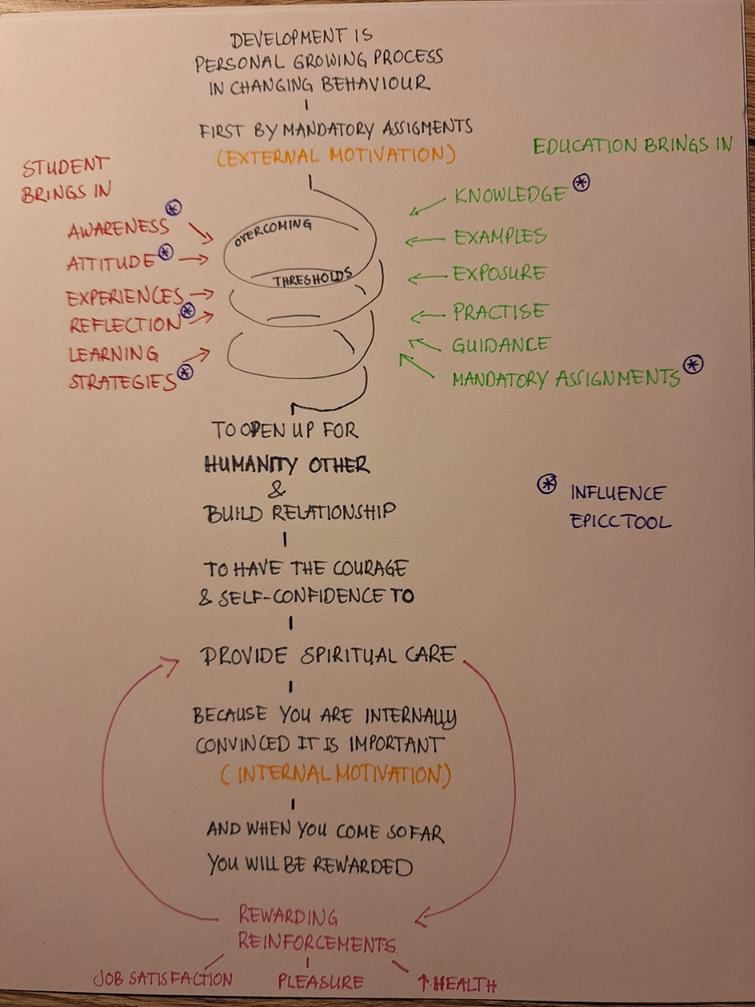

Figure 4 Drawing 4
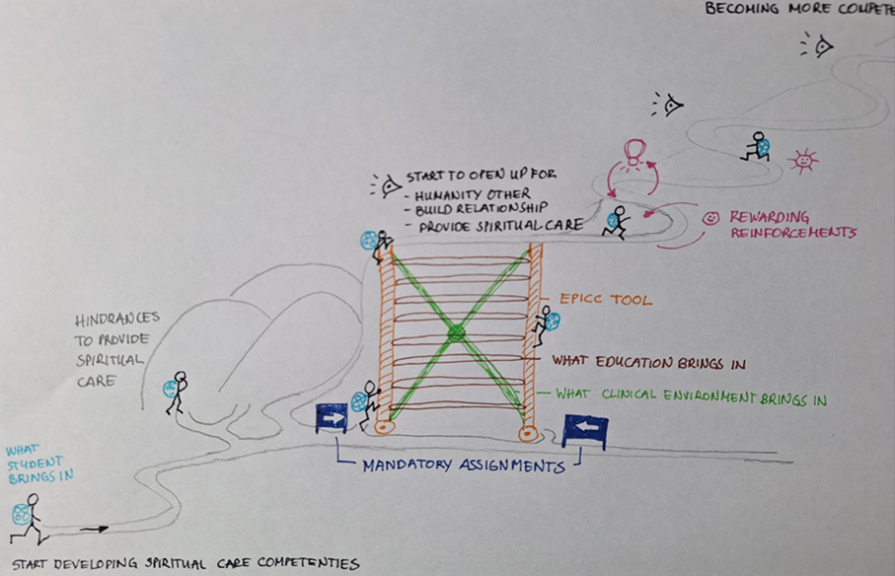

Figure 5 Drawing 5
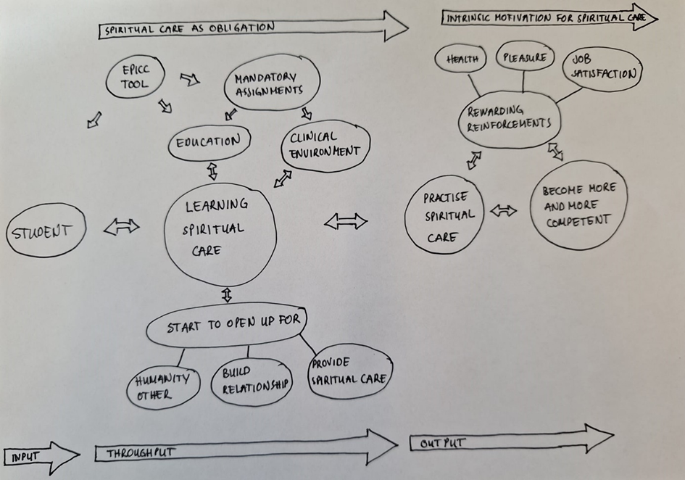

Figure 6 Drawing 6
