Supplementary File 1

Table 1: Quality Appraisal Scores
Citation | Criterion - JBI Critical Appraisal Checklist for Analytical Cross Sectional Studies |  |  |  |  |  |  |  | Results (%)
Citation | 1 | 2 | 3 | 4 | 5 | 6 | 7 | 8 | Results (%)
Aboshaiqah et al. (2013) | Y | Y | Y | Y | N | N | Y | Y | 6/8  (75%)
Alabbas et al. (2023) | Y | Y | Y | Y | N | N | Y | Y | 6/8  (75%)
Alanazi et al. (2023) | Y | Y | Y | Y | Y | Y | Y | Y | 8/8  (100%)
Al-Awa et al. (2012) | Y | Y | Y | Y | N | N | Y | U | 5/8  (62.5%)
Alayed et al. (2014) | Y | Y | Y | Y | U | U | Y | Y | 6/8  (75%)
Alharbi et al. (2018) | Y | Y | Y | Y | Y | U | Y | Y | 7/8  (87.5%)
Aljadhey et al. (2016) | Y | Y | Y | Y | U | U | Y | Y | 6/8  (75%)
AlMalki et al. (2018) | Y | Y | Y | Y | Y | U | Y | Y | 7/8  (87.5%)
Almutairi et al. (2013) | Y | Y | Y | Y | N | N | Y | Y | 6/8  (75%)
Alonazi et al. (2016) | Y | Y | Y | Y | N | N | Y | Y | 6/8  (75%)
Alquwez et al. (2018) | Y | Y | Y | Y | U | U | Y | Y | 6/8  (75%)
Alquwez, (2023) | Y | Y | Y | Y | U | U | Y | Y | 6/8  (75%)
Alrabae et al. (2021) | Y | Y | Y | Y | N | N | Y | Y | 6/8  (75%)
Alrowely et al. (2019) | Y | Y | Y | Y | U | U | Y | Y | 6/8  (75%)
Alsabaani, (2020) | Y | Y | Y | Y | N | N | Y | Y | 6/8  (75%)
Alshammari, (2019) | Y | Y | Y | Y | N | N | Y | Y | 6/8  (75%)
Alzahrani et al. (2018) | Y | Y | Y | Y | Y | U | Y | Y | 7/8  (87.5%)
Elmorsy et al. (2019) | Y | Y | Y | Y | N | N | Y | Y | 6/8  (75%)
Elsayed et al. (2020) | Y | Y | Y | Y | N | N | Y | Y | 6/8  (75%)
Elsheikh et al. (2017) | Y | Y | Y | Y | N | N | Y | Y | 6/8  (75%)
Hamaideh, (2017) | Y | Y | Y | Y | U | U | Y | Y | 6/8  (75%)
Mahrous, (2018) | Y | Y | Y | Y | N | N | Y | Y | 6/8  (75%)
Moussa et al. (2022) | Y | Y | Y | Y | U | U | Y | Y | 6/8  (75%)
Rawas et al. (2023) | Y | Y | Y | Y | U | U | Y | Y | 6/8  (75%)
Saleh Aboufour and Subbarayalu (2022) | Y | Y | Y | Y | U | U | Y | Y | 6/8  (75%)
Taher et al. (2014) | Y | Y | Y | Y | U | U | Y | Y | 6/8  (75%)
Zakari, (2011) | Y | Y | Y | Y | U | U | Y | Y | 6/8  (75%)
Y = yes; N = no; U = unclear
1. Were the criteria for inclusion in the sample clearly defined?
2. Were the study subjects and the setting described in detail?
3. Was the exposure measured in a valid and reliable way?
4. Were objective, standard criteria used for measurement of the condition?
5. Were confounding factors identified?
6. Were strategies to deal with confounding factors stated?
7. Were the outcomes measured in a valid and reliable way?
8. Was appropriate statistical analysis used?

Table 2: Summary Table of Nurses’ Safety Attitudes in KSA.
Author & year | Region & City | Design/Sample | Settings | Areas of work | Instrument | Findings relating to safety attitude
Aboshaiqah et al. (2013) | Central Region  Riyadh City | Cross-sectional design  498 nurses  Response rate = 83.0% | One MOH hospital | Different units:  Medical/surgical  Intensive care  Maternity  Paediatric  Cardiac  Oncology  Rehabilitation | HSOPSC  12 sub-scales | Areas of strength ^{A}:  Hospital management support for patient safety and organisational learning continuous improvement.  Areas for improvement ^{B}:  Teamwork within units, feedback and communication about error, frequency of events reported, teamwork across hospital units, staffing and overall perceptions of safety  Areas of weakness ^{C}:  Supervisor/manager expectations and actions promoting patient safety, non-punitive response to error, communication openness, and hospital handoffs and transitions.
Alabbas et al. (2023) | Western Region  Jeddah City | Cross-sectional design  web-based  315 nurses  Response rate = 100.0% | Two MOH hospitals | Different units:  Medical/surgical  Intensive care  Maternity  Paediatric  Cardiac  Emergency room | HSOPSC*  12 sub-scales  42 items  Not included in the meta-analysis | Areas of strength ^{A}:  Overall perceptions of safety and feedback and communication about error.  Areas for improvement ^{B}:  Supervisor/manager expectations and actions promoting patient safety, hospital management support for patient safety, non-punitive response to error, communication openness, hospital handoffs and transitions, teamwork within units, teamwork across hospital units, frequency of events reported, and staffing.  Areas of weakness ^{C}:  Organisational learning continuous improvement.
Alanazi et al. (2023) | Central and  Eastern Region | Cross-sectional design  web-based  653 nurses  Response rate = 69.0% | Five MOH hospitals | Different units:  Critical care.  Medical.  Surgical.  Mixed medical-surgical. | SAQ  eight sub-scales  41-item | Areas of strength ^{A}:  None.  Areas for improvement ^{B}:  Teamwork climate, safety climate, job satisfaction, perceptions of unit and hospital management, stress recognition, working condition, and safety behavior.  Areas of weakness ^{C}:  None.
Al-Awa et al. (2012) | Western Region  Jeddah City | Cross-sectional design  web-based  605 nurses  Response rate = 69.5% | One university hospital | Not stated | HSOPSC  12 sub-scales  40 items | Areas of strength ^{A}:  None  Areas for improvement ^{B}:  Teamwork within units, organisational learning continuous improvement, frequency of events reported, supervisor/manager expectations and actions promoting patient safety, feedback and communication about error, hospital management support for patient safety, teamwork across hospital units.  Areas of weakness ^{C}:  Overall perceptions of safety, non-punitive response to error, communication openness, staffing and hospital handoffs and transitions.
Alayed et al. (2014) | Not stated | Cross-sectional design  Paper-based  213 nurses  Response rate = 64.0% | Six university hospitals | Adult intensive care units | SAQ  Six sub-scales  30 items | Areas of strength ^{A}:  None.  Areas for improvement ^{B}:  Safety climate, teamwork climate, stress recognition, working condition and job satisfaction and the perception of management.  Areas of weakness ^{C}:  None.
AL-Dossary 2023 | Not stated | Cross-sectional design  Web-based  473 nurses  Response rate = 64.0% | Five MOH and three private hospitals |  | HSOPSC  12 sub-scales  42 items | Areas of strength ^{A}:  None.  Areas for improvement ^{B}:  Teamwork within units, management support for patient safety, overall perceptions of safety, frequency of events reported, hospital handoffs and transitions, and staffing.  Areas of weakness ^{C}:  Supervisor/manager expectations and actions promoting patient safety, organisational learning continuous improvement, communication openness, feedback and communication about error, teamwork across hospital units, and non-punitive response to error.
Alharbi et al. (2018) | Not stated | Cross-sectional design  Paper-based  88 nurses  Response rate = 97.7% - nurses represented 67.7% of the total sample. | Not stated | Adult oncology unit | HSOPSC*  12 sub-scales  42 items  Not included in the meta-analysis | Areas of strength ^{A}:  None  Areas for improvement ^{B}:  Teamwork within units, organisational learning continuous improvement, overall perceptions of safety, feedback and communication about error, frequency of events reported and staffing.  Areas of weakness ^{C}:  Supervisor/manager expectations and actions promoting patient safety, non-punitive response to error, communication openness, hospital management support for patient safety, teamwork across hospital units, and hospital handoffs and transitions.
Alharbi et al. 2024 | Central Region  Riyadh City | Cross-sectional design  138 nurses | One university hospital | Pediatric specialty units | HSOPSC  12 sub-scales  42 items | Areas of strength ^{A}:  Organisational learning continuous improvement,  Areas for improvement ^{B}:  Teamwork within units, overall perceptions of safety, feedback and communication about error, frequency of events reported, supervisor/manager expectations and actions promoting patient safety, staffing, hospital management support for patient safety, teamwork across hospital units, and non-punitive response to error.  Areas of weakness ^{C}:  Communication openness, and hospital handoffs and transitions.
Aljadhey et al. (2016) | Central Region  Riyadh City | Cross-sectional design  Paper-based  418 nurses  Response rate = 84.9% | One university hospital | Not stated | SAQ  Six sub-scales | Areas of strength ^{A}:  Safety climate, teamwork climate, working condition and job satisfaction.  Areas for improvement ^{B}:  The perception of management  Areas of weakness ^{C}:  Stress recognition
AlMalki et al. (2018) | Not stated | Cross-sectional design  Paper-based  106 nurses  Response rate = 60.0% | Two university hospitals | Intensive care units | SAQ  Six sub-scales | Areas of strength ^{A}:  None  Areas for improvement ^{B}:  Safety climate, teamwork climate, stress recognition, working condition and job satisfaction.  Areas of weakness ^{C}:  Perceptions of management.
Almutairi et al. (2013) | Central Region  Riyadh City | Cross-sectional design  Paper-based  319 nurses  Response rate = 76.8% | One military hospital | Different units:  Medical  Surgical  Paediatrics  Rehabilitation  Gynaecology | SCS*  21 items  Not included in the meta-analysis | The overall mean level of nurses’ attitudes was less than positive with a score of 3.9 out of 5.
Alonazi et al. (2016) | Central Region  Riyadh City | Cross-sectional design  244 nurses  Response rate = 44.8% | One military hospital | Different units:  Medical  Surgical  Paediatrics  Orthopaedics  Urology  Others | HSOPSC*  12 sub-scales  40 items  Not included in the meta-analysis | Areas of strength ^{A}:  Organisational learning continuous improvement, teamwork within units, and supervisor/manager expectations and actions promoting patient safety.  Areas for improvement ^{B}:  Hospital management support for patient safety, frequency of events reported, feedback communication about error, and teamwork across hospital units.  Areas of weakness ^{C}:  Overall perceptions of safety, non-punitive response to error, communication openness, staffing, and hospital handoffs and transitions.
Alquwez et al. (2018) | Central Region  Riyadh City | Cross-sectional design  Paper-based  351 nurses  Response rate = 78.0% | Three MOH hospitals | Different units:  Emergency  Medical  Surgical  Intensive care  Maternity  Pediatrics | HSOPSC  12 sub-scales | Areas of strength ^{A}:  Organisational learning continuous improvement, and teamwork within units.  Areas for improvement ^{B}:  Hospital management support for patient safety, supervisor/manager expectations and actions promoting patient safety, feedback communication about error, and teamwork across hospital units.  Areas of weakness ^{C}:  Overall perceptions of safety, frequency of events reported, non-punitive response to error, communication openness, staffing, and hospital handoffs and transitions.
Alquwez, (2023) | Central Region  Riyadh City | Cross-sectional design  Paper-based  261 nurses  Response rate = 73.1% | Two MOH hospitals | Different units:  Emergency  Medical  Surgical  Intensive care  Outpatient  Operating and recovery rooms.  Obstetric department.  Artificial kidney. | HSOPSC  12 sub-scales  42­items | Areas of strength ^{A}:  Organisational learning continuous improvement, and teamwork within units.  Areas for improvement ^{B}:  Hospital management support for patient safety, feedback communication about error, teamwork across hospital units, and frequency of events reported.  Areas of weakness ^{C}:  Overall perceptions of safety, supervisor/manager expectations and actions promoting patient safety, non-punitive response to error, communication openness, staffing, and hospital handoffs and transitions.
Alrabae et al. (2021) | Central Region  Riyadh City | Cross-sectional design  380 nurses | Two MOH hospitals | Intensive care units | HSOPSC  12 sub-scales  42­items. | Areas of strength ^{A}:  Teamwork within units.  Areas for improvement ^{B}:  Organisational learning continuous improvement, feedback communication about error, teamwork across hospital units, hospital management support for patient safety, supervisor/manager expectations and actions promoting patient safety, overall perceptions of safety, frequency of events reported, and hospital handoffs and transitions.  Areas of weakness ^{C}:  Non-punitive response to error, communication openness, and staffing.
Alrowely et al. (2019) | Northeast Region  Arar, Rafah, and Turaif cities | A descriptive correlational cross-sectional design  Paper-based  503 nurses  Response rate = 73.0% | Six MOH hospitals | Different units:  Medical  Surgical  Intensive care  Maternity  Pediatrics  Psychiatry  Oncology  Rehabilitation  Outpatient | HSOPSC  11 sub-scales  39 items | Areas of strength ^{A}:  Organisational learning continuous improvement, and teamwork within units.  Areas for improvement ^{B}:  Feedback communication about error and teamwork across hospital units.  Areas of weakness ^{C}:  Hospital management support for patient safety, supervisor/manager expectations and actions promoting patient safety, overall perceptions of safety, non-punitive response to error, communication openness, staffing and hospital handoffs and transitions.
Alsabaani, (2020) | Southwestern  Region | Cross-sectional design  Paper-based  249 nurses  Response rate = not stated | Not stated | Not stated | HSOPSC  12 sub-scales | Areas of strength ^{A}:  Organisational learning continuous improvement, and teamwork within units.  Areas for improvement ^{B}:  Feedback communication about error, teamwork across hospital units, hospital management support for patient safety, supervisor/manager expectations and actions promoting patient safety, overall perceptions of safety, non-punitive response to error, communication openness, frequency of events reported, staffing and hospital handoffs and transitions.  Areas of weakness ^{C}:  None.
Alshammari, (2019) | Northwestern Region  Hail City | Cross-sectional design  Paper-based  441 nurses (303 nurses from public hospitals and 138 private)  Response rate = 80.1% | Four MOH and three private hospitals | Not stated | HSOPSC*  12 sub-scales  Not included in the meta-analysis | Areas of strength ^{A}:  None.  Areas for improvement ^{B}:  Organisational learning continuous improvement, teamwork within units, feedback communication about error, teamwork across hospital units, hospital management support for patient safety, supervisor/manager expectations and actions promoting patient safety, overall perceptions of safety, non-punitive response to error, communication openness, staffing, frequency of events reported and hospital handoffs and transitions.  Areas of weakness ^{C}:  None.
Alzahrani et al. (2018) | Central Region  Riyadh City | Cross-sectional design  363 nurses  Response rate = not stated | Two MOH hospitals | Emergency departments | SAQ  6 sub-scales | Areas of strength ^{A}:  None.  Areas for improvement ^{B}:  Safety climate, teamwork climate, stress recognition, perceptions of management, working condition and job satisfaction.  Areas of weakness ^{C}:  None.
Elmorsy et al. (2019) | Northeast Region  Arar City | A descriptive cross-sectional survey  Paper-based  103 nurses  Response rate = 69.1% – nurses represented 33% of the total sample. | Four MOH hospitals | Different units:  Medical  Surgical  Paediatric  Maternity  Ophthalmology | HSOPSC  12 sub-scales | Areas of strength ^{A}:  Teamwork within units and across hospital units.  Areas for improvement ^{B}:  Organisational learning continuous improvement, feedback communication about error, hospital management support for patient safety, supervisor/manager expectations and actions promoting patient safety, overall perceptions of safety and staffing.  Areas of weakness ^{C}:  Non-punitive response to error, communication openness, hospital handoffs and transitions and frequency of events reported.
Elsayed et al. (2020) | Central Region  Riyadh City | A descriptive cross-sectional design  Web-based  314 nurses  Response rate = not stated | 35 MOH healthcare centres | Primary healthcare centres | SAQ  6 sub-scales | Areas of strength ^{A}:  None.  Areas for improvement ^{B}:  Safety climate, teamwork climate, perceptions of management, working condition and job satisfaction.  Areas of weakness ^{C}:  Stress recognition
Elsheikh et al. (2017) | Western Region  Makkah City | A comparative case study  Paper-based  225 nurses  Response rate = 67.0% – nurses represented 62% of the total sample. | One military hospital | Different Units:  Emergency  Medical  Surgical  Intensive care  Paediatric  Maternity  Rehabilitation  Other | HSOPSC  12 sub-scales | Areas of strength ^{A}:  Organisational learning continuous improvement, and teamwork within units.  Areas for improvement ^{B}:  Feedback communication about error, teamwork across hospital units, hospital management support for patient safety, supervisor/manager expectations and actions promoting patient safety and frequency of events reported.  Areas of weakness ^{C}:  Overall perceptions of safety, non-punitive response to error, communication openness, staffing and hospital handoffs and transitions.
Hamaideh, (2017) | Not stated | A predictive correlational design  Paper-based  224 mental health nurses  Response rate = 56.0% | Three MOH hospital | Psychiatric hospitals | HSOPSC  12 sub-scales  42 items | Areas of strength ^{A}:  Teamwork within units.  Areas for improvement ^{B}:  Organisational learning continuous improvement, teamwork across hospital units, feedback communication about error, hospital management support for patient safety, supervisor/manager expectations and actions promoting patient safety and overall perceptions of safety.  Areas of weakness ^{C}:  Non-punitive response to error, communication openness, hospital handoffs and transitions, staffing and frequency of events reported.
Mahrous, (2018) | Western Region  Almadinah city | Cross-sectional design  Paper-based  240 nurses  Response rate = 60.0% | One MOH hospital | All units and specialised centres belonging to the hospital such as:  Cardiology  Diabetes  Renal dialysis | HSOPSC  12 sub-scales  42 items | Areas of strength ^{A}:  None.  Areas for improvement ^{B}:  Supervisor/manager expectations and actions promoting patient safety, organisational learning continuous improvement, teamwork within units and feedback communication about error.  Areas of weakness ^{C}:  Teamwork across hospital units, hospital management support for patient safety, overall perceptions of safety, non-punitive response to error, communication openness, staffing, frequency of events reported and hospital handoffs and transitions.
Moussa et al. (2022) | Western Region  Almadinah city | Cross-sectional design  68 nurses  Response rate = 68.0% | One MOH hospital | Intensive care units | SAQ  6 sub-scales | Areas of strength ^{A}:  None.  Areas for improvement ^{B}:  Safety climate, teamwork climate, job satisfaction, stress recognition, perceptions of management and working condition.  Areas of weakness ^{C}:  None.
Rawas et al. (2023) | Western Region  Jeddah city | Cross-sectional design  184 nurses | One military hospital | Different Units:  ICU  Medical  Surgical  Intensive care  Paediatric  Maternity  Oncology | HSOPSC  12 sub-scales  42 items | Areas of strength ^{A}:  Organisational learning continuous improvement, teamwork within units and feedback communication about error.  Areas for improvement ^{B}:  Teamwork across hospital units, hospital management support for patient safety, supervisor/manager expectations and actions promoting patient safety, overall perceptions of safety, communication openness, and frequency of events reported.  Areas of weakness ^{C}:  Non-punitive response to error, staffing and hospital handoffs and transitions.
Saleh Aboufour and Subbarayalu (2022) | Eastern Region  Dammam city | Cross-sectional design  221 nurses | Three MOH healthcare settings | Dammam Complex, Qateef Central Hospital and primary healthcare centre in the Qateef Sector. | HSOPSC  12 sub-scales  42 items | Areas of strength A:  Supervisor/manager expectations and actions promoting patient safety, communication openness, overall perceptions of safety, and staffing.  Areas for improvement B:  Teamwork across hospital units, frequency of events reported, and non-punitive response to error.  Areas of weakness C:  Organisational learning continuous improvement, hospital management support for patient safety, teamwork within units’ hospital, feedback and communication about error, handoffs and transitions.
Taher et al. (2014) | Mixed Regions  Riyadh, Jeddah, and Dammam cities | Cross-sectional design  Paper-based  463 nurses  Response rate = 76.6% | Not stated | Five dialysis units | SCS*  17 items  Not included in the meta-analysis | The overall mean level of nurses’ attitudes was positive with a score of 4.13 out of 5.
Wazqar et al. 2023 | Western Region | Cross-sectional design  Web -based  101 nurses  Response rate = 66.0% | Two university hospitals | Oncology units | HSOPSC  12 sub-scales  42 items | Areas of strength A:  Organisational learning continuous improvement, feedback and communication about error.  Areas for improvement B:  Teamwork across hospital units, frequency of events reported, hospital management support for patient safety, teamwork within hospital units, overall perceptions of safety, and handoffs and transitions.  Areas of weakness C:  Supervisor/manager expectations and actions promoting patient safety, communication openness, staffing, and non-punitive response to error.
Zakari, (2011) | Central Region  Riyadh City | Cross-sectional design  Paper-based  221 nurses  Response rate = 88.1% | Four university healthcare settings | Ambulatory academic departments | SAQ  6 sub-scales | Areas of strength ^{A}:  Working condition and job satisfaction.  Areas for improvement ^{B}:  Safety climate, teamwork climate, stress recognition and perceptions of management.  Areas of weakness ^{C}:  None.
HSOPSC: The Hospital Survey of Patients’ Safety Culture; SAQ: Safety Attitudes Questionnaire; SCS: Safety Climate Survey
^{A.} Areas of strength: average percentage of positive responses or mean scores > 75% or mean score 4 out of 5.
^{B.} Areas for improvement: average percentage of positive responses or mean scores ≥ 50% and < 75% or mean score ≥ 2.50 and < 4 out of 5.
^{C.} Areas of weakness: average percentage of positive responses or mean scores < 50% or mean score < 2.50 out of 5.
* Studies not included in the meta-analysis.

Subgroup analysis for HSOPSC
Table 3: Effect Size Estimates for Subgroup Analysis
 | Subgroups |  | Effect Size | Std. Error | Z | Sig. (2-tailed) | 95% Confidence Interval
 |  |  |  |  |  |  | Lower | Upper
Overall HSOPSC | Settings | Non-Public Hospitals | 59.48 | 5.53 | 10.76 | <.001 | 48.64 | 70.32
Overall HSOPSC | Settings | Public Hospitals | 52.24 | 5.46 | 9.57 | <.001 | 41.54 | 62.94
Overall HSOPSC | Settings | Overall | 55.82 | 3.88 | 14.37 | <.001 | 48.20 | 63.43
Overall HSOPSC | Regions | Other Regions | 56.15 | 4.56 | 12.29 | <.001 | 47.20 | 65.11
Overall HSOPSC | Regions | Central Region | 55.00 | 7.33 | 7.49 | <.001 | 40.62 | 69.39
Overall HSOPSC | Regions | Overall | 55.83 | 3.87 | 14.40 | <.001 | 48.23 | 63.43
Organisational learning and continuous improvement | Settings | Non-Public Hospitals | 83.19 | 5.53 | 15.04 | <.001 | 72.35 | 94.03
Organisational learning and continuous improvement | Settings | Public Hospitals | 62.55 | 5.46 | 11.46 | <.001 | 51.85 | 73.25
Organisational learning and continuous improvement | Settings | Overall | 72.69 | 4.53 | 16.06 | <.001 | 63.82 | 81.56
Organisational learning and continuous improvement | Regions | Other Regions | 69.56 | 6.08 | 11.43 | <.001 | 57.64 | 81.48
Organisational learning and continuous improvement | Regions | Central Region | 78.49 | 7.34 | 10.70 | <.001 | 64.11 | 92.88
Organisational learning and continuous improvement | Regions | Overall | 72.38 | 4.51 | 16.04 | <.001 | 63.54 | 81.23
Teamwork within units | Settings | Non-Public Hospitals | 73.84 | 5.53 | 13.35 | <.001 | 63.00 | 84.68
Teamwork within units | Settings | Public Hospitals | 68.03 | 8.31 | 8.18 | <.001 | 51.74 | 84.33
Teamwork within units | Settings | Overall | 71.35 | 4.72 | 15.13 | <.001 | 62.11 | 80.59
Teamwork within units | Regions | Other Regions | 69.65 | 6.34 | 10.99 | <.001 | 57.23 | 82.08
Teamwork within units | Regions | Central Region | 72.15 | 7.34 | 9.83 | <.001 | 57.76 | 86.53
Teamwork within units | Regions | Overall | 70.66 | 4.61 | 15.34 | <.001 | 61.63 | 79.68
Non-punitive response to error | Settings | Non-Public Hospitals | 36.62 | 8.83 | 4.15 | <.001 | 19.32 | 53.93
Non-punitive response to error | Settings | Public Hospitals | 33.14 | 6.18 | 5.36 | <.001 | 21.02 | 45.26
Non-punitive response to error | Settings | Overall | 34.61 | 5.11 | 6.78 | <.001 | 24.60 | 44.61
Non-punitive response to error | Regions | Other Regions | 34.41 | 5.21 | 6.60 | <.001 | 24.19 | 44.63
Non-punitive response to error | Regions | Central Region | 36.41 | 10.70 | 3.40 | <.001 | 15.44 | 57.37
Non-punitive response to error | Regions | Overall | 35.37 | 4.84 | 7.31 | <.001 | 25.89 | 44.86
Staffing | Settings | Non-Public Hospitals | 36.27 | 7.58 | 4.78 | <.001 | 21.41 | 51.13
Staffing | Settings | Public Hospitals | 41.84 | 8.53 | 4.90 | <.001 | 25.11 | 58.57
Staffing | Settings | Overall | 39.50 | 5.64 | 7.00 | <.001 | 28.44 | 50.55
Staffing | Regions | Other Regions | 40.29 | 7.22 | 5.58 | <.001 | 26.14 | 54.45
Staffing | Regions | Central Region | 35.75 | 9.93 | 3.60 | <.001 | 16.29 | 55.21
Staffing | Regions | Overall | 38.94 | 5.65 | 6.89 | <.001 | 27.86 | 50.02
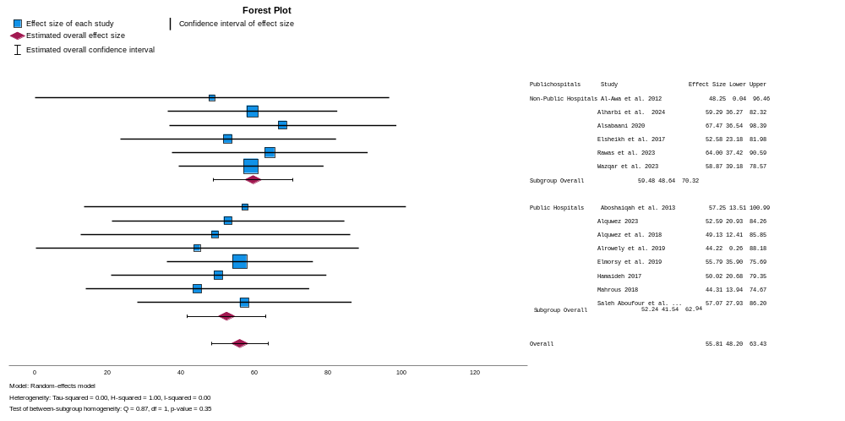
Figure 1: Forest plot for overall HSOPSC by type of healthcare

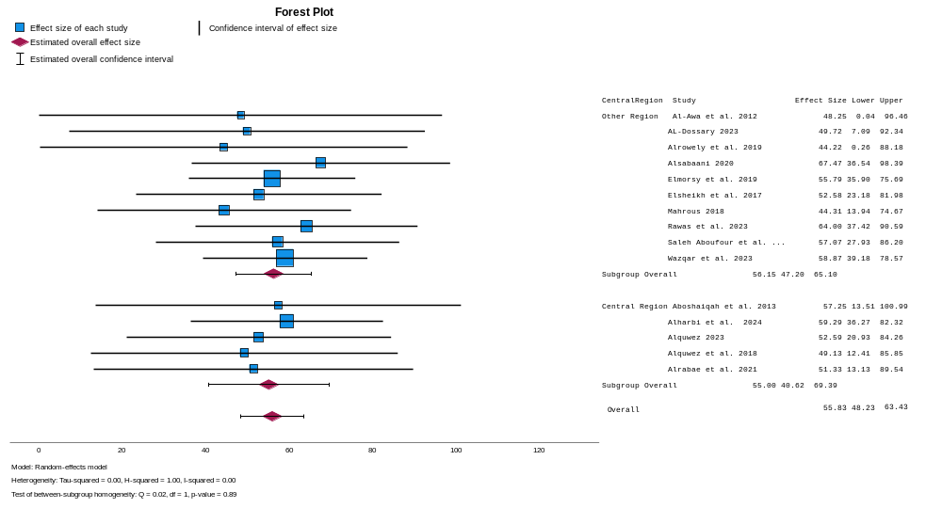
Figure 2: Forest plot for overall HSOPSC by geographic location

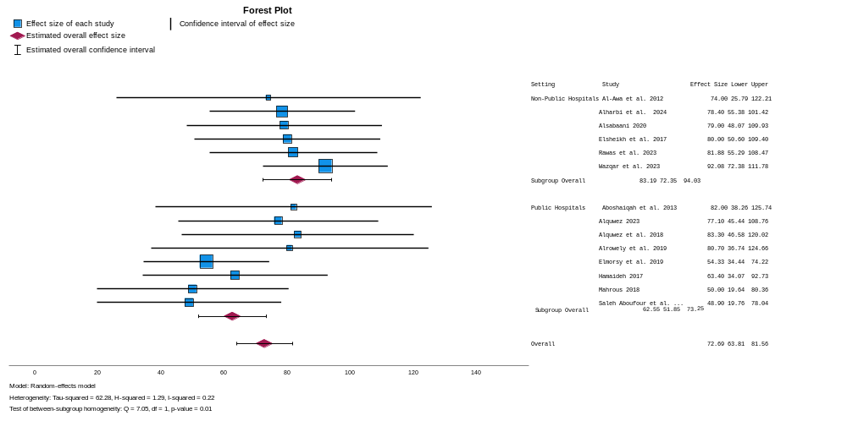
Figure 3: Forest plot for Organisational learning by type of healthcare

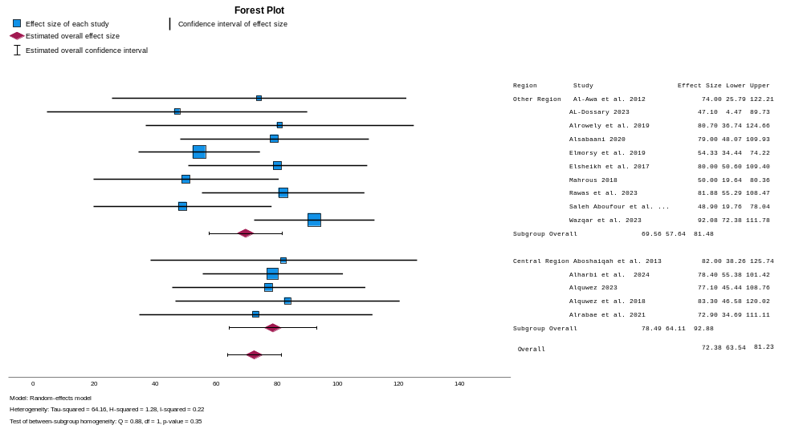
Figure 4: Forest plot for Organisational learning by region

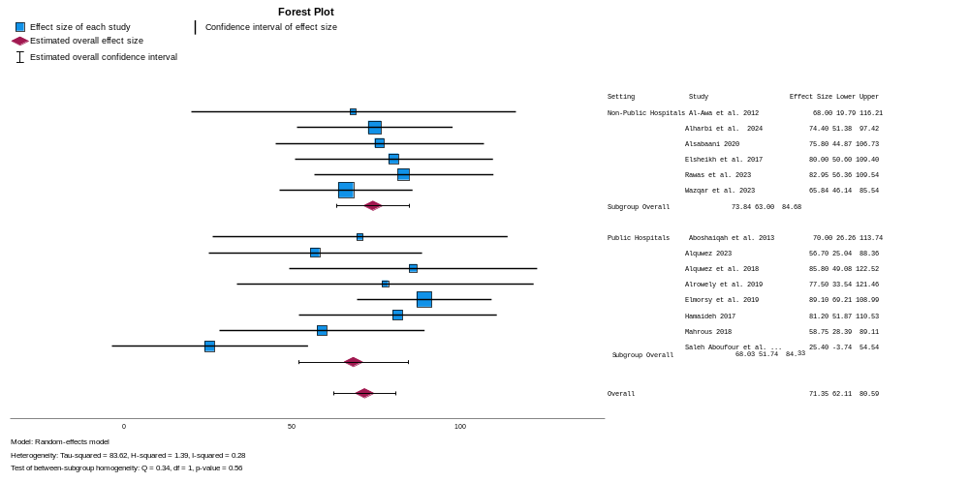
Figure 5: Forest plot for teamwork within unit by type of healthcare

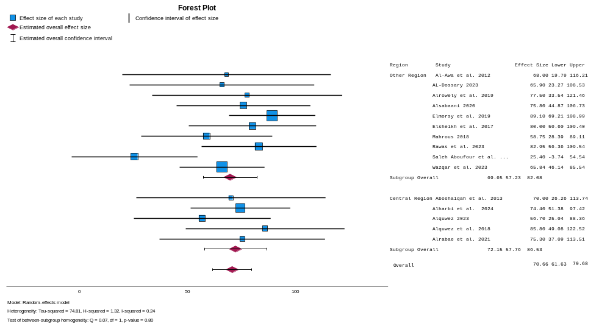
Figure 6: Forest plot for teamwork within unit by region

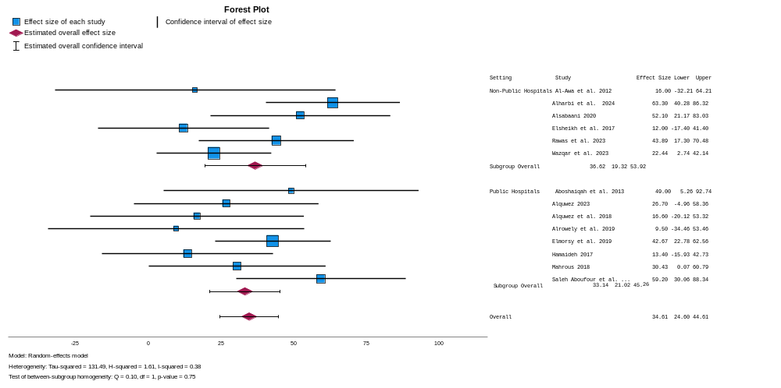
Figure 7: Forest plot for non-punitive response to error by type of healthcare

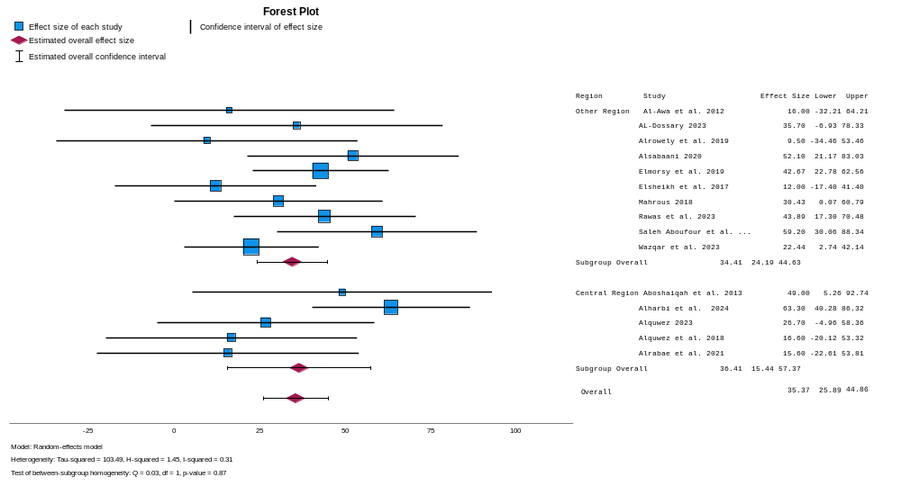
Figure 8: Forest plot for non-response to error by region

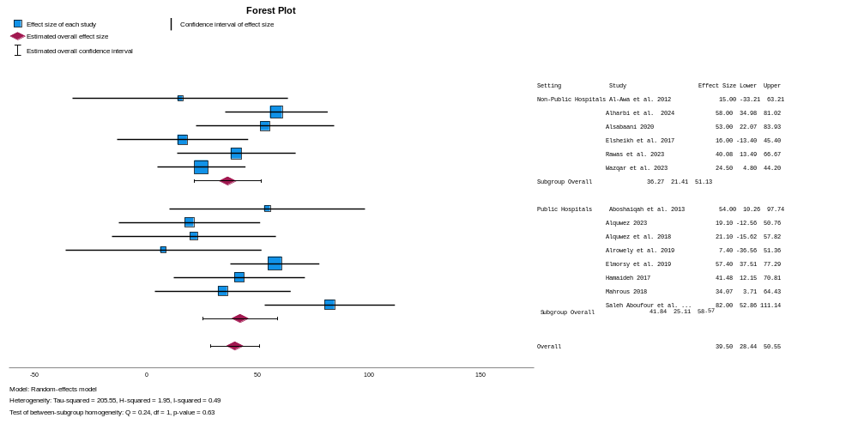
Figure 9: Forest plot for Staffing by type of healthcare

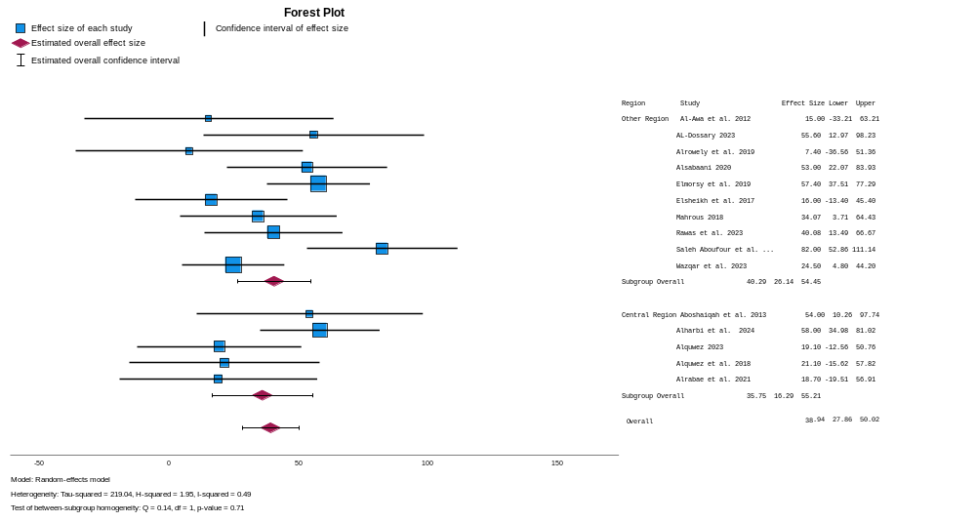
Figure 10: Forest plot for teamwork by region

