Supplementary materials
Table S1. Descriptive pairwise standardized mean differences in the nine patient safety culture dimensions across the three latent profiles.
Patient safety culture dimension | Low profile (n = 778), mean (SD) | Moderate profile (n = 1,192), mean (SD) | High profile (n = 1,381), mean (SD) | Low–moderate  comparison, Cohen’s d | Moderate–high  comparison, Cohen’s d | Low–high comparison, Cohen’s d
Patient Safety Support | 20.01 (4.04) | 25.01 (3.44) | 28.67 (2.71) | 1.36 | 1.19 | 2.66
Staffing and Work Pace | 12.47 (2.81) | 14.44 (2.54) | 17.79 (2.32) | 0.74 | 1.38 | 2.12
Response to Errors | 12.39 (2.82) | 14.91 (2.67) | 18.41 (1.91) | 0.92 | 1.53 | 2.64
Communication About Errors | 9.37 (3.48) | 11.64 (2.70) | 14.04 (1.97) | 0.75 | 1.02 | 1.79
Communication Openness | 12.18 (2.51) | 14.70 (2.44) | 18.38 (2.14) | 1.02 | 1.61 | 2.72
Handoffs and Information Exchange | 9.45 (1.47) | 12.32 (1.71) | 14.45 (1.19) | 1.78 | 1.46 | 3.85
Organizational Learning and Continuous Improvement | 9.23 (1.43) | 12.10 (1.64) | 14.40 (1.24) | 1.84 | 1.60 | 3.95
Teamwork | 9.56 (1.61) | 12.41 (1.57) | 14.41 (1.26) | 1.80 | 1.42 | 3.47
Reporting Patient Safety Events | 6.28 (2.39) | 6.87 (2.22) | 7.86 (2.61) | 0.26 | 0.41 | 0.62
Note: Cohen’s d was calculated as the difference between the mean of the higher-level profile and that of the lower-level profile, divided by the pooled within-profile standard deviation. Positive values indicate higher dimension scores in the higher-level profile. Estimates are descriptive and based on most-likely profile assignments. SD = standard deviation.

Table S2. Complete R3STEP multinomial logistic regression results for perceived patient safety culture profile membership.
Profile comparison | Variable | Category | B | SE | OR (95% CI) | p
Low profile vs.  high profile | Gender (reference: Female) | Male | 0.112 | 0.180 | 1.119 (0.786–1.592) | 0.534
Low profile vs.  high profile | Age (years) (reference: ≤25) | 26–35 | -0.126 | 0.150 | 0.882 (0.657–1.183) | 0.401
Low profile vs.  high profile | Age (years) (reference: ≤25) | 36–45 | 0.222 | 0.200 | 1.249 (0.844–1.848) | 0.267
Low profile vs.  high profile | Age (years) (reference: ≤25) | ≥46 | -0.384 | 0.280 | 0.681 (0.393–1.179) | 0.170
Low profile vs.  high profile | Work experience (years) (reference: ≤5) | 6–10 | 0.072 | 0.160 | 1.075 (0.785–1.470) | 0.653
Low profile vs.  high profile | Work experience (years) (reference: ≤5) | 11–15 | 0.293 | 0.190 | 1.340 (0.924–1.945) | 0.123
Low profile vs.  high profile | Work experience (years) (reference: ≤5) | 16–20 | -0.166 | 0.240 | 0.847 (0.529–1.356) | 0.489
Low profile vs.  high profile | Work experience (years) (reference: ≤5) | ≥21 | 0.315 | 0.260 | 1.370 (0.823–2.281) | 0.226
Low profile vs.  high profile | Marital status (reference: Unmarried) | Married | -0.259 | 0.160 | 0.772 (0.564–1.056) | 0.106
Low profile vs.  high profile | Marital status (reference: Unmarried) | Divorced or widowed | 0.399 | 0.420 | 1.490 (0.654–3.395) | 0.342
Low profile vs.  high profile | Professional title (reference: Junior level) | Intermediate level | 0.027 | 0.150 | 1.027 (0.766–1.379) | 0.857
Low profile vs.  high profile | Professional title (reference: Junior level) | Associate senior title or above | -0.307 | 0.240 | 0.736 (0.460–1.178) | 0.201
Low profile vs.  high profile | Education (reference: Junior college degree and below) | Bachelor's degree | 0.227 | 0.160 | 1.255 (0.917–1.717) | 0.156
Low profile vs.  high profile | Education (reference: Junior college degree and below) | Master's degree and above | -0.174 | 0.310 | 0.840 (0.458–1.543) | 0.575
Low profile vs.  high profile | Sleep quality during the past week (reference: Poor) | Fair | -0.646 | 0.139 | 0.524 (0.399–0.688) | <0.001
Low profile vs.  high profile | Sleep quality during the past week (reference: Poor) | Good | -1.134 | 0.198 | 0.322 (0.218–0.474) | <0.001
Low profile vs.  high profile | Frequency of workplace violence (reference: 0) | 1 | 0.110 | 0.150 | 1.116 (0.832–1.498) | 0.463
Low profile vs.  high profile | Frequency of workplace violence (reference: 0) | 2–3 | -0.168 | 0.160 | 0.845 (0.618–1.157) | 0.294
Low profile vs.  high profile | Frequency of workplace violence (reference: 0) | ≥4 | 0.293 | 0.220 | 1.340 (0.871–2.063) | 0.183
Low profile vs.  high profile | Weekly working hours (reference: ≤40 h) | 41–50 h | -0.043 | 0.140 | 0.958 (0.728–1.260) | 0.759
Low profile vs.  high profile | Weekly working hours (reference: ≤40 h) | ≥51 h | 0.284 | 0.180 | 1.328 (0.934–1.890) | 0.115
Low profile vs.  high profile | Nursing practice environment (reference: Good) | Fair | 0.764 | 0.239 | 2.146 (1.343–3.430) | 0.001
Low profile vs.  high profile | Nursing practice environment (reference: Good) | Poor | 0.892 | 0.264 | 2.440 (1.454–4.094) | <0.001
Low profile vs.  high profile | Nursing care quality in the department (reference: Poor) | Fair | -1.904 | 0.364 | 0.149 (0.073–0.304) | <0.001
Low profile vs.  high profile | Nursing care quality in the department (reference: Poor) | Good | -2.666 | 0.365 | 0.070 (0.034–0.142) | <0.001
Low profile vs.  high profile | Physical and mental health score |  | -0.067 | 0.006 | 0.935 (0.925–0.946) | <0.001
Low profile vs.  high profile | Missed nursing care score |  | 0.031 | 0.005 | 1.031 (1.022–1.041) | <0.001
Moderate profile vs.  high profile | Gender (reference: Female) | Male | -0.086 | 0.180 | 0.918 (0.645–1.306) | 0.633
Moderate profile vs.  high profile | Age (years) (reference: ≤25) | 26–35 | 0.186 | 0.150 | 1.204 (0.898–1.616) | 0.215
Moderate profile vs.  high profile | Age (years) (reference: ≤25) | 36–45 | -0.152 | 0.200 | 0.859 (0.580–1.271) | 0.447
Moderate profile vs.  high profile | Age (years) (reference: ≤25) | ≥46 | 0.423 | 0.280 | 1.527 (0.882–2.643) | 0.131
Moderate profile vs.  high profile | Work experience (years) (reference: ≤5) | 6–10 | -0.187 | 0.160 | 0.829 (0.606–1.135) | 0.243
Moderate profile vs.  high profile | Work experience (years) (reference: ≤5) | 11–15 | 0.074 | 0.190 | 1.077 (0.742–1.563) | 0.697
Moderate profile vs.  high profile | Work experience (years) (reference: ≤5) | 16–20 | 0.259 | 0.240 | 1.296 (0.809–2.074) | 0.281
Moderate profile vs.  high profile | Work experience (years) (reference: ≤5) | ≥21 | -0.372 | 0.260 | 0.689 (0.414–1.148) | 0.152
Moderate profile vs.  high profile | Marital status (reference: Unmarried) | Married | 0.107 | 0.160 | 1.113 (0.813–1.523) | 0.504
Moderate profile vs.  high profile | Marital status (reference: Unmarried) | Divorced or widowed | -0.092 | 0.420 | 0.912 (0.400–2.078) | 0.827
Moderate profile vs.  high profile | Professional title (reference: Junior level) | Intermediate level | 0.204 | 0.150 | 1.226 (0.914–1.645) | 0.174
Moderate profile vs.  high profile | Professional title (reference: Junior level) | Associate senior title or above | -0.218 | 0.240 | 0.804 (0.502–1.287) | 0.364
Moderate profile vs.  high profile | Education (reference: Junior college degree and below) | Bachelor's degree | 0.086 | 0.160 | 1.090 (0.796–1.491) | 0.591
Moderate profile vs.  high profile | Education (reference: Junior college degree and below) | Master's degree and above | -0.493 | 0.310 | 0.611 (0.333–1.121) | 0.112
Moderate profile vs.  high profile | Sleep quality during the past week (reference: Poor) | Fair | -0.326 | 0.110 | 0.722 (0.582–0.896) | 0.003
Moderate profile vs.  high profile | Sleep quality during the past week (reference: Poor) | Good | -0.737 | 0.167 | 0.479 (0.345–0.664) | <0.001
Moderate profile vs.  high profile | Frequency of workplace violence (reference: 0) | 1 | 0.173 | 0.150 | 1.189 (0.886–1.595) | 0.249
Moderate profile vs.  high profile | Frequency of workplace violence (reference: 0) | 2–3 | 0.045 | 0.160 | 1.046 (0.764–1.431) | 0.779
Moderate profile vs.  high profile | Frequency of workplace violence (reference: 0) | ≥4 | -0.288 | 0.220 | 0.750 (0.487–1.154) | 0.191
Moderate profile vs.  high profile | Weekly working hours (reference: ≤40 h) | 41–50 h | 0.116 | 0.140 | 1.123 (0.854–1.478) | 0.407
Moderate profile vs.  high profile | Weekly working hours (reference: ≤40 h) | ≥51 h | -0.113 | 0.180 | 0.893 (0.628–1.271) | 0.530
Moderate profile vs.  high profile | Nursing practice environment (reference: Good) | Fair | 0.679 | 0.163 | 1.973 (1.432–2.717) | <0.001
Moderate profile vs.  high profile | Nursing practice environment (reference: Good) | Poor | 0.811 | 0.190 | 2.249 (1.551–3.262) | <0.001
Moderate profile vs.  high profile | Nursing care quality in the department (reference: Poor) | Fair | -0.938 | 0.362 | 0.391 (0.192–0.796) | 0.010
Moderate profile vs.  high profile | Nursing care quality in the department (reference: Poor) | Good | -1.558 | 0.362 | 0.211 (0.104–0.428) | <0.001
Moderate profile vs.  high profile | Physical and mental health score |  | -0.037 | 0.005 | 0.964 (0.955–0.972) | <0.001
Moderate profile vs.  high profile | Missed nursing care score |  | 0.018 | 0.004 | 1.018 (1.009–1.027) | <0.001
Note: N = 3,351; the high profile was the reference outcome. All covariates were entered simultaneously, with R3STEP accounting for classification uncertainty. Categorical reference groups are shown in parentheses; ORs for continuous variables represent a one-unit increase. B = regression coefficient; SE = standard error; OR = odds ratio; CI = confidence interval.

Table S3. Five nodes with the highest expected influence and one-step bridge expected influence values in each profile-specific network.
Profile | Rank | EI node | EI value | BEI node | BEI value
Low profile | 1 | RE (Role-Emotional) | 0.992 | PSS (Patient Safety Support) | 0.099
Low profile | 2 | RP (Role-Physical) | 0.859 | VT (Vitality) | 0.092
Low profile | 3 | GH (General Health) | 0.809 | MH (Mental Health) | 0.081
Low profile | 4 | VT (Vitality) | 0.806 | RTE (Response to Errors) | 0.057
Low profile | 5 | OLCI (Organizational Learning and Continuous Improvement) | 0.736 | OLCI (Organizational Learning and Continuous Improvement) | 0.053
Moderate profile | 1 | RP (Role-Physical) | 0.945 | SWP (Staffing and Work Pace) | 0.103
Moderate profile | 2 | RE (Role-Emotional) | 0.886 | RTE (Response to Errors) | 0.101
Moderate profile | 3 | MH (Mental Health) | 0.879 | MH (Mental Health) | 0.091
Moderate profile | 4 | VT (Vitality) | 0.855 | PSS (Patient Safety Support) | 0.066
Moderate profile | 5 | SF (Social Functioning) | 0.829 | VT (Vitality) | 0.061
High profile | 1 | RP (Role-Physical) | 1.095 | MH (Mental Health) | 0.139
High profile | 2 | MH (Mental Health) | 0.995 | GH (General Health) | 0.068
High profile | 3 | VT (Vitality) | 0.915 | RP (Role-Physical) | 0.065
High profile | 4 | SF (Social Functioning) | 0.874 | BP (Bodily Pain) | 0.062
High profile | 5 | BP (Bodily Pain) | 0.871 | SWP (Staffing and Work Pace) | 0.062
Note. Nodes were ranked in descending order according to their raw EI and BEI values within each profile-specific network. Rankings were based on the unrounded estimates. EI = expected influence; BEI = one-step bridge expected influence.

Table S4. Global characteristics of the profile-specific networks and pairwise Network Comparison Test results.
Measure | Low profile (Network 1) | Moderate profile (Network 2) | High profile (Network 3) | Network 1 vs. 2 | Network 1 vs. 3 | Network 2 vs. 3
Descriptive network density | 0.46 (70/153) | 0.41 (62/153) | 0.60 (92/153) | — | — | —
Global EI (signed connectivity) | 4.64 | 4.00 | 5.03 | — | — | —
NCT results | — | — | — | — | — | —
Network structure invariance test, p | — | — | — | 0.001 | 0.001 | 0.001
Absolute difference in global EI | — | — | — | 0.63 | 0.39 | 1.02
Global EI invariance test, p | — | — | — | 0.026 | 0.005 | 0.002
Note: EI = expected influence; NCT = Network Comparison Test. Network density was calculated as the proportion of nonzero edges among the 153 possible edges and is reported descriptively. Global EI was calculated as signed connectivity by setting abs = FALSE. The global EI difference represents the absolute difference between the two networks.

Fig. S1. Model-estimated mean scores for the nine patient safety culture dimensions in the four-profile solution.

Fig. S2. Model-estimated mean scores for the nine patient safety culture dimensions in the five-profile solution.

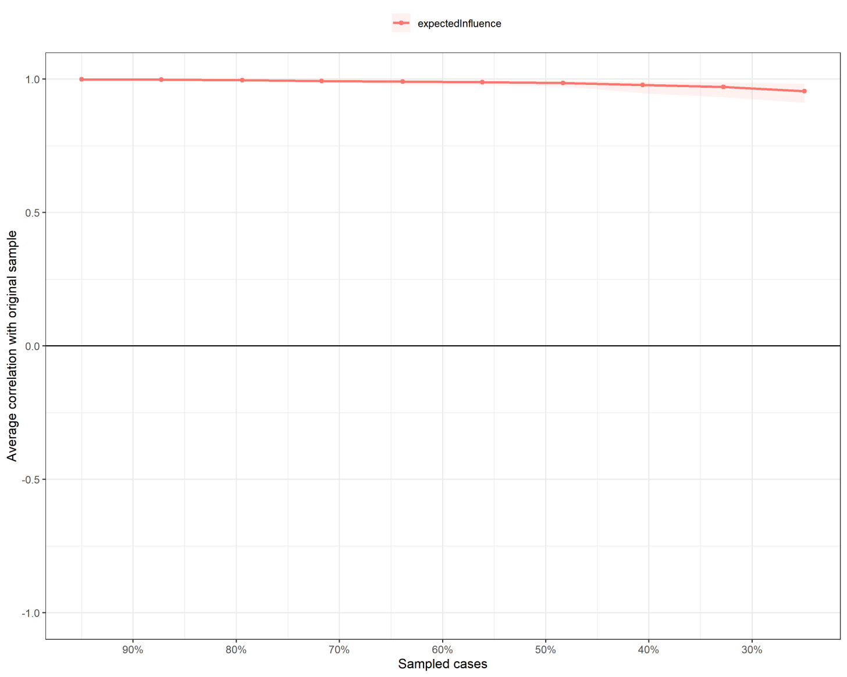
Fig. S3. Case-dropping bootstrap analysis of the stability of expected influence in the low perceived patient safety culture profile network.
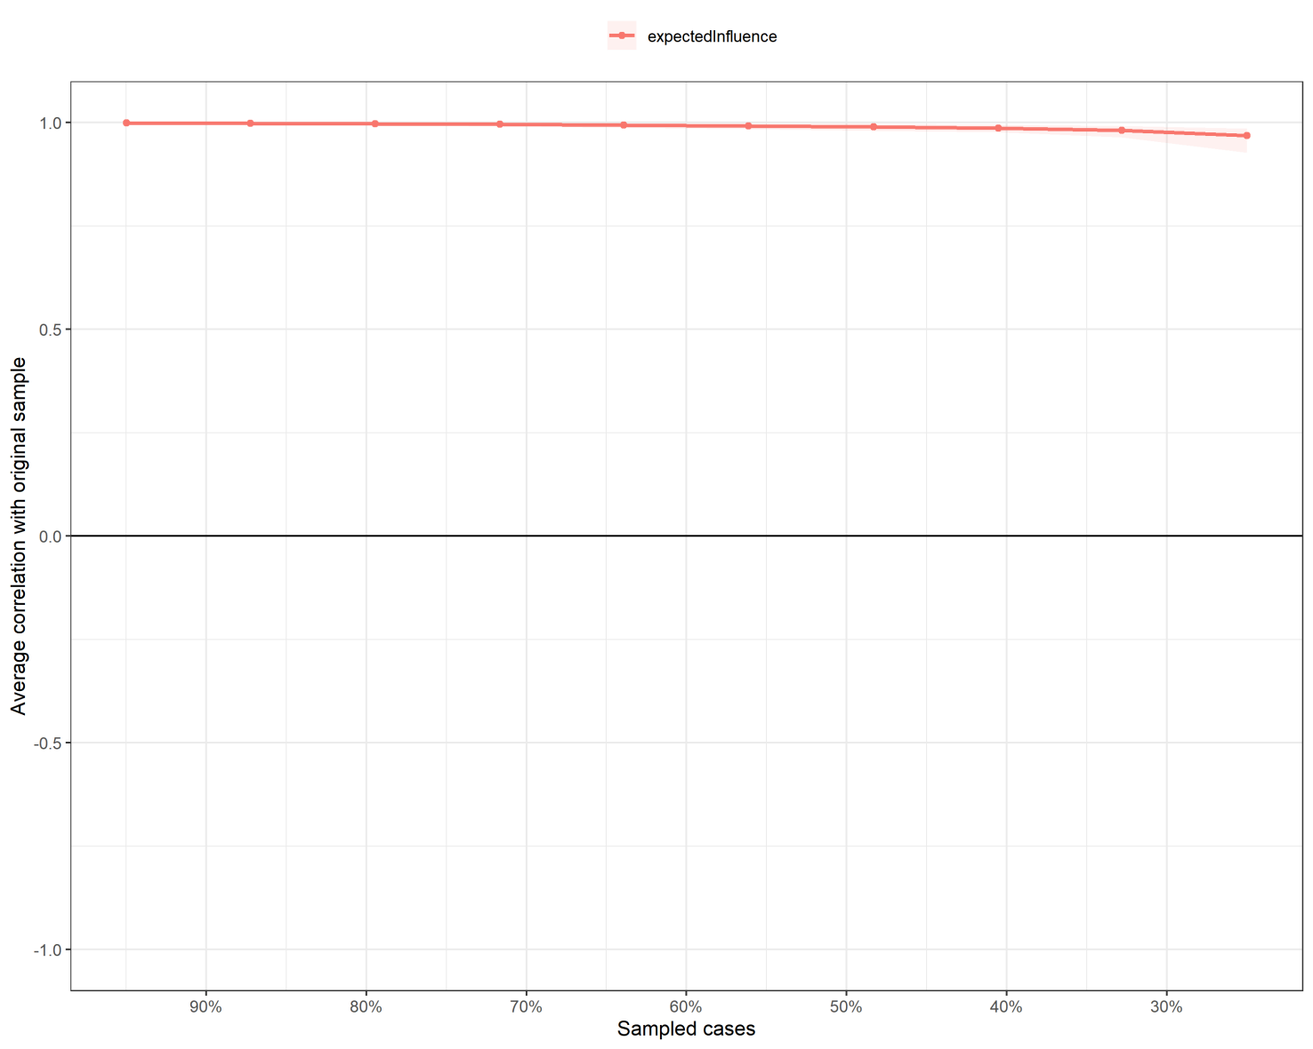
Fig. S4. Case-dropping bootstrap analysis of the stability of expected influence in the moderate perceived patient safety culture profile network.
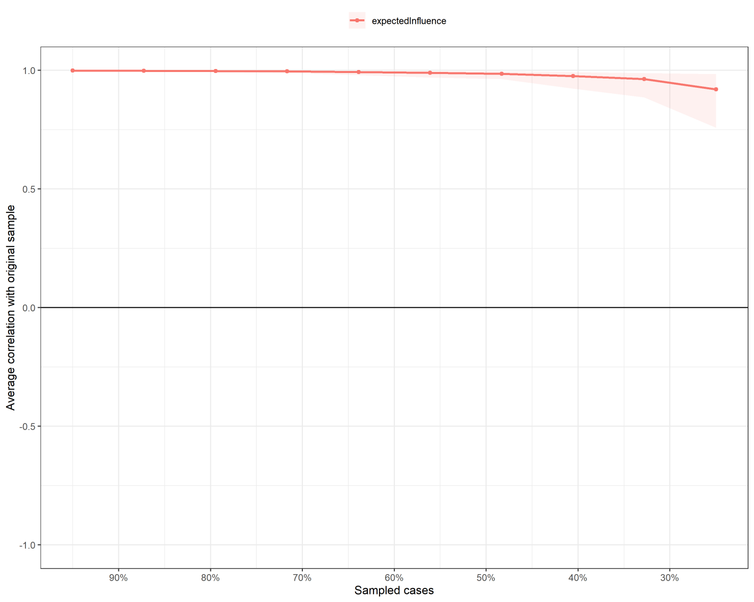
Fig. S5. Case-dropping bootstrap analysis of the stability of expected influence in the high perceived patient safety culture profile network.
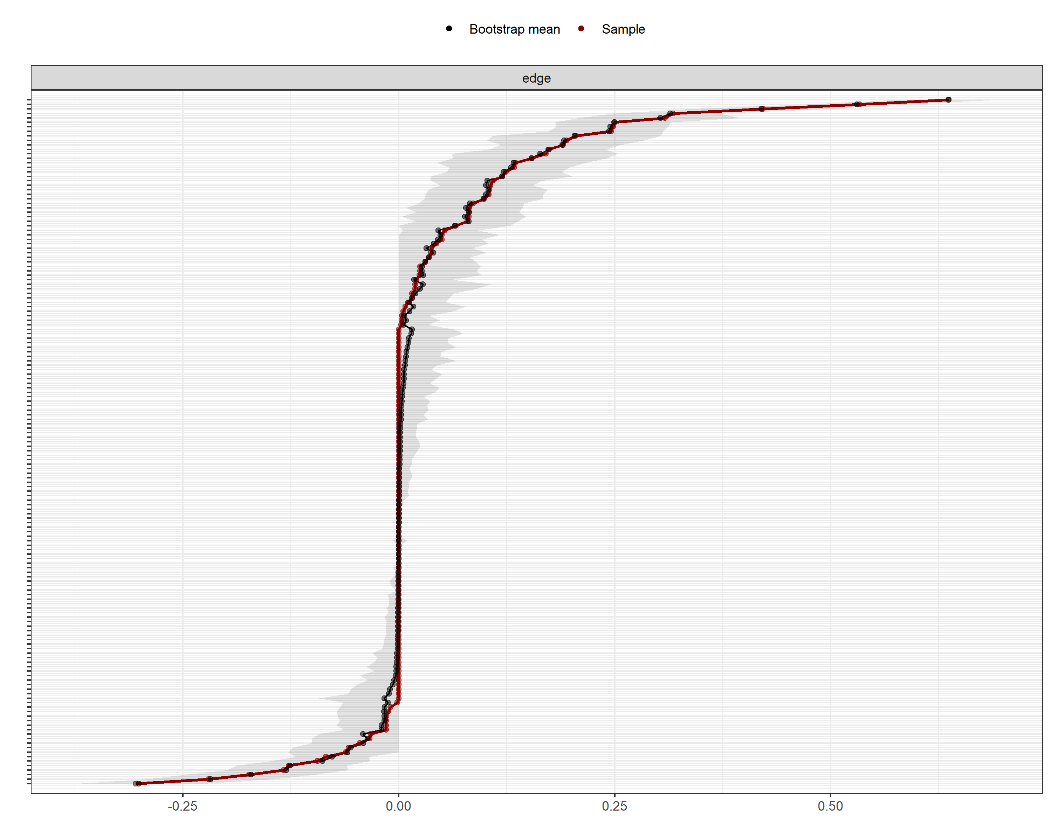
Fig. S6. Accuracy of edge-weight estimates in the low perceived patient safety culture profile network. Black points represent bootstrap means, red points represent sample estimates, and gray bars represent bootstrapped 95% confidence intervals.
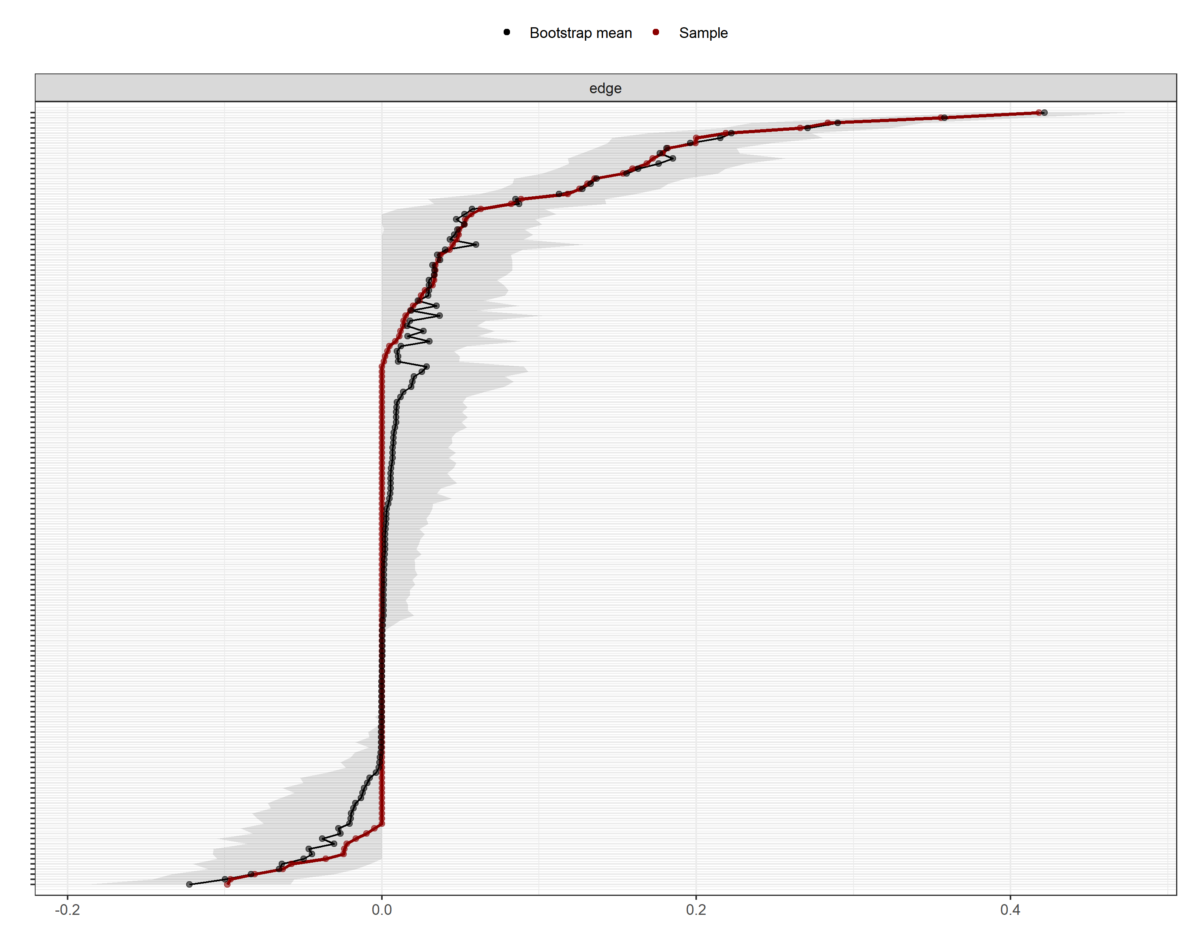
Fig. S7. Accuracy of edge-weight estimates in the moderate perceived patient safety culture profile network. Black points represent bootstrap means, red points represent sample estimates, and gray bars represent bootstrapped 95% confidence intervals.
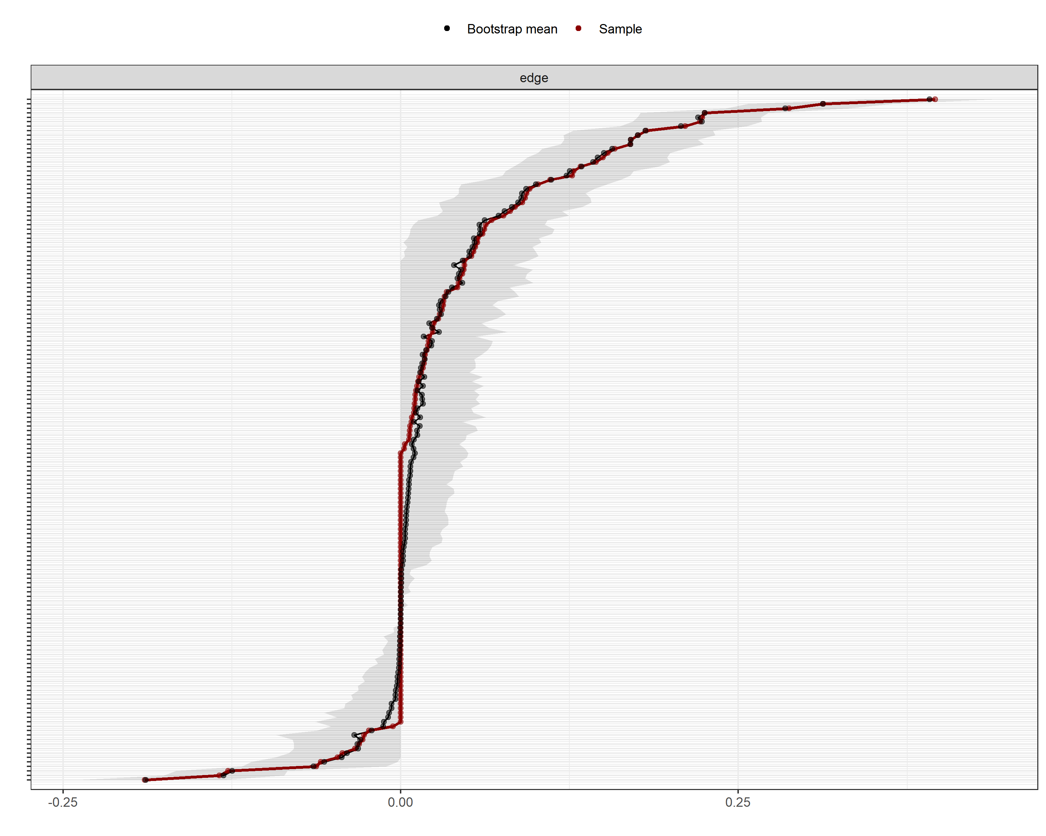
Fig. S8. Accuracy of edge-weight estimates in the high perceived patient safety culture profile network. Black points represent bootstrap means, red points represent sample estimates, and gray bars represent bootstrapped 95% confidence intervals.
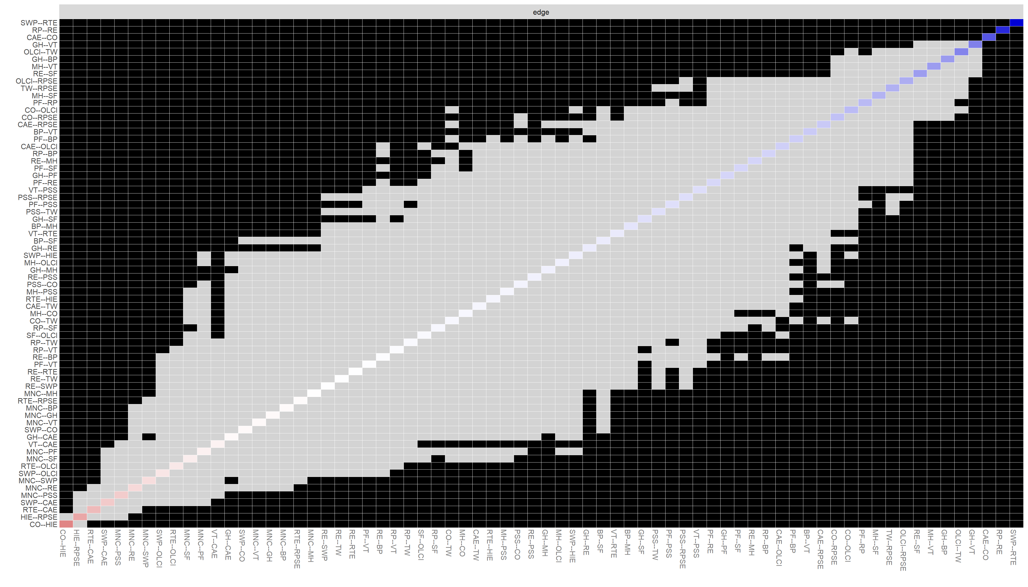
Fig. S9. Bootstrapped difference tests (α = 0.05) for nonzero edge weights in the low perceived patient safety culture profile network. Gray boxes indicate pairs of edge weights that did not differ significantly, whereas black boxes indicate pairs that differed significantly. Colored boxes correspond to the edge colors in Fig. 2(a).
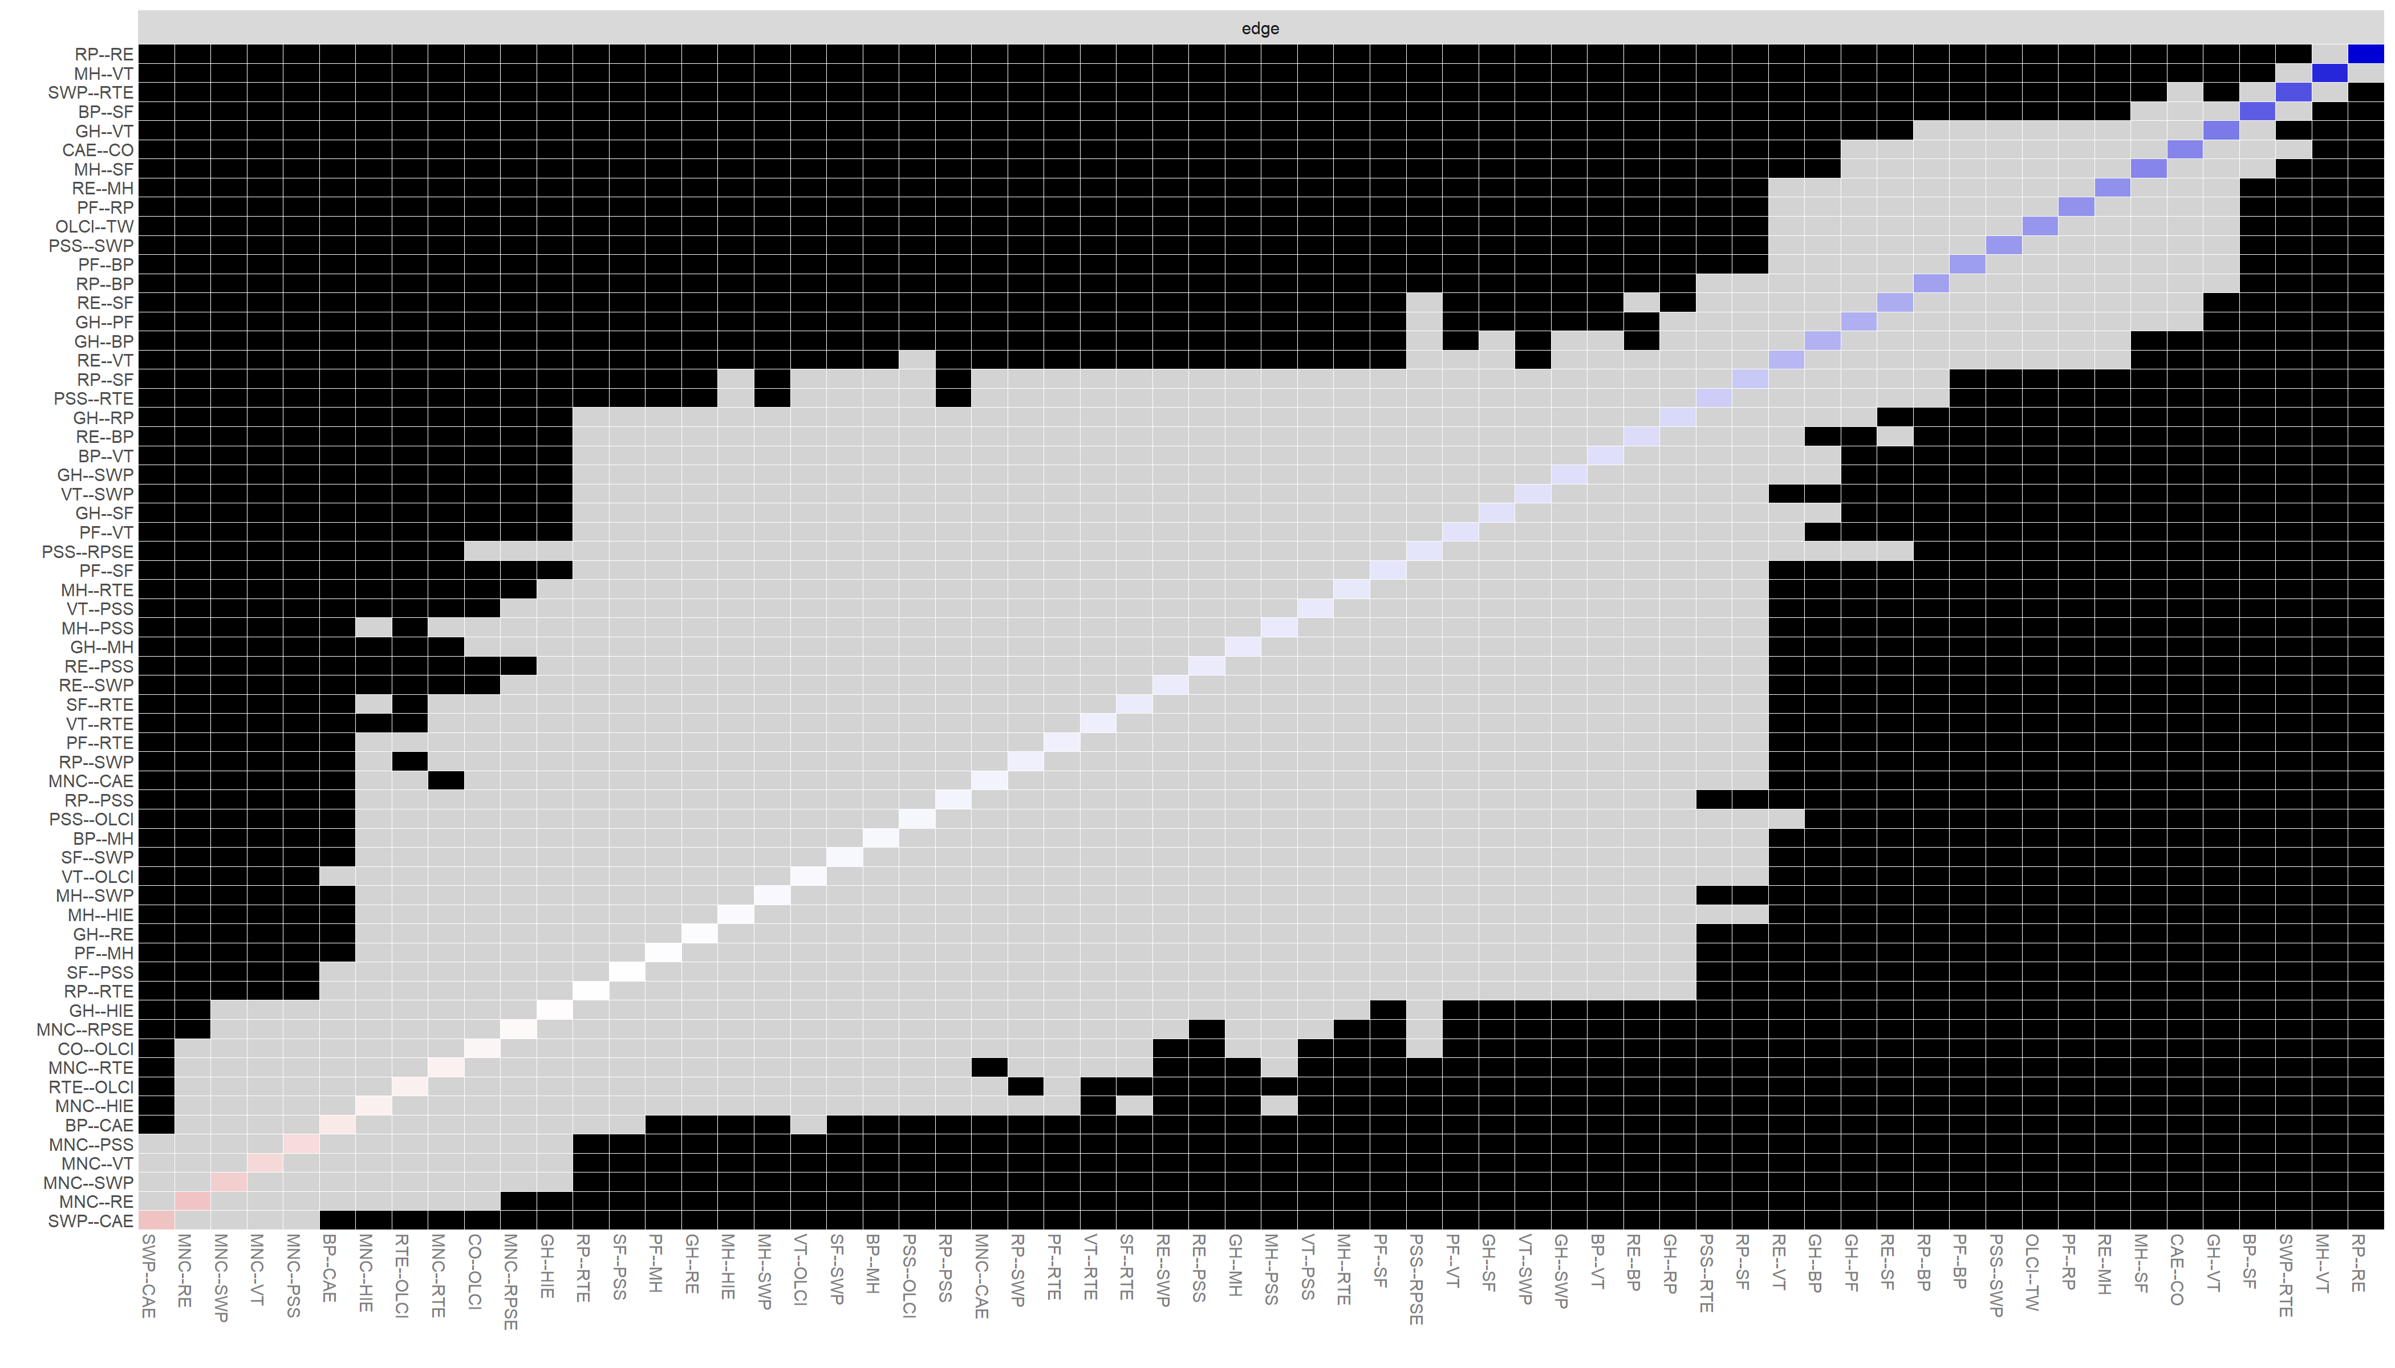
Fig. S10. Bootstrapped difference tests (α = 0.05) for nonzero edge weights in the moderate perceived patient safety culture profile network. Gray boxes indicate pairs of edge weights that did not differ significantly, whereas black boxes indicate pairs that differed significantly. Colored boxes correspond to the edge colors in Fig. 2(d).
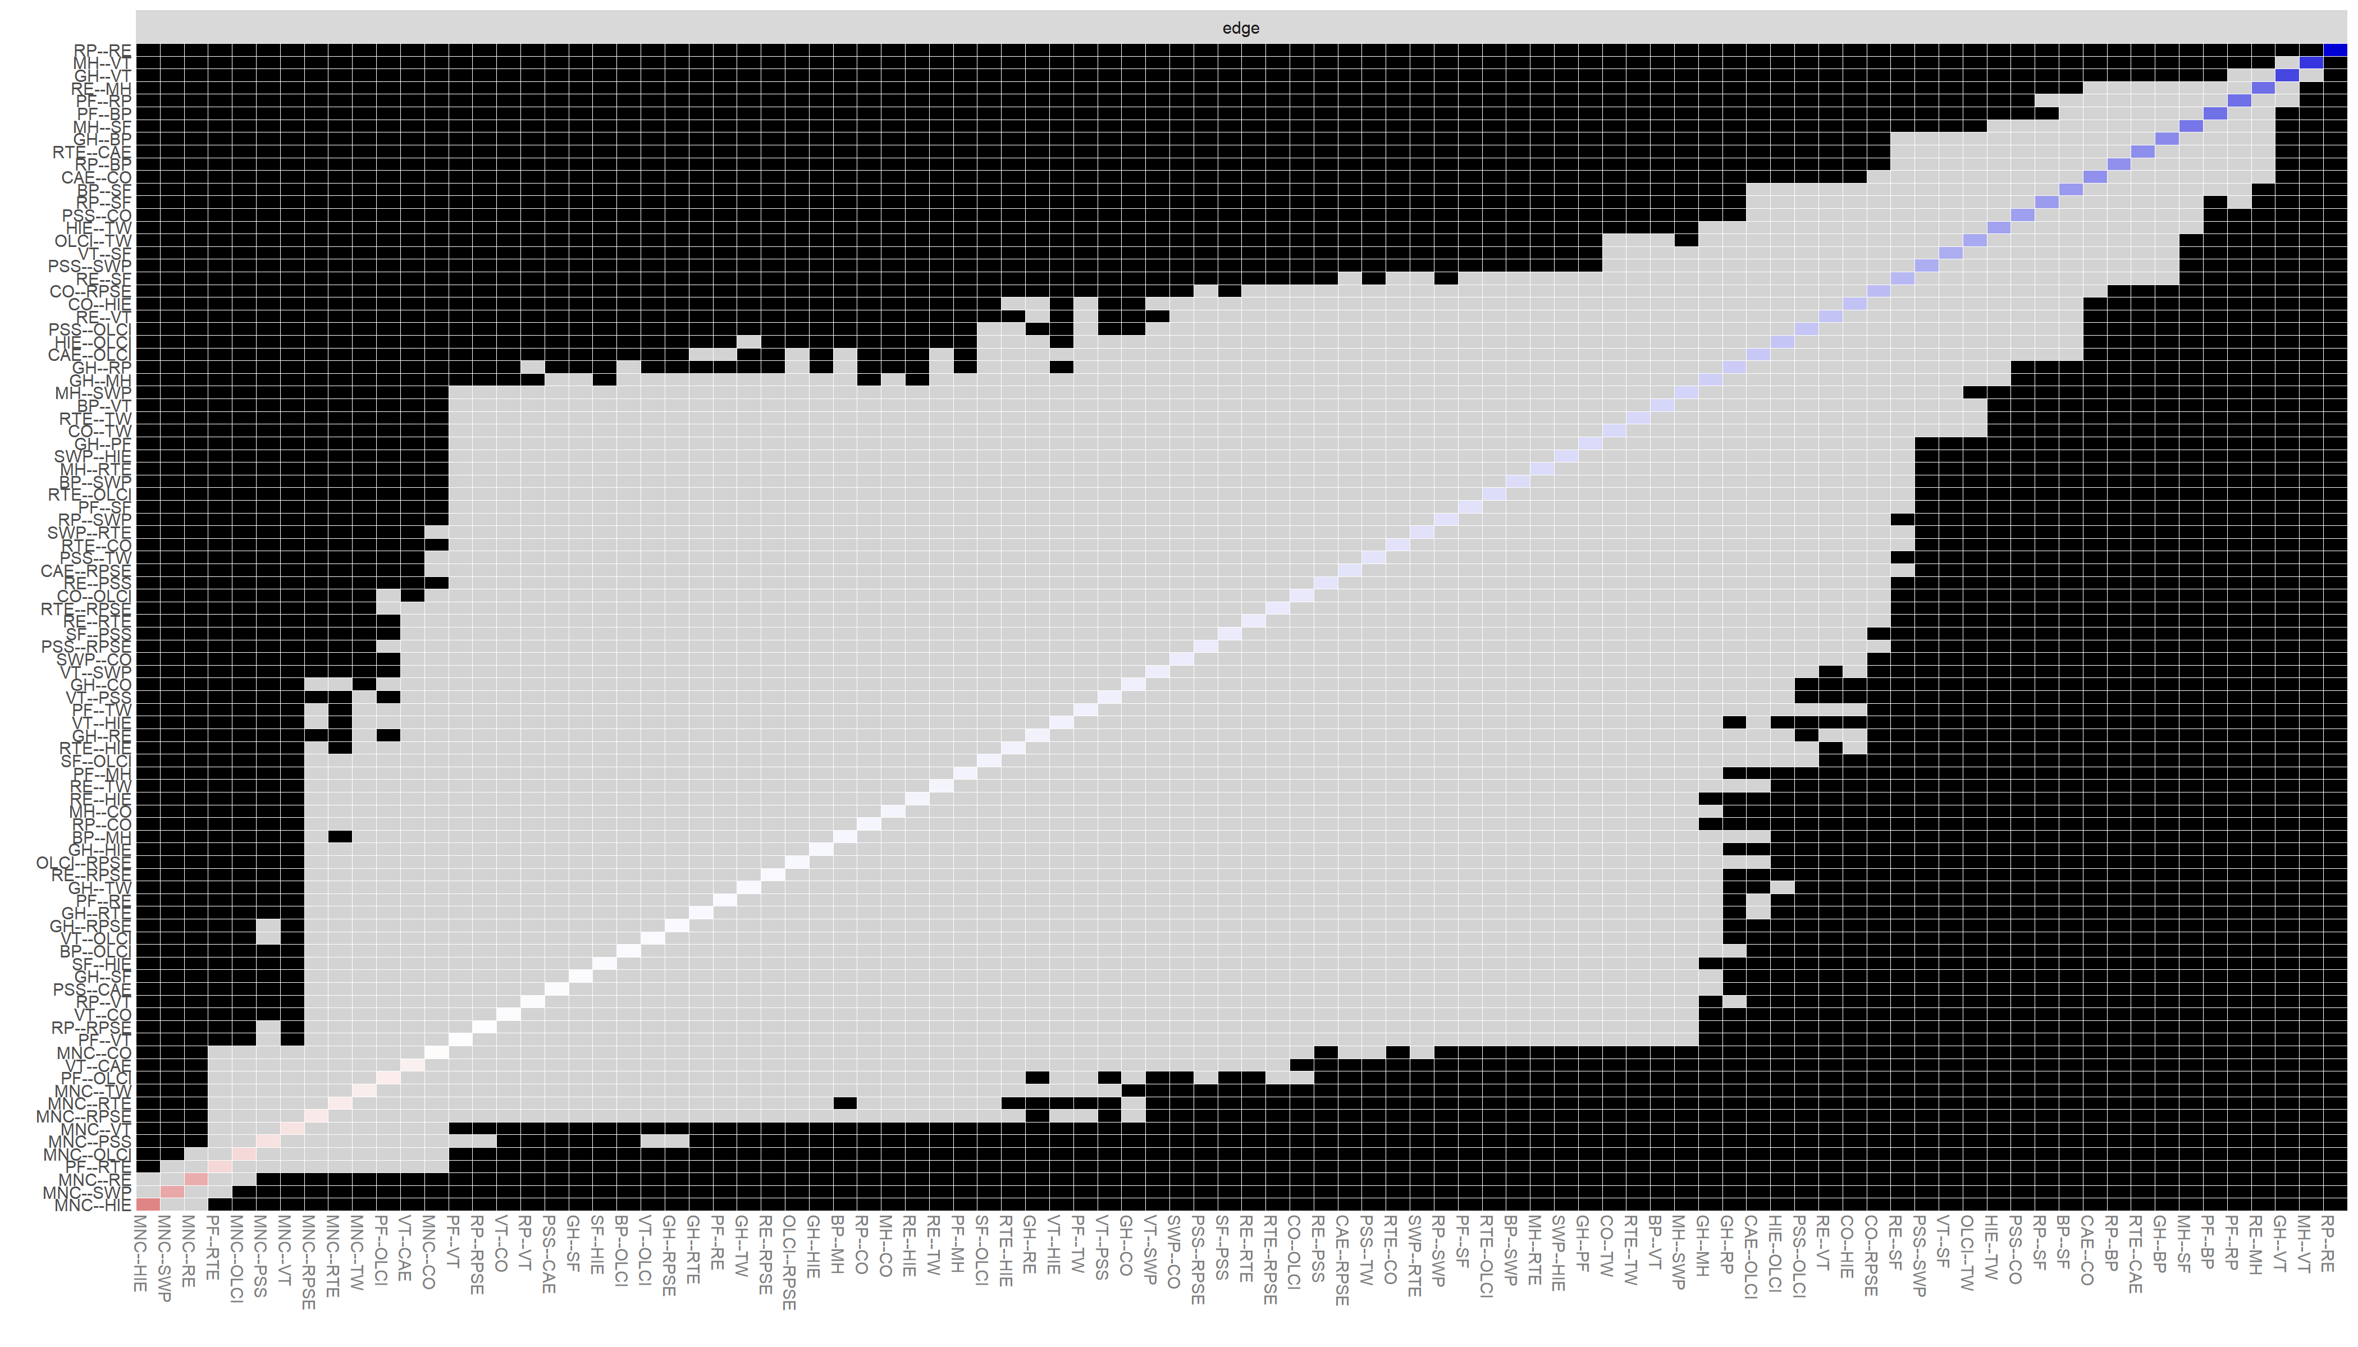
Fig. S11. Bootstrapped difference tests (α = 0.05) for nonzero edge weights in the high perceived patient safety culture profile network. Gray boxes indicate pairs of edge weights that did not differ significantly, whereas black boxes indicate pairs that differed significantly. Colored boxes correspond to the edge colors in Fig. 2(g).

