Supplementary Appendix 4

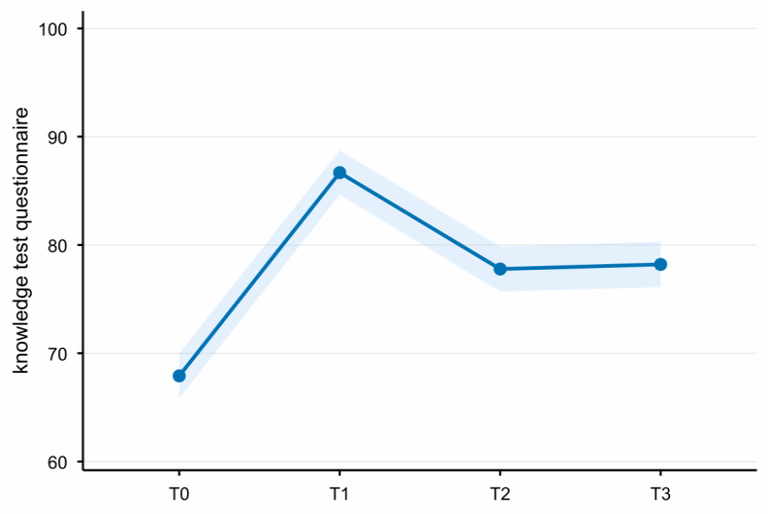
Supplementary Figure 1. Changes in estimated mean scores for clinical nurses’ geriatric nursing knowledge over time
Note. The total score of the geriatric nursing knowledge test questionnaire ranges from 0 to 100.

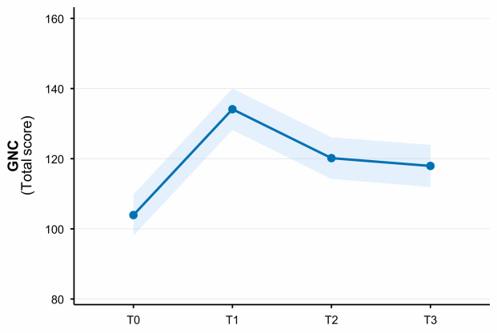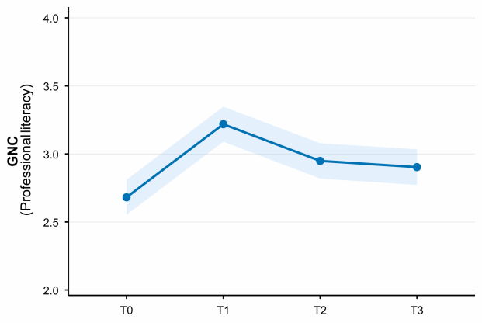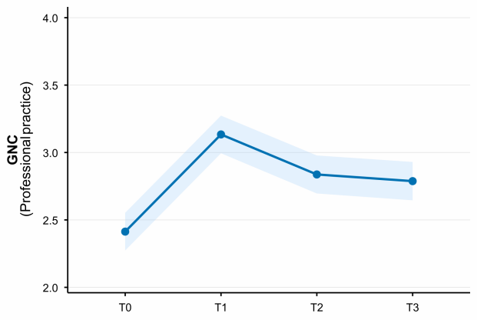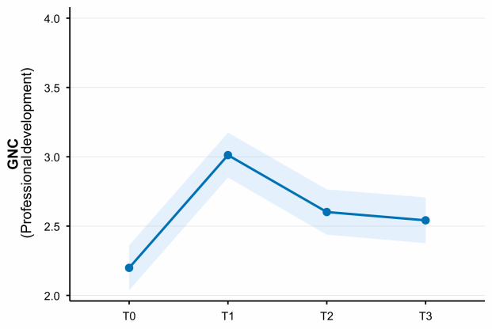
Supplementary Figure 2. Changes in estimated mean scores for clinical nurses’ total geriatric nursing competence and domain scores over time
Note: The first panel presents the total score of the Geriatric Nursing Competence Scale, with scores ranging from 0 to 172.
Panels 2-4 present the mean item scores for each GNC domain, with scores ranging from 0 to 4.
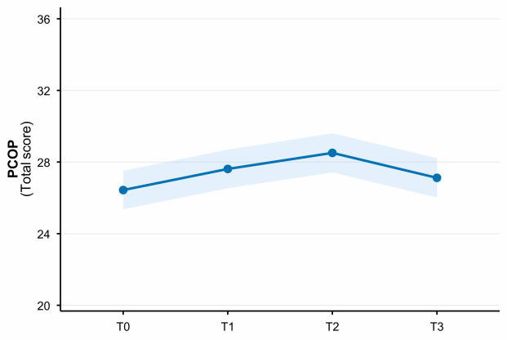
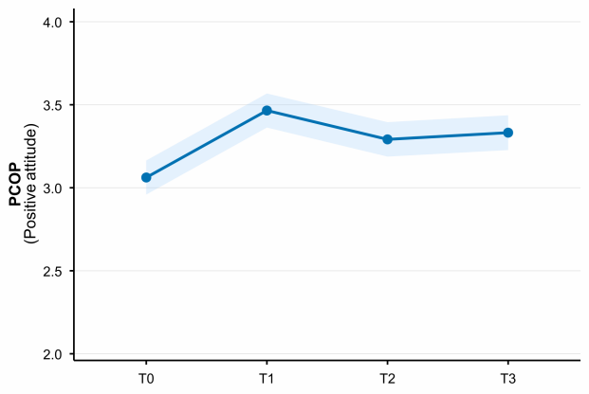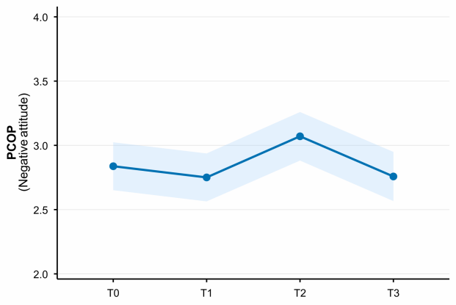
Supplementary Figure 3. Changes in estimated mean scores for clinical nurses’ total attitudes toward caring for older patients and domain scores over time
Note. The first panel presents the total score of the Perspectives on Caring for Older Patients Scale, with scores ranging from 0 to 36.
Panels 2-3 present the mean item scores for each PCOP domain, with scores ranging from 0 to 4.

