Supplementary Materials
Appendix A

Table A (January 21, 2026)
Search strategies of each database.
Database | Index and keyword terms
PubMed  183 | #1 ("Alzheimer Disease"[Mesh]) OR (Alzheimer Syndrome[Title/Abstract]) OR (Alzheimer Type Dementia[Title/Abstract]) OR (Alzheimer Disease[Title/Abstract]) OR (Alzheimer Dementia[Title/Abstract]) OR (Alzheimer's Disease[Title/Abstract]) OR (Alzheimer Type Senile Dementia[Title/Abstract])  #2 (Nurses[Title/Abstract]) OR (Personnel, Nursing[Title/Abstract]) OR (Registered Nurse[Title/Abstract]) OR ("Nurses"[Mesh]) OR ("Students, Nursing"[Mesh]) OR (Pupil Nurse[Title/Abstract]) OR (Nursing Student[Title/Abstract]) OR (student nurse[Title/Abstract])  #3 (knowledge) OR (attitude*)  #4 #1 AND #2 AND #3
Web of science  400 | #1TS=(Nurses OR Nursing Personnel OR Registered Nurses OR Students, Nursing OR Pupil Nurse OR Nursing Student OR student nurse)  #2TS=(Alzheimer Disease OR Alzheimer Syndrome OR Alzheimer Type Dementia OR Alzheimer Dementia OR Alzheimer Type Senile Dementia)  #3TS=(knowledge OR attitude)  #4 #1 AND #2 AND #3
EMBASE  64 | #1 'Alzheimer Disease'/exp  #2 'Alzheimer Disease':ab,ti OR 'Alzheimer Syndrome':ab,ti OR 'Alzheimer Type Dementia':ab,ti OR 'Alzheimer Dementia':ab,ti OR 'Alzheimer Type Senile Dementia':ab,ti  #3 #1 OR #2  #4 'nurse':ab,ti OR 'nursing personnel':ab,ti OR 'registered nurses':ab,ti OR 'Students, Nursing':ab,ti OR 'Pupil Nurse':ab,ti OR 'Nursing Student':ab,ti OR 'student nurse':ab,ti  #5 'knowledge':ab,ti OR 'attitude':ab,ti  #6 #3 AND #4 AND #5
CINAHL  7 | S1 TI Nurses OR TI Nursing Personnel OR TI Registered Nurse OR TI Students, Nursing OR TI Nursing Student OR TI student nurse  S2 TI Alzheimer Disease OR TI Alzheimer Syndrome OR TI Alzheimer Type Dementia OR TI Alzheimer Dementia OR TI Alzheimer Type Senile Dementia  S3 TI knowledge OR TI attitude

Appendix B Methodological quality
Study | JBI critical appraisal checklist for analytical cross-section studies |  |  |  |  |  |  |  | Result
Study | C1 | C2 | C3 | C4 | C5 | C6 | C7 | C8 | Result
Wang et al | Y | Y | NA | Y | Y | Y | Y | Y | High quality
Parra-Anguita et al | Y | Y | NA | Y | N | N | Y | Y | Moderate quality
Strøm et al | Y | Y | NA | Y | Y | Y | Y | Y | High quality
Aljezaw et al | Y | Y | NA | Y | Y | Y | Y | Y | High quality
Zuo et al | Y | Y | NA | Y | N | N | Y | Y | Moderate quality
Yaghmour et al | Y | Y | NA | Y | Y | Y | Y | Y | High quality
Paul et al | Y | Y | NA | Y | N | N | Y | Y | Moderate quality
Wang et al | Y | Y | NA | Y | Y | Y | Y | Y | High quality
Smyth et al | Y | Y | NA | Y | Y | Y | Y | Y | High quality
Zhao et al | Y | Y | NA | Y | Y | Y | Y | Y | High quality
Nguyen et al | Y | Y | NA | Y | N | N | Y | Y | Moderate quality
Alzahrani et al | Y | Y | NA | Y | N | N | Y | Y | Moderate quality
Singh et al | Y | Y | NA | Y | N | N | Y | Y | Moderate quality
Romem et al | Y | Y | NA | Y | Y | Y | Y | Y | High quality
Aljezawi et al | Y | Y | NA | Y | N | N | Y | Y | Moderate quality
Laura et al | Y | Y | NA | Y | N | N | Y | Y | Moderate quality
Skriver et al | Y | Y | NA | Y | Y | Y | Y | Y | High quality
Abdalrahim et al | Y | Y | NA | Y | N | N | Y | Y | Moderate quality
Wiese et al | Y | Y | NA | Y | Y | Y | Y | Y | High quality
Aslan et al | Y | Y | NA | Y | Y | Y | Y | Y | High quality
Scerri et al | Y | Y | NA | Y | N | N | Y | Y | Moderate quality
Khatiwada et al | Y | Y | NA | Y | Y | Y | Y | Y | High quality
Olajide et al | Y | Y | NA | Y | N | N | Y | Y | Moderate quality
Alharbi et al | Y | Y | NA | Y | Y | Y | Y | Y | High quality
Alotaibi et al | Y | Y | NA | Y | Y | Y | Y | Y | High quality
Kirve et al | Y | Y | NA | Y | N | N | Y | Y | Moderate quality
My et al | Y | Y | NA | Y | Y | Y | Y | Y | High quality
Dong et al | Y | Y | NA | Y | Y | Y | Y | Y | High quality
Wang et al | Y | Y | NA | Y | N | N | Y | Y | Moderate quality
Poreddi et al | Y | Y | NA | Y | N | N | Y | Y | Moderate quality
Liu et al | Y | Y | NA | Y | Y | Y | Y | Y | High quality
Gönen Sentürk et al | Y | Y | NA | Y | N | N | Y | Y | Moderate quality
Akyol et al | Y | Y | NA | Y | Y | Y | Y | Y | High quality
Note: Y: Yes; N: No; UC: Unclear; NA: Not applicable; C1: Were the criteria for inclusion in the sample clearly defined?; C2: Were the study subjects and the setting described in detail?; C3: Was the exposure measured in a valid and reliable way?; C4: Were objective, standard criteria used for measurement of the condition?; C5: Were confounding factors identified?; C6: Were strategies to deal with confounding factors stated?; C7:Were the outcomes measured in a valid and reliable way?; C8: Was appropriate statistical analysis used?

Appendix C
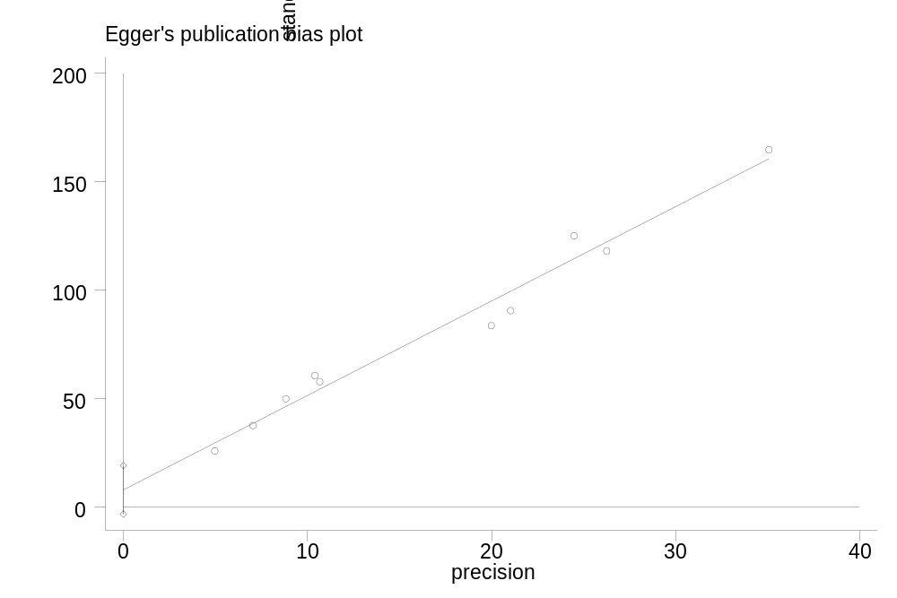
Supplementary Figure 1: Bias in the publication of nurses' attitude of AD.

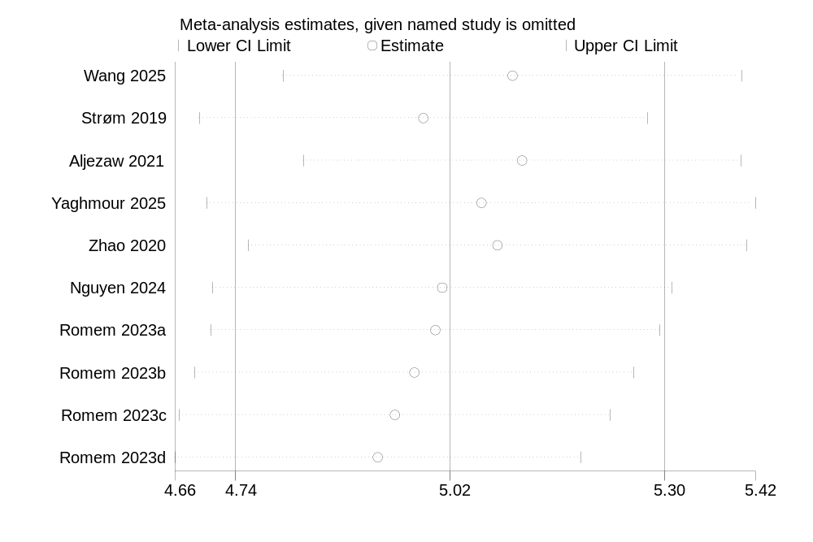
Supplementary Figure 2 Sensitivity Analysis of nurses' attitude of AD.

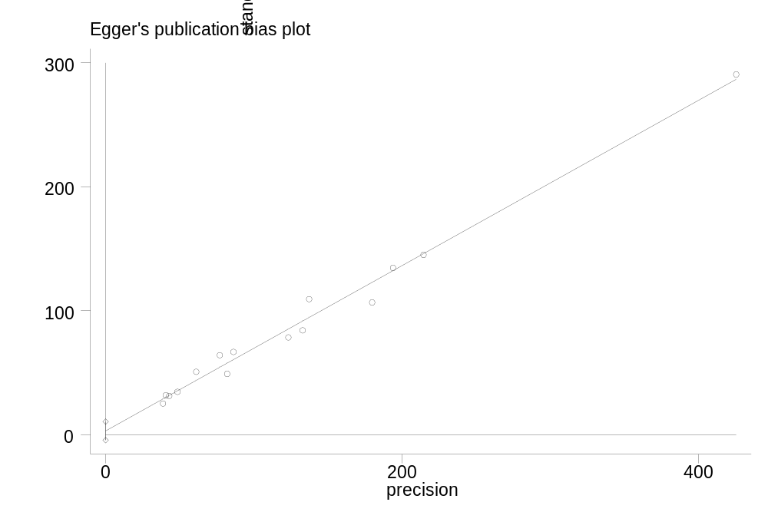
Supplementary Figure.3 Bias in the publication of nurses' knowledge of AD.

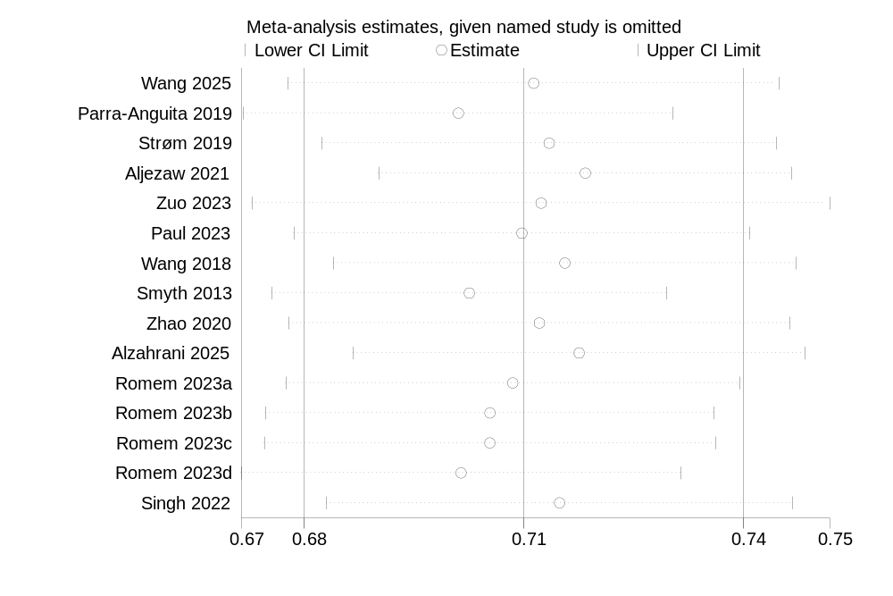
Supplementary Figure.4 Sensitivity Analysis of nurses' knowledge of AD.
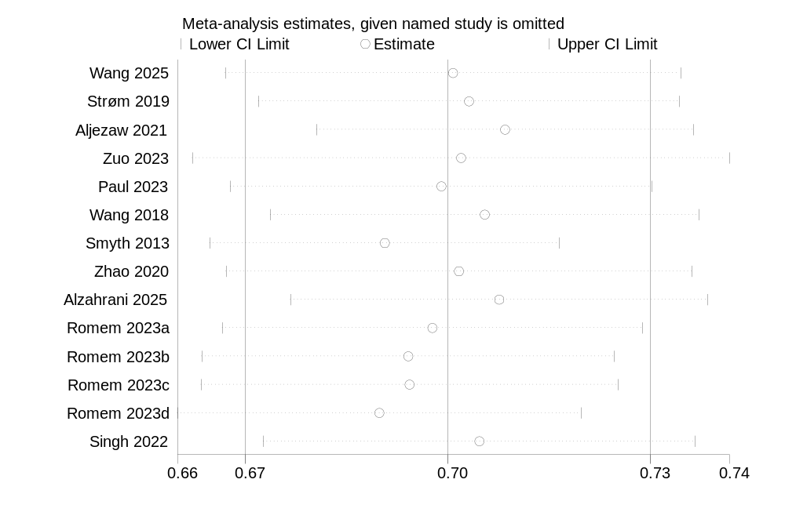
Supplementary Figure.5 ADKS-only sensitivity Analysis of nurses' knowledge of AD.

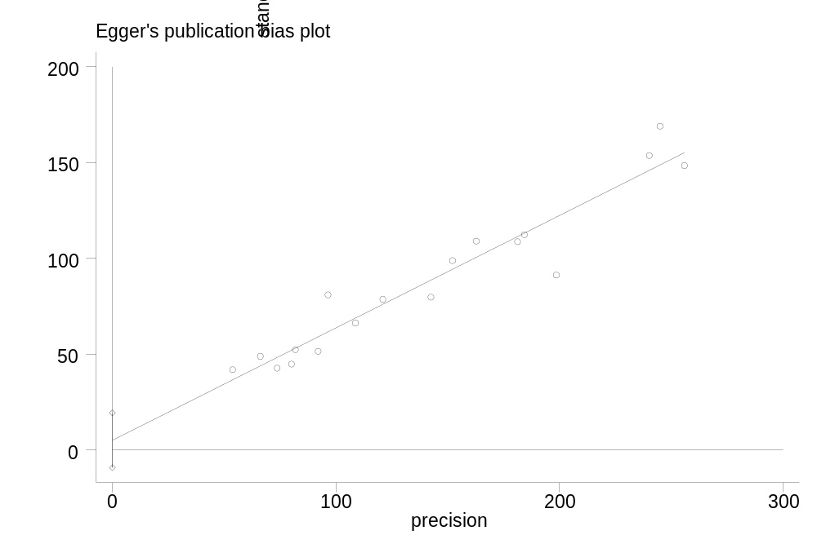
Supplementary Figure.6 Bias in the publication of nursing students' knowledge of AD.

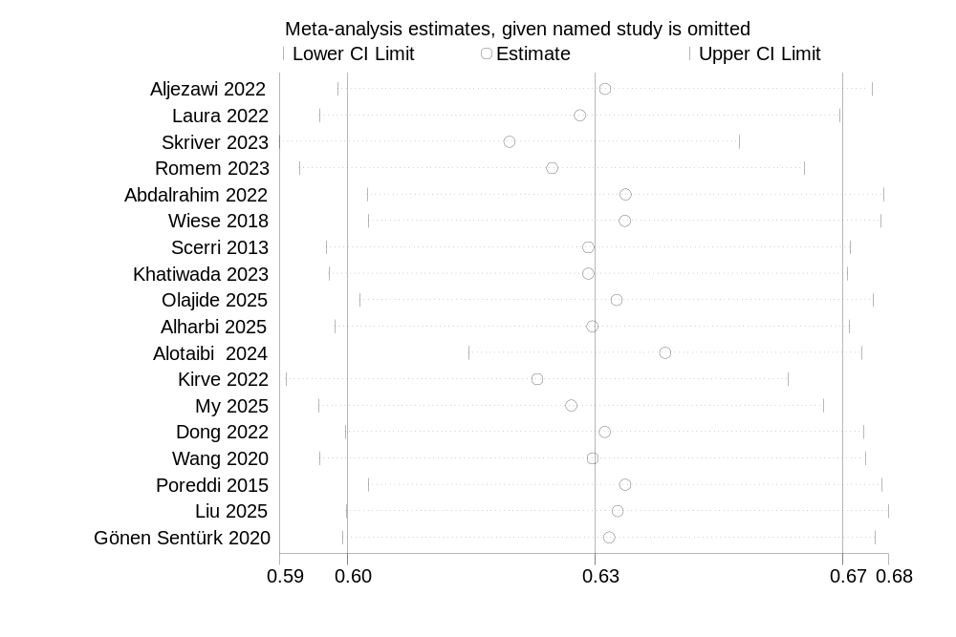
Supplementary Figure.7 Sensitivity Analysis of nursing students' knowledge of AD.
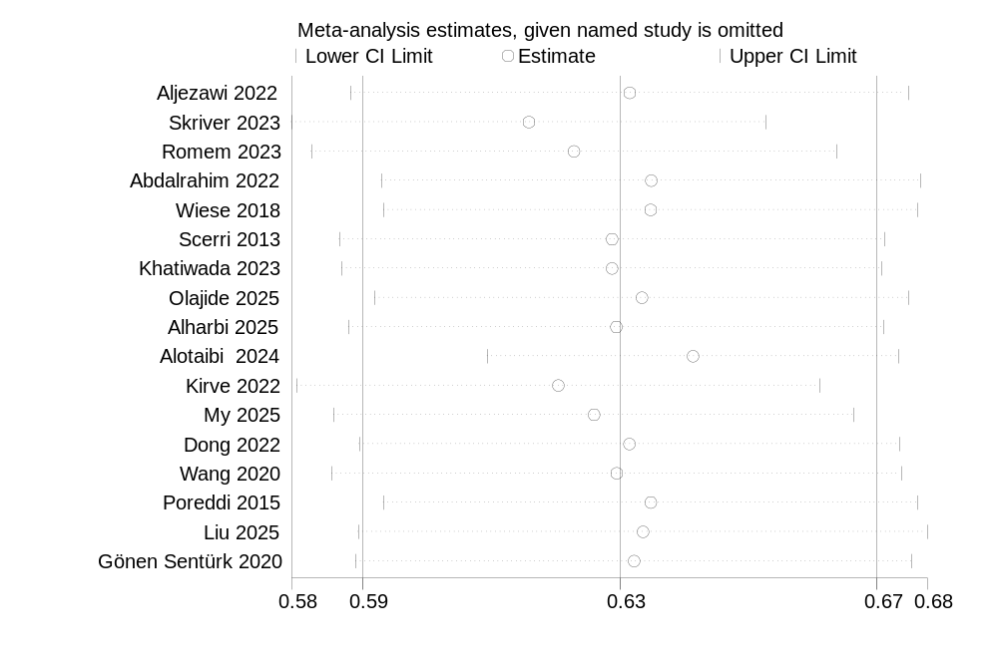
Supplementary Figure.8 ADKS-only sensitivity Analysis of nursing students' knowledge of AD.

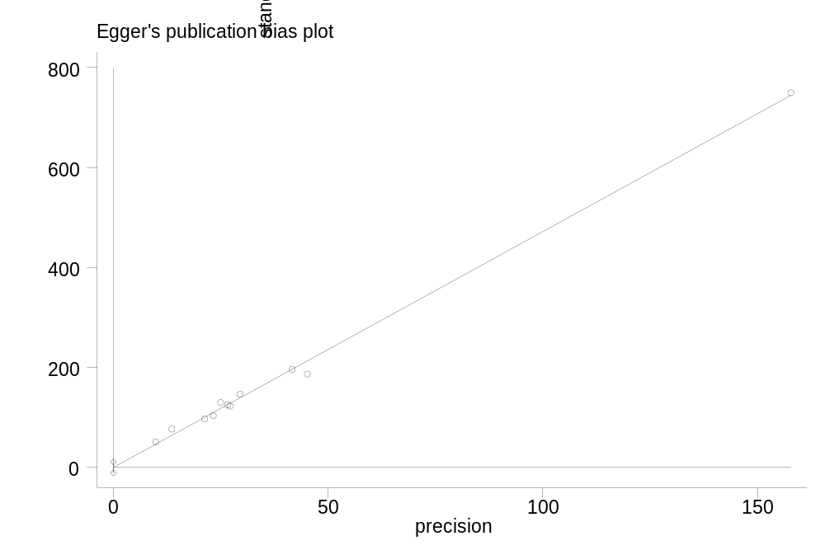
Supplementary Figure.9 Bias in the publication of nursing students' attitude of AD.

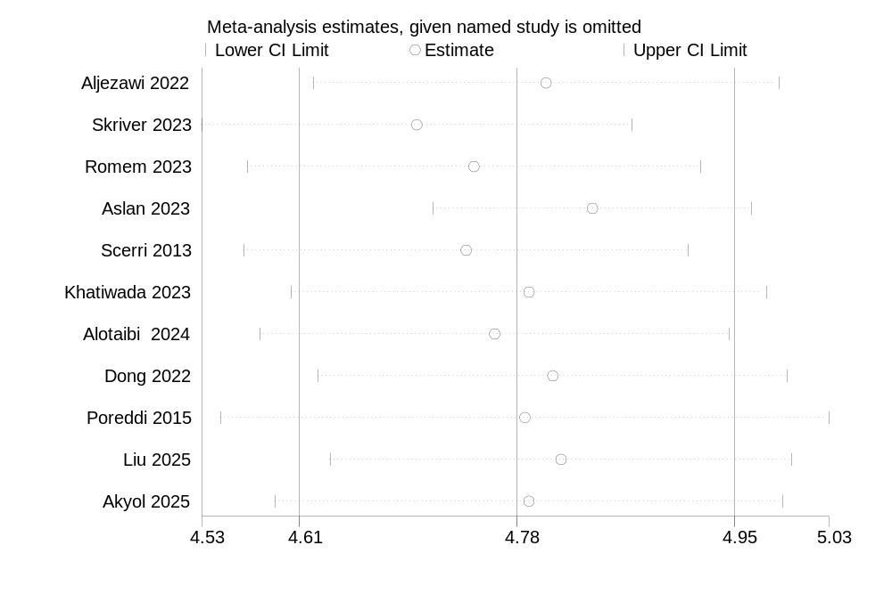
Supplementary Figure.10 Sensitivity Analysis of nursing students' attitude of AD.

Stata
Nurses' knowledge of AD
clear
input study_id N mean sd
1 223 0.69 0.08
2 15 0.65 0.1
3 207 0.59 0.08
4 1896 0.68 0.10
5 48 0.71 0.14
6 178 0.63 0.10
7 169 0.80 0.09
8 430 0.68 0.10
9 70 0.60 0.10
10 17 0.73 0.10
11 71 0.77 0.10
12 36 0.78 0.15
13 50 0.83 0.12
14 61 0.64 0.06
end

gen se = sd / sqrt(N)

label define study_lab 1 "Wang 2025" 2 "Strøm 2019" 3 "Aljezaw 2021" 4 "Zuo 2023" 5 "Paul 2023" 6 "Wang 2018" 7 "Smyth 2013" 8 "Zhao 2020" 9 "Alzahrani 2025" 10 "Romem 2023a" 11 "Romem 2023b" 12 "Romem 2023c" 13 "Romem 2023d" 14 "Singh 2022"

label values study_id study_lab

metan mean se, random label(namevar=study_id) xlabel(0.4, 0.9) effect("Mean Score")

Subgroup analysis: Economic level（Nurse Knowledge-AD）
clear
input study_id N mean sd year str9 economic
1 69 0.83304347826087 0.107826086956522 2019 "High-income"
2 48 0.714285714285714 0.142857142857143 2023 "High-income"
3 169 0.796666666666667 0.0946666666666667 2013 "High-income"
4 70 0.598333333333333 0.102 2025 "High-income"
5 17 0.73 0.096 2023 "High-income"
6 71 0.774333333333333 0.0976666666666667 2023 "High-income"
7 36 0.782666666666667 0.147333333333333 2023 "High-income"
8 50 0.830666666666667 0.115666666666667 2023 "High-income"
9 223 0.694 0.077 2025 "Non-High-income"
10 15 0.65 0.1 2019 "Non-High-income"
11 207 0.593333333333333 0.08 2021 "Non-High-income"
12 1896 0.683 0.102333333333333 2023 "Non-High-income"
13 178 0.633333333333333 0.100333333333333 2018 "Non-High-income"
14 430 0.676666666666667 0.0966666666666667 2020 "Non-High-income"
15 61 0.636666666666667 0.0633333333333333 2022 "Non-High-income"
end

gen se = sd / sqrt(N)

encode economic, gen(econ_group)
label define econ_group 1 "High-income" 2 "Non-High-income", replace
label values econ_group econ_group

label define study_lab 1 "Parra-Anguita 2019" 2 "Paul 2023" 3 "Smyth 2013" 4 "Alzahrani 2025" 5 "Romem 2023a" 6 "Romem 2023b" 7 "Romem 2023c" 8 "Romem 2023d" 9 "Wang 2025" 10 "Strøm 2019" 11 "Aljezaw 2021" 12 "Zuo 2023" 13 "Wang 2018" 14 "Zhao 2020" 15 "Singh 2022"
label values study_id study_lab

metan mean se if econ_group == 1, random label(namevar=study_id) xlabel(0.4, 0.9) effect("Mean Score")
metan mean se if econ_group == 2, random label(namevar=study_id) xlabel(0.4, 0.9) effect("Mean Score")

metareg mean se, wsse(se) covar(econ_group) reml

