Supplementary Figure S5. Class 3 and Class 4 Profile Diagrams
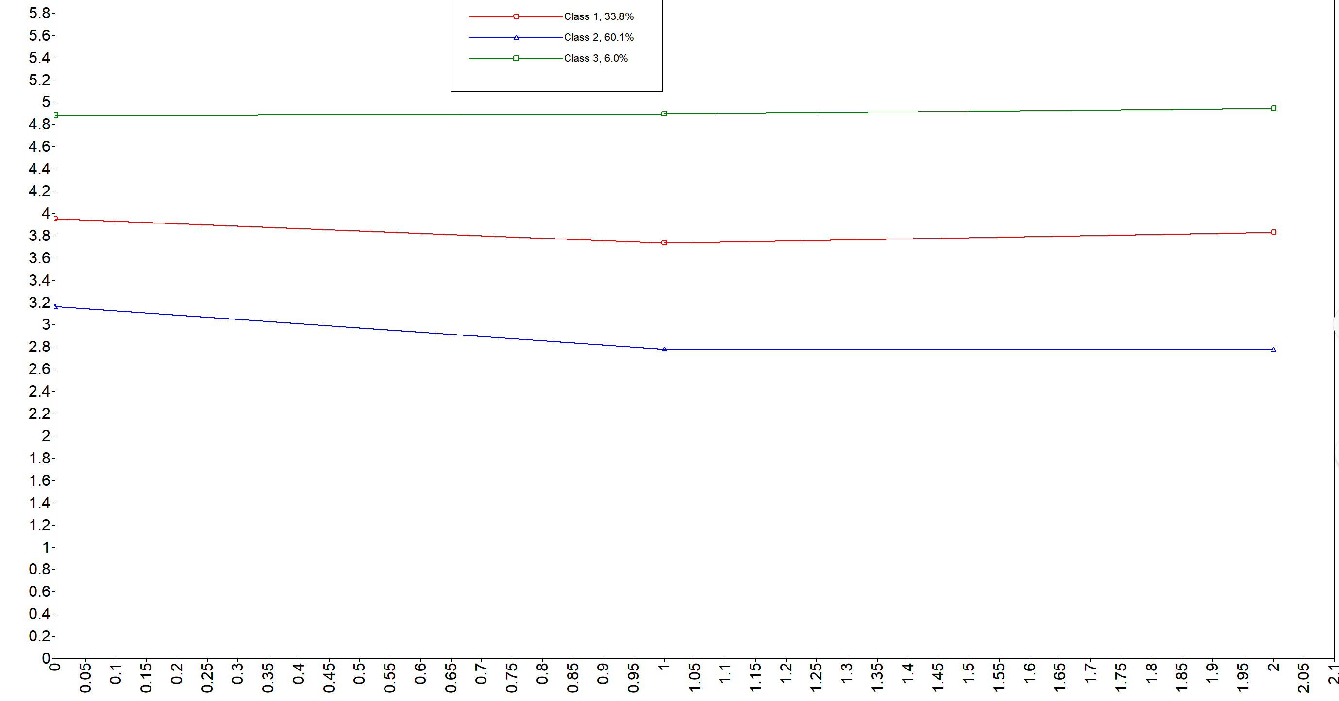

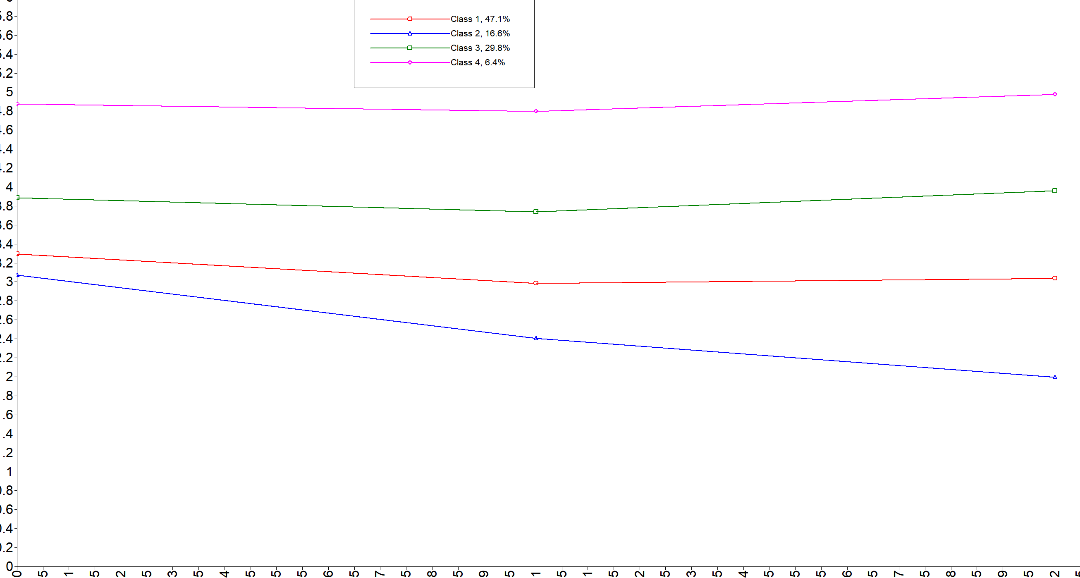
Note: Mplus class numbers are arbitrary and have no substantive meaning. For the retained three-profile solution, the manuscript relabels the profiles by substantive level as C1 = relative low-innovation level (n=261, 61.85%), C2 = relative moderate-innovation level (n=135, 31.99%), and C3 = relative high-innovation level (n=26, 6.16%). The original Mplus numbering was Class 2, Class 1, and Class 3, respectively.
Model selection requires a balance among statistical fit, parsimony, stability, and substantive interpretability. The 4-profile solution had lower AIC, BIC, and aBIC values and higher entropy than the 3-profile solution, and the BLRT remained statistically significant. However, the LMR-LRT was not statistically significant (P = 0.1111), providing no evidence that adding a fourth profile significantly improved the model over the 3-profile solution. Therefore, neither the 3-profile nor the 4-profile solution can be considered "absolutely optimal" on the basis of any single fit index.
Inspection of the profile plots showed that the 4-profile solution retained a broadly monotonic ordering of profiles according to overall level. The newly added profile primarily represented a further subdivision along the existing low-to-moderate-to-high level continuum, rather than a response configuration with a clearly distinct relative pattern across dimensions. Thus, the improvement in statistical fit provided by the 4-profile solution did not correspond to a new conceptual configuration. Given that the purpose of this study was empirical level stratification rather than identification of fundamentally mutually exclusive discrete subtypes, the 3-profile solution offered greater parsimony and interpretability.
The 4-profile solution yielded profile proportions of approximately 46.91%, 16.59%, 30.10%, and 6.40%, while the 5-profile solution introduced an additional very small profile comprising 1.42% of the sample. Given that subsequent covariate analyses were also constrained by the small sample size of the high-innovation profile, we retained the 3-profile solution for descriptive stratification and hypothesis generation, while explicitly acknowledging in the main text that the 4-profile solution showed better statistical fit according to the information criteria. This decision should not be interpreted as indicating that the 3-profile solution had better statistical fit than the 4-profile solution.

Additional quantitative comparison of the three- and four-profile solutions
The complete Mplus outputs allow a direct comparison of the retained three-profile solution with the four-profile alternative. The table below reports the estimated dimension means and most-likely class sizes using the same three observed indicators.
Model | Profile | n (%) | Generating ideas | Obtaining support | Realizing ideas | Interpretation
3-profile | C1 | 261 (61.85%) | 3.164 | 2.778 | 2.775 | Relative low level
3-profile | C2 | 135 (31.99%) | 3.954 | 3.735 | 3.831 | Relative moderate level
3-profile | C3 | 26 (6.16%) | 4.880 | 4.892 | 4.944 | Relative high level
4-profile | C1 | 198 (46.91%) | 3.293 | 2.985 | 3.036 | Lower level
4-profile | C2 | 70 (16.59%) | 3.070 | 2.405 | 1.994 | Further subdivision of lower range
4-profile | C3 | 127 (30.10%) | 3.887 | 3.739 | 3.962 | Moderately high level
4-profile | C4 | 27 (6.40%) | 4.877 | 4.796 | 4.975 | Highest level
Interpretation. The three-profile solution shows a clear low–moderate–high ordering, with presentation labels standardized as C1=low, C2=moderate, and C3=high in the manuscript. The four-profile solution is ordered C2 < C1 < C3 < C4 across all three dimensions and does not introduce a qualitatively different response configuration. The additional fourth profile mainly subdivides the lower-to-moderate portion of the same overall level continuum. The highest-level group is almost unchanged between solutions (26 vs. 27 nurses; 6.16% vs. 6.40%), with very similar dimension means. Thus, the four-profile model provides finer statistical resolution but limited additional substantive differentiation.
Model-selection rationale for retaining three profiles
The four-profile solution had better AIC, BIC, aBIC, and entropy, so it should not be described as statistically inferior to the three-profile solution. However, the adjusted LMR-LRT did not support a significant improvement from three to four profiles (P = 0.1111). In addition, the four-profile BLRT was based on only five successful bootstrap draws and was accompanied by an Mplus warning that the P value might not be trustworthy because of local maxima. Taken together with the monotonic profile ordering, the small highest-level subgroup, and the study aim of empirical level stratification rather than identification of mutually exclusive behavioral types, the three-profile solution was retained as the primary descriptive solution. The continuous-model comparison further indicates that the profile structure may represent clustering along an underlying continuous dimension.
Technical note: The three-profile Mplus output reported the best loglikelihood as -1128.407, AIC 2284.814, BIC 2341.444, aBIC 2297.017, and entropy 0.894. The four-profile output reported -976.012, AIC 1988.023, BIC 2060.833, aBIC 2003.714, and entropy 0.970. The adjusted LMR-LRT was P = 0.0005 for two versus three profiles and P = 0.1111 for three versus four profiles.

