Supplementary Material
Supplementary Material 1: Confirmatory Factor Analysis of the Work-Immersion Measure
Purpose. These supplementary analyses examine whether the 13 indicators are better represented by a single general factor or by the theoretically specified three correlated dimensions: focus (A1-A4), work enjoyment (A5-A8), and intrinsic work motivation (A9-A13).
Supplementary Table S1. Confirmatory Factor Analysis: Comparison of the One-Factor and Theoretical Three-Factor Models
Model | χ² | df | χ²/df | CFI | TLI | RMSEA (90% CI) | Standardized loadings
One-factor model | 1096.754 | 65 | 16.873 | 0.816 | 0.780 | 0.168 [0.159, 0.177] | 0.396-0.949
Three-factor model | 381.517 | 62 | 6.153 | 0.943 | 0.928 | 0.096 [0.087, 0.105] | 0.552-0.962
Note. The three-factor model fit significantly better than the one-factor model, Δχ²(3) = 715.237, p < .001. Although the three-factor solution showed substantially improved relative fit, RMSEA = .096 indicates some remaining absolute model misfit.
Supplementary Table S2. Standardized Factor Loadings for the Theoretical Three-Factor CFA Model
Latent factor | Item | Standardized loading
Focus | A1 | 0.680
Focus | A2 | 0.716
Focus | A3 | 0.783
Focus | A4 | 0.902
Work enjoyment | A5 | 0.867
Work enjoyment | A6 | 0.891
Work enjoyment | A7 | 0.962
Work enjoyment | A8 | 0.959
Intrinsic work motivation | A9 | 0.613
Intrinsic work motivation | A10 | 0.674
Intrinsic work motivation | A11 | 0.890
Intrinsic work motivation | A12 | 0.552
Intrinsic work motivation | A13 | 0.738
Note. Standardized factor loadings ranged from .552 to .962 in the theoretical three-factor model.
Supplementary Table S3. Correlations Among Latent Factors in the Theoretical Three-Factor CFA Model
Factor pair | Latent correlation
Focus - Intrinsic work motivation | 0.590
Focus - Work enjoyment | 0.630
Work enjoyment - Intrinsic work motivation | 0.824
Note. Latent factor correlations ranged from .590 to .824, indicating that the dimensions were substantially related but not identical.

Supplementary Figure
Supplementary Figure S1. Theoretical Three-Factor Correlated CFA Measurement Model
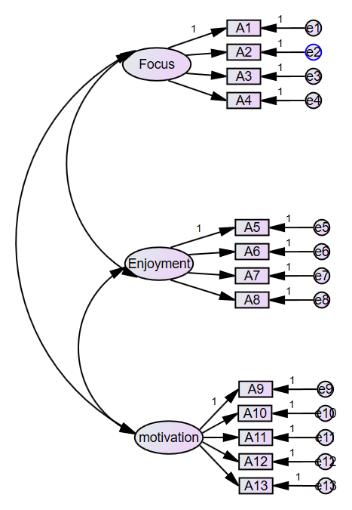
Note. The model specifies Focus (A1-A4), Work enjoyment (A5-A8), and Intrinsic work motivation (A9-A13) as three correlated latent factors. Standardized factor loadings and latent correlations are reported in Supplementary Tables S6 and S7, respectively.

Supplementary Interpretation
The one-factor CFA model showed poor fit, whereas the theoretical three-factor model provided substantially better fit. The significant chi-square difference, together with the standardized factor loadings and latent correlations, indicates that a single-factor representation is insufficient relative to the proposed multidimensional structure. However, because the three-factor model retained some absolute misfit (RMSEA = 0.096), these CFA results are interpreted as supporting the relative plausibility of the three-dimensional measurement structure rather than as evidence that the latent profiles represent qualitatively distinct subpopulations.
Abbreviations: CFA = confirmatory factor analysis; CFI = comparative fit index; RMSEA = root mean square error of approximation; TLI = Tucker-Lewis index.
Supplementary Material 2: Sensibility Analysis
Supplementary Table S4. Table of model fit indices for the latent profile model constructed based on scores across three dimensions
Model | AIC | BIC | aBIC | Entropy | LMR | BLRT | Profile probability
1-profile | 9024.966 | 9050.976 | 9031.929 | — | — | — | —
2-profile | 8528.203 | 8571.553 | 8539.808 | 0.795 | <0.001 | <0.001 | 37.77/62.23
3-profile | 8390.554 | 8451.245 | 8406.802 | 0.796 | <0.001 | <0.001 | 12.59/48.76/38.65
4-profile | 8185.510 | 8263.541 | 8206.399 | 0.944 | 0.028 | <0.001 | 29.79/10.46/13.83/45.92
5-profile | 7992.646 | 8088.018 | 8018.178 | 0.971 | <0.001 | <0.001 | 27.66/2.84/14.18/44.33/10.99
6-profile | 7983.259 | 8095.970 | 8013.433 | 0.974 | 0.002 | <0.001 | 13.83/27.66/2.84/10.99/44.33/0.36
7-profile | 7934.365 | 8064.417 | 7969.181 | 0.961 | 0.204 | <0.001 | 9.22/2.84/26.42/6.74/42.91/1.77/10.11

Supplementary Figure S2. Table of model fit indices for the latent profile model constructed based on scores across three dimensions
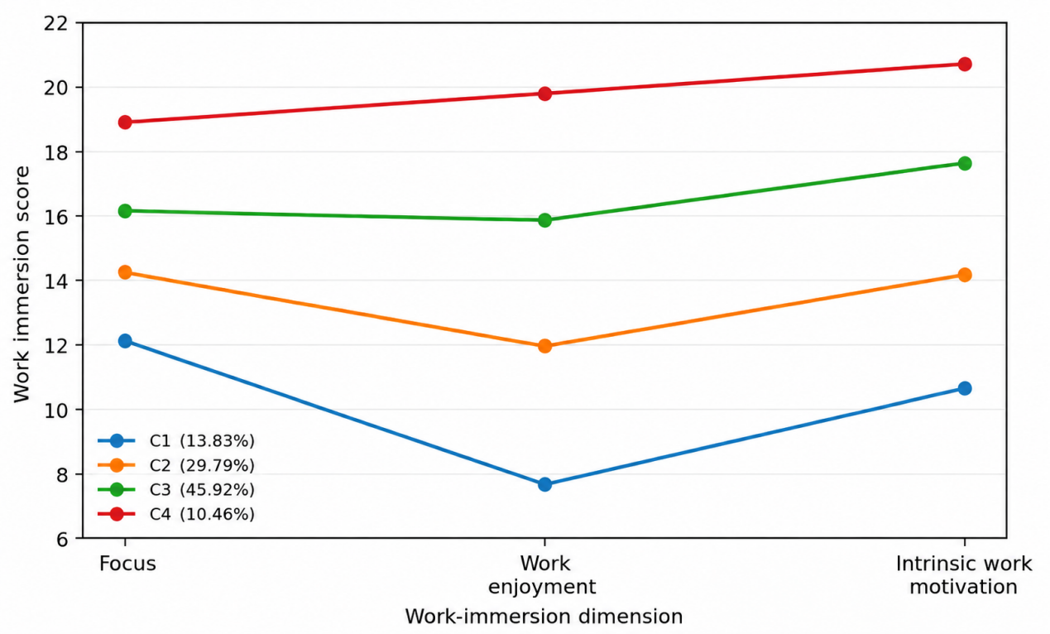

Supplementary Material 3: Additional Analyses of Profile Shape and Level Differences
Purpose. These supplementary analyses formally evaluate whether the four latent profiles differ only in overall level or also in profile shape across focus, work enjoyment, and intrinsic work motivation. The original LPA used all 13 items (A1-A13). Sensitivity analyses additionally used three dimension scores: focus(A1-A4), work enjoyment (A5-A8), and intrinsic work motivation (A9-A13).
Supplementary Table S5. Original 13-Item Four-Class LPA: Model Fit, Classification, and Formal Profile-Shape Test
Statistic | Result
Sample size | 564
Log-likelihood | -7759.049
AIC | 15654.099
BIC | 15948.882
Sample-size adjusted BIC | 15733.015
Entropy | 0.987
Joint Wald test of profile shape | chi-square(6) = 239.744, P ＜ .001
Note. The Wald test evaluated equality of the relative contrasts among the three work-immersion dimensions across the four latent classes. A significant result rejects the hypothesis that the profiles are strictly parallel and differ only in overall level.
Supplementary Table S6. Class Size and Dimension-Level Means in the Original 13-Item Four-Class Solution
Profile | Most likely n (%) | Focus | Work enjoyment | Intrinsic motivation | Focus - Enjoyment
C1 | 85 (15.1) | 3.038 | 1.973 | 2.155 | 1.065
C2 | 173 (30.7) | 3.602 | 3.048 | 2.868 | 0.554
C3 | 243 (43.1) | 4.026 | 3.982 | 3.544 | 0.044
C4 | 63 (11.2) | 4.720 | 4.921 | 4.144 | -0.201
Note. Dimension-level means were calculated from the item-level class-specific means: focus = A1-A4, work enjoyment = A5-A8, and intrinsic work motivation = A9-A13. The decreasing Focus - Enjoyment contrast illustrates a systematic change in profile shape from the low to the high profile.
Supplementary Table S7. Three-Dimension Four-Class LPA Sensitivity Analysis
Profile | Most likely n (%) | Focus | Work enjoyment | Intrinsic motivation | Focus - Enjoyment
C1 | 78 (13.8) | 3.029 | 1.919 | 2.131 | 1.110
C2 | 259 (45.9) | 4.030 | 3.964 | 3.528 | 0.066
C3 | 168 (29.8) | 3.553 | 2.988 | 2.833 | 0.565
C4 | 59 (10.5) | 4.722 | 4.947 | 4.141 | -0.225
Note. For interpretive clarity, the Mplus classes were reordered from low to high overall work immersion (C1, C2, C3, C4). Model fit: log-likelihood = -1603.292; AIC = 3242.584; BIC = 3320.615; sample-size adjusted BIC = 3263.473; entropy = .944. The joint Wald test again rejected parallel profile shapes, chi-square(6) = 252.391, P < .001.
Supplementary Table S8. Comparison of Unrestricted and Parallel-Profile Three-Dimension Models
Model | Log-likelihood | AIC | BIC | Adjusted BIC | Entropy
Unrestricted profile shape | -1603.292 | 3242.584 | 3320.615 | 3263.473 | .944
Parallel-profile constrained | -1700.509 | 3425.019 | 3477.040 | 3438.945 | .802
Difference (constrained - unrestricted) | -97.217 | +182.435 | +156.425 | +175.472 | -.142
Note. The parallel-profile model constrained the four classes to have an identical shape and to differ only by an overall vertical shift. Lower AIC, BIC, and adjusted BIC indicate better fit. The unrestricted model fit substantially better, with Delta BIC = 156.425 in favor of allowing shape differences.

Supplementary Interpretation
Across both the original 13-item model and the three-dimension sensitivity analysis, the four profiles were clearly ordered in overall work-immersion level. However, the formal Wald tests rejected strict parallelism in both specifications, and imposing a parallel-profile structure substantially worsened model fit. The most visible shape change concerned the relative standing of focus and work enjoyment: the former was much higher than the latter in the low profile, whereas the difference progressively narrowed and reversed in the high profile. Taken together, these results support describing the solution as ordered profiles with substantial level differences accompanied by statistically significant shape differences, rather than as purely severity-based classes or wholly qualitatively distinct types.
Abbreviations: AIC = Akaike information criterion; BIC = Bayesian information criterion; LPA = latent profile analysis.
Supplementary Material 4: Direct pairwise Wald tests of regression-coefficient differences across latent profiles
Supplementary Table S9. Direct pairwise Wald tests of regression-coefficient differences across latent profiles
Variables | Category | C1 vs C2, P | C1 vs C3, P | C2 vs C3, P
Department (Reference: Internal medicine department) | Surgical department | 0.759 | 0.880 | 0.685
 | Obstetrics and gynecology department | 0.402 | 0.713 | 0.402
 | Pediatrics department | 0.306 | 0.149 | 0.724
 | Other departments | 0.465 | 0.571 | 0.705
Gender (Reference: Male) | Female | 0.003 | 0.178 | <0.001
Age (Reference: ≤ 30 years) | 31–35 years | 0.756 | 0.283 | 0.271
 | 36–40 years | 0.964 | 0.861 | 0.726
 | > 40 years | 0.988 | 0.759 | 0.677
Years of nursing experience (Reference: ≤ 5 years) | 6–10 years | 0.572 | 0.270 | 0.439
 | ≥ 10 years | 0.895 | 0.346 | 0.061
Education level (Reference: Associate degree or below) | Bachelor's degree | <0.001 | <0.001 | <0.001
 | Master's degree or above | <0.001 | 0.373 | <0.001
Professional title (Reference: Nurse) | Senior nurse | 0.490 | 0.808 | 0.395
 | Nurse-in-charge | 0.938 | 0.972 | 0.938
 | Associate professor of nursing or above | 0.668 | 0.384 | 0.616
Marital status (Reference: Unmarried) | Married | 0.610 | 0.776 | 0.639
Monthly income (Reference: ≤ 6000 CNY) | 6,001–10,000 CNY | 0.645 | 0.255 | 0.009
 | ≥ 10,000 CNY | 0.867 | 0.791 | 0.929
Salary satisfaction (Reference: Very satisfied) | Satisfied | 0.385 | 0.005 | 0.004
 | Dissatisfied | 0.454 | 0.736 | 0.369
Departmental work satisfaction (Reference: Very satisfied) | Satisfied | 0.602 | 0.530 | 0.051
 | Dissatisfied | 0.343 | 0.218 | 0.894
Family support availability (Reference: Yes) | No | 0.214 | 0.893 | 0.024
Practice environment |  | <0.001 | <0.001 | 0.279
Job resources |  | 0.095 | 0.020 | 0.696
Job demands |  | 0.753 | 0.018 | <0.001
Perceived professional benefits |  | 0.002 | <0.001 | 0.327
Note. These P values are direct Wald tests obtained by reparameterizing the same Mplus R3STEP multinomial model with alternative reference classes. They test whether the regression coefficients for the two profiles differ.
Supplementary Material 5: Supplementary Analyses Addressing Conceptual Overlap Among Predictors
Pearson correlations were calculated among nursing practice environment, job demands, job resources, and perceived professional benefits. Tolerance and variance inflation factor (VIF) statistics were obtained from a linear-regression collinearity diagnostic model containing the four continuous predictors. To assess robustness to conceptual overlap, a series of conventional multinomial logistic sensitivity models were fitted using assigned four-category profile membership as the dependent variable and C4 as the reference category. All sensitivity models included the same sociodemographic covariates. The models were: Model 0, sociodemographic covariates only; Model 1, Model 0 plus nursing practice environment; Model 2, Model 0 plus job demands and job resources; Model 3, Model 0 plus perceived professional benefits; and Model 4, Model 0 plus all four constructs. These conventional multinomial models are complementary sensitivity analyses and do not replace the primary R3STEP analyses, which account for classification uncertainty.
Supplementary Table S10. Empirical overlap and collinearity diagnostics
Predictor | Practice  environment | Job  demands | Job  resources | Professional  benefits | Tolerance | VIF
Practice environment | 1.000 | 0.380 | 0.307 | 0.413 | 0.755 | 1.325
Job demands | 0.380 | 1.000 | 0.438 | 0.333 | 0.728 | 1.373
Job resources | 0.307 | 0.438 | 1.000 | 0.332 | 0.761 | 1.314
Perceived professional benefits | 0.413 | 0.333 | 0.332 | 1.000 | 0.769 | 1.301
Note. N = 564. All six pairwise correlations were positive and statistically significant (two-tailed P < 0.001). The largest pairwise correlation was r = 0.438.
Supplementary Table S11. Hierarchical sensitivity models
Model | Continuous constructs added | Final −2LL | Cox–Snell R² | Nagelkerke R² | McFadden R²
Model 0 | None (sociodemographic covariates only) | 979.731 | 0.539 | 0.586 | 0.308
Model 1 | Practice environment | 850.581 | 0.633 | 0.689 | 0.399
Model 2 | Job demands + job resources | 837.709 | 0.641 | 0.698 | 0.408
Model 3 | Perceived professional benefits | 843.222 | 0.638 | 0.694 | 0.404
Model 4 | All four constructs | 721.069 | 0.708 | 0.771 | 0.491
Note. The intercept-only −2 log likelihood was 1415.989 for each model. Model 4 likelihood-ratio tests for the four continuous constructs were: practice environment χ² = 47.185, P < 0.001; job demands χ² = 15.638, P = 0.001; job resources χ² = 26.143, P < 0.001; perceived professional benefits χ² = 48.170, P < 0.001 (all df = 3).
Supplementary Table S12. Stability of construct-specific associations in reduced and fully adjusted models
Predictor | Contrast | Reduced model OR (95% CI) | Reduced P | Full model OR (95% CI) | Full P
Practice environment | C1 vs C4 | 0.690 (0.635–0.750) | <0.001 | 0.754 (0.687–0.828) | <0.001
 | C2 vs C4 | 0.786 (0.733–0.843) | <0.001 | 0.848 (0.785–0.915) | <0.001
 | C3 vs C4 | 0.791 (0.739–0.847) | <0.001 | 0.832 (0.774–0.895) | <0.001
Job demands | C1 vs C4 | 0.825 (0.778–0.875) | <0.001 | 0.882 (0.823–0.945) | <0.001
 | C2 vs C4 | 0.885 (0.841–0.932) | <0.001 | 0.932 (0.878–0.989) | 0.020
 | C3 vs C4 | 0.898 (0.856–0.943) | <0.001 | 0.943 (0.892–0.997) | 0.040
Job resources | C1 vs C4 | 0.814 (0.742–0.893) | <0.001 | 0.886 (0.793–0.989) | 0.030
 | C2 vs C4 | 0.852 (0.789–0.920) | <0.001 | 0.882 (0.811–0.960) | 0.004
 | C3 vs C4 | 0.956 (0.891–1.026) | 0.211 | 0.991 (0.916–1.071) | 0.813
Perceived professional benefits | C1 vs C4 | 0.809 (0.772–0.848) | <0.001 | 0.850 (0.806–0.896) | <0.001
 | C2 vs C4 | 0.888 (0.859–0.919) | <0.001 | 0.914 (0.878–0.952) | <0.001
 | C3 vs C4 | 0.908 (0.879–0.938) | <0.001 | 0.925 (0.890–0.961) | <0.001
Note. Reduced models contained the same sociodemographic covariates as the full model. For practice environment and perceived professional benefits, the reduced model included that construct alone; job demands and job resources were entered together in their reduced model. ORs below 1 indicate lower odds of membership in C1, C2, or C3 relative to C4 with increasing predictor score. The job-resources association for C3 versus C4 was non-significant in both the reduced and full models.
Supplementary Material 6

Profile comparison | Variables | Domain-specific model  OR (95% CI) | P | Fully adjusted model  OR (95% CI) | P
C1 vs C4 | Nursing practice environment | 0.690 (0.635-0.750) | <0.001 | 0.754 (0.687-0.828) | <0.001
C1 vs C4 | Job demands | 0.825 (0.778-0.875) | <0.001 | 0.882 (0.823-0.945) | <0.001
C1 vs C4 | Job resources | 0.814 (0.742-0.893) | <0.001 | 0.886 (0.793-0.989) | 0.030
C1 vs C4 | Perceived professional benefits | 0.809 (0.772-0.848) | <0.001 | 0.850 (0.806-0.896) | <0.001
C2 vs C4 | Nursing practice environment | 0.786 (0.733-0.843) | <0.001 | 0.848 (0.785-0.915) | <0.001
C2 vs C4 | Job demands | 0.885 (0.841-0.932) | <0.001 | 0.932 (0.878-0.989) | 0.020
C2 vs C4 | Job resources | 0.852 (0.789-0.920) | <0.001 | 0.882 (0.811-0.960) | 0.004
C2 vs C4 | Perceived professional benefits | 0.888 (0.858-0.919) | <0.001 | 0.914 (0.878-0.952) | <0.001
C3 vsC4 | Nursing practice environment | 0.791 (0.739-0.847) | <0.001 | 0.832 (0.774-0.895) | <0.001
C3 vsC4 | Job demands | 0.898 (0.856-0.943) | <0.001 | 0.943 (0.892-0.997) | 0.040
C3 vsC4 | Job resources | 0.956 (0.891-1.026) | 0.211 | 0.991 (0.916-1.071) | 0.813
C3 vsC4 | Perceived professional benefits | 0.908 (0.879-0.938) | <0.001 | 0.925 (0.890-0.961) | <0.001
Note. OR, odds ratio; CI, confidence interval. Profile 4 was the reference category. All models were adjusted for the same sociodemographic and work-related covariates: department, sex, age, years of work experience, education, professional title, marital status, monthly income, salary satisfaction, department work satisfaction, and family support. Domain-specific models additionally included the corresponding workplace construct; job demands and job resources were entered together in their domain-specific model. The fully adjusted model simultaneously included nursing practice environment, job demands, job resources, and perceived professional benefits. P values are two-sided.

