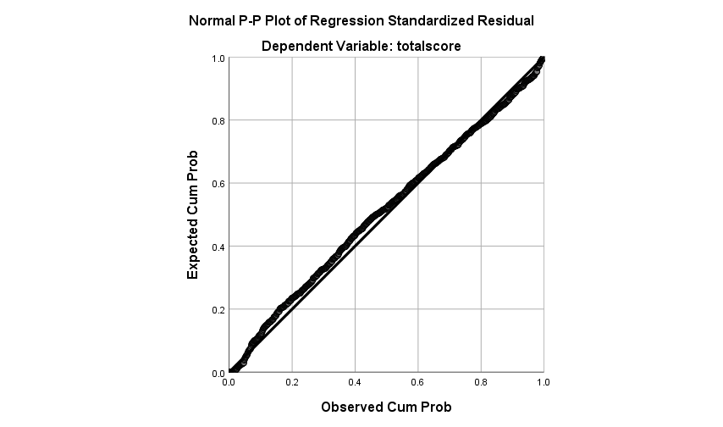
Supplementary Figure 1- Normal P-P plots of standardized residuals

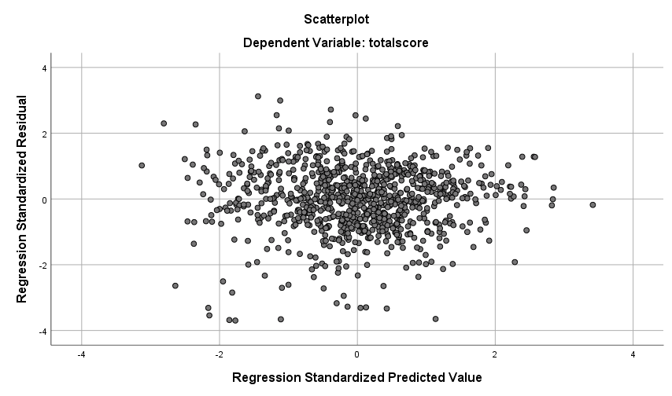
Supplementary Figure 2- Scatterplots of standardized residuals against predicted values

