Additional file 1 – Appendix

Appendix Supplement.
In the case of missing or illogical data, respondents were contacted by phone and/or email to resolve the issue. In 6 cases, missing data could not be resolved after repeated contact by telephone, due to respondent refusal. The chief at hospital 941 failed to complete the entirety of Part D of the survey. The other missing responses were isolated data points (D48 in 841’s staff, D70 in 841’s staff, D43_4 in 943’s chief, D44_3 in 833’s staff, and C11 in 833’s chief).

Figure S1 - Hospital sampling strategy.
Flowchart showing the hospital sampling strategy of the China PEACE research network. The resulting 162 hospitals participated in this survey study.
AMI, acute myocardial infarction

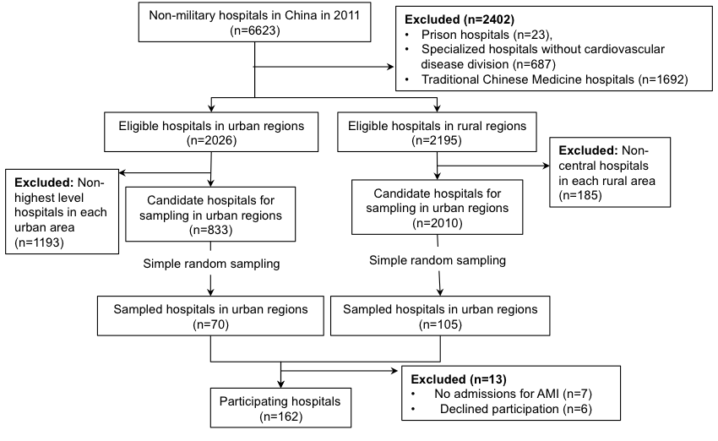
Figure S2 - Breakdown of responses per question by domain.
Percentage of participants (y-axis) providing a given response (x-axis) for each survey question. Questions are grouped by organizational learning domain as defined by the LOS-27. The responses from all 317 survey respondents are represented, including those of the 1 respondent who failed to complete Part D of the survey.
LOS, Learning Organization Survey
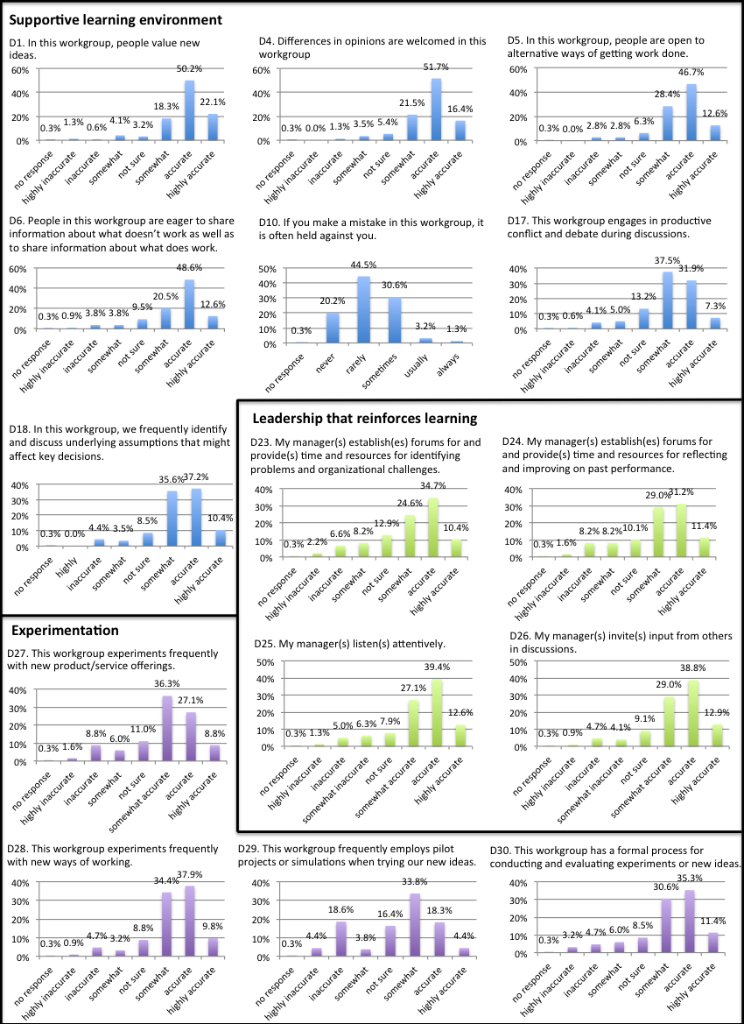
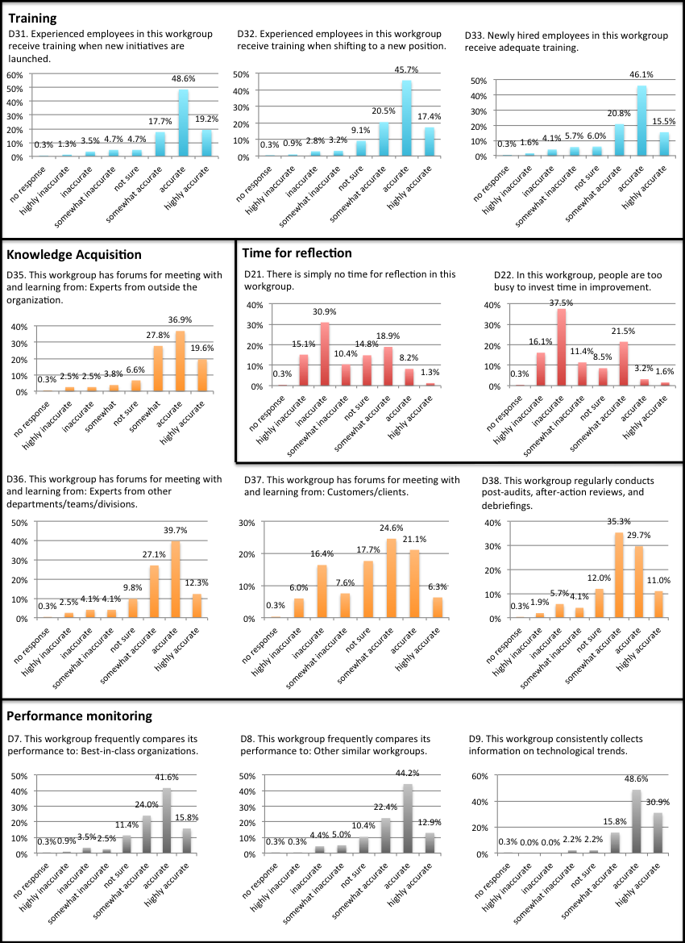

Table S1 – Learning Organization Survey (LOS) domains.
The LOS-27 is composed of 7 domains of organizational learning: supportive learning environment; time for reflection; leadership that reinforces learning; experimentation; training; knowledge acquisition; and performance monitoring.[1] These domains were derived from three “building blocks” and nine sub-domains outlined by Garvin et al.[2] To reduce redundancy and enhance validity in a healthcare setting, questions were re-distributed into 7 domains using exploratory factor analysis. Question responses were scaled from 1-7 (Highly inaccurate, Inaccurate, Somewhat inaccurate, Neither accurate nor inaccurate, Somewhat accurate, Accurate, Highly accurate) or 1-5 (Never, Rarely, Sometimes, Usually, Always).

 | Characteristics | Question Example (scale)
Supportive learning environment | Members:  - Are comfortable with raising disagreements  - Feel safe admitting to mistakes  - Appreciate opposing ideas | This workgroup engages in productive conflict and debate during discussions. (1-7)
Time for reflection | Members:  - Have sufficient time to reflect  - Have time to invest in improvement | There is simply no time for reflection in this workgroup. (1-7)
Leadership that reinforces learning | Leaders:  - Allow for input and discussion  - Provide structured means for identifying problems | My manager(s) establish(es) forums for and provide(s) time and resources for reflecting and improving on past performance. (1-7)
Experimentation | The workgroup:  - Experiments with new ideas or methods | This workgroup frequently employs pilot projects or simulations when trying our new ideas. (1-7)
Training | - New employees receive adequate training  - Experienced employees continue to receive training regularly or when new skills are necessary | Experienced employees in this workgroup receive training when shifting to a new position. (1-7)
Knowledge acquisition | The team has formal processes for:  - Sharing information  - Acquiring information from experts and customers | This workgroup has forums for meeting with and learning from: Experts from outside the organization. (1-7)
Performance monitoring | The team has formal processes for:  - Gathering and interpreting outside information  - Monitoring technological trends | This workgroup frequently compares its performance to: Best-in-class organizations. (1-7)

Table S2 - Overall PRR by domain and hospital level factors.
Indicates values of: Median (IQR) [Range]. P-values are shown for chi-squared tests between domain positive response rates (PRRs) by hospital-level factors. Domains are abbreviated as follows: SLE = Supportive learning environment; TFR = Time for reflection; LRL = Leadership that reinforces learning; E = Experimentation; T = Training; KA = Knowledge acquisition; PM = Performance monitoring.
 | n | All domains | SLE | TFR | LRL | E | T | KA | PM
All hospitals | 162 | 81.5% (59.3%-92.6%)  [9.3%-100%] | 85.7% (71.4%-100%)  [0%-100%] | 50.0% (0.0%-100%)  [0%-100%] | 100.0% (25.0%-100%)  [0%-100%] | 75.0% (25.0%-100%)  [0%-100%] | 100.0% (66.7%-100%)  [0%-100%] | 75.0% (50.0%-100%)  [0%-100%] | 100.0% (66.7%-100%)  [0%-100%]
Urban/rural
Urban | 63 | 85.2%  (70.4%-92.6%) | 85.7%  (71.4%-100%) | 100.0%  (50.0%-100%) | 100.0%  (25.0%-100%) | 75.0%  (50.0%-100%) | 100.0%  (66.7%-100%) | 75.0%  (50.0%-100%) | 100.0%  (100%-100%)
Rural | 99 | 74.1%  (55.6%-88.9%) | 85.7%  (71.4%-100%) | 50.0%  (0.0%-100%) | 75.0%  (25.0%-100%) | 75.0%  (25.0%-100%) | 100.0%  (66.7%-100%) | 75.0%  (25.0%-100%) | 100.0%  (66.7%-100%)
Chi-square | – | 5.7024 | 3.0186 | 3.6657 | 1.5580 | 2.8506 | 1.9870 | 2.6854 | 8.0059
P-value | – | 0.0169 | 0.0823 | 0.0555 | 0.2120 | 0.0913 | 0.1587 | 0.1013 | 0.0047
Region
Eastern | 64 | 85.2%  (70.4%-96.3%) | 85.7%  (71.4%-100%) | 100.0%  (50.0%-100%) | 100.0%  (50.0%-100%) | 75.0%  (50%-100%) | 100.0%  (100%-100%) | 75.0%  (75.0%-100%) | 100.0%  (100%-100%)
Central | 48 | 75.9%  (55.6%-88.9%) | 85.7%  (71.4%-85.7%) | 50.0%  (0.0%-100%) | 100.0%  (31.3%-100%) | 75.0%  (25.0%-100%) | 100.0%  (66.7%-100%) | 75.0%  (25.0%-100%) | 66.7%  (100%-100%)
Western | 50 | 68.5%  (47.2%-85.2%) | 85.7%  (57.1%-89.3%) | 50.0%  (0.0%-100%) | 62.5%  (25.0%-100%) | 75.0%  (25.0%-100%) | 100.0%  (33.3%-100%) | 75.0%  (18.8%-100%) | 100.0%  (33.3%-100%)
Chi-square | – | 13.5898 | 8.8835 | 4.5520 | 6.7235 | 5.3276 | 6.7870 | 7.3740 | 8.9147
P-value | – | 0.0011 | 0.0118 | 0.1027 | 0.0347 | 0.0697 | 0.0336 | 0.0250 | 0.0116
Hospital level
Secondary or below | 97 | 74.1%  (55.6%-88.9%) | 85.7%  (71.4%-100%) | 50.0%  (0.0%-100%) | 75.0%  (25.0%-100%) | 75.0%  (25.0%-100%) | 100.0%  (66.7%-100%) | 75.0%  (25.0%-100%) | 100.0%  (66.7%-100%)
Tertiary | 65 | 85.2%  (66.7%-94.5%) | 85.7%  (71.4%-100%) | 100.0%  (0.0%-100%) | 100.0%  (25.0%-100%) | 75.0%  (50.0%-100%) | 100.0%  (100%-100%) | 75.0%  (50.0%-100%) | 100.0%  (100%-100%)
Chi-square | – | 6.4749 | 2.3891 | 2.2473 | 1.5830 | 2.6036 | 4.1234 | 2.5816 | 7.0312
P-value | – | 0.0109 | 0.1222 | 0.1338 | 0.2083 | 0.1066 | 0.0423 | 0.1081 | 0.0080

Table S3 - Sensitivity table of hospital positive response rates (PRRs).
Proportion of hospitals with a specified number of domains (rows) and overall PRR meeting or exceeding specified thresholds (columns).

 | PRR threshold
Number of Domains | ≥50% | ≥75% | ≥100%
≥1 | 98.1% | 90.7% | 88.3%
≥2 | 93.2% | 83.3% | 79.0%
≥3 | 88.9% | 77.2% | 64.2%
≥4 | 83.3% | 66.0% | 48.8%
≥5 | 75.3% | 54.3% | 35.8%
≥6 | 63.6% | 40.7% | 21.6%
7 | 39.5% | 19.1% | 6.8%
Overall PRR | 81.5% | 55.6% | 6.8%

Table S4 - Sensitivity table of hospital positive response rates (PRRs) by hospital characteristics.
Proportion of hospitals with an overall PRR meeting or exceeding specified thresholds (columns), stratified by hospital characteristics (rows).

 | PRR threshold
CHARACTERISTIC | 50.0% | 75.0% | 100.0%
Urban/rural
Urban | 87.3% | 66.7% | 7.9%
Rural | 77.8% | 48.5% | 6.1%
Hospital Level
Secondary or below | 81.5% | 55.6% | 6.8%
Tertiary | 84.6% | 64.6% | 9.2%
Region
Eastern | 87.5% | 70.3% | 7.8%
Central | 83.3% | 50.0% | 6.3%
Western | 72.0% | 42.0% | 6.0%

Table S5 - Variation in positive response rate (PRR) per question by participant type, organized by domain.
PRR (abs) indicates absolute difference in PRR between principal investigator (PI) and study coordinator (SC).

Supportive learning environment |  |  |  |  | Range |  |  |  | PI, Median (IQR) |  | SC, Median (IQR) |  | Total, Median (IQR) |  | PI  PRR |  | SC  PRR | PRR (abs) | Chi-square | P-value*
D1 | In this workgroup, people value new ideas. |  |  |  | 1-7 |  |  |  | 6 (5,6) |  | 6 (6,6) |  | 6 (5,6) |  | 88.82% |  | 92.90% | 4.08% | 1.58 | 0.21
D4 | Differences in opinions are welcomed in this workgroup. |  |  |  | 1-7 |  |  |  | 6 (5,6) |  | 6 (5,6) |  | 6 (5,6) |  | 88.20% |  | 91.61% | 3.41% | 1.56 | 0.21
D5 | In this workgroup, people are open to alternative ways of getting work done. |  |  |  | 1-7 |  |  |  | 6 (5,6) |  | 6 (5,6) |  | 6 (5,6) |  | 85.09% |  | 90.97% | 5.87% | 2.58 | 0.11
D6 | People in this workgroup are eager to share information about what doesn’t work as well as to share information about what does work. |  |  |  | 1-7 |  |  |  | 6 (5,6) |  | 6 (5,6) |  | 6 (5,6) |  | 81.37% |  | 82.58% | 1.21% | 0.08 | 0.78
D10 | If you make a mistake in this workgroup, it is often held against you. (Among clinicians taking care of patients with AMI, there is a tendency to blame individuals for errors in patient care). (negative) |  |  |  | 1-5 |  |  |  | 2 (2,3) |  | 2 (2,3) |  | 2 (2,3) |  | 63.35% |  | 66.45% | 3.10% | 0.33 | 0.56
D17 | This workgroup engages in productive conflict and debate during discussions. |  |  |  | 1-7 |  |  |  | 5 (5,6) |  | 5 (5,6) |  | 5 (5,6) |  | 77.02% |  | 76.77% | 0.24% | <0.01 | 0.96
D18 | In this workgroup, we frequently identify and discuss underlying assumptions that might affect key decisions. |  |  |  | 1-7 |  |  |  | 5 (5,6) |  | 6 (5,6) |  | 5 (5,6) |  | 85.71% |  | 81.29% | 4.42% | 1.12 | 0.29
Time for reflection
D21 | There is simply no time for reflection in this workgroup. (negative) |  |  |  | 1-7 |  |  |  | 3 (2,5) |  | 2 (2,4) |  | 3 (2,5) |  | 52.17% |  | 61.29% | 9.12% | 2.67 | 0.10
D22 | In this workgroup, people are too busy to invest time in improvement. (negative) |  |  |  | 1-7 |  |  |  | 2 (2,5) |  | 2 (2,5) |  | 2 (2,5) |  | 61.49% |  | 69.03% | 7.54% | 1.98 | 0.16
Leadership that reinforces learning
D23 | My manager(s) establish(es) forums for and provide(s) time and resources for identifying problems and organizational challenges. |  |  |  |  | 1-7 |  |  | 5 (4,6) |  | 5 (4,6) |  | 5 (4,6) |  | 65.22% |  | 74.84% | 9.62% | 3.48 | 0.06
D24 | My manager(s) establish(es) forums for and provide(s) time and resources for reflecting and improving on past performance. |  |  |  |  | 1-7 |  |  | 5 (4,6) |  | 5 (4,6) |  | 5 (4,6) |  | 73.29% |  | 70.32% | 2.97% | 0.34 | 0.56
D25 | My manager(s) listen(s) attentively. |  |  |  |  | 1-7 |  |  | 6 (5,6) |  | 6 (5,6) |  | 6 (5,6) |  | 79.50% |  | 79.35% | 0.15% | <0.01 | 0.97
D26 | My manager(s) invite(s) input from others in discussions. |  |  |  |  | 1-7 |  |  | 6 (5,6) |  | 6 (5,6) |  | 6 (5,6) |  | 79.50% |  | 82.58% | 3.08% | 0.49 | 0.49
Experimentation
D27 | This workgroup experiments frequently with new product/service offerings. |  |  |  |  | 1-7 |  |  | 5 (4,6) |  | 5 (5,6) |  | 5 (4,6) |  | 68.32% |  | 76.77% | 8.45% | 2.83 | 0.09
D28 | This workgroup experiments frequently with new ways of working. |  |  |  |  | 1-7 |  |  | 6 (5,6) |  | 5 (5,6) |  | 5 (5,6) |  | 81.37% |  | 83.23% | 1.86% | 0.19 | 0.67
D29 | This workgroup frequently employs pilot projects or simulations when trying our new ideas. |  |  |  |  | 1-7 |  |  | 5 (3,5) |  | 5 (3,5) |  | 5 (3,5) |  | 55.90% |  | 57.42% | 1.52% | 0.07 | 0.79
D30 | This workgroup has a formal process for conducting and evaluating experiments or new ideas. |  |  |  |  | 1-7 |  |  | 5 (5,6) |  | 5 (5,6) |  | 5 (5,6) |  | 77.02% |  | 78.06% | 1.05% | 0.05 | 0.82
Training
D31 | Experienced employees in this workgroup receive training when new initiatives are launched. |  |  |  |  | 1-7 |  |  | 6 (5,6) |  | 6 (5,6) |  | 6 (5,6) |  | 86.34% |  | 85.16% | 1.17% | 0.09 | 0.77
D32 | Experienced employees in this workgroup receive training when shifting to a new position. |  |  |  |  | 1-7 |  |  | 6 (5,6) |  | 6 (5,6) |  | 6 (5,6) |  | 80.75% |  | 87.10% | 6.35% | 2.35 | 0.13
D33 | Newly hired employees in this workgroup receive adequate training. |  |  |  |  | 1-7 |  |  | 6 (5,6) |  | 6 (5,6) |  | 6 (5,6) |  | 81.37% |  | 83.87% | 2.50% | 0.35 | 0.56
Knowledge acquisition
D35 | This workgroup has forums for meeting with and learning from: Experts from outside the organization. |  |  |  |  | 1-7 |  |  | 6 (5,6) |  | 6 (5,6) |  | 6 (5,6) |  | 83.85% |  | 85.16% | 1.31% | 0.10 | 0.75
D36 | This workgroup has forums for meeting with and learning from: Experts from other departments/teams/divisions. |  |  |  |  | 1-7 |  |  | 6 (5,6) |  | 6 (5,6) |  | 6 (5,6) |  | 78.26% |  | 80.65% | 2.38% | 0.28 | 0.60
D37 | This workgroup has forums for meeting with and learning from: Customers/clients. |  |  |  |  | 1-7 |  |  | 5 (3,6) |  | 5 (3,6) |  | 5 (3,6) |  | 53.42% |  | 50.97% | 2.45% | 0.19 | 0.66
D38 | This workgroup regularly conducts post-audits, after-action reviews, and debriefings. |  |  |  |  | 1-7 |  |  | 5 (5,6) |  | 5 (5,6) |  | 5 (5,6) |  | 75.78% |  | 76.77% | 1.00% | 0.04 | 0.83
Performance monitoring
D7 | This workgroup frequently compares its performance to: Best-in-class organizations. |  |  |  |  | 1-7 |  |  | 6 (5,6) |  | 6 (5,6) |  | 6 (5,6) |  | 80.12% |  | 83.23% | 3.10% | 0.51 | 0.48
D8 | This workgroup frequently compares its performance to: Other similar workgroups. |  |  |  |  | 1-7 |  |  | 6 (5,6) |  | 6 (5,6) |  | 6 (5,6) |  | 77.02% |  | 82.58% | 5.56% | 1.51 | 0.22
D9 | This workgroup consistently collects information on technological trends. |  |  |  |  | 1-7 |  |  | 6 (6,6) |  | 6 (6,7) |  | 6 (6,7) |  | 95.65% |  | 95.48% | 0.17% | 0.01 | 0.94

AMI, acute myocardial infarction

References
1. Singer SJ, Moore SC, Meterko M, Williams S. Development of a short-form Learning Organization Survey: the LOS-27. Med Care Res Rev. 2012;69:432-59.
2. Garvin DA, Edmondson AC, Gino F. Is yours a learning organization? Harvard Bus Rev. 2008;86:109-16, 34.

