Additional file 1

Table S1. Characteristics of nurse practitioners, physician assistants, and primary care physicians who prescribed anticoagulant prescription medications in Pennsylvania, 2011*
Characteristics | Nurse Practitioner | Physician Assistant | Primary Care Physician
 | N=441 | N=529 | N=4329
Provider sex, % | -- | -- | --
Female | 93.2 | 76.9 | 33.9
Provider setting, % | -- | -- | --
Rural | 20.4 | 28.4 | 12.0
Provider prescribing | -- | -- | --
Annual prescription volume, mean (sd) | 70.1 | 66.0 | 132.3
Patient age, % | -- | -- | --
<64 | 38.8 | 40.3 | 34.6
65-74 | 21.0 | 22.6 | 21.7
75-84 | 24.7 | 23.6 | 25.9
85+ | 15.5 | 13.5 | 17.8
Source of payment for prescription, % | -- | -- | --
Cash | 4.0 | 4.9 | 5.4
Commercial | 48.1 | 46.5 | 49.3
Medicaid | 6.5 | 7.1 | 4.7
Medicare | 41.4 | 41.5 | 40.6
Primary care medical group | -- | -- | --
Number of practice sites | 487 | 521 | 3268
Number of providers per site, mean (sd) | 49.5 (171.1) | 45.5 (143.9) | 20.7 (89.1)

*P <0.001 for comparisons across providers for all variables
Table S2. Characteristics of nurse practitioners, physician assistants, and primary care physicians who prescribed oral hypoglycemic prescription medications in Pennsylvania, 2011*
Characteristics | Nurse Practitioner | Physician Assistant | Primary Care Physician
 | N=486 | N=582 | N=4442
Provider sex, % | -- | -- | --
Female | 93.6 | 77.2 | 34.0
Provider setting, % | -- | -- | --
Rural | 21.4 | 27.3 | 12.0
Provider prescribing | -- | -- | --
Annual prescription volume, mean (sd) | 343.8 | 409.7 | 635.8
Patient age, % | -- | -- | --
<64 | 59.1 | 59.9 | 47.6
65-74 | 21.2 | 21.5 | 24.1
75-84 | 14.1 | 13.0 | 19.2
85+ | 5.6 | 5.6 | 9.1
Source of payment for prescription, % | -- | -- | --
Cash | 4.1 | 4.3 | 4.3
Commercial | 49.2 | 47.9 | 51.4
Medicaid | 12.4 | 12.9 | 7.4
Medicare | 34.3 | 34.9 | 36.9
Primary care medical group | -- | -- | --
Number of practice sites | 531 | 565 | 3311
Number of providers per site, mean (sd) | 46.3 (163.3) | 42.7 (136.5) | 20.6 (88.5)

*P <0.001 for comparisons across providers for all variables
Table S3. Characteristics of nurse practitioners, physician assistants, and primary care physicians who prescribed HMG-CoA reductase inhibitor prescriptions in Pennsylvania, 2011*
Characteristics | Nurse Practitioner | Physician Assistant | Primary Care Physician
 | N=486 | N=574 | N=4394
Provider sex, % | -- | -- | --
Female | 93.0 | 77.2 | 34.3
Provider setting, % | -- | -- | --
Rural | 20.8 | 27.5 | 11.8
Provider prescribing | -- | -- | --
Annual prescription volume, mean (sd) | 431.7 | 439.6 | 776.4
Patient age, % | -- | -- | --
<64 | 56.3 | 56.1 | 45.4
65-74 | 21.2 | 21.3 | 22.9
75-84 | 14.2 | 14.7 | 19.1
85+ | 6.9 | 6.9 | 10.8
Source of payment for prescription, % | -- | -- | --
Cash | 4.2 | 4.4 | 4.9
Commercial | 52.4 | 50.5 | 52.0
Medicaid | 9.5 | 10.1 | 6.2
Medicare | 33.9 | 35.2 | 36.8
Primary care medical group | -- | -- | --
Number of practice sites | 532 | 554 | 3270
Number of providers per site, mean (sd) | 44.3 (158.9) | 44.1 (140.1) | 20.7 (89.1)

*P <0.001 for comparisons across providers for all variables

Table S4. Characteristics of female nurse practitioners, physician assistants, and primary care physicians who prescribed select antihypertensiveª prescription medications in Pennsylvania, 2011^{b}
Characteristics | Nurse Practitioner | Physician Assistant | Primary Care Physician
 | N=469 | N=454 | N=1511
Provider setting, % | -- | -- | --
Rural | 19.6 | 27.5 | 9.33
Provider prescribing | -- | -- | --
Annual prescription volume, mean (sd) | 417.5 (490.5) | 401.3 (485.3) | 803.3 (654.4)
Patient age, % | -- | -- | --
<64 | 59.3 | 60.1 | 50.0
65-74 | 20.1 | 20.1 | 22.3
75-84 | 13.1 | 12.9 | 17.4
85+ | 7.5 | 6.9 | 10.3
Source of payment for prescription, % | -- | -- | --
Cash | 5.4 | 5.3 | 5.0
Commercial | 55.7 | 55.3 | 54.5
Medicaid | 8.5 | 9.1 | 6.7
Medicare | 30.4 | 30.2 | 33.8
Primary care medical group | -- | -- | --
Number of practice sites | 512 | 478 | 1545
Number of providers per site, mean (sd) | 45.2 (163.5) | 53.0 (158.2) | 39.0 (125.5)

ªAntihypertensive medications included those targeting the renin-angiotensin-aldosterone system, including angiotensin-converting enzyme inhibitors, angiotensin II receptor blockers, and direct renin inhibitors; ^{b}P <0.001 for comparisons across providers for all variables

Table S5. Proportion of cardiovascular prescriptions ordered by female nurse practitioners, physician assistants, and primary care physicians over time, 2007—2011
 | 2007 | 2008 | 2009 | 2010 | 2011
Antihypertensives
Total prescriptions, N | 535,942 | 575,346 | 613,199 | 666,368 | 705,578
NP (%) | 7.1 | 8.6 | 9.8 | 11.5 | 12.2
PA (%) | 5.9 | 7.2 | 8.5 | 10.1 | 11.5
PCP (%) | 87.0 | 84.2 | 81.7 | 78.4 | 76.3
Anticoagulants
Total, N | 59,293 | 62,376 | 66,748 | 74,654 | 80,790
NP | 5.9 | 7.3 | 8.3 | 10.5 | 10.7
PA | 4.3 | 6.0 | 7.9 | 9.5 | 10.9
PCP | 89.9 | 86.6 | 83.8 | 80.0 | 78.4
Oral hypoglycemics
Total, N | 320,801 | 336,021 | 357,585 | 379,088 | 390,593
NP | 7.0 | 8.5 | 9.8 | 11.7 | 12.2
PA | 5.8 | 6.9 | 8.4 | 10.0 | 11.6
PCP | 87.2 | 84.6 | 81.8 | 78.3 | 76.2
HMG-CoA Reductase inhibitors
Total, N | 338,368 | 361,447 | 396,540 | 435,148 | 468,689
NP | 7.4 | 9.0 | 10.4 | 12.0 | 12.5
PA | 6.0 | 7.0 | 8.4 | 10.2 | 11.8
PCP | 86.6 | 84.0 | 81.2 | 77.8 | 75.8

Abbreviations: NP, nurse practitioner; PA, physician assistant; PCP, primary care physician

Table S6. Proportion of prescriptions from female providers in each category accounted for by the newly approved medications, 2011

Primary care provider typeª | Total number of prescriptions, N  (% of all prescriptions in medication class)
 | Dabigatran
Nurse practitioner (N=356) | 237 (2.7)
Physician assistant (N=347) | 278 (3.2)
Primary care physician (N=1,388) | 2,542 (4.0)
 | Aliskiren
Nurse practitioner (N=436) | 433 (0.5)
Physician assistant (N=419) | 574 (0.7)
Primary care physician (N=1,474) | 2,912 (0.5)
 | Sitagliptin/saxagliptin
Nurse practitioner (N=406) | 5,586 (11.7)
Physician assistant (N=409) | 6,026 (13.3)
Primary care physician (N=1,451) | 36,876 (12.4)
 | Pitavastatin
Nurse practitioner (N=421) | 123 (0.2)
Physician assistant (N=412) | 250 (0.5)
Primary care physician (N=1,454) | 1,175 (0.3)

ªN indicates the total number of each provider type regularly prescribing each medication class

Figure S1. Percent of each female provider type with any prescription for a newly approved medication in 2011ª

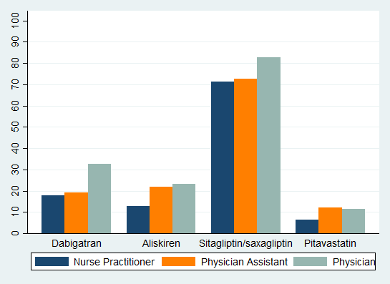

ªPrevalence of any prescription of newly approved chronic disease medications among primary care providers prescribing any drug from the medication class

Figure S2. Time to adoption of new chronic disease medications post-FDA approval among female primary care providers by specialtyª
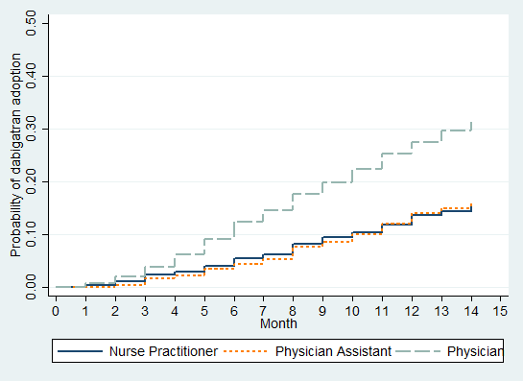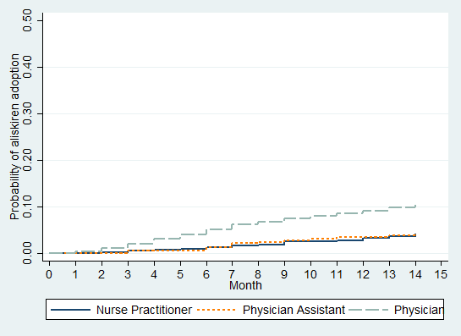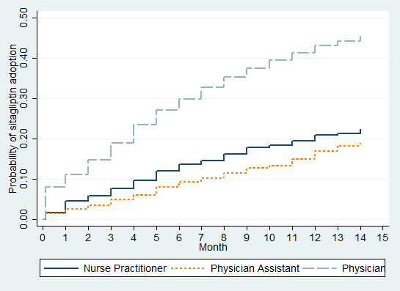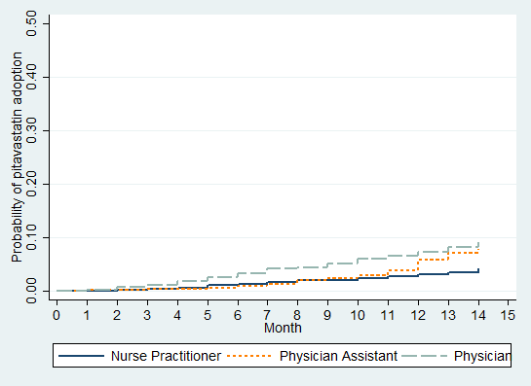

ªP<0.01 log-rank test for all curves

