Additional file 2:
The SIMEX method comprises four main steps:
Consider a set of values 0= λ₁ < λ₂ < λ₃ …. < λ_{j}
First step - Simulation: Generate additional independent measurement error added to the observed HPI value (W). This is a computer-simulated standard normal augmentation of the error variance (U). Contaminated datasets are generated with successively larger measurement error variance. For the j^{th} data set, the total measurement error variance is ∑_{u} + λ_{j} ∑_{u} = (1 + λ_{j}) ∑_{u}
Second step – Estimation: For each contaminated data set generated in the previous step, a Poisson model assessing the association between HPI (W) and each outcome (HSMR) is fitted.
Third step - Replication: The first two steps are repeated many times (e.g. 1000). For each level of contamination, the average value of the estimates is calculated. A graph is drawn between the level of contamination values and the estimated average with a quadratic regression. If the quadratic regression does not fit the data well, a linear regression is performed.
Fourth step - Extrapolation: Corrected coefficient is estimated with the extrapolation model. The true coefficient corresponds to the ideal case without any measurement error (λ₀= -1)
Figure S1: SIMEX graphic association between BASI Score (HPI2) and 30 dpa HSMR
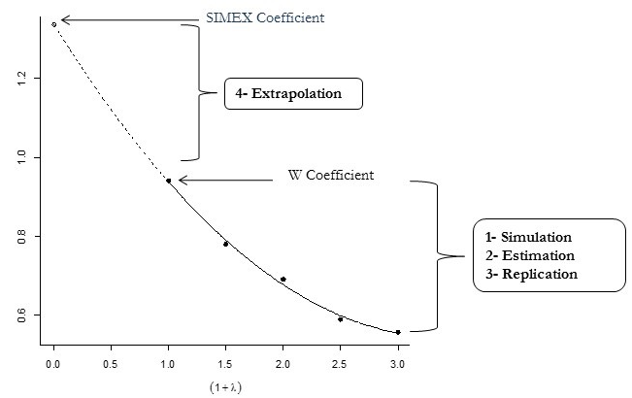
The precision of the corrected coefficient HPI (true coefficient) is estimated using two techniques: the asymptotic method and the jackknife method [47]. The choice depends on the type of variance [48] heteroscedastic (jackknife method) versus homoscedastic (asymptotic method) variance. Heteroscedasticity or homoscedasticity was tested using two known tests: The White [49] and Breusch-Pagan tests [50]. We established a conservative rule whereby if one of the two tests concluded in heteroscedasticity, we used the jackknife method to estimate precision. Otherwise, if neither test concluded in heteroscedasticity, we conclude in homoscedasticity.

