Annex: Goodness-of-fit of model: Confirmatory Factor Analysis (CFA) of the modified Questionnaire of Continuity between Care Levels (CCAENA) 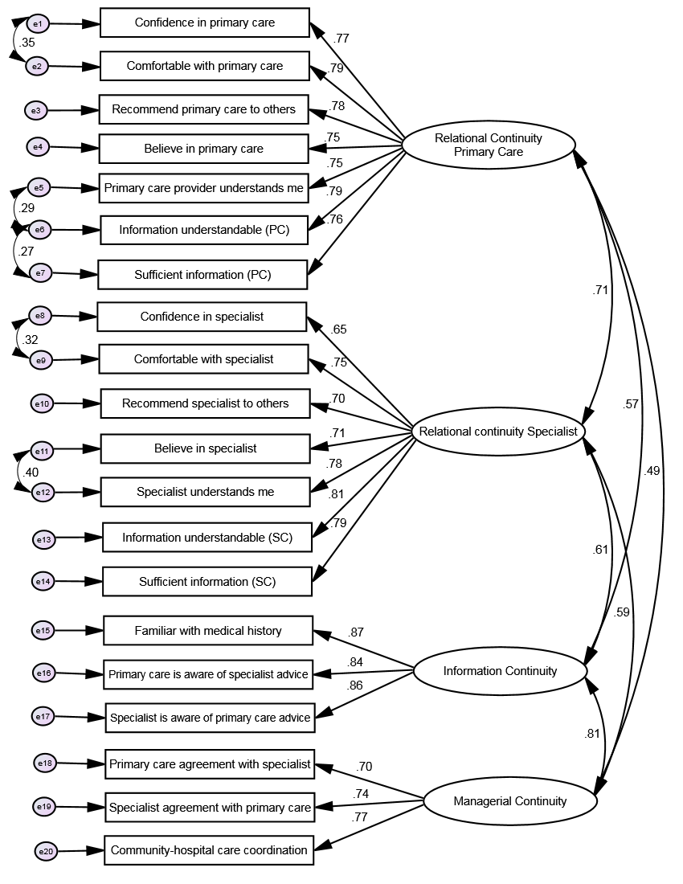
Note: The model allows correlation of errors with high covariation within a domain. GFI=0.912; CFI=0.943; NFI=0.927; TLI=0.932; RMSEA=0.069 (90% CI 0.063, 0.074); χ²(df)=683.358 (159), p<0.001.

