Figure S1. Interrupted time series analysis for different outcomes per month per 100,000 population in the cohort of Japan Medical Data Center during November 2010 to November 2012. Prais-Winsten and Cochrane-Orcutt regression was performed for a the number of new diagnosis and b the number of newly diagnosed patients treated with medication. The interrupted time periods were set at November 2011 and December 2011. For details of interrupted time series analysis, please refer to the manuscript's Methods section.
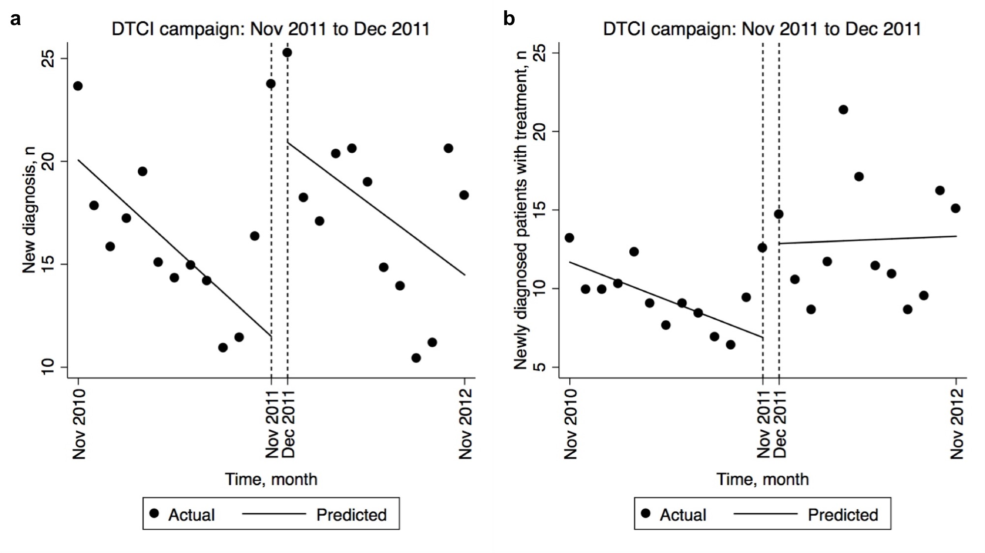
Table S1. Interrupted time series analysis by Prais-Winsten and Cochrane-Orcutt regression for different outcomes within a cohort of 795,370 enrollees in the database of Japan Medical Data Center during November 2010 to November 2012.
Characteristics | Coefficient (95% CI)
Monthly number for new diagnosis per 100,000 population
β₀: starting level of new diagnosis | 20.1 (15.4 to 24.7)***
β₁: time | -0.71 (-1.46 to 0.03)
β₂: November 2011 | 10.2 (5.38 to 15.0)***
β₃: time $×$ November 2011 | 0.13 (-1.08 to 1.34)
β₄: December 2011 | -0.20 (-7.04 to 6.64)
β₅: time $×$ December 2011 | omitted
β₂ + β₄: effect of DTCI campaign¹ | 10.0 (2.15 to 17.9)*
β₁ + β₃ + β₅: post-intervention linear trend | -0.58 (-1.53 to 0.36)
Monthly number for new patients treated with medication per 100,000 population
β₀: starting level of newly diagnosed patients treated with medication | 11.7 (9.26 to 14.1)***
β₁: time | -0.40 (-0.79 to -0.01)*
β₂: November 2011 | 4.64 (1.95 to 7.34)**
β₃: time $×$ November 2011 | 0.44 (-0.32 to 1.20)
β₄: December 2011 | 1.29 (-3.24 to 5.82)
β₅: time $×$ December 2011 | omitted
β₂ + β₄: effect of DTCI campaign¹ | 5.93 (0.09 to 11.8)*
β₁ + β₃ + β₅: post-intervention linear trend | 0.04 (-0.59 to 0.67)
*p <.05 **p <.01 ***p <.001
¹Sample size, N₂ of analyzed time periods = 25. The aggregated data samples were extracted from 795,370 enrollees covered by the Japan Medical Data Center from November 2010 to November 2012.
²The effect of DTCI campaign is a combination of the effects in November and December 2011.
³The equation are as follows: (Aggregated outcome) =β₀ + β₁*(time since the start of the study) + β₂*(post-November 2011) + β₃*(time since the start of the study)*(post-November 2011) + β₄*(post-December 2011) + β₅*(time since the start of the study)*(post-December 2011); where (1) β₀ is an “intercept” in a regression, representing the starting level of the outcome variable. (2) β₁ is a “slope” in a regression and indicates trajectory of the outcome variable prior to the introduction of the intervention. If β₁ is not statistically significant, the outcome level remains constant at β₀ prior to the intervention. In this case, β₀ also represents the level of the outcome variable immediately before the intervention. (3) β₂ and β₄ represent the “one-time” change in a “regression-intercept” or the level of the outcome that occurs in the period immediately after the intervention, which is hypothesized to be caused by the intervention. (4) β₃ and β₅ represent the “long-term” change, expressed as the “slope” difference between pre-intervention and post-intervention in a regression, which is also hypothesized to be caused by the intervention. Time since the start of the study is a continuous variable, and post-November 2011 and post-December 2011 are dummy variables (post-interrupted time point, 1; otherwise, 0).

