Supplemental Materials
Table S1: UDN clinical sites from which applications were reviewed
Assigned UDN site | Not Accepted | Accepted | All
Baylor | 15 | 7 | 22
Duke | 31 | 7 | 38
Harvard | 18 | 7 | 25
NIH UDP | 27 | 8 | 35
Stanford | 7 | 7 | 14
UCLA | 21 | 7 | 28
Vanderbilt | 32 | 7 | 39
Total | 151 | 50 | 201

Table S2: Details of data collected on applicants Not Accepted (n=151) and Accepted (n=50)
Data Points
Demographic Information | Race
Demographic Information | Ethnicity
Demographic Information | Gender
Demographic Information | Age at Application
Demographic Information | Age at Symptom Onset
Application Metrics | Assigned Clinical Site
Application Metrics | Length of Application Review
Application Metrics | Application Outcome (Decision Letter from UDN Clinical Site)
Application Metrics | Recommendations Provided
Application Metrics | Primary Symptom Category (Applicant Identified)
Application Metrics | Referring Healthcare Provider Specialty
Application Metrics | Presence/Absence of Objective Findings in Healthcare Provider Recommendation Letter
Subjective Symptoms in Healthcare Provider Referral Letter as Reason(s) for Referral | 33 symptoms commonly reported, see Supplementary Table S3
Specific Diagnoses in Healthcare Provider Referral Letter | Fibromyalgia
Specific Diagnoses in Healthcare Provider Referral Letter | Chronic Fatigue Syndrome
Specific Diagnoses in Healthcare Provider Referral Letter | Mitochondrial/Presumed Mitochondrial Disorder
Specific Diagnoses in Healthcare Provider Referral Letter | Lyme Disease
Specific Diagnoses in Healthcare Provider Referral Letter | Other Specific/Correct Diagnosis
Objective Findings in Healthcare Provider Referral Letter | Present or absent in 22 different organ systems, see Supplementary Table S4
Prior Specialty Consultations note in Healthcare Provider Referral Letter | Specialty consultations noted specifically by the referring provider.
Table S3: Subjective symptoms commonly reported in healthcare provider referral letters

Symptom Noted in Referral Letter | Count – Not Accepted | Count – Accepted
Pain | 99 (65.56%) | 20 (40.00%)
Fatigue | 63 (41.72%) | 10 (20.00%)
Headache | 41 (27.15%) | 6 (12.00%)
Difficulty Thinking/Focusing, Memory Problems | 36 (23.84%) | 5 (10.00%)
Nausea | 29 (19.21%) | 4 (8.00%)
Unable/Unwilling to Work or Maintain Employment / Out of Work | 29 (19.21%) | 1 (2.00%)
Muscle Weakness | 25 (16.56%) | 12 (24.00%)
Disability / Disabled / Disabling Condition (without implication of patient receiving benefits) | 24 (15.89%) | 0 (0.00%)
Depression | 23 (15.23%) | 1 (2.00%)
Anxiety | 22 (14.57%) | 2 (4.00%)
Tingling | 21 (13.91%) | 4 (8.00%)
Dizziness | 20 (13.25%) | 1 (2.00%)
Difficulty Breathing | 19 (12.58%) | 2 (4.00%)
Insomnia/Difficulty Sleeping | 18 (11.92%) | 0 (0.00%)
Weight Loss | 15 (9.93%) | 3 (6.00%)
Constipation | 12 (7.95%) | 3 (6.00%)
Fainting/Passing Out/Altered Consciousness | 12 (7.95%) | 2 (4.00%)
Speech abnormality or difficulty | 11 (7.28%) | 1 (2.00%)
Temperature Intolerance, Heat/Cold Sensitivity | 11 (7.28%) | 0 (0.00%)
Light Sensitivity/Photophobia | 10 (6.62%) | 2 (4.00%)
Burning | 10 (6.62%) | 0 (0.00%)
Food Allergies | 10 (6.62%) | 0 (0.00%)
Blurry/Double Vision | 9 (5.96%) | 0 (0.00%)
Throat Constriction/Difficult Swallowing | 8 (5.30%) | 0 (0.00%)
Ringing in Ears | 7 (4.64%) | 0 (0.00%)
Loss of Appetite | 6 (3.97%) | 2 (4.00%)
Weight Gain | 6 (3.97%) | 1 (2.00%)
Noise Sensitivity/Phonophobia | 6 (3.97%) | 1 (2.00%)
Bloated | 5 (3.31%) | 0 (0.00%)
Hair Loss | 4 (2.65%) | 1 (2.00%)
On Disability (implies receiving disability benefits) | 4 (2.65%) | 1 (2.00%)
Tiredness/Somnolence/Sleepiness | 3 (1.99%) | 0 (0.00%)
Increased Appetite | 1 (0.66%) | 0 (0.00%)

Table S4: Organ systems under which objective findings from healthcare provider referral letter were categorized
 | Not Accepted Applicants |  | Accepted Applicants
 | Patient-Reported Symptom Category | Objective Findings Noted in Referral Letter | Patient-Reported Symptom Category | Objective Findings Noted in Referral Letter
Allergies and Disorders of The Immune System | 16 (10.60%) | 19 (12.58%) | 4 (8.00%) | 10 (20.00%)
Cardiology and vascular conditions | 1 (0.66%) | 28 (18.54%) | 2 (4.00%) | 11 (22.00%)
Dentistry and craniofacial | 1 (0.66%) | 2 (1.32%) | 0 (0.00%) | 4 (8.00%)
Dermatology | 2 (1.32%) | 7 (4.63%) | 1 (2.00%) | 5 (10.00%)
Endocrinology | 4 (2.65%) | 21 (13.90%) | 1 (2.00%) | 11 (22.00%)
Gastroenterology | 10 (6.62%) | 30 (19.87%) | 1 (2.00%) | 13 (26.00%)
Genetics | 0 (0.00%) | 7 (4.63%) | 0 (0.00%) | 17 (34.00%)
Gynecology and reproductive medicine | 1 (0.66%) | 5 (3.31%) | 0 (0.00%) | 0 (0.00%)
Hematology | 3 (1.99%) | 10 (6.62%) | 0 (0.00%) | 5 (10.00%)
Infectious Diseases | 2 (1.32%) | 8 (5.30%) | 0 (0.00%) | 2 (4.00%)
Musculoskeletal and orthopedics | 12 (7.95%) | 26 (17.22%) | 6 (12.00%) | 14 (28.00%)
Nephrology | 0 (0.00%) | 4 (2.65%) | 0 (0.00%) | 6 (12.00%)
N/A | 19 (12.58%) | 0 (0.00%) | 1 (2.00%) | 0 (0.00%)
Neurology | 44 (29.14%) | 43 (28.5%) | 24 (48.00%) | 39 (78.00%)
Oncology | 1 (0.66%) | 4 (2.65%) | 0 (0.00%) | 1 (2.00%)
Ophthalmology | 1 (0.66%) | 7 (4.63%) | 0 (0.00%) | 10 (20.00%)
Other | 16 (10.60%) | 0 (0.00%) | 5 (10.00%) | 4 (8.00%)
Psychiatry | 0 (0.00%) | 3 (1.99%) | 0 (0.00%) | 1 (2.00%)
Pulmonology | 6 (3.97%) | 11 (7.28%) | 0 (0.00%) | 3 (6.00%)
Rheumatology | 10 (6.62%) | 13 (8.61%) | 5 (10.00%) | 7 (14.00%)
Toxicology and Environmental Medicine | 1 (0.66%) | 0 (0.00%) | 0 (0.00%) | 0 (0.00%)
Urology | 1 (0.66%) | 4 (2.65%) | 0 (0.00%) | 3 (6.00%)

Figure S1: Frequency of the top four diagnoses mentioned in the healthcare provider referral letters.
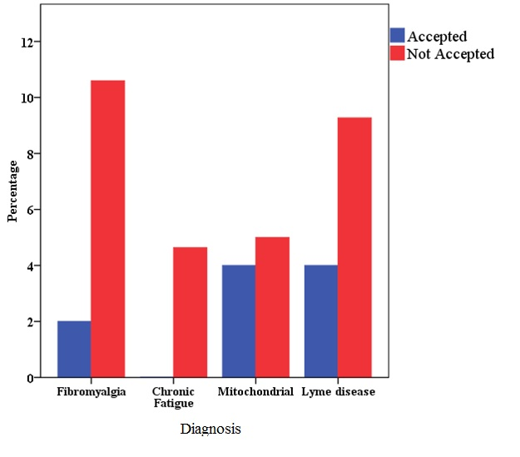

The diagnosis of fibromyalgia was reported significantly more often in the Not Accepted applications (16/151, 10.6%) relative to the Accepted (1/50, 2%, FET p=<0.05). No other diagnoses were reported with significantly different frequencies between the two groups.

