Additional file: search strategy
Phrases used to search articles from google scholar, AJOL, research gate, Scopus and EMBASE
Maternity waiting home
Maternity waiting areas
Maternity waiting villages
Maternity waiting shelters
Maternity waiting dormitories
Maternity waiting home AND maternal death OR stillbirth
Maternity waiting home AND maternal mortality OR stillbirth
Maternity waiting areas AND maternal death OR stillbirth
Maternity waiting areas AND maternal mortality OR stillbirth
Search terms for PubMed
lang: English
MeSH Terms: Infant, Newborn; female; humans
"Infant, Newborn"[Mesh] OR infant* OR newborn* OR neonat* OR small for gestational age OR "low birth weight" OR premature AND (("maternity waiting home" OR "maternity waiting homes” OR "maternity waiting house” OR "maternity waiting houses” OR "maternal home" OR "maternal homes" OR “maternal house” OR "maternal houses”)) OR (((maternity OR maternal OR birth OR childbirth) PRE/3 (waiting OR shelter OR shelters OR hut OR huts)))

Appendix II: Appraisal instrument
JBI critical appraisal checklist for cohort/case control studies
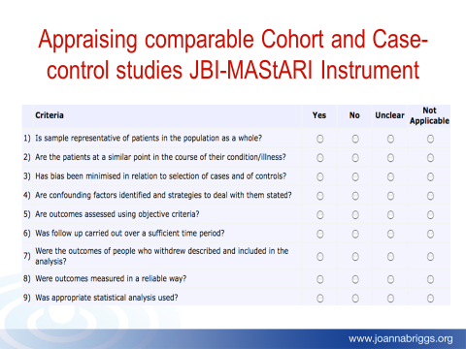

Appendix III
JBI Data extraction format
