Table S1. Characteristics of interviewees.
 | Initial interviews | Iterative design interviews
n | 8 | 5*
Gender  - Female  - Male | 4 (50)  4 (50) | 3 (60)  2 (40)
Primary role (n, %)  - Academic  - Clinical  - Leadership | 3 (37.5)  3 (37.5)  2 (25) | 3 (60)  2 (40)  0 (0)
Employer (n, %)  - USC  - LA County Department of Health | 6 (75)  2 (25) | 5 (100)  0 (0)
Years since start residency (median, range) | 12 (9-45) | 13 (9-21)
Years at LAC+USC ED (median, range) | 8 (2-31) | 9 (4-21)
Duration interview in minutes (median, range) | 57 (35-77) | 36 (33-56)
Legend: *4 interviewees were included in both the initial round of interviews and the iterative design interviews. Abbreviations: ED = emergency department; n = number; LA = Los Angeles; LAC+USC = Los Angeles County + University of Southern California; USC = University of Southern California.

Table S2. Measures discussed in interviews.
Measure type | Metric
Summary data | Number of patients, discharge disposition (% admitted to hospital, discharged, or admitted for observation), left without being seen, left before treatment complete, left against medical advice.
LOS measures | Total LOS, time to first provider, provider to disposition decision time, boarding time, time between test results and disposition decision.
Utilization data | N CT scans, MR scans, labs, repeat labs, consultations, narcotics.
Outcomes | Return rates, LOS in hospital after admission, deaths, patient satisfaction, complaints.

Table S3. Characteristics of survey respondents.
 | Pre-test | Post-test | Pre- and post-test
N | 42 | 21 | 19
Involved in development – n (%) | 9 (21) | 5 (24) | 5 (26)
Male gender – n (%) | 23 (55) | 13 (62) | 12 (63)
Years experience – median (IQR) | 10 (6-15) | 10 (6-12) | 10 (7-14)
Years in this ED – median (IQR) | 6.5 (2-10) | 5 (2-8) | 6 (2-10)

Legend: ED = emergency department; IQR = interquartile range; n = number.
Figure S1. Monthly email report.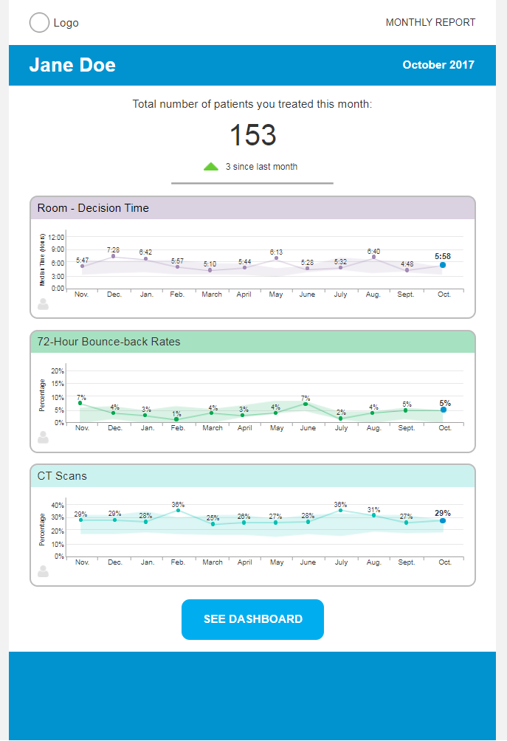
Legend: Prototype monthly email report. The name Jane Doe is a false name.

Figure S2. Performance feedback dashboard. 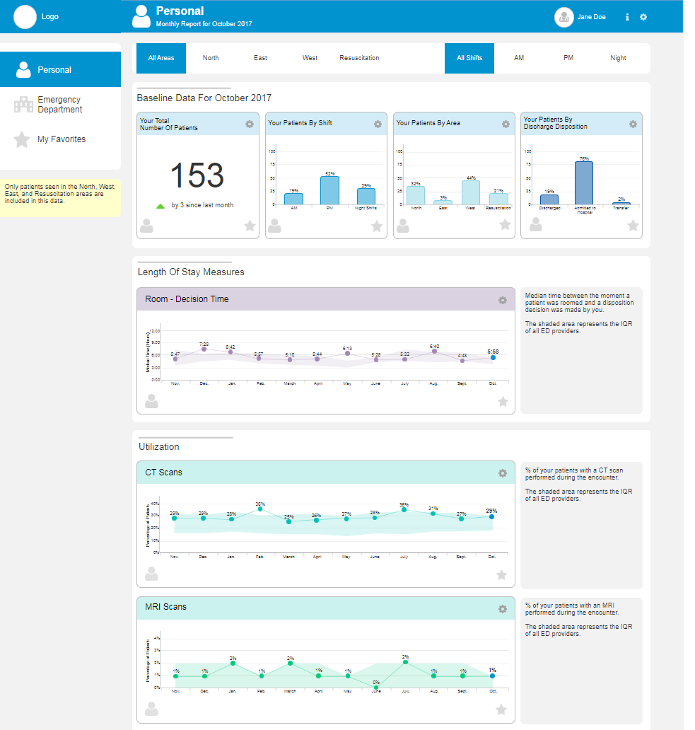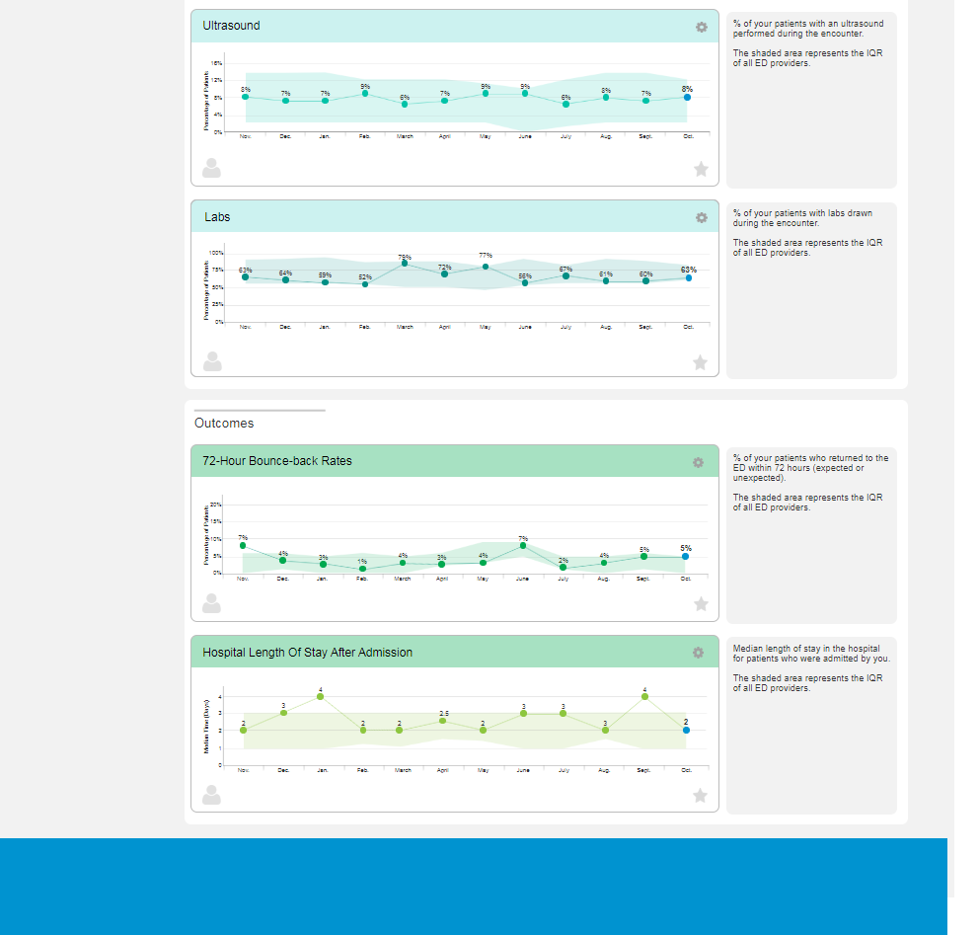
Legend: Prototype performance feedback dashboard. The name Jane Doe is a false name.

