Supplemental Figure 1. Representative safety climate score distributions for NICUs with stronger and weaker safety climate strengths.

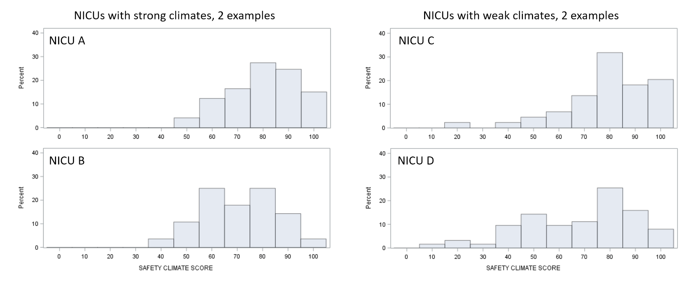

Supplemental Table 1. Relationship between safety climate, safety climate strength, and length of stay. Sensitivity analyses using r_{wg(j)} as marker of safety climate strength, post-menstrual age at discharge as marker of length of stay, and patient deaths included in length of stay analysis.
Dependent variable | Independent variable | Incremental F | P
Length of stay | Safety Climate PPR | 1.04 | .31
Length of stay | Safety Climate r_{wg(j)} | 7.45 | .006
Length of stay | Safety Climate PPR * r_{wg(j)} | 4.06 | .04
Post-menstrual age at discharge | Safety Climate PPR | 6.76 | .009
Post-menstrual age at discharge | Safety Climate Strength | 9.69 | .002
Post-menstrual age at discharge | Safety Climate PPR * Strength | 4.54 | .03
Length of stay (including patient deaths) | Safety Climate PPR | 0.93 | .33
Length of stay (including patient deaths) | Safety Climate Strength | 3.51 | .06
Length of stay (including patient deaths) | Safety Climate PPR * Strength | 2.59 | .11
n = 6682 infants in 44 NICUs (7335 infants in model including patient deaths). Ordinary least squares regression analysis at the patient level, with length of stay and post-menstrual age at discharge transformed to log-normal scale.
PPR – Percent positive response
All models adjusted for clinical factors: sex, gestational age, 5 minute Apgar score, small for gestational age, outborn, birth weight, antenatal steroids, fetal distress, major anomalies, maternal hypertension, and maternal race.

Supplemental Table 2. Relationship between safety climate and secondary clinical outcomes.
 | Incremental F | P | Hosmer-Lemeshow goodness-of-fit
Health care-associated infections
Safety Climate PPR | 7.85 | .005 | χ² = 19.84  DF = 8  P value = .01
Safety Climate Strength | 7.20 | .007 | χ² = 19.84  DF = 8  P value = .01
Safety Climate PPR * Strength | 5.36 | .02 | χ² = 19.84  DF = 8  P value = .01
Chronic lung disease
Safety Climate PPR | 2.50 | .11 | χ² = 2.45  DF = 8  P value = .96
Safety Climate Strength | 3.55 | .06 | χ² = 2.45  DF = 8  P value = .96
Safety Climate PPR * Strength | 4.12 | .04 | χ² = 2.45  DF = 8  P value = .96
Mortality
Safety Climate PPR | 6.34 | .01 | χ² = 12.37  DF = 8  P value = .14
Safety Climate Strength | 7.86 | .005 | χ² = 12.37  DF = 8  P value = .14
Safety Climate PPR * Strength | 8.31 | .004 | χ² = 12.37  DF = 8  P value = .14
n = 7338 infants in 44 NICUs. Multivariable logistic regression, analysis at the patient level.
PPR – Percent positive response
DF – degrees of freedom
All models adjusted for clinical factors (sex, gestational age, 5 minute Apgar score, small for gestational age, outborn) and perceptions of management, California Children’s Services (CCS) level, number of VLBW infants, birth year, survey response rate, and number of survey respondents.

Supplemental Figure 2. Effect of safety climate strength on the relation between safety climate percent positive response (PPR) and risk-adjusted length of stay among very low birthweight infants, stratified by birth year.

