Supplement
Variance of cost difference explained by basic features using multiple linear regression analysis

Statistical Methods
Because of the skewness of the cost observations, the logarithmic transformation has been applied to assure the approximate normality of the outcome. Multiple linear regression was applied to log(total costs) for 2014 and 2015, and the cost difference was calculated as log(total costs 2015) – log(total costs 2014) to estimate the adjusted coefficient of determination, which describes the explained variance. The computations for the non-transformed costs are also provided to assure comparability with the literature. All models were calculated using R (Version 3.3.1).

Results
Using the set of basic features, the explained variance in health care costs, as indicated by the adjusted R-squared value, was considerably smaller for the cost difference than for total costs (basic model: cost difference: 0.2% vs. costs 2014: 3.3% and costs 2015: 2.4%; extended model: cost difference: 7.4% vs. costs 2014: 40.3% and costs 2015: 24.3%). This finding was consistent for all evaluated models (Table S1).

TABLE S1. Multiple linear regression models using features observed in 2014
Outcome
 | Costs  2014 | Log(Costs) 2014 | Costs  2015 | Log(Costs) 2015 | Cost Difference  2015–2014 | Log(Cost Difference) 2015–2014
Features | adj. R² | adj. R² | adj. R² | adj. R² | adj. R² | adj. R²
age + gender | 0.021 | 0.041 | 0.030 | 0.052 | 0.002 | 0.001
age + gender + area of residence | 0.022 | 0.043 | 0.031 | 0.054 | 0.002 | 0.001
age + gender + area of residence + deductible | 0.027 | 0.060 | 0.036 | 0.070 | 0.002 | 0.001
Demographic model* | 0.033 | 0.068 | 0.042 | 0.077 | 0.002 | 0.001
+ number of different drugs  + number of individual prescriptions | 0.243  0.284 | 0.391  0.337 | 0.134  0.186 | 0.220  0.237 | 0.020  0.010 | 0.031  0.022
+ number of hospitalisations | 0.234 | 0.261 | 0.099 | 0.149 | 0.057 | 0.010
+ number of outpatient physician office visits | 0.183 | 0.345 | 0.093 | 0.173 | 0.022 | 0.020
+ chronic conditions | 0.228 | 0.275 | 0.156 | 0.208 | 0.016 | 0.022
Extended model** | 0.403 | 0.459 | 0.243 | 0.306 | 0.074 | 0.043

*Demographic model = age + gender + area of residence + deductible + insurance model
**Extended model = Demographic model + number of different drugs + number of individual prescriptions + number of hospitalisations + number of outpatient physician office visits + chronic conditions

Backward deletion: Included features

TABLE S2. Features included in the small model derived from backward deletion
Feature name
1 | Length of hospital stay per year
2 | Total health care costs in 2014
3 | Mode of drug administration: intravenous
4 | Number of hospitalisations
5 | Drug group: S01CA (ophthalmologic corticosteroids and anti-infectives in combination)
6 | Drug group: N01AX (other general anesthetics)
7 | Age (categorical variable)
8 | Number of individual drug prescriptions (GTINs) filled in the last quarter of the year
9 | Length of stay in inpatient psychiatric facility per year
10 | Number of days of home care (including basic care, treatments, and administration)
11 | Number of hospitalisations: major diagnostic category — muscular–skeletal-related diseases
12 | Number of outpatient physician office visits
13 | Drug group: B03BB (folic acid)
14 | Number of hospitalisations: major diagnostic category — delivery
15 | Number of outpatient physician office visits: physician specialisation — gynaecologist
16 | Number of outpatient physician office visits: physician specialisation — gastroenterologist
17 | Number of outpatient physician office visits in December
18 | Deductible
19 | Change of chosen deductible in the next year
20 | Drug group: N01AH (opioid anesthetics)
21 | Number of outpatient physician bedside visits in the last quarter of the year
22 | Length of nursing home stay per year
23 | Drug group: S01BC (ophthalmologic non-steroidal anti-inflammatory agents)
24 | Gender
25 | Drug group: A03BA (belladonna alkaloids)
26 | Length of stay in rehabilitation facility per year
27 | Number of days of home care (basic care only)
28 | Number of individual drug prescriptions (GTINs)
29 | Number of outpatient physician office visits in the last quarter of the year
30 | Number of outpatient physician office visits: physician specialisation — ophthalmologist
31 | Median interval between outpatient physician office visits
32 | Number of individual drug prescriptions (GTINs) filled in December
33 | Chronic condition: diabetes mellitus
34 | Individual drug prescriptions (GTINs) dispensed by hospitals
35 | Number of outpatient physician office visits in the first quarter of the year
36 | Number of invoices for home care (including basic care, treatments, and administration)
Most important 36 features, arranged in descending order of loss reduction. GTIN = Global Trade Item Number, which was used to identify prescribed drugs

Backward deletion: Process

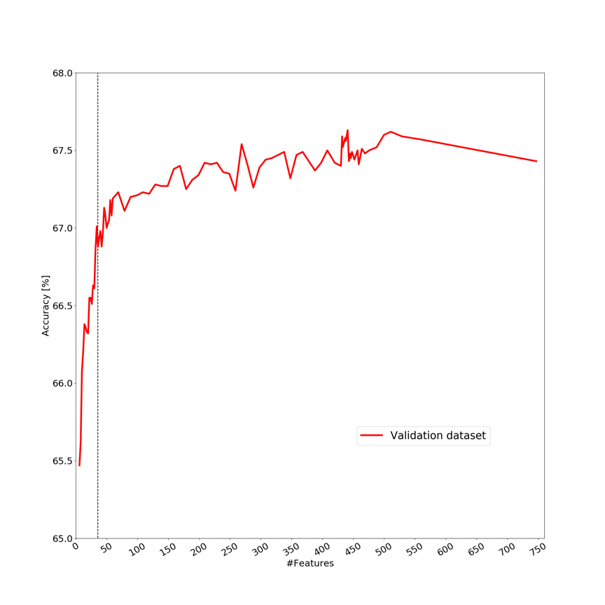

Figure S1. Backward deletion: Number of features included in the complete model (boosted decision tree, 747) and corresponding accuracy levels. The vertical black line represents the 36 most important features.

