Additional File 3: Map of Ghana administrative regions, districts, and Ashanti enumeration areas
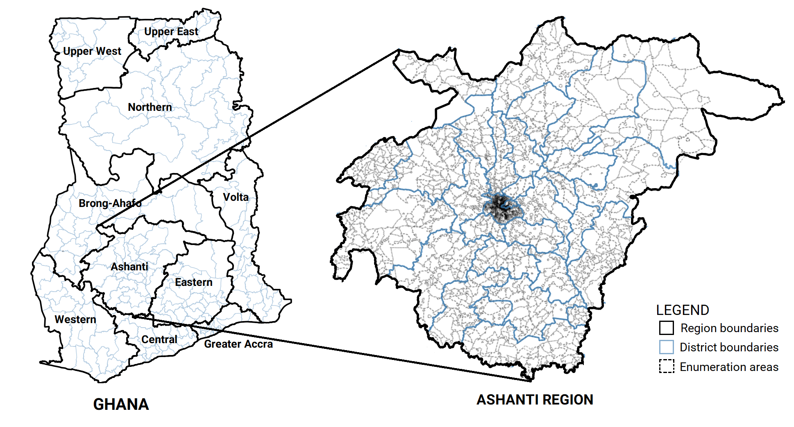
Source: All shape files used were uploaded by the Ghana Statistical Service to the Ghana Open Data Initiative website (https://data.gov.gh/about). Data found in this site is publicly available and free for use, modification, or sharing.
https://data.gov.gh/dataset/shapefiles-all-regions-ghana-2010-10-regions
https://data.gov.gh/dataset/shapefiles-all-districts-ghana-170-districts
https://data.gov.gh/dataset/shapefiles-enumeration-areas-ashanti-region

This figure was generated by authors using GeoDa v1.12.1.139 – a free and open source software developed by Dr. Luc Anselin and his team for spatial analyses.

