Additional file 1

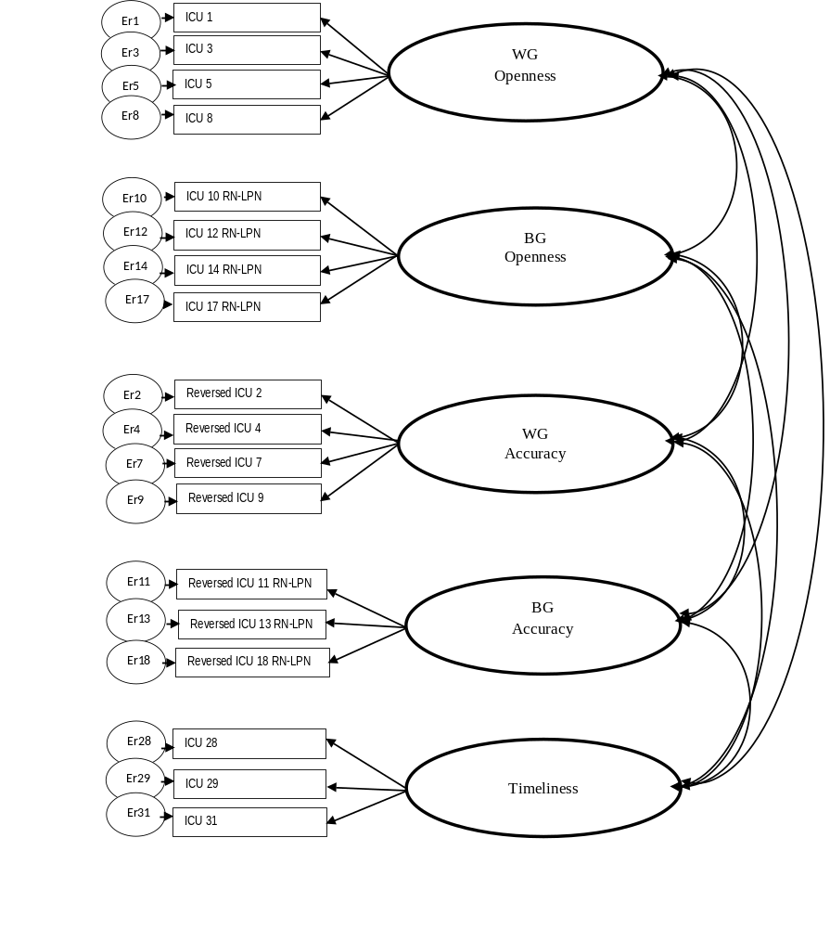
Figure 1. A schematic illustration of the original model - Model 1. Between-Group (BG), Within-Group (WG).

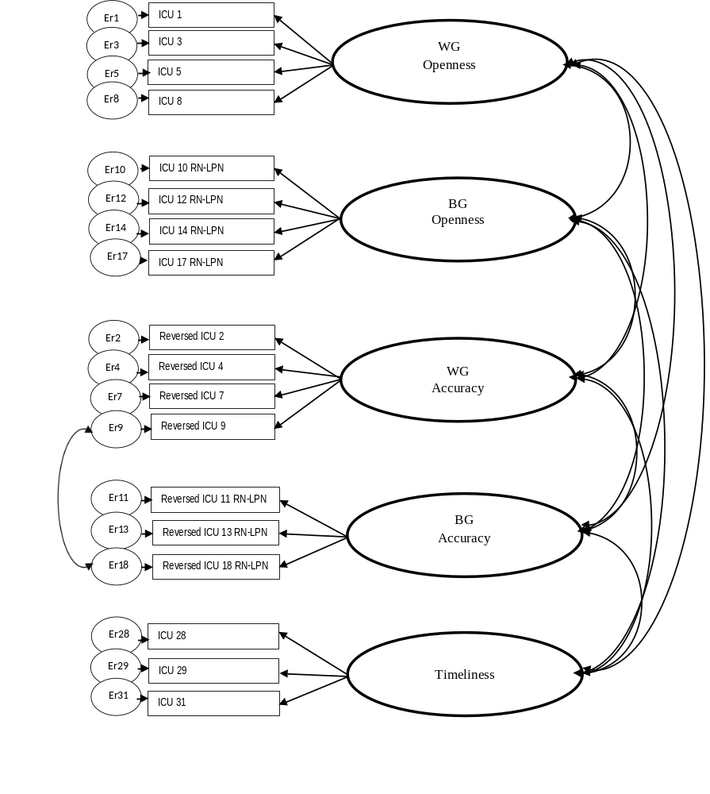
Figure 2. A schematic illustration of Model 2. Between-Group (BG), Within-Group (WG).

