Supplementary material for: Impact of the Programa Mais Medicos (More Doctors Programme) on primary care doctor supply and amenable mortality: quasi-experimental study of 5565 Brazilian municipalities

Table A1 – Amenable mortality International classification of disease codes (ICD-10) and age restrictions
Cause of Death | Age | ICD-10 Code |  | Group
Intestinal infections | 0-14 | A00-9 |  | Infectious diseases
Tuberculosis | 0-74 | A15-9, B90 |  | Infectious diseases
Other infections (diphtheria, tetanus, septicaemia, poliomyelitis) | 0-74 | A36, A35, A40-1, A80 |  | Infectious diseases
Whooping cough | 0-14 | A37 |  | Infectious diseases
Measles | 1-11 | B05 |  | Infectious diseases
Malignant neoplasm of colon and rectum | 0-74 | C18-21 |  | Neoplasms
Malignant neoplasm of skin | 0-74 | C44 |  | Neoplasms
Malignant neoplasm of breast | 0-74 | C50 |  | Neoplasms
Malignant neoplasm of cervix uteri | 0-74 | C53 |  | Neoplasms
Malignant neoplasm of cervix uteri and body of uterus | 0-44 | C54, C55 |  | Neoplasms
Malignant neoplasm of testis | 0-74 | C62 |  | Neoplasms
Hodgkin’s disease | 0-74 | C81 |  | Neoplasms
Leukaemia | 0-44 | C91-5 |  | Neoplasms
Diseases of the thyroid | 0-74 | E00-7 |  | Circulatory and endocrine diseases
Diabetes | 0-49 | E10-4 |  | Circulatory and endocrine diseases
Chronic rheumatic heart disease | 0-74 | I05-9 |  | Circulatory and endocrine diseases
Hypertensive disease | 0-74 | I15 |  | Circulatory and endocrine diseases
Ischaemic heart disease: 50% of deaths | 0-74 | I20-25 |  | Circulatory and endocrine diseases
Cerebrovascular disease | 0-74 | I60-9 |  | Circulatory and endocrine diseases
Congenital cardiovascular anomalies | 0-74 | Q20-8 |  | Circulatory and endocrine diseases
All respiratory diseases (excl. pneumonia, influenza) | 1-14 | J00-9, J20-99 |  | Respiratory disease
Influenza | 0-74 | J10-1 |  | Respiratory disease
Pneumonia | 0-74 | J12-8 |  | Respiratory disease
Peptic ulcer | 0-74 | K25-7 |  | Digestive disorders, genitourinary disease, and epilepsy
Appendicitis | 0-74 | K35-8 |  | Digestive disorders, genitourinary disease, and epilepsy
Abdominal hernia | 0-74 | K40-6 |  | Digestive disorders, genitourinary disease, and epilepsy
Cholelithiasis and cholecystitis | 0-74 | K80-1 |  | Digestive disorders, genitourinary disease, and epilepsy
Nephritis and nephrosis | 0-74 | N00-7, N17-9, N25-7 |  | Digestive disorders, genitourinary disease, and epilepsy
Benign prostatic hyperplasia | 0-74 | N40 |  | Digestive disorders, genitourinary disease, and epilepsy
Epilepsy | 0-74 | G40-1 |  | Digestive disorders, genitourinary disease, and epilepsy
Misadventures to patients during surgical and medical care | 0-74 | Y60-9, Y83-4 |  | Iatrogenic harm
Maternal death | 0-74 | O00-99 |  | Maternal and perinatal
Perinatal deaths, all causes (excl. stillbirths) | 0-74 | P00-96 |  | Maternal and perinatal
Source: Nolte and McKee (2008)

Figure A2 – Number of doctors (FTEs) by sector in Brazil (2008-2017)
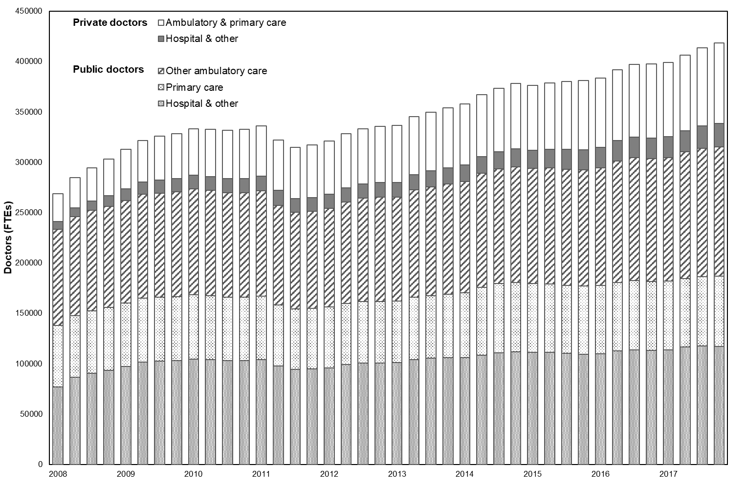
Source: CNES, Ministry of Health and author’s own work

Figure A3 – Number of PMM doctors registered (2013-2017)
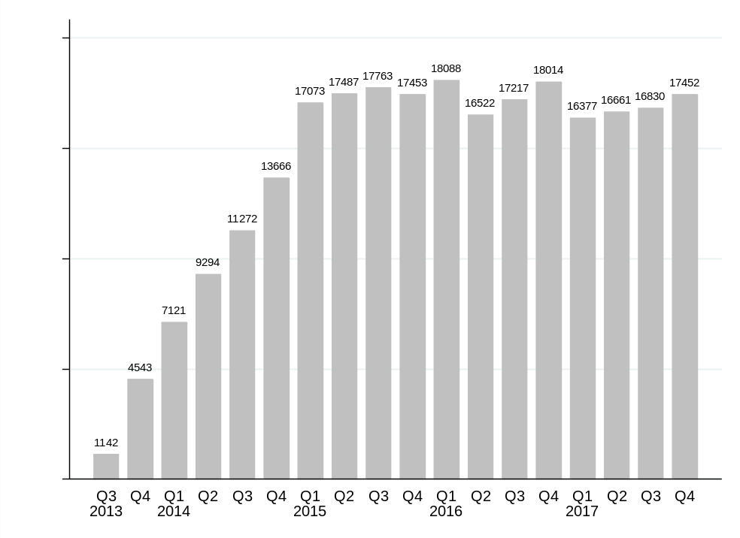
Source: CNES, Ministry of Health and author’s own work
Figure A4 – Distribution of public doctors in Brazil between hospital care, primary care and other ambulatory care services (2008-2017)
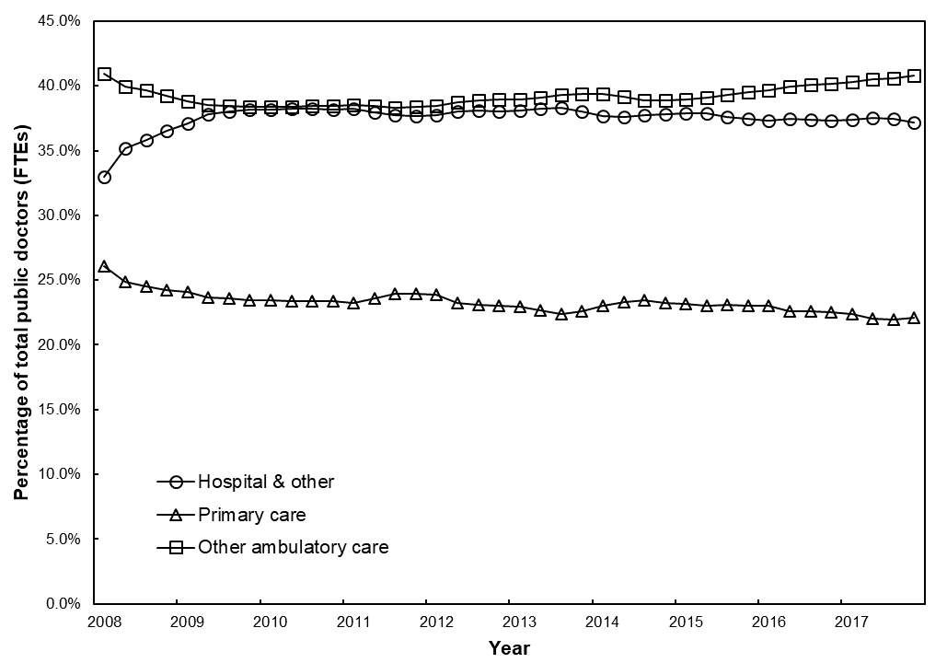
Source: CNES, Ministry of Health and author’s own work

Figure A5 – Number of municipalities with PMM doctors registered (2013-2017)
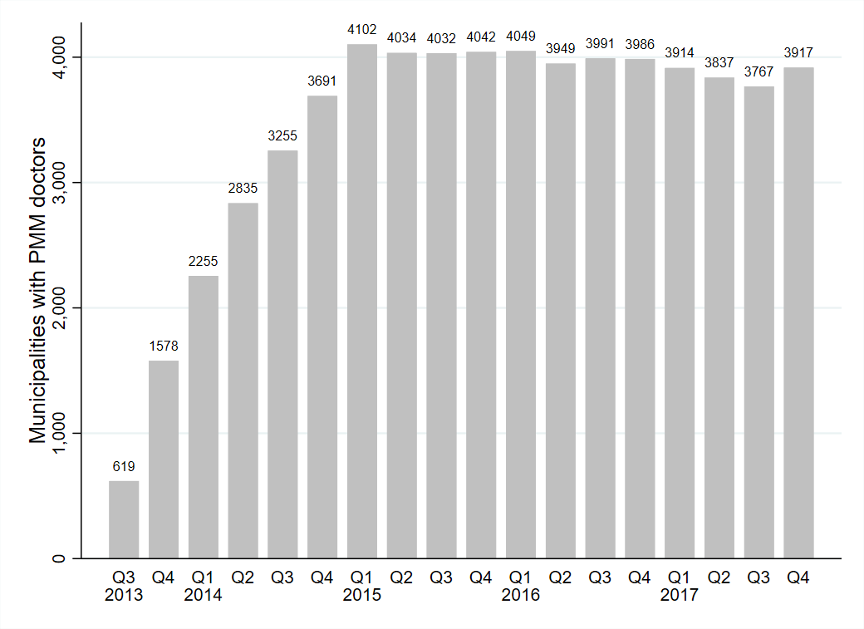
Source: CNES, Ministry of Health and author’s own work
Table A6 – Municipalities receiving PMM by state
State | Non-PMM municipalities | PMM-municipalities | %
Rondônia | 0 | 52 | 100%
Acre | 1 | 21 | 95%
Amazonas | 0 | 62 | 100%
Roraima | 0 | 15 | 100%
Pará | 3 | 140 | 98%
Amapá | 0 | 16 | 100%
Tocantins | 51 | 88 | 63%
Maranhão | 21 | 196 | 90%
Piauí | 58 | 166 | 74%
Ceará | 4 | 180 | 98%
Rio Grande do Norte | 25 | 142 | 85%
Paraíba | 44 | 179 | 80%
Pernambuco | 7 | 178 | 96%
Alagoas | 15 | 87 | 85%
Sergipe | 7 | 68 | 91%
Bahia | 18 | 399 | 96%
Minas Gerais | 250 | 603 | 71%
Espírito Santo | 10 | 68 | 87%
Rio de Janeiro | 7 | 85 | 92%
São Paulo | 214 | 431 | 67%
Paraná | 72 | 327 | 82%
Santa Catarina | 58 | 235 | 80%
Rio Grande do Sul | 92 | 404 | 81%
Mato Grosso do Sul | 11 | 67 | 86%
Mato Grosso | 26 | 115 | 82%
Goiás | 59 | 187 | 76%
Brasilia (Federal District) | 0 | 1 | 100%

Source: Ministry of Health and author’s own work

Table A7 – Baseline doctor density and mean PMM doctors by programme priority
 | Mean | Min | Max | Non PMM municipalities | PMM municipalities
Baseline doctor density (Primary care doctors per 100,000 (2008-2012))
Non-priority | 52.0 | 5.1 | 197.1 | 1,056 | 1,920
Priority | 41.6 | 0.9 | 150.3 | 0 | 2,589
Mean PMM doctor density (PMM doctors per 100,000 (2013-2017))
Non-priority | 16.2 | 0.2 | 72.4 | 1,056 | 1,920
Priority | 15.4 | 0.1 | 66.0 | 0 | 2,589

Source: CNES, Ministry of Health and author’s own work

Table A8 – Baseline doctor density and mean PMM doctors by quintiles of municipalities
 | Mean | Min | Max | Non PMM municipalities | PMM municipalities
Baseline doctor density (Primary care doctors per 100,000 (2008-2012))
Q1 (lowest) | 23.6 | 0.9 | 30.6 | 89 | 1024
Q2 | 35.4 | 30.6 | 39.5 | 149 | 964
Q3 | 43.4 | 39.5 | 47.5 | 209 | 904
Q4 | 52.9 | 47.5 | 60.0 | 240 | 873
Q5 (highest) | 80.6 | 60.0 | 197.1 | 369 | 744
Mean PMM doctor density (PMM doctors per 100,000 (2013-2017))
No PMM | 0 | 0 | 0 | 1056 | 0
Q1 (lowest) | 3.9 | 0.1 | 6.5 | 0 | 902
Q2 | 8.8 | 6.6 | 11.1 | 0 | 902
Q3 | 13.5 | 11.1 | 16.1 | 0 | 902
Q4 | 19.6 | 16.1 | 23.4 | 0 | 902
Q5 (highest) | 32.8 | 23.4 | 72.4 | 0 | 901

Source: CNES, Ministry of Health and author’s own work

Figure A9 – Numbers of municipalities by month of receiving first MM doctor
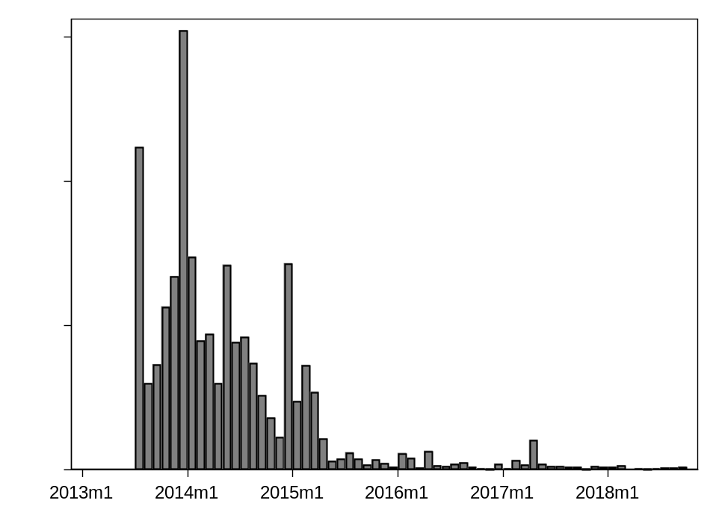
Source: CNES, Ministry of Health and author’s own work.

Appendix A10 – Estimation strategy
The equation used to estimate this
y_{mq} = β₁X₁ + β_{n}X_{n} + a_{m} + q + T_{s} + ε
Where:
y_{mq} is the outcome (e.g. amenable mortality rate) in municipality m in year-quarter q;
β₁ is the coefficient for binary variable X₁ (the introduction of the PMM) in a municipality in municipality m in year-quarter q ;
β_{n} are the coefficients for a range of covariates X_{n} ;
a_{m} is the municipal fixed effect;
q is the year-quarter fixed effect (e.g. 2010 Q1; 2010 Q2; 2012 Q3 etc);
T_{s} are linear time trends for each State s; and
ε is the unestimated error term;

A11 Table - Univariate panel regression analyses on amenable mortality
The table below shows univariate regression analysis for each covariate. Each line represents a different regression model. Each model controls for municipality and year-quarter fixed effects and linear state time trends.

 | Amenable Mortality Rate | 95% CI
PMM Implementation | -1.244*** | -1.968,-0.520
Health expenditure (R$) per capita | 2.272 | -0.928,5.472
Private insurance plan coverage (%) | 0.356*** | 0.276,0.432
Hospital beds per 1000 pop | 0.872*** | 0.456,1.288
GDP per capita | -1.120 | -33.196,30.956
Bolsa Familia expenditure per poor person | 0.008* | 0.001,0.016
Illiteracy rate (15+year) | 0.164 | -0.192,0.516
Households with inadequate sanitation (%) | -0.160** | -0.280,-0.040
Urbanisation rate (%) | 0.116* | 0.012,0.216
Income (R$) per capita | -0.016*** | -0.028,-0.008
Households with no electricity (%) | 0.200* | 0.040,0.360

* p<0.05, ** p<0.01, *** p<0.001; Amenable mortality rate is expressed per 100,000 population and reported as annual effect sizes; Heteroskedastic and Autocorrelation cluster-robust standard errors employed;

A12 Table – Sequential addition of covariates on panel regression models on amenable mortality
 | β  95%CI | β  95%CI | β  95%CI | β  95%CI | β  95%CI | β  95%CI | β  95%CI | β  95%CI | β  95%CI | β  95%CI | β  95%CI
PMM Implementation | -1.244*** | -1.216*** | -1.284*** | -1.304*** | -1.296*** | -1.180*** | -1.284*** | -1.260*** | -1.228*** | -1.096** | -1.056**
 | -1.968,-0.520 | -1.960,-0.476 | -2.024,-0.548 | -2.040,-0.564 | -2.036,-0.556 | -1.912,-0.444 | -2.016,-0.548 | -1.996,-0.528 | -1.960,-0.500 | -1.820,-0.372 | -1.780,-0.332
Health expenditure (R$) per capita | - | 2.184 | 1.736 | 1.632 | 1.992 | 2.348 | 2.164 | 2.196 | 2.152 | 3.008* | 2.956*
 |  | -0.964,5.336 | -1.164,4.640 | -1.236,4.504 | -1.012,5.000 | -0.676,5.372 | -0.868,5.192 | -0.802,5.216 | -0.832,5.140 | 0.088,5.924 | 0.052,5.856
Private insurance plan coverage (%) | - | - | 0.352*** | 0.348*** | 0.352*** | 0.376*** | 0.376*** | 0.376*** | 0.376*** | 0.352*** | 0.336***
 |  |  | 0.272,0.432 | 0.268,0.428 | 0.272,0.428 | 0.296,0.456 | 0.292,0.456 | 0.296,0.460 | 0.296,0.456 | 0.276,0.428 | 0.26,0.412
Hospital beds per 1000 pop | - | - | - | 0.804*** | 0.808*** | 0.776*** | 0.772*** | 0.780*** | 0.780*** | 0.804*** | 0.808***
 |  |  |  | 0.400,1.212 | 0.404,1.216 | 0.368,1.18 | 0.368,1.18 | 0.376,1.184 | 0.376,1.188 | 0.404,1.208 | 0.404,1.208
GDP per capita | - | - | - | - | -20.788 | -14.588 | -17.240 | -16.656 | -16.508 | -7.848 | -7.808
 |  |  |  |  | -48.480,6.928 | -42.760,13.588 | -45.280,10.816 | -44.760,11.448 | -44.560,11.548 | -34.784,19.084 | -34.680,19.060
Bolsa Familia expenditure per poor person | - | - | - | - | - | 0.012*** | 0.016*** | 0.016*** | 0.016*** | 0.016*** | 0.020***
 |  |  |  |  |  | 0.004,0.02 | 0.008,0.024 | 0.008,0.028 | 0.008,0.024 | 0.008,0.024 | 0.008,0.028
Illiteracy rate (15+year) | - | - | - | - | - | - | 0.448* | 0.440* | 0.492** | 0.784*** | 0.628***
 |  |  |  |  |  |  | 0.092,0.800 | 0.080,0.796 | 0.136,0.848 | 0.428,1.140 | 0.284,0.972
Households with inadequate sanitation (%) | - | - | - | - | - | - | - | -0.180** | -0.176** | -0.152* | -0.136*
 |  |  |  |  |  |  |  | -0.296,-0.064 | -0.292,-0.060 | -0.272,-0.036 | -0.252,-0.020
Urbanisation rate (%) | - | - | - | - | - | - | - | - | 0.096* | 0.092* | 0.104*
 |  |  |  |  |  |  |  |  | 0.008,0.188 | 0.004,0.184 | 0.016,0.192
Income (R$) per capita | - | - | - | - | - | - | - | - | - | -0.020*** | -0.020***
 |  |  |  |  |  |  |  |  |  | -0.028,-0.008 | -0.028,-0.012
Households with no electricity (%) | - | - | - | - | - | - | - | - | - | - | 0.288***
 |  |  |  |  |  |  |  |  |  |  | 0.120,0.456

* p<0.05, ** p<0.01, *** p<0.001; Heteroskedastic and Autocorrelation cluster-robust standard errors employed; Amenable mortality rate is expressed per 100,000 population and reported as annual effect sizes; All models adjusted for municipality and year-quarter fixed effects and linear state time trends; Regression results are weighted by municipal population.

A13 Table – Panel regression on amenable mortality with linear-trend covariate specification
The table below shows the results from a fixed effects panel regression on amenable mortality where covariates are specified as baseline values (Q1 2008) interacted with linear time trends.
 | Amenable Mortality Rate | 95% CI
PMM Implementation | -0.756* | -1.484,-0.028
Linear time trends interacted with:
Health expenditure (R$) per capita | 0.016 | -0.188,0.216
Private insurance plan coverage (%) | -0.004* | -0.004,0.000
Hospital beds per 1000 pop | -0.016** | -0.024,-0.004
GDP per capita | -0.628 | -3.664,2.404
Bolsa Familia expenditure per poor person | 0.000 | 0.000,0.000
Illiteracy rate (15+year) | -0.004 | -0.012,0.004
Households with inadequate sanitation (%) | -0.004 | -0.004,0.000
Urbanisation rate (%) | 0.000 | 0.000,0.000
Income (R$) per capita | 0.000* | 0.000,0.000
Households with no electricity (%) | -0.004 | -0.008,0.000
N (municipalities) | 5565
N (observations) | 222600

* p<0.05, ** p<0.01, *** p<0.001; Amenable mortality rate is expressed per 100,000 population and reported as annual effect sizes; Heteroskedastic and Autocorrelation cluster-robust standard errors employed;

Figure A14 - Mean amenable mortality rates of MM-receiving and non-MM receiving municipalities (2008-2017)
Mean rates weighted by municipal population;

Table A15 – Results from longitudinal fixed effects regression models on groups of amenable mortality
Amenable mortality group | PMM introduction | 95%CI
Infectious diseases | 0.024 | -0.036,0.084
Neoplasms | -0.067 | -0.138,0.003
Circulatory and endocrine diseases | -0.050 | -0.141,0.040
Respiratory disease | -0.167*** | -0.250,-0.084
Digestive disorders, genitourinary disease, and epilepsy | -0.011 | -0.067,0.044
Iatrogenic harm | 0.011 | -0.001,0.024
Maternal and perinatal | -0.009 | -0.081,0.064

* p<0.05, ** p<0.01, *** p<0.001; Heteroskedastic and Autocorrelation cluster-robust standard errors employed; regression models weighted by municipal population size; Each effect size for PMM introduction from a separate regression model adjusted for: health expenditure (R$) per capita, private insurance plan coverage (%), hospital beds per 1000 pop, GDP per capita, Bolsa Familia expenditure per poor person, illiteracy rate (15+year), households with inadequate sanitation (%), urbanisation rate (%), income (R$) per capita, households with no electricity (%), and state-year-quarter and municipal fixed effects.

Table A16 – Sensitivity of longitudinal regression models on amenable mortality to varying time and fixed effects specifications
 | Model 1 | 95%CI | Model 2 | 95%CI | Model 3
PMM introduction | -1.264** | -2.024,-0.504 | -1.220** | -2.004,-0.440 | -1.300*** | -2.052,0.552
Municipality fixed effects | Y |  | Y |  | Y
Quarter-year fixed effects | Y |  | - |  | Y
State-quarter-year fixed effects | - |  | Y |  | -
State year-quarter linear trends | - |  | - |  | Y
N (Municipalities) | 5565 |  | 5565 |  | 5565
N (Observations) | 222600 |  | 222600 |  | 222600
AIC | 1523009 |  | 1521516 |  | 1522574
BIC | 1523421 |  | 1531293 |  | 1523244

* p<0.05, ** p<0.01, *** p<0.001; Heteroskedastic and Autocorrelation cluster-robust standard errors employed; regression models weighted by municipal population size; Results from longitudinal regression models on amenable mortality.

Table A17 – Longitudinal regression models on amenable mortality including slope and step changes following PMM introduction
 | Model 1 – step change  (same as main analysis) |  | Model 2 – step and slope change
 | β | 95%CI | β | 95%CI
Step change | -1.060** | -1.784,-0.336 | -0.800* | -1.572,-0.032
Slope change (quarters since PMM introduction) | - |  | 0.100 | -0.096,0.296
N | 222600 |  | 180360

* p<0.05, ** p<0.01, *** p<0.001; Cluster robust standard errors employed; Adjusted for Health expenditure (R$) per capita, Private insurance plan coverage (%), Hospital beds per 1000 pop, GDP per capita, Bolsa Familia expenditure per poor person, Illiteracy rate (15+year), Households with inadequate sanitation (%), Urbanisation rate (%), Income (R$) per capita, Households with no electricity (%), and state-year-quarter and municipal fixed effects; Doctor densities expressed per 100,000 population. Amenable mortality rate per 100,000 population aged under 75 years.

Table A18 – Sensitivity analysis using inverse probability weighting of treatment with regression adjustment (IPTW-RA)
Logistic regression models were carried out on the likelihood of a municipality ever receiving a PMM doctor (binary outcome) to calculate predicted probabilities of PMM introduction use and generate inverse probability weighting of treatment (IPTW). The predictive model was a cross-sectional analysis of municipalities in 2010 and adjusted for municipal primary care coverage, Gini index, index of human development, percentage of households without electricity, mean household income, percentage of households with inadequate sanitation, municipal illiteracy rate of those age 15 years or more, municipal expenditure on Bolsa Familia, private health insurance coverage, hospital beds per 100,000, health expenditure per capita, and public primary care doctors per 100,000.
The IPTW was estimated from this predicted probability using the equation:

$$IPTW= \frac{Z}{e}+\frac{1-Z}{1-e}$$
Where Z refers to a binary variable denoting actual treatment (PMM ever introduced; either 0 or 1), and e refers to the predicted probability of receiving PMM from the logistic regression model.
Using IPTW, the main regression models were repeated.
 | Main regression results (population weighted only) |  | IPTW regression results (IPTW and population weighted)
 | Amenable mortality rate | 95%CI | Amenable mortality rate | 95%CI
PMM Introduction | -1.06** | -1.78,-0.33 | -1.608** | -2.724,-0.492
Health expenditure (R$) per capita | 2.95* | 0.17,5.86 | 2.932 | -0.204,6.068
Private insurance plan coverage (%) | 0.34*** | 0.26,0.41 | 0.292*** | 0.188,0.396
Hospital beds per 1000 pop | 0.81*** | 0.40,1.21 | 0.536* | 0.004,1.068
GDP per capita | -7.81 | -34.68,19.06 | 0.192 | -33.516,33.900
Bolsa Familia expenditure per poor person | 0.02*** | 0.02,0.03 | 0.016** | 0.004,0.024
Illiteracy rate (15+year) | 0.63*** | 0.28,0.97 | 0.816*** | 0.392,1.240
Households with inadequate sanitation (%) | -0.14* | -0.25,-0.02 | -0.064 | -0.204,0.076
Urbanisation rate (%) | 0.10* | 0.02,0.29 | 0.168** | 0.048,0.292
Income (R$) per capita | -0.02*** | -0.03,-0.01 | -0.028*** | -0.040,-0.016
Households with no electricity (%) | 0.29*** | 0.12,0.46 | 0.248* | 0.004,0.456
N (municipalities) | 5565 |  | 5565
N (observations) | 222600 |  | 222600

* p<0.05, ** p<0.01, *** p<0.001; Heteroskedastic and Autocorrelation cluster-robust standard errors employed;

References
Austin PC, Stuart EA. Moving towards best practice when using inverse probability of treatment weighting (IPTW) using the propensity score to estimate causal treatment effects in observational studies. Statistics in medicine. 2015;34(28):3661-79.

Appendix A19 - Event study analyses with leads and lags dummies for PMM introduction on amenable mortality and doctor density
Primary care doctor density
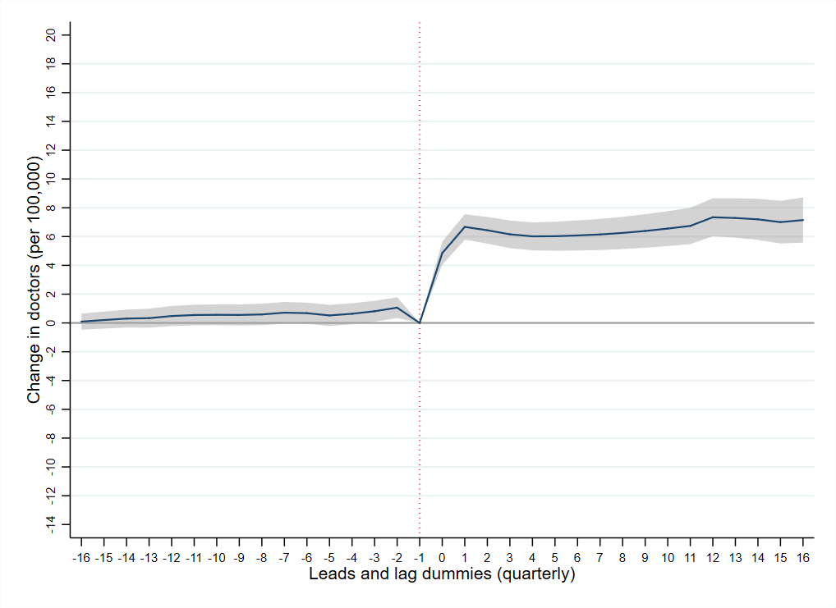
Non-PMM doctor density
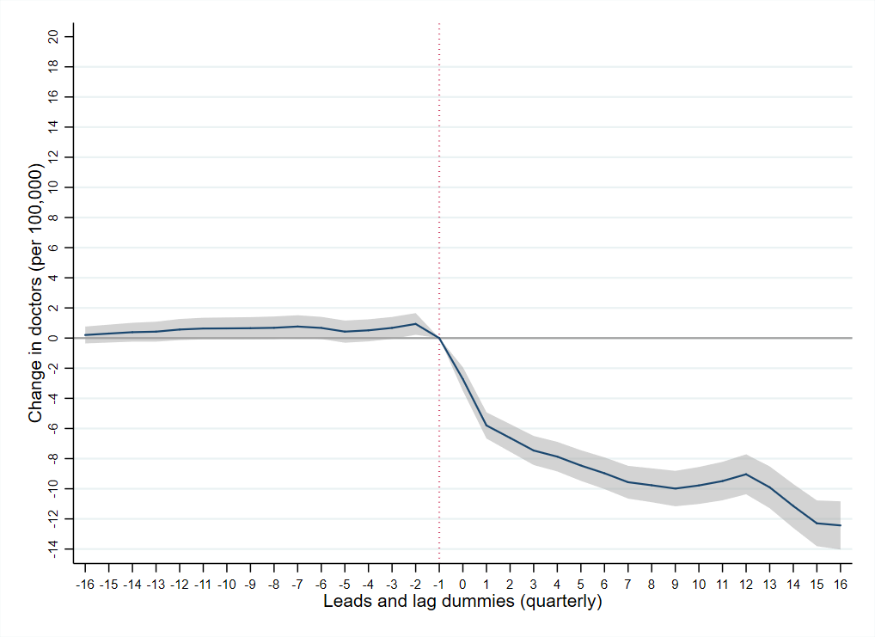
PMM doctor density
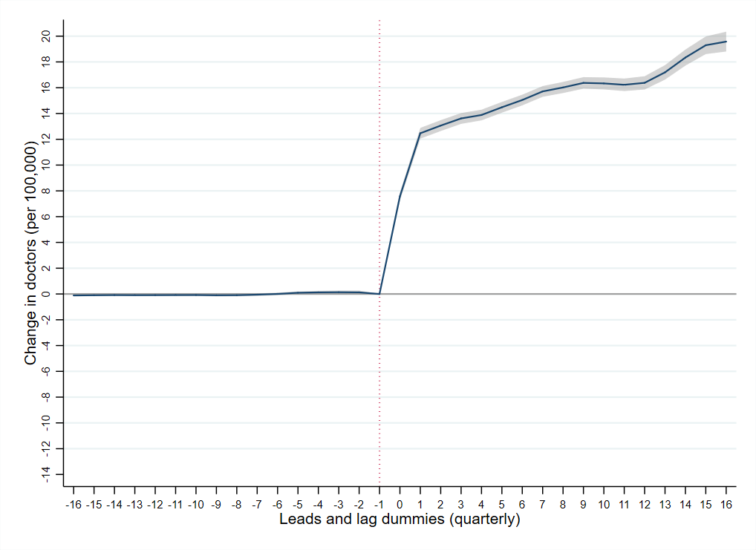
Heteroskedastic and autocorrelation cluster-robust standard errors employed; lead and lag dummies refer to quarter-year periods before and after PMM introduction in a municipality.
Amenable mortality
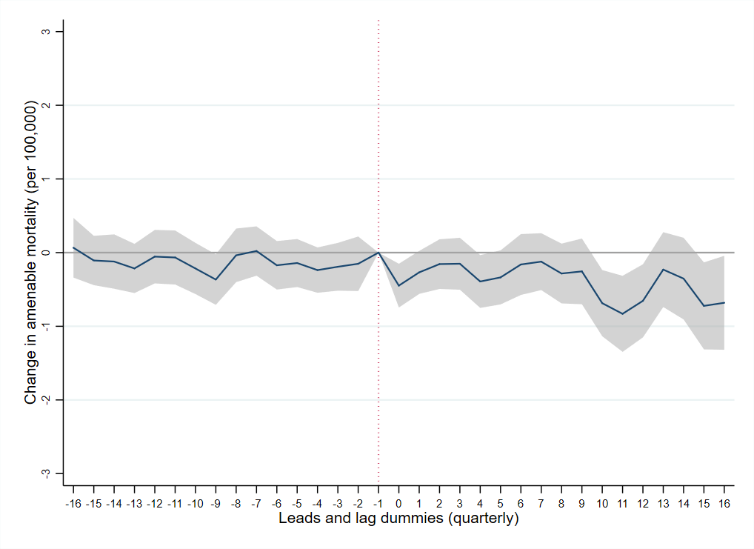
Heteroskedastic and autocorrelation cluster-robust standard errors employed; regression model weighted by municipal population size; lead and lag dummies refer to quarter-year periods before and after PMM introduction in a municipality.

