Additional file 1. English translation of the questionnaire (translated from Serbian)

ONLINE SURVEY

Changes in work environment of community pharmacists during the COVID-19 pandemic

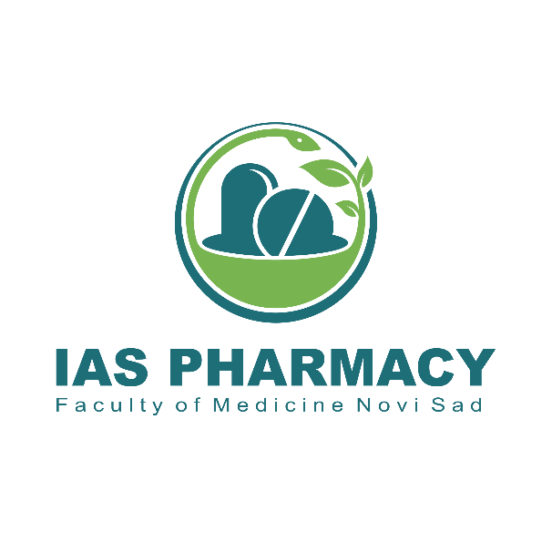
Department of Pharmacy
Faculty of Medicine, University of Novi Sad

April 2020

General characteristics
The following questions are about You and the community pharmacy You work at.
- Gender
  - male
  - female
- Age: ____________ (fill in the number)
- Years of work experience in community pharmacy: ______________ (fill in the number)
- Your position in the community pharmacy You work at could be best described as:
  - responsible/chief pharmacist
  - pharmacist
- Community pharmacy You work at is:
  - part of a chain of community pharmacies with ≤ 4 pharmacies
  - part of a chain of community pharmacies with 5 to 15 pharmacies
  - part of a chain of community pharmacies with > 15 pharmacies
  - independent
- Community pharmacy You work at pharmacies has an agreement with the National Health Insurance Fund.
  - yes
  - no
- Community pharmacy You work at is located in:
  - urban area
  - suburban area
  - rural area

Workload
The following questions are about Your workload during the COVID-19 pandemic.
- Since the beginning of COVID-19 pandemic, workload in the pharmacy You work at:
(participants choosing the answer 8.1 or 8.2 were automatically tranfered to question 17)
  - decreased
  - did not change
  - increased
- In Your opinion, increase in workload is caused by:
(participants were informed they are free to choose more than one question)
  - more prescriptions
  - increase in demand for antiseptics and disinfectants
  - increase in demand for protective equipment (masks, gloves)
  - increase in demand for certain groups of medications
  - increase in demand for dietary supplements
  - increase in demand for compounding of antiseptics and disinfectants
  - increase in counseling activities on COVID-19-related issues
  - more complex disinfecting procedures
  - other reasons
- If Your answer to the previous question was “other reasons”, please cite those reasons.
(answer not required)
_______________________________________________
- Demand increased for the following medication groups:
(participants were informed they are free to choose more than one question)
  - analgesics and antipyretics
  - antivirotics
  - antimalarials
  - antihypertensives
  - anxiolytics, sedatives and hypnotics
  - antiseptics
  - compounded medicines
  - galenic preparations
  - other
  - demand for medicines did not change
- If Your answer to the previous question was “other”, plese note the specific groups of medicines.
(answer not required)
_______________________________________________
- Demand increased for the following dietary supplements
(participants were informed they are free to choose more than one question)
  - vitamin C
  - zinc
  - multivitamins/multiminerals
  - ehinacea
  - beta glucan
  - germanium/ganoderma
  - bee products - propolis, royal jelly
  - alkylglycerols
  - aloa, noni
  - valerian, melatonin
  - other
  - demand for dietary supplements did not change
- If Your answer to the previous question was “other”, plese note the specific dietary supplements.
(answer not required)
_______________________________________________
- Since the start of the pandemic, shortages happened of which of these items:
(participants were informed they are free to choose more than one question)
  - antieptics and disinfectants
  - safety equipment (masks, gloves)
  - certain groups of medicines
  - certain dietary supplements
  - there were no shortages
- What steps did the pharmacy You work at undertook to overcome shortages?
(participants were informed they are free to choose more than one question)
  - compounding (solutions, gels)
  - frequent communication with suppliers
  - limiting the number of product units per purchase
  - no specific steps were undertaken
  - there were no shortages

Workflow
The following questions are about the workflow during the COVID-19 pandemic.
- Since the beginning of COVID-19 pandemic, workflow in the pharmacy You work at:
(participants choosing the answer 17.1 were automatically tranfered to question 21)
  - did not change
  - did change
- New procedures intended to lower the risks of COVID-19 transmission were implemented at the pharmacy You work at
  - yes
  - no
- New procurement-related procedures are
  - more simple
  - more cmplex
  - these proceSdures did not change
- What aspects of procurement-related procedures do You find more simple/more complex than before.
(answer not required)
_______________________________________________

Interactions with clients
The following questions are about the interactions with clients during the COVID-19 pandemic in the pharmacy You work in.
- Since the start of the COVID-19 pandemic, clients behavior in the pharmacy You work in:
  - did not change
  - is more pleasant than before the pandemic
  - is less pleasant than before the pandemic
- Since the start of the COVID-19 pandemic, clients in the pharmacy You work in:
  - are calm and respecting towards the recommended preventive measures
  - did not respect the recommended preventive measures
- Since the start of the COVID-19 pandemic, clients are asking for advice or counseling:
(participants choosing the answer 23.2 or 23.3 were automatically tranfered to question 25)
  - more often than before
  - less than before
  - there is no change in the frequency of clients asking for advice of counselilng
- Since the start of the COVID-19 pandemic, clients are more often interested in advice or counseling on:
(participants were informed they are free to choose more than one question)
  - rational use of medicines
  - rational use and/or at-home preparation of antiseptics and disinfectants
  - nutrition
  - rational supplementation
  - disease prevention
  - other
- When advising or counseling about COVID-19, You rely mostly on guidelines provided by:
  - World Health Organization
  - Ministry of Health of the Republic of Serbia
  - Pharmaceutical Chamber of Serbia
  - other

Work conditions
The following questions are about the work conditions in the pharmacy You work in during the COVID-19 pandemic.
- What safety equipment do You use while working with clients?
(participants were informed they are free to choose more than one question)
  - mask
  - gloves
  - protective gown
  - face shield
  - glass (or similar material) barrier to clients
  - disinfecting barrier at the entrance to the pharmacy (shoe sanitizer mat)
  - UV lamp
  - other
  - I do not use any safety equipment
- Since the start of the COVID-19 pandemic, safety equipment in the pharmacy You work in were::
  - always available in sufficient amounts/quantities
  - not always available in sufficient amounts/quantities
- Safety equipment during COVID-19 pandemic was:
  - provided by Your employee
  - provided by yourself
  - partially provided by Your employee, partially provided by yourself
  - not provided

Personal attitudes
The following questions are about Your personal attitudes towards COVID-19 related issues.
- Please rate Your level of concer for Your/Your family’s health during the COVID-19 pandemic.
  - High
  - Low
  - Neither low, nor high
- Because of the COVID-19 pandemic, I don’t have enough time to devote to clients.
  - I agree
  - I disagree
  - Neither agree, nor disagree
- Inaccurate and incomplete reporting about COVID-19 related issues in the media impeded my work.
  - I agree
  - I disagree
  - Neither agree, nor disagree
- Physical barrier (glass or similar material) to clients in pharmacies are necessary.
  - I agree
  - I disagree
  - Neither agree, nor disagree
- Compounding could possibly improve pharmaceutical care during the COVID-19 pandemic.
  - I agree
  - I disagree
  - Neither agree, nor disagree
- Pharmacists should be authorized to independently renew prescriptions for stable chronic conditions during the COVID-19 pandemic.
  - I agree
  - I disagree
  - Neither agree, nor disagree
- Pharmacists should be authorized (after additional training) to participate in the COVID-19 immunization process.
  - I agree
  - I disagree
  - Neither agree, nor disagree
- How would you rate you job-related stress level during the COVID-19 pandemic?
  - high
  - moderate
  - low

NOTE: Italic font was used to highlight functions that were available in online form, but are not available in pdf documents

