Appendix 1 Screenshots of the dr. Bart app
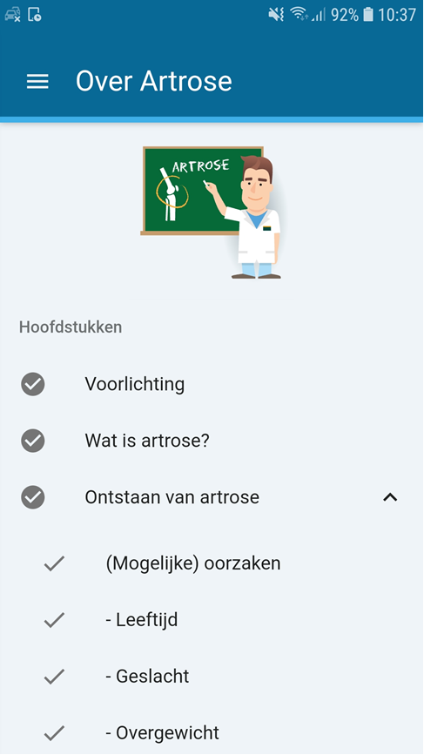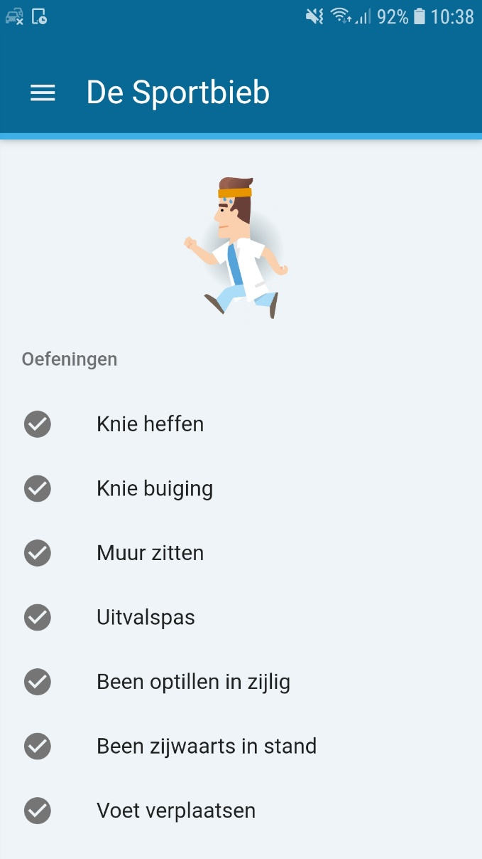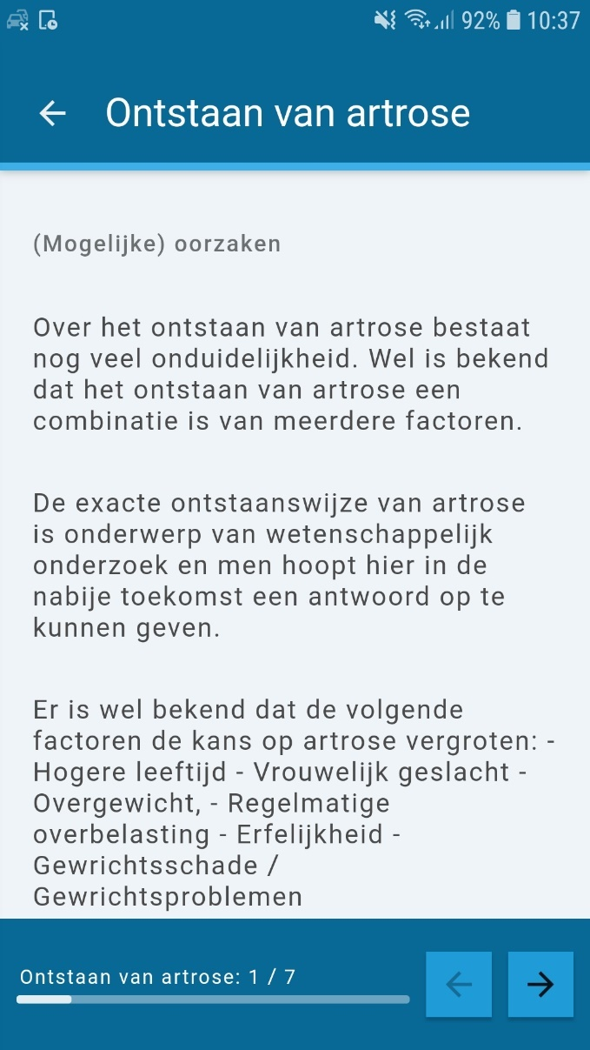
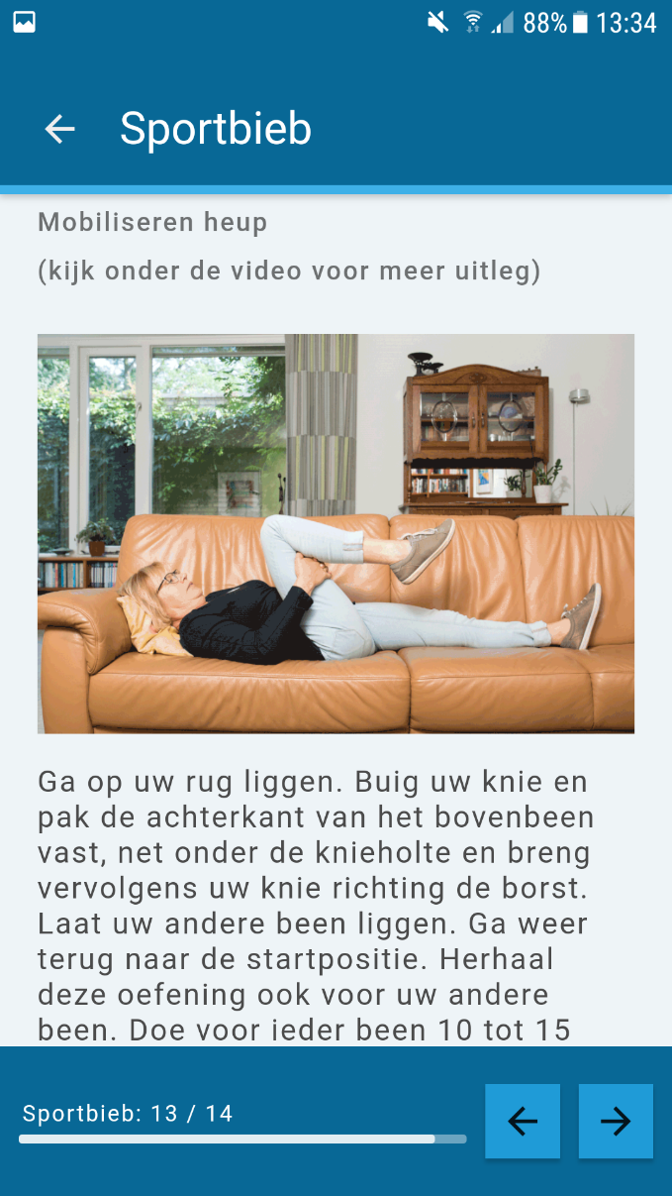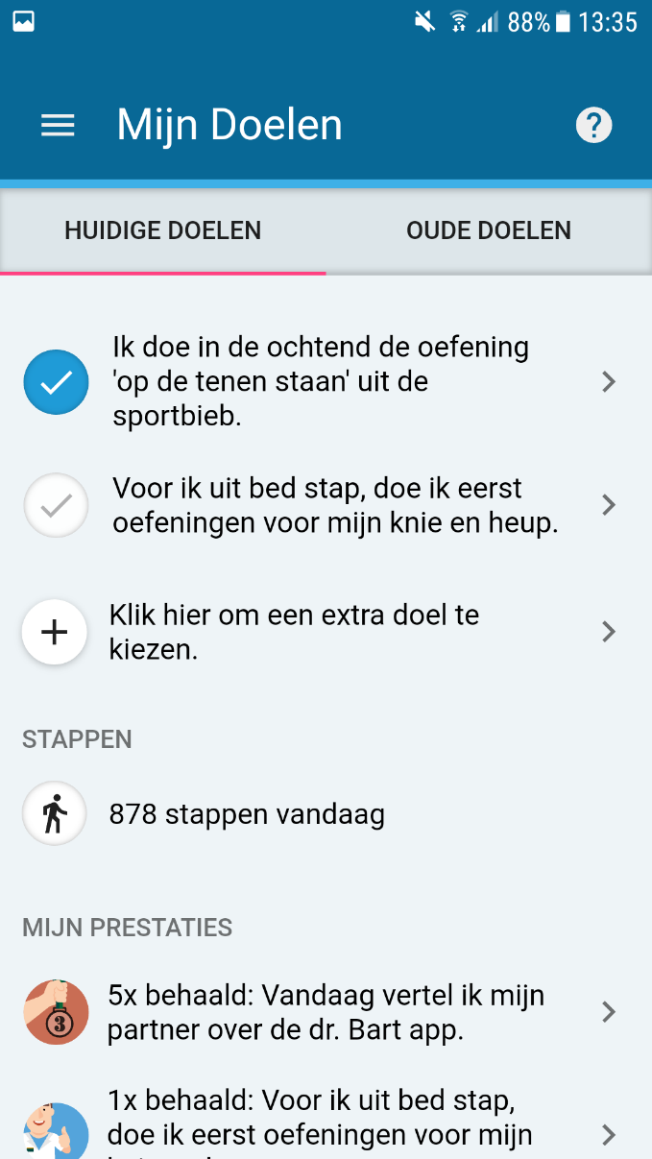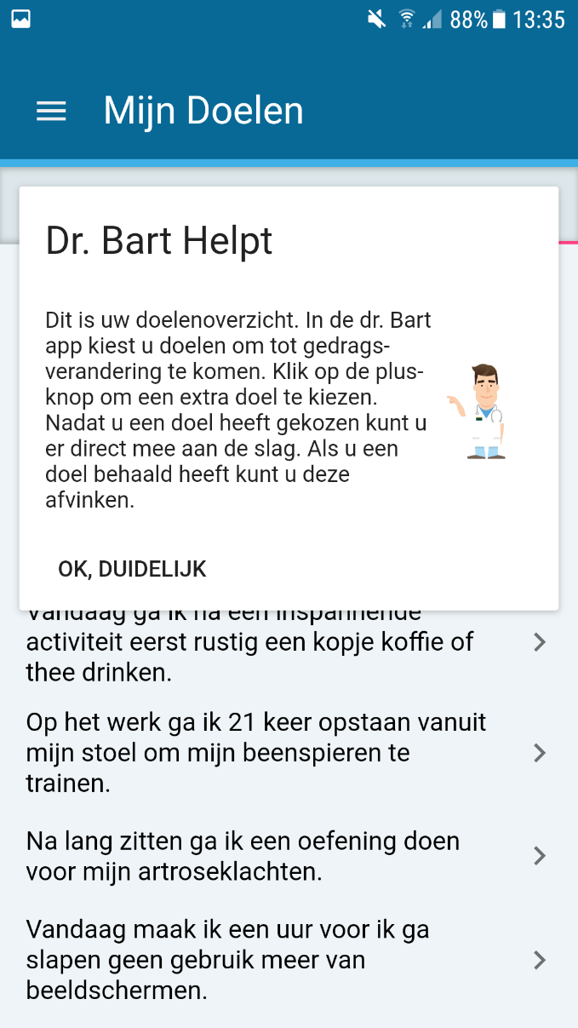


Appendix 2 Baseline characteristics of participants in the study per indicator of use and non-users
 | Non-user  (N=43) | Logged in, but no further activity  (N=20) | Chose ≥ 1 goal, but did not complete goals  (N=38) | Completed ≥ 1 goal  (N=113)
Age, years; mean (SD) | 62.2 (7.1) | 63.9 (6.4) | 64.7 (10.5) | 60.8 (6.8)
Female, n(%) | 31 (72.1) | 12 (60.0) | 23 (60.5) | 81 (71.7)
Body Mass Index, kg/m²; mean (SD) | 29.0 (6.0) | 28.9 (5.6) | 27.5 (4.8) | 27.2 (4.7)
Level of education (≤ 12 years, n(%) | 13 (33.3) | 5 (29.4) | 12 (33.3) | 26 (24.1)
Main OA location
- Knee, n(%) | 31 (72.1) | 16 (80.0) | 28 (73.7) | 82 (72.6)
Duration of symptoms, n(%)
- < 1 year | 5 (11.6) | 2 (10.0) | 7 (18.4) | 11 (9.7)
- 1 – 5 years | 23 (53.5) | 9 (45.0) | 18 (47.4) | 54 (47.8)
- 5 – 10 years | 9 (20.9) | 2 (10.0) | 11 (29.0) | 27 (23.9)
- > 10 years | 6 (14.0) | 7 (35.0) | 2 (5.3) | 21 (18.6)
Abbreviations: SD, Standard Deviation; n, number; OA, osteoarthritis.

Appendix 3 The 5 most and least often read paragraphs
Most popular paragraphs | Least popular paragraphs (<20%)
- General information regarding osteoarthritis. | - Information about the four themes in the dr. Bart app.
- What is osteoarthritis? | 2. If drugs do not help enough, what other treatment are available?
- Complaints (especially fatigue) | 3. With what frequency and intensity should I exercise?
- Prognosis of OA | 4. Are there any specific points I need to consider with regard to my job activities?
- Treatment of osteoarthritis | 5. How long does an artificial joint (joint replacement) last?

Appendix 4 Median and interquartile range of the number of cumulative completed goals over time of the active users (n = 151)
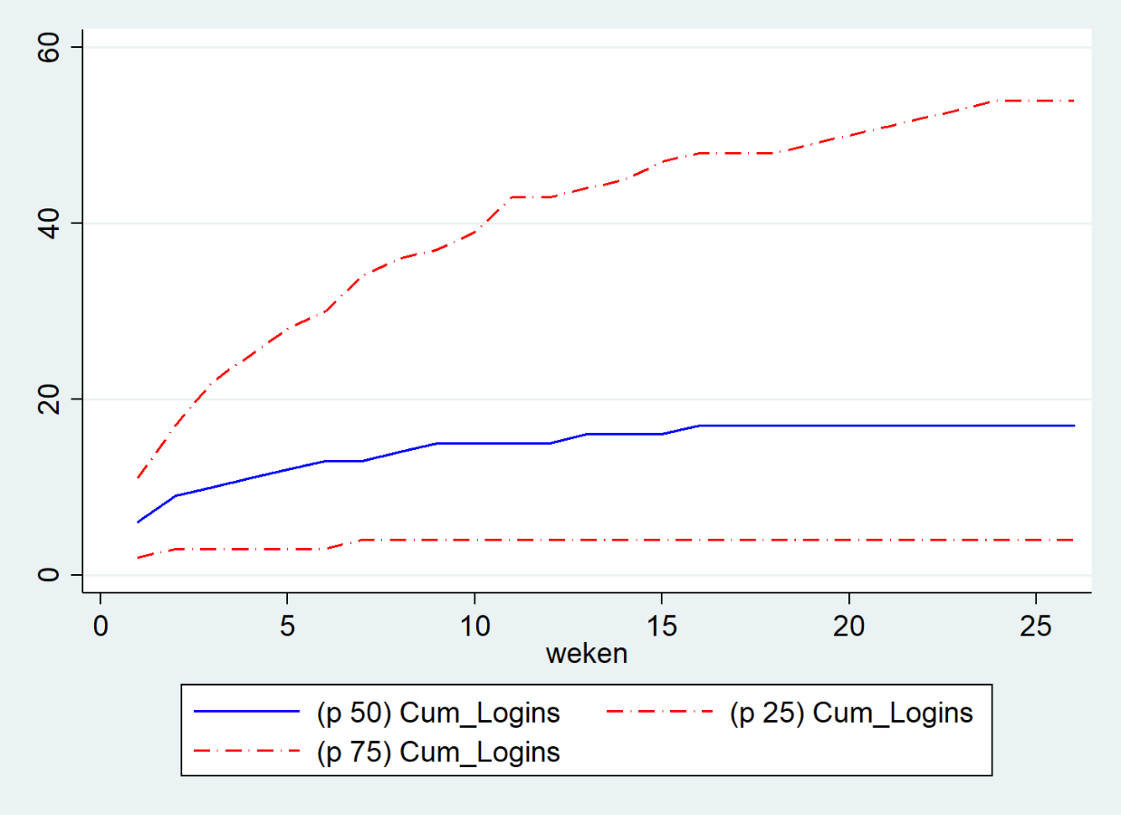
Appendix 5 Median and interquartile range of the number of cumulative logins over time of the active users (n = 151)

Appendix 6 The 5 relatively most and least often completed goals (i.e. times completed / times chosen) .
The 5 relatively most often completed goals. | The 5 relative least often completed goals
Today I participate in Netherlands on the move {trigger] on the television. | Today I'm telling to {spouse/neighbor} what osteoarthritis comprises.
Today I walk [number of] steps. | Today I'm telling {spouse/neighbor} about the dr. Bart app.
Today I won't spoon more than once with dinner. | Today I read a chapter about osteoarthritis from the education library.
I'm going to perform [number of exercises] from the exercise library {trigger}. | I'm going to swim [number of laps] {trigger}.
{Trigger} I 'm going to get up [number of times] from my chair to train my lug muscles. | Today I put a sweetener in the coffee or tea instead of sugar.

Appendix 7 The 5 relatively most and least often chosen goals (I.e. times chosen / times proposed).
The 5 relatively most and least often chosen goals. | Least often chosen goals
During {trigger} I drink a glass of water. | Today I participate in Netherlands on the move {trigger] on the television.
Today I won't spoon more than once during dinner. | Today I'm telling to {spouse/neighbor} what osteoarthritis comprises.
I'm going to improve the stability of my legs by doing an exercise from the exercise library during {trigger}. | Today I get out of the bus one stop earlier than usual and walk the rest.
Today I don't drink any sweetened drinks (such as soda or fruit juice). | Today I divide my household activities over the day.
During {trigger} I'm going to stand on my toes and slowly lower myself again and repeat this [number] times. | {Trigger} I'm going to walk for [number] minutes.

Appendix 8 Some responses to the free-text option of the SUS
“I only keep using the exercise library”.
“Personally, the exercises are easy and easy to sustain”
“Besides the (exercise) library, I do not think the app has any added value”
“The exercises are beneficial. I cannot judge the other elements as beneficial”
“Use of the app encourage me to do exercises and learn about different behaviors (e.g. eating and drinking)”
“Lots of useful info in the library”
“Good structure and clear information”
“Lots of information that you can go through in your own pace”
“I used to be afraid of movement ….. Now I have more confidence due to the provided information”
“Info and instructions are clear”
“Do not see the benefit of the app compared to an information leaflet”
“The app does not add anything for me”
“The app does not have any added value for me”
“For the elderly (70+), using an app seems to difficult, but this applies to all electronical devices”
“Besides the (exercise) library, I do not think the app has any added value”
“Quickly bored of using the app”
“I do not think the app really adds any value once you have read the library and performed the exercises”.
Appendix 9 Regression coefficient and 95% confidence interval of the relation between baseline characteristics and different parameters of use
 | Age | Genderª | BMI | Main OA location^{b} | Level of education^{c} | Duration of symptoms^{d}
Logins | 0.0  (-1.1; 1.1) | 9.9  (-8.3; 28.2) | -1.5  (-3.2; 0.3) | 8.9  (-10.5; 28.3) | -10.1  (-29.3; 9.1) | -8.8  (-35.3; 17.8)
Unique Goals Chosen | 0.0  (-0.1; 0.2) | 0.8  (-1.9;3.4) | -0.8  (-0.3; 0.2) | 0.4  (-3.1; 2.4) | -0.9  (-3.6; 1.9) | -1.5  (-5.3; 2.2)
Unique Goals Completed | 0.1  (-0.1; 0.3) | 0.1  (-2.9; 3.1) | -0.1  (-0.3; 0.2) | -0.5  (-3.6; 2.6) | -1.2 (-4.4; 1.9) | -2.9  (-7.5; 1.7)
Total goals completed | 2.7  (-0.1; 5.5) | 9.1  (-34.2; 52.4) | -3.2  (-7.3; 0.9) | 14.1  (-29.6; 57.8) | -34.7  (-81.5; 12.1) | -30.0  (-95.6; 35.6)
Paragraphs | -0.8  (-1.5; -0.2) | 10.2  (-0.9; 21.4) | -1.0  (-2.1; 0.1) | 3.2  (-8.7; 15.1) | 12.9  (0.8; 24.9) | 19.0  (3.0; 35.1)
ª Male as reference category
^{b} Knee as reference category
^{c} Less than 12 years as reference category
^{d} duration of symptoms > 10 years as reference category

Appendix 10 Spearman rank correlation coefficients between different indicators of use and beliefs regarding 5 treatment modalities in knee/hip OA as measured with the treatment beliefs in osteoarthritis questionnaire (TOA) (relative difference between baseline and 6 month follow-up)
TOA (1-5) | Logins | Unique Goals Chosen | Unique Goals Completed | Total goals completed | Paragraphs
PA Pos.  PA Neg. | -0.01  -0.38* (p = .0002) | -0.18  -0.18 | -0.22  -0.11 | -0.11  -0.22 | -0.17  -0.20
Med. Pos.  Med. Neg. | 0.08  -0.19 | 0.05  -0.30* (p = .0059) | 0.14  -0.31* (p = .0071) | 0.19  -0.27* (p = .0224) | 0.11  -0.24* (p = .0222)
PT Pos.  PT Neg. | 0.01  -0.12 | 0.03  -0.23* (p = .0463) | 0.05  -0.32* (p = .0001) | -0.13  -0.09 | -0.09  0.01
Inj. Pos.  Inj. Neg. | -0.01  0.06 | 0.09  -0.05 | 0.11  0.01 | -0.03  0.14 | 0.09  0.07
TJR Pos.  TJR Neg. | 0.02  -0.04 | -0.01  -0.06 | 0.05  -0.17 | 0.02  -0.02 | -0.14  -0.05
Abbreviations: PA, physical activity; Med., medication; PT, physical therapy; Inj, injections; TJR, total joint arthroplasty; Pos., positive; Neg., Negative.

