APPENDIX 2: MULTIGROUP ANALYSIS

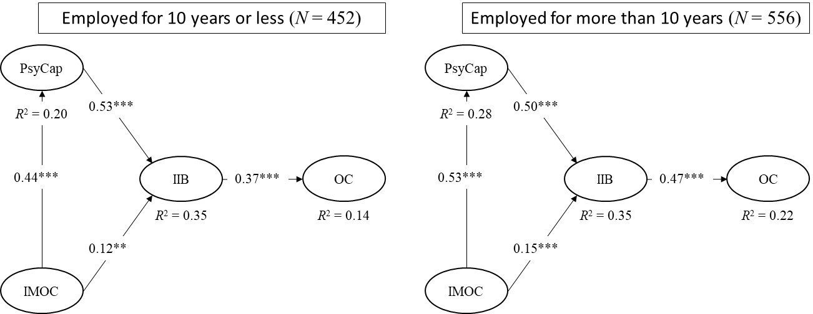

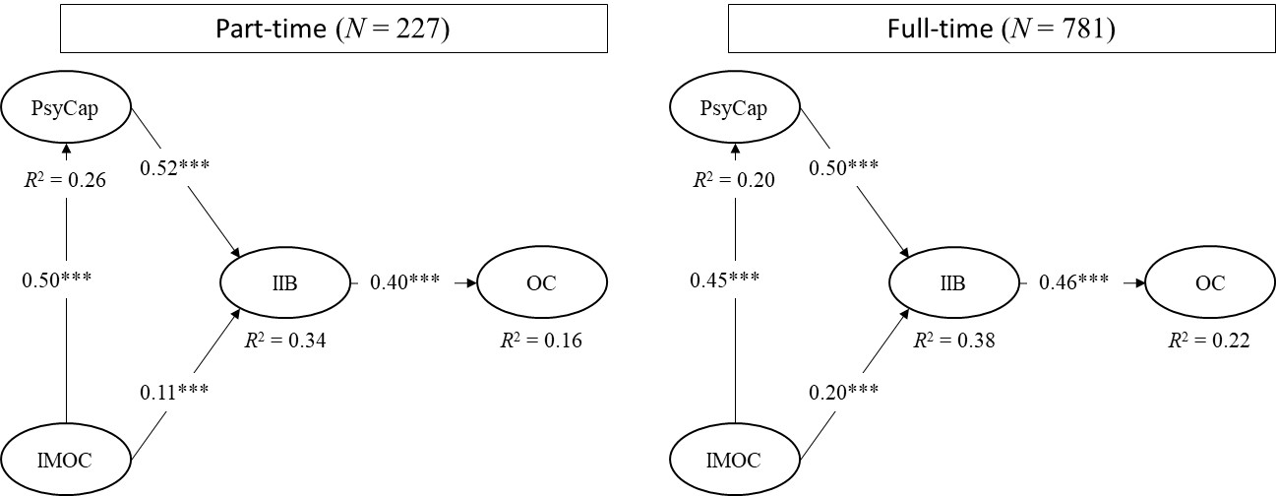

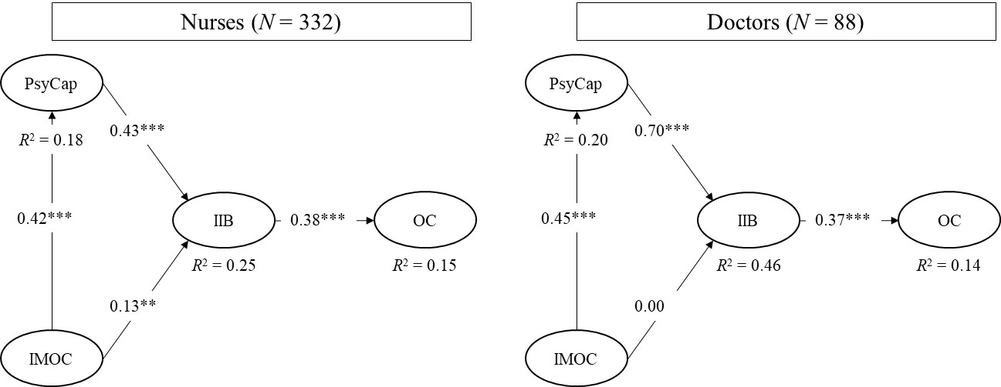

Fig. A1. Multigroup analysis of : 1) number of years employed at the hospital (upper panel); 2) part-time or full-time (in the middle); and 3) occupation type (lower panel) (** <0.05, *** <0.01)

