Additional files
Annex tables and figures

Table A1. General characteristics of main sources of data in West and Central Africa countries
Country | Latest census  Year | Latest household survey |  |  |  | Latest RHIS data
Country | Latest census  Year | Survey-Year | Number of households | Number of sub-national units | Year |  | Number of administrative units
Benin | 2013 | DHS-2017/18 | 14156 | 12 Departments | 2018 |  | 22 Districts
Burkina Faso | 2006 | DHS-2010 | 14424 | 13 Regions | 2018 |  | 34 Districts
Cabo Verde | 2010 | DHS-2005 | 5712 | 12 Islands/ Municipalities | 2018 |  | 70 Districts
Cameroon | 2005 | DHS-2018 | 11710 | 12 Regions | 2018 |  | 180 Districts
CAR | 2003 | MICS-2010 | 11756 | 17 Prefectures | 2018 |  | 16 Districts
Chad | 2009 | DHS-2014/15 | 17233 | 21 Regions | - |  | -
Congo | 2007 | MICS-2014/15 | 12811 | 12 Departments | 2018 |  | 12 Regions
Cote d'Ivoire | 2014 | MICS-2016 | 11879 | 11 Regions | 2018 |  | 81 Districts
DRC | 1984 | MICS-2017/18 | 20792 | 26 Provinces | 2018 |  | 519 Districts
Gabon | 2013 | DHS-2012 | 9755 | 10 Provinces | 2018 |  | 51 Districts
Ghana | 2010 | MICS-2017/18 | 12886 | 10 Regions | 2018 |  | 260 Districts
Guinea | 2014 | DHS-2018 | 7912 | 8 Regions | 2018 |  | 38 Regions
Guinea-Bissau | 2009 | MICS-2014 | 6601 | 9 Regions | 2018 |  | 111 Districts
Liberia | 2008 | DHS-2013/14 | 9333 | 15 Counties | 2018 |  | 92 Districts
Mali | 2009 | DHS-2018 | 9510 | 9 Regions | 2018 |  | 74 Districts
Niger * | 2012 | DHS-2012 | 10750 | 8 Regions | 2018 |  | 72 Districts
Nigeria | 2006 | DHS-2018 | 40427 | 37 States | 2018 |  | 145 Districts
Senegal † | 2013 | DHS-2016/17/18 | 17409 | 14 Regions | 2018 |  | 77 Districts
Sierra Leone | 2015 | MICS-2017 | 15309 | 14 Districts | 2018 |  | 14 Districts
Togo | 2010 | MICS-2017 | 7916 | 7 Regions | 2018 |  | 41 Districts
Median | 2010 | 2017 | 11818 | 12 | 2018 |  | 72
* DHS 2017, but report not released and data not distributed
† Continuous DHS

Table A2. List of coverage indicators available from the RHIS data analyzed
Category | Indicator | Definition
Maternal health | Antenatal care from a health facility (ANC1) | Proportion of pregnant women who had at least one contact with a health facility during a calendar year for reasons related to antenatal care
Maternal health | Institutional delivery | Proportion of women who had a live birth in a health facility during a calendar year
Child health | BCG immunization | Proportion of infants born during a calendar year who received one dose of Bacille de Calmette and Guerin (BCG) vaccine in a health facility
Child health | Penta/DPT3 immunization | Proportion of infants born during a calendar year who received three doses of Pentavalent/diphtheria-pertussis-tetanus vaccine in a health facility
Child health | Measles immunization | Proportion of infants born during a calendar year who received one dose of measles vaccine in a health facility

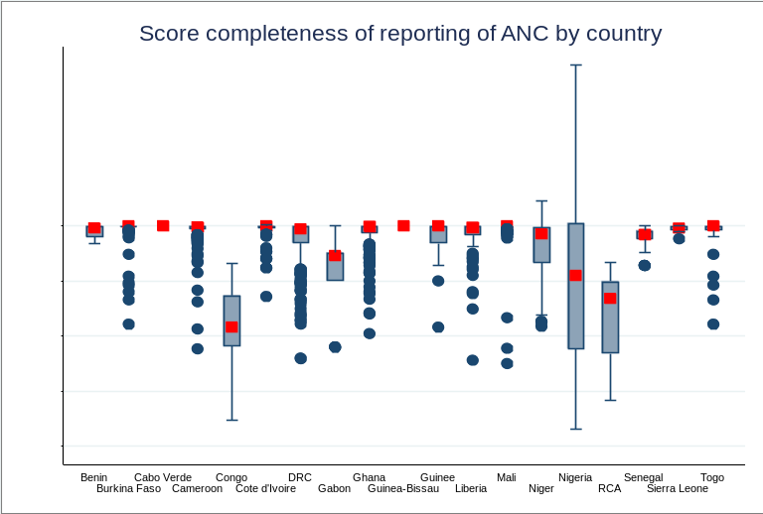 | 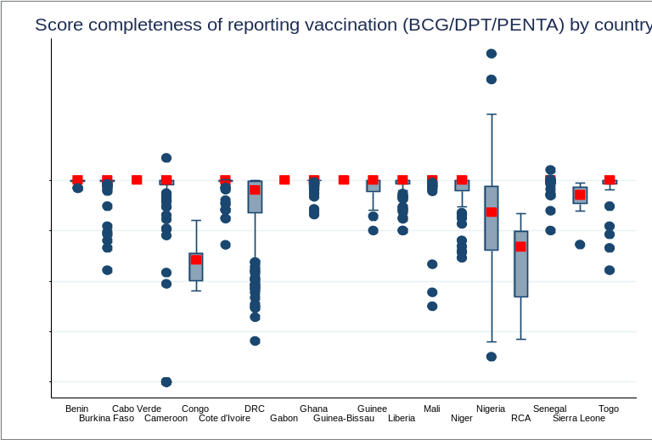
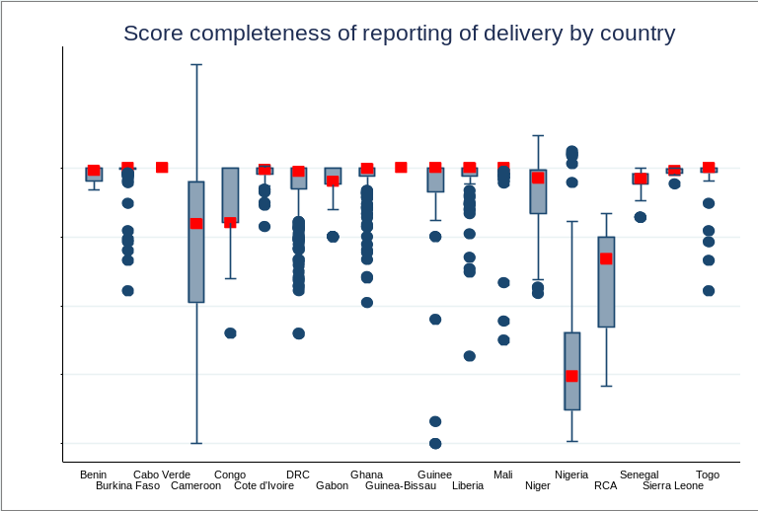 | 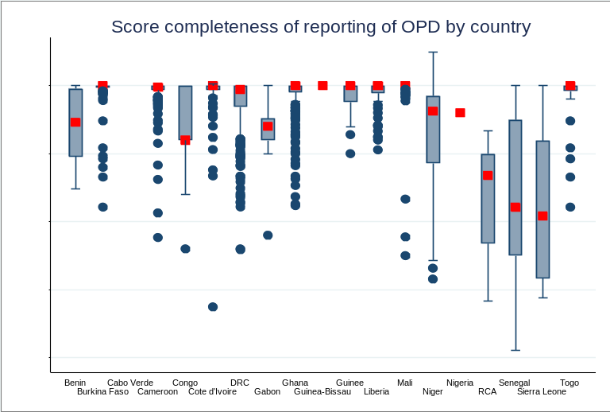
Red dots correspond to median scores of completeness of reporting
Figure A1. Median score of completeness of reporting (%) of ANC, vaccination, institutional delivery and OPD

Table A3. Percentage of districts with good consistency of reported data in 2018 compared to the 3 preceding years
Country | CPN1 | DTP1 | OPD | Average score
Country | % districts with good consistency (Z-score<2) | % districts with good consistency (Z-score<2) | % districts with good consistency (Z-score<2) | % districts with good consistency (Z-score<2)
Benin | 41 | 53 | 41 | 45
Burkina | 56 | 70 | 78 | 68
Cabo Verde | 30 | 50 |  | 40
CAR | - | 47 | - | 47
Cameroun | 52 | 4 | 59 | 38
Congo | 100 | 25 |  | 63
Cote d'Ivoire | 51 | - | 73 | 62
DRC | - | - | - | -
Gabon | 73 | 50 | 41 | 55
Ghana | 52 | 52 | 48 | 51
Guinea | 5 | 8 | 45 | 19
Guinea-Bissau | 78 | - | 55 | 66
Liberia | 52 | 71 | 69 | 64
Mali | - | - | 57 | 57
Niger | 32 | 49 | 25 | 35
Nigeria | 51 | 62 | 56 | 56
Senegal | 71 | 51 | 66 | 63
Sierra Leone | 29 | 36 | 71 | 45
Togo | 49 | 73 | 76 | 66
Median | 51 | 50 | 57 | 55
Color scale indicates good data quality for dark green color while light green color corresponds to poor data quality.

Table A4. Numerator internal consistency: Difference between ratio of expected and ratio of reported for ANC1 & DPT1 and DPT3 (%)
Country | Difference ratio 2018 |  | Percentage districts difference ratio ANC1 - DPT1 |  |  | Percentage districts difference ratio DPT1 - DPT3 |  |  | Average score difference ratio ANC1 - DPT1 & difference ratio DPT1 - DPT3
Country | ANC1 - DPT1 | DPT1 - DPT3 | more or equal to 15% | in-between 5-15% | less or equal to 5% | more or equal to 15% | in-between 5-15% | less or equal to 5% | less than 15%
Benin | 23 | 7 | 71 | 18 | 12 | 35 | 21 | 44 | 47
Burkina Faso | 5 | 2 | 37 | 41 | 21 | 0 | 23 | 77 | 81
Cabo Verde |  |  | 59 | 23 | 18 | 9 | 32 | 59 | 66
CAR | 5 | 113 | 92 | 0 | 8 | 100 | 0 | 0 | 4
Cameroon | 23 | 0 | 72 | 17 | 11 | 18 | 46 | 37 | 55
Congo | 79 |  | 100 | 0 | 0 | 91 | 9 | 0 | 5
Cote d'Ivoire | 2 | 28 | 52 | 31 | 17 | 77 | 17 | 6 | 36
DRC | - | - | - | - | - | - | - | - | -
Gabon | 9 | 6 | 77 | 14 | 9 | 37 | 37 | 25 | 43
Ghana | 25 | 9 | 62 | 24 | 14 | 24 | 52 | 24 | 57
Guinea | 46 | 62 | 89 | 3 | 8 | 100 | 0 | 0 | 5
Guinea-Bissau | 7 | 1 | - | - | - | - | - | - | -
Liberia | 15 | 22 | 69 | 22 | 9 | 77 | 12 | 11 | 27
Mali | 40 | 15 | 85 | 8 | 7 | 65 | 26 | 9 | 25
Niger | 24 | 19 | 78 | 18 | 4 | 58 | 22 | 19 | 32
Nigeria | 198 | 76 | 100 | 0 | 0 | 100 | 0 | 0 | 0
Senegal | 39 | 2 | 88 | 5 | 7 | 4 | 39 | 57 | 54
Sierra Leone | 4 | 5 | 21 | 57 | 21 | 7 | 43 | 50 | 86
Togo | 8 | 1 | 41 | 39 | 20 | 0 | 22 | 78 | 79
Median | 23 | 8 | 72 | 18 | 9 | 37 | 22 | 24 | 43
Color scale indicates good data quality for green color while red color corresponds to poor data quality.

Table A5. ANC1 Coverage estimates from household survey and absolute difference of ANC1 coverage estimates using RHIS data with the household survey coverage estimates
 | Coverage estimates from household survey, 2017 MICS (%) |  |  | Absolute difference of RHIS coverage estimates from survey estimates, using the different methods for calculating denominators (%)
Country | Estimate | SE | 95% CI | Birth-method | CBR- method | BCG-method | DPT1-method
Bo | 99.1 | 0.5 | [97.2-99.7] | 28.3 | 29.2 | -4.3 | 34.6
Bombali | 98.7 | 0.9 | [94.8-99.7] | -22.2 | -34.7 | -13.7 | -5.1
Bonthe | 96.3 | 1.3 | [92.8-98.2] | 15.6 | 20.2 | 10.9 | 10.0
Kailahun | 99.2 | 0.5 | [97.5-99.7] | -22.5 | -28.0 | -18.8 | -12.9
Kambia | 94.6 | 1.4 | [91.2-96.8] | 5.8 | 2.8 | 2.6 | -0.9
Kenema | 98.5 | 0.8 | [95.6-99.5] | 26.5 | 15.9 | -12.2 | 3.9
Koinadugu | 92.9 | 2.6 | [86.0-96.6] | 9.2 | -17.0 | 11.2 | -11.0
Kono | 99.2 | 0.5 | [97.4-99.8] | -23.9 | -32.2 | 6.1 | 3.2
Moyamba | 95.5 | 1.2 | [92.6-97.4] | 16.3 | 37.6 | -14.5 | 4.0
Port Loko | 94.2 | 1.8 | [89.5-96.9] | -2.4 | -7.5 | -6.7 | 8.0
Pujehun | 98.8 | 0.8 | [95.8-99.7] | 13.2 | 8.2 | -14.8 | 0.7
Tonkolili | 95.3 | 1.5 | [91.3-97.5] | 34.4 | 25.6 | 3.7 | 7.1
Western Rural | 98.5 | 0.7 | [96.1-99.4] | 43.0 | 33.9 | 4.3 | 8.6
Western Urban | 97.1 | 1.1 | [94.1-98.6] | -1.0 | -22.6 | -30.8 | -29.0
Total | 97.1 | 0.3 | [96.4-97.7] | 7.4 | -2.5 | -9.1 | -1.4

SE: Standard errors; 95% CI: 95% confidence interval
Color scale indicates good agreement (lower difference) for green color while orange color corresponds to poor agreement (higher difference). Dark green corresponds to difference between RHIS estimates and survey estimates less than 5%, light green 5-9%, yellow 10-19%, and orange 20% and more.

Table A6. Institutional delivery coverage estimates from household survey and absolute difference of ANC1 coverage estimates using RHIS data with the household survey coverage estimates
 | Coverage estimates from household survey, 2017 MICS (%) |  |  | Absolute difference of RHIS coverage estimates from survey estimates, using the different methods for calculating denominators (%)
Country | Estimate | SE | 95% CI | Birth-method | CBR- method | BCG-method | ANC1-method | DPT1-method
Bo | 96.4 | 1.1 | [93.5-98.0] | 20.9 | 21.7 | -9.2 | -6.0 | 26.7
Bombali | 76.7 | 3.5 | [69.2-82.9] | 10.3 | -3.9 | 19.9 | 31.8 | 29.8
Bonthe | 91.8 | 2.6 | [84.9-95.7] | -4.9 | -1.3 | -8.5 | -15.5 | -9.2
Kailahun | 93.9 | 2.4 | [87.3-97.1] | -7.1 | -13.4 | -3.0 | 17.8 | 3.8
Kambia | 53.9 | 5.1 | [43.8-63.7] | 42.5 | 39.6 | 39.4 | 37.7 | 36.0
Kenema | 91.0 | 2.8 | [83.7-95.2] | 32.2 | 21.8 | -5.9 | 6.3 | 10.0
Koinadugu | 76.4 | 5.0 | [65.3-84.7] | 10.0 | -12.2 | 11.7 | 4.3 | -7.1
Kono | 74.6 | 5.1 | [63.4-83.2] | -15.1 | -21.7 | 8.6 | 3.4 | 6.3
Moyamba | 60.3 | 7.0 | [46.2-72.9] | 66.1 | 90.2 | 31.3 | 50.8 | 52.2
Port Loko | 56.5 | 3.8 | [48.9-63.8] | 34.0 | 29.0 | 29.7 | 37.5 | 44.3
Pujehun | 92.3 | 3.1 | [83.4-96.6] | 33.9 | 28.2 | 2.3 | 18.3 | 19.8
Tonkolili | 61.4 | 4.9 | [51.5-70.4] | 51.4 | 43.7 | 24.7 | 21.6 | 27.6
Western Rural | 67.0 | 5.6 | [55.3-77.0] | 26.7 | 20.7 | 1.1 | -1.6 | 3.9
Western Urban | 79.8 | 2.7 | [73.9-84.6] | -17.6 | -31.6 | -36.9 | -15.9 | -35.7
Total | 76.2 | 1.1 | [74-78.4] | 18.3 | 9.3 | 3.4 | 11.9 | 10.3

SE: Standard errors; 95% CI: 95% confidence interval
Color scale indicates good agreement (lower difference) for green color while orange color corresponds to poor agreement (higher difference). Dark green corresponds to difference between RHIS estimates and survey estimates less than 5%, light green 5-9%, yellow 10-19%, and orange 20% and more.

Table A7. DPT3 Coverage estimates from household survey and absolute difference of DPT3 coverage estimates using RHIS data with the household survey coverage estimates
 | Coverage estimates from household survey, 2017 MICS (%) |  |  | Absolute difference of RHIS coverage estimates from survey estimates, using the different methods for calculating denominators (%)
Country | Estimate | SE | 95% CI | Birth-method | CBR- method | BCG-method | ANC1-method | DPT1-method
Bo | 95.8 | 1.3 | [92.4-97.7] | -10.8 | -10.2 | -32.5 | -30.2 | -6.5
Bombali | 89.6 | 3.0 | [82.0-94.2] | -19.8 | -31.2 | -12.1 | -2.6 | -4.2
Bonthe | 85.8 | 3.7 | [77.1-91.6] | 8.6 | 12.5 | 4.7 | -2.9 | 3.9
Kailahun | 94.0 | 2.2 | [88.1-97.1] | -9.9 | -16.0 | -5.9 | 14.2 | 0.7
Kambia | 69.9 | 5.0 | [59.2-78.8] | 20.2 | 17.5 | 17.3 | 15.7 | 14.2
Kenema | 91.6 | 2.8 | [84.1-95.8] | 21.2 | 11.6 | -13.7 | -2.5 | 0.8
Koinadugu | 81.8 | 4.1 | [72.4-88.6] | 24.2 | -3.0 | 26.3 | 17.3 | 3.2
Kono | 84.6 | 2.8 | [78.2-89.3] | -20.3 | -27.4 | 5.2 | -0.4 | 2.8
Moyamba | 84.1 | 4.2 | [74.1-90.7] | 19.3 | 39.0 | -9.2 | 6.7 | 7.9
Port Loko | 77.8 | 3.5 | [70.2-83.9] | -6.1 | -10.1 | -9.5 | -3.3 | 2.1
Pujehun | 99.2 | 0.6 | [96.7-99.8] | 4.2 | -0.4 | -21.6 | -8.5 | -7.3
Tonkolili | 77.3 | 3.6 | [69.5-83.6] | 30.1 | 22.8 | 4.6 | 1.7 | 7.4
Western Rural | 70.5 | 5.2 | [59.3-79.7] | 43.9 | 36.6 | 12.6 | 9.3 | 16.1
Western Urban | 85.8 | 3.8 | [76.7-91.8] | 31.8 | 5.3 | -4.7 | 34.9 | -2.5
Total | 84.9 | 1.0 | [82.8-86.7] | 10.0 | 1.0 | -5.0 | 3.6 | 2.0

SE: Standard errors; 95% CI: 95% confidence interval
Color scale indicates good agreement (lower difference) for green color while orange color corresponds to poor agreement (higher difference). Dark green corresponds to difference between RHIS estimates and survey estimates less than 5%, light green 5-9%, yellow 10-19%, and orange 20% and more.

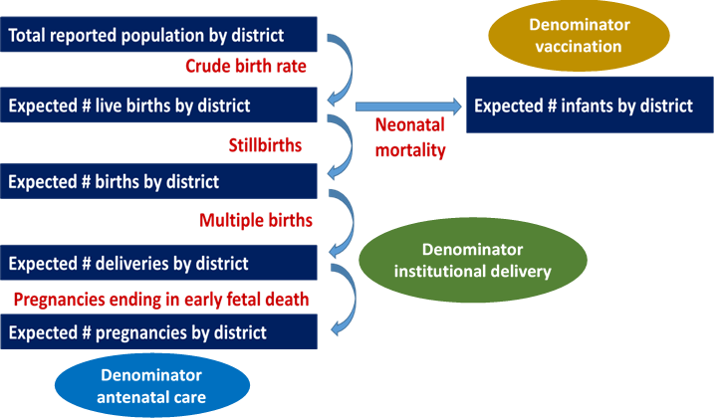

Figure A2. Summary of the steps of denominators calculation from census-based methods

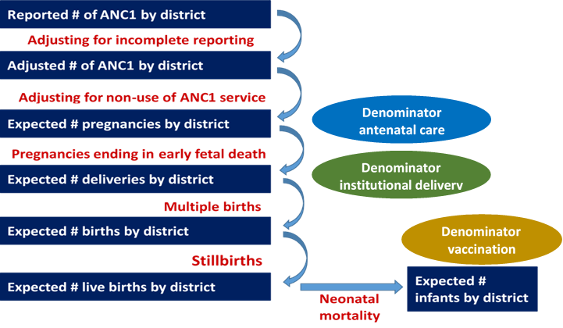

Figure A3. Summary of the steps of denominators calculation from health service-based method using the example of ANC1 data

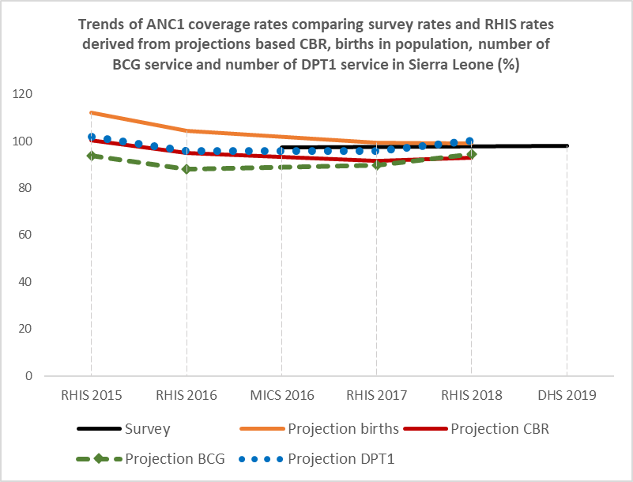
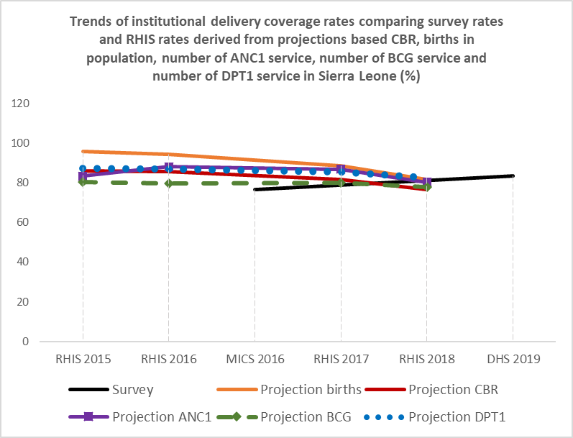
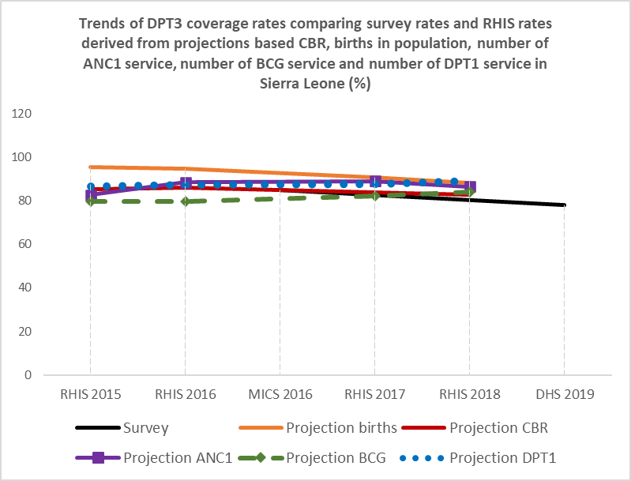

Figure A4. Trends of ANC1, institutional delivery and DPT3 coverage rates comparing survey rates and RHIS rates derived from projections based CBR, births in population, number of ANC1 service, number of BCG service and number of DPT1 service in Sierra Leone (%)

