Supplementary file: Appendix

Designing a stakeholder-inclusive service model for an eHealth service to support older adults in an active and social life
Marijke Broekhuis* ^{a,b} (m.broekhuis@rrd.nl), Marit Dekker-van Weering^{c}, Cheyenne Schuit^{d} (schuit@innoboost.nl), Stefan Schürz ^{e} (stefan.schuerz@lifetool.at) and Lex van Velsen ^{a,b} (l.vanvelsen@rrd.nl)
ª Roessingh Research and Development, eHealth group, Roessinghsbleekweg 33b, 7522AH Enschede, the Netherlands
^{b} Biomedical Signals and Systems, Faculty of Electrical Engineering, Mathematics and Computer Science (EEMCS), University of Twente, Enschede, the Netherlands
^{c} TSN Thuiszorg Groningen
^{d} National Foundation for the Elderly, Smallepad 30e, 3811 MG Amersfoort, the Netherlands
^{e} LIFEtool gemeinnützige GmbH, Linz, Austria
* Corresponding author

Appendix A: Personas
Persona | Demographics | Behaviours | Needs and goals
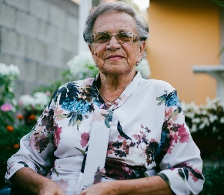  Jenny  (Photo by Damir Bosnjak on Unsplash) | - 72 years old  - Married, 2 kids  - Lives in small village  - Low digital literacy | Jenny is strongly focused on her family and calls her kids regularly. She likes gardening and baking. | She has problems with her hip and back and needs physiotherapy. She wants to become more active and adopt a healthier lifestyle
  Marcus  (Photo by Oliver Cole on Unsplash) | - 75 years old  - Divorced, 1 son  - Lives in small village  - Low digital literacy | Marcus does not like to exercise. He is a big soccer fan and spends large parts of the day watching TV. He is a heavy smoker and is suspicious of doctors and therapists. | Marcus has COPD for some time now. He is physically limited but wants to remain independent. He also wants to have more social contacts.
  Wendy  (Photo by Brian Mercado on Unsplash) | - 28 years old  - Physiotherapist  - Single  - Lives and works in the city (own practice)  - High digital literacy | Wendy loves her job and is always open to new ideas. She is a sporty person and likes travelling and dancing. | She is always looking for ways to improve therapy and believes ICT solutions could help to improve the workflow or to improve motivation and compliance of her clients.

Appendix B: Illustrations from service model story board

