SUPPLEMENTARY MATERIAL
Sex differences in direct healthcare costs following stroke: A population-based cohort study

Amy Y X Yu MD MSc^{1,2,3}, Murray Krahn MD MSc^{2,3,4,5}, Peter C Austin PhD^{2,3}, Mohammed Rashid MSc², Jiming Fang PhD², Joan Porter MSc², Manav V Vyas MBBS MSc^{1,2,3}, Susan E Bronskill PhD^{2,3}, Eric E Smith MD MPH⁶, Richard H. Swartz MD PhD^{1,2}, Moira K Kapral MD MSc^{2,3,4}

¹Department of Medicine (Neurology), University of Toronto, Sunnybrook Health Sciences Centre, Toronto, Ontario, Canada, ²ICES, Toronto, Ontario, Canada, ³Institute of Health Policy, Management, and Evaluation, University of Toronto, ⁴Department of Medicine (General Internal Medicine), University of Toronto-University Health Network, Toronto, Ontario, Canada, ⁵Toronto Health Economics and Technology Assessment, Toronto, Ontario, Canada, ⁶Department of Clinical Neurosciences, Community Health Sciences, and Hotchkiss Brain Institute, University of Calgary, Calgary, Alberta, Canada.

Supplemental Table I Administrative health data sources
Database | Full database name | Description
DAD | Discharge Abstract Database | Inpatient hospitalization data
NACRS | National Ambulatory Care Reporting System | Emergency department data
NRS | National Rehabilitation Reporting System | Rehabilitation data
CCRS | Continuing Care Reporting System | Complex continuing care
CCRS-LTC | Continuing Care Reporting System Long-Term Care | Long-term care data
HCD | Ontario home care database | Home-care data
OHIP | Ontario Health Insurance Plan | Outpatient physician billings data
ODBP | Ontario Drug Benefit Program | Pharmacy data
NDFP | New Drug Funding Program | Chemotherapy drugs
RPDB | Ontario Registered Persons Database | Mortality data

Supplemental Table II Case definitions for covariates
Covariate | Database | Case definition
Age | Registered Persons Database | Age
Stroke type | Discharge Abstract Database | Ischemic stroke: H34.1, I63.x, I64.x  Intracerebral hemorrhage: I61.x
Diabetes | Discharge Abstract Database  Ontario Health Insurance Plan  Ontario Drug Benefit Program | ≥2 outpatient claims (ICD-9 250) in a one-year period  or  ≥1 hospitalization (ICD-10-CA E10, E11, E13, E14)  or  ≥1 diabetes drug claim in a one-year period
Hypertension | Discharge Abstract Database  Ontario Health Insurance Plan | ≥1 hospitalization (ICD-10-CA I10.x, I11.x, I12.x, I13.x, or I15.x) or  ≥2 outpatient claims (ICD-9 401.x, 402.x, 403.x, 404.x, or 405.x) in a two-year period  or  1 outpatient claim followed by 1 outpatient/hospitalization within two years
Dyslipidemia | Ontario Health Insurance Plan | 2 outpatient claims (ICD-9 272) in 2 years
Atrial fibrillation | Discharge Abstract Database  Ontario Health Insurance Plan  National Ambulatory Care Reporting System | 1 hospitalization or 1 emergency department visit (ICD-10-CA I48)  or  4 outpatient claims (ICD-9 427) in a 1-year period
Coronary artery disease | Discharge Abstract Database  Same Day Surgery Database | ICD10-CA I21, I22  or  CCI 1IJ50, 1IJ57GQ, 1IJ54, or 1IJ76
Peripheral vascular disease | Discharge Abstract Database  Same Day Surgery Database | ICD-10-CA I713, I714, I702, I739, I743, or I744  or  CCI 1JE57, 1JE50, or 1JE87
ICD-9 International classification of diseases, ninth revision, ICD-10-CA – International classification of diseases, tenth revision, Canada, CCI – Canadian Classification of Health Interventions

Supplemental Table III Mean ± standard deviation of direct healthcare costs in the one-year pre-stroke, the one-year post-stroke, and the differences in cost (post-stroke minus pre-stroke) by sex

 | Female  n=49,419 |  | Male  n=51,833 |  | p-value
 | Pre-stroke | Post-stroke | Pre-stroke | Post-stroke
Acute care | 4,557 ± 14,380 | 22,033 ± 30,811 | 4,138 ± 14,010 | 22,745 ± 36,868
Mean difference in cost | 17,476 ± 32,903 |  | 18,606 ± 38,330 |  | <0.001
Outpatient care | 6,333 ± 11,883 | 9,547 ± 10,560 | 5,968 ± 12,155 | 10,195 ± 11,570
Mean difference in cost | 3,214 ± 11,749 |  | 4,227 ± 12,333 |  | <0.001
Rehabilitation | 504 ±  3,657 | 8,964 ± 15,764 | 403 ±  3,640 | 9,698 ± 16,525
Mean difference in cost | 8,460 ± 16,163 |  | 9,295 ± 16,874 |  | <0.001
Homecare services | 1,812 ± 5,244 | 3,140 ± 7,134 | 1,051 ± 4,120 | 2,411 ± 6,092
Mean difference in cost | 1,328 ± 7,708 |  | 1,361 ± 6,456 |  | 0.459
Complex and continuing services | 484 ±  6,220 | 6,152 ± 24,823 | 350 ±  5,805 | 5,668 ± 24,725
Mean difference in cost | 5,667 ± 25,166 |  | 5,319 ± 24,910 |  | 0.027
Long-term care | 2,265 ± 9,247 | 4,176 ± 11,551 | 917 ±  5,889 | 2,111 ± 8,098
Mean difference in cost | 1,911 ± 12,252 |  | 1,194 ± 8,232 |  | <0.001
Total cost | 15,956 ± 27,928 | 54,012 ± 54,766 | 12,827 ± 26,589 | 52,829 ± 59,955
Mean difference in cost | 38,056 ± 58,774 |  | 40,002 ± 62,328 |  | <0.001

Supplemental Table IV Mean ± standard deviation of direct healthcare costs in the one-year post-stroke by sex and by survival.
 | Died within 1 year  n=27,252 |  | Alive at 1 year  n=74,000
 | Women  n=14,910 | Men  n=12,342 | Women  n=34,509 | Men  n=39,491
Acute care | 23,802 ± 31,593 | 28,417 ± 41,491 | 21,269 ± 30,436 | 20,972 ± 35,113
Outpatient care | 5,958 ± 7,852 | 7,284 ± 9,513 | 11,098 ± 11,185 | 11,105 ± 11,998
Rehabilitation | 3,385 ± 10,393 | 4,382 ± 12,037 | 11,374 ± 17,028 | 11,359 ± 17,365
Homecare services | 1,475 ± 4,946 | 1,345 ± 4,276 | 3,859 ± 7,784 | 2,745 ± 6,522
Complex and continuing services | 3,617 ± 15,510 | 4,036 ± 17,345 | 7,247 ± 27,830 | 6,178 ± 26,595
Long-term care | 1,915 ± 6,495 | 1,210 ± 5,232 | 5,153 ± 13,026 | 2,393 ± 8,785
Total cost | 40,152 ± 46,541 | 46,673 ± 57,382 | 60,000 ± 56,926 | 54,753 ± 60,610

Supplemental Table V Regression coefficients for each covariate of the generalized linear model with a gamma distribution and a log link function

Variable | Regression coefficient
Intercept | 10.3394
sex=F | 0.0384
age † | 0.0010
age' † | 0.0066
age'' † | -0.0498
age''' † | -0.0080
sex=F * age † | -0.0010
sex=F * age' † | 0.0019
sex=F * age'' † | -0.0049
sex=F * age''' † | -0.0480
Hypertension | 0.0523
Diabetes | 0.1052
Atrial fibrillation | -0.0427
Dyslipidemia | -0.0239
History of stroke | -0.0347
Coronary artery disease | -0.0584
Peripheral vascular disease | 0.0083
Intermediate frailty (score 5-15) | 0.4584
High frailty (>15) | 0.6485
Income quintile
Second to highest | 0.0025
Middle | 0.0074
Second to lowest | 0.0282
Lowest | 0.0612
Rural residence | -0.1052
Intracerebral hemorrhage | 0.0727
Moderate stroke | 0.1579
Severe stroke | 0.2537
Pre-stroke cost (per $1,000) | 0.0012

† Represent the component terms in the restricted cubic spline model that accounts for the interaction between age and sex
Supplemental Figure I Distribution of the overall direct healthcare cost in the year following stroke by sex

Supplemental Figure II Adjusted one-year survival stratified by sex from the proportional hazard models
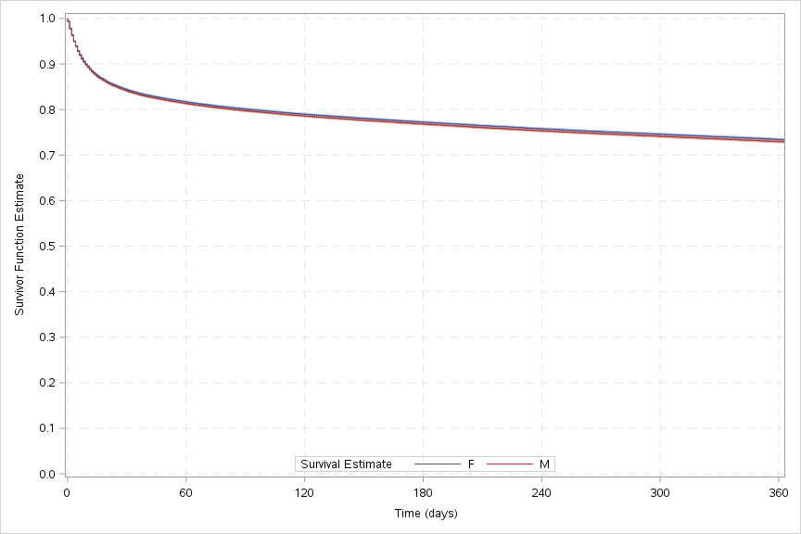

Adjusted hazard ratio and 95% confidence intervals for one-year all-cause mortality: 0.98 [0.95,1.00]. Adjusted for age, income quintile, rurality, hypertension, diabetes, atrial fibrillation, dyslipidemia, history of stroke, coronary artery disease, peripheral vascular disease, frailty, stroke type, and stroke severity

Supplemental Figure III Adjusted relative cost ratio of mean total healthcare costs comparing female to male by age (shaded area represents confidence band) among people who died within the first year
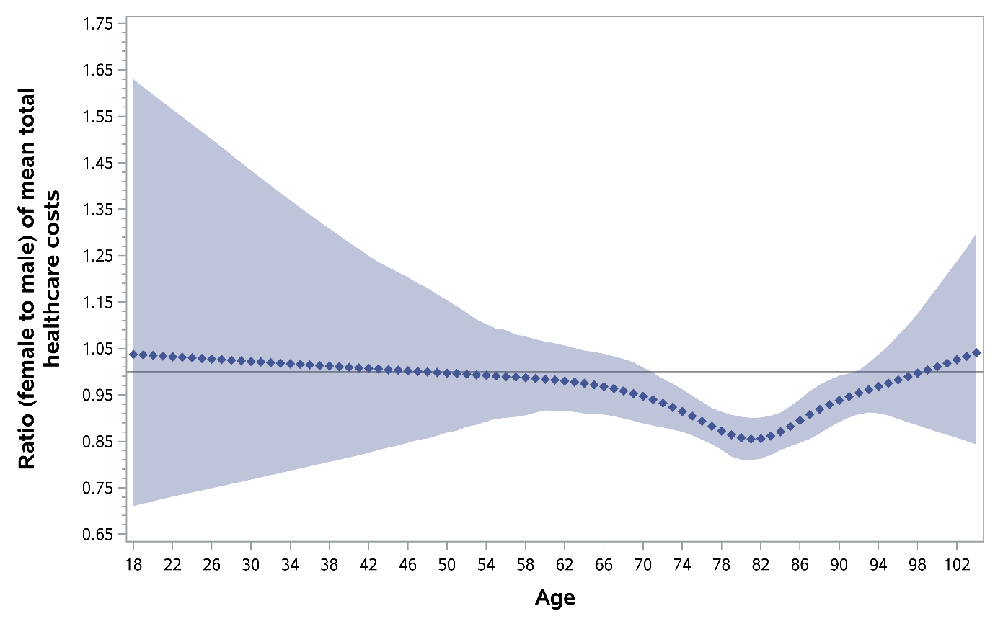

Supplemental Figure IV Adjusted relative cost ratio of mean total healthcare costs comparing female to male by age (shaded area represents confidence band) among people who survived the first year
