Supplementary materials

Difficulties encountered by public health workers in COVID-19 outbreak: a cross-sectional study based on five provinces

Zhicheng Du ^{1#}, Hua You ^{2#}, Huan Zhou ³, Xiaohui Wang ⁴, Jingdong Xu ⁵, Yan Li ⁶, Shan Li ⁷, Lina Ma ⁵, Jing Gu ^{1*}, Yuantao Hao ¹

¹School of Public Health, Global Health Institute, Sun Yat-sen University; Key Laboratory of Tropical Disease Control (Sun Yat-sen University), Ministry of Education, Guangzhou 510080
²School of Public Health, Nanjing Medical University, Nanjing 210000
³West China School of Public Health, No. 4 West China Teaching Hospital, Sichuan University, Chengdu 610000
⁴School of Public Health, Lanzhou University, Lanzhou 730000
⁵Hubei Center for Disease Control and Prevention, Wuhan 430097
⁶Guangzhou Center for Disease Control and Prevention, Guangzhou 510440
⁷Zigong Center for Disease Control and Prevention, Zigong 643000
#Zhicheng Du and Hua You have equal contributions
*Corresponding author: Jing Gu, Email: gujing5@mail.sysu.edu.cn

Table S1. Questionnaire on difficulties encountered by public health workers in COVID-19 outbreak.
1. Basic Information
1.1 Sex: □Male □Female
1.2 Age: ____ years
1.3 Do you have children? □No □Yes
if yes: How old is your youngest child? □Primary school and below □Junior high school and above
1.4 What’s your job title? □Primary and below □Intermediate □Advanced
2. What difficulties have you encountered in your work on the epidemic?
2.1 Resources shortage (multiple choice): □Protective equipment □Self-skill □Manpower □Funding □Reagents
if “Protective equipment” (multiple choice): □N95 mask □Surgical masks for medical use □Protective clothing □Medical goggles □Medical alcohol □Epidural gun □Medical gloves
2.2 Data processing (multiple choice): □Excessive documentation □Cumbersome and time-consuming data filling □Cumbersome and time-consuming work accounts □Time-consuming transmission of information □Inconvenient transmission of documents
2.3 Communication and coordination (multiple choice): □Poor inter-agency coordination □Poor intra-departmental coordination □Unclear assignments from superiors □Unclear overtime incentive system
2.4 Target audiences (multiple choice): □Uncooperative □Verbal abuse/intimidation by work targets □Concerns about survey reliability
3. Do you have any trouble with the following aspects of your work on the epidemic? To what extent?
3.1 Being treated differently at work: □None □Few □Medium □Often □Very often
3.2 Feeling aggrieved at work: □None □Few □Medium □Often □Very often
3.3 Family members not understanding: □None □Few □Medium □Often □Very often
3.4 Worrying about routine work outside of the epidemic: □None □Few □Medium □Often □Very often

Figure S1. The geographic locations of the five provinces.

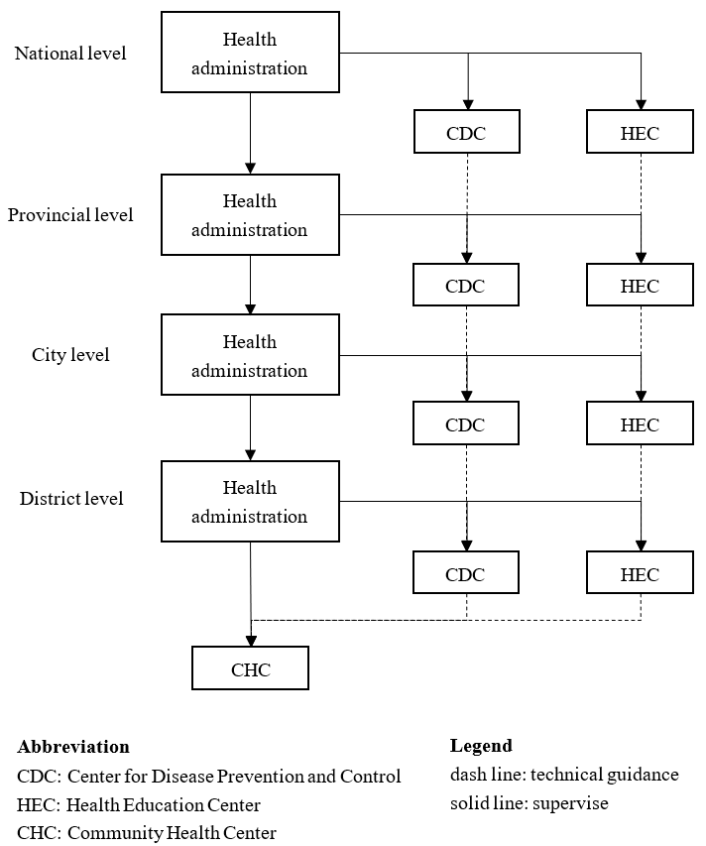
Figure S2. The relationship bewteen different levels and types health institutes in China.

