Supplementary Material

Additional File 1 (Diagram)

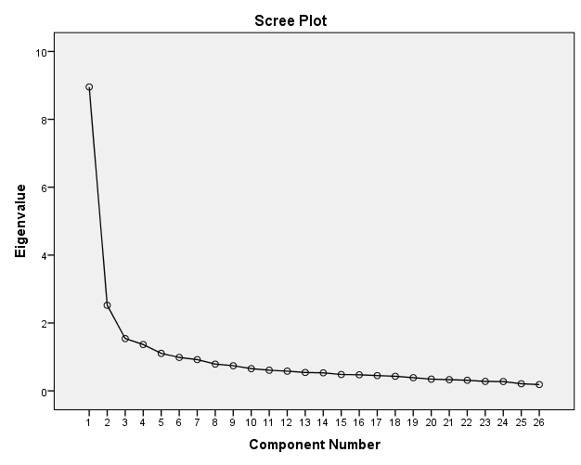
Fig. 1: Scree plot of principal component analysis of questionnaire between eigenvalue and principal components (factors)

