Supplementary material
Table S1: Anatomical Therapeutic Chemical classifications with their defined daily dose (N), revenue (Euro), weighted average price (Euro) by patent status between 1/2017 and 2/2019
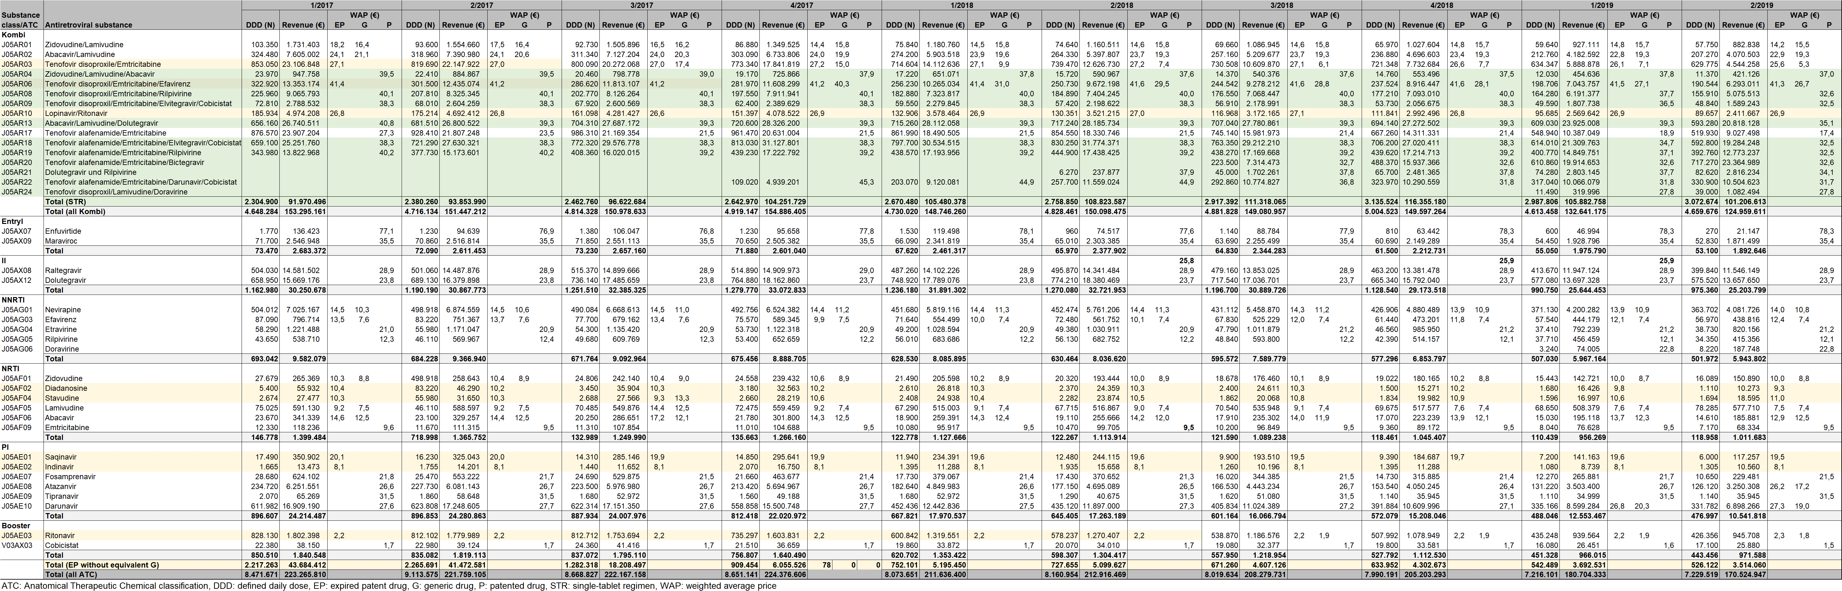
Table S2: Cost-savings (Euro, % of revenue) through the distribution of generic antiretroviral drugs between 1/2017 and 2/2019
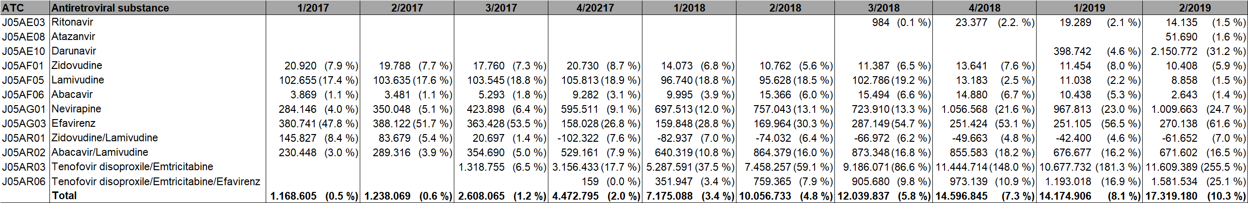

Table S3: Potential cost-savings (Euro, % of revenue) through the maximum possible use of generic antiretroviral drugs between 1/2017 and 2/2019
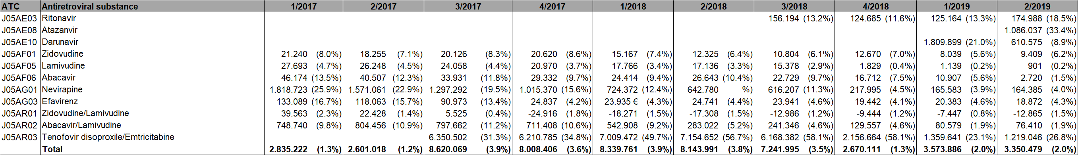
Table S4: Potential cost-savings (Euro, % of revenue) through the splitting of single-tablet regimens and replacing all substance partners with generic antiretroviral drugs between 1/2017 and 2/2019
Table S5: Potential cost-savings (Euro, % of revenue) through replacing patented tenofovir alafenamide/emtricitabine with generic tenofovir disoproxil/emtricitabine between 1/2017 and 2/2019

