Additional file 1
Supplementary figure 1: Overview of predictors included in the inpatient fall risk adjustment model and their corresponding odds ratios.
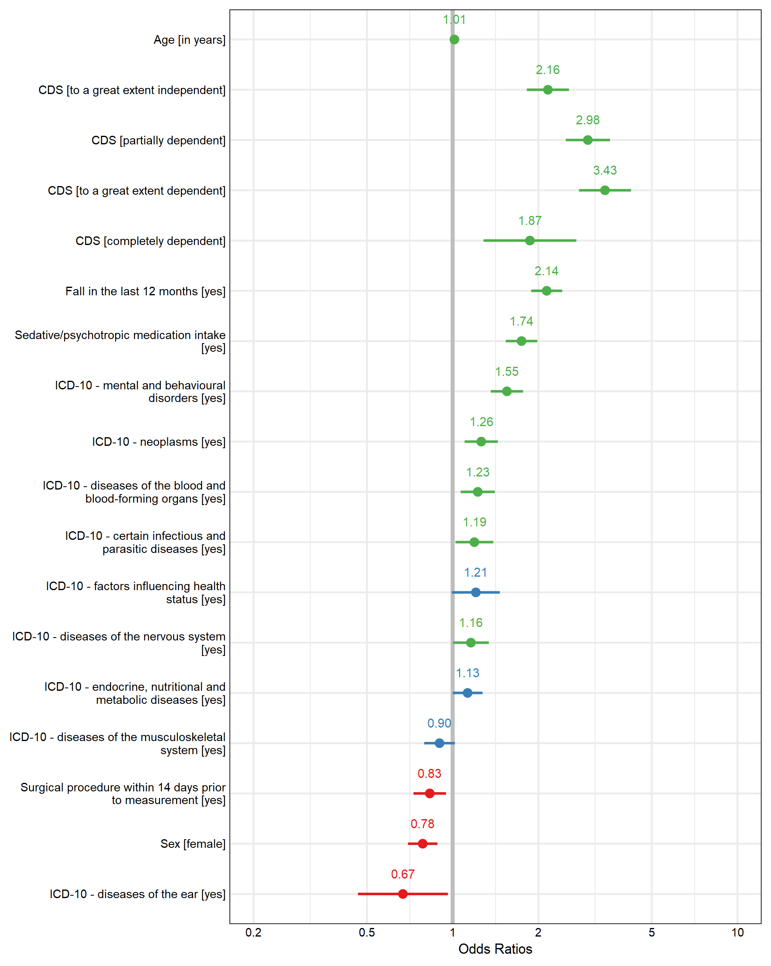
Green values indicate a statistically significant factor increasing inpatient fall risk, blue values indicate a statistically non-significant risk factor and red values indicate a statistically significant factor decreasing inpatient fall risk.

