Supplementary Information:

Appendix A: Patient Characteristics from the Outcome Study
 |  | All participants (n= 186)
Age of children and young people (<18 years) at the hospital in years, mean (SD) | 9 (4)
Age of parents, mean (SD) |  | 39 (8)
IMD decile, median (IQR) |  | 5 (3-9)
Gender, % (n)
Female |  | 62 (116/186)
Male |  | 38 (70/186)
Primary recipient of the intervention, % (n/n total)
Patient |  | 75 (139/186)
Parent / carer |  | 19 (36/186)
Sibling |  | 10 (18/186)
Ethnicity, % (n/n total)
White |  | 62 (116/186)
Asian |  | 11 (21/186)
Black |  | 10 (19/186)
Any mixed background |  | 7 (13/186)
Any other ethnicity |  | 4 (8/186)
Not stated/prefer not to say |  | 5 (9/186)
Parent relationship to child, % (n/n total)
Mother |  | 90 (167/186)
Father |  | 10 (19/186)
Parent marital status, % (n/n total)
Married |  | 60 (62/104)
Single |  | 16 (17/104)
Divorced/separated |  | 12 (12/104)
Living with partner |  | 9 (9/104)
Widowed |  | 1 (1/104)
Not stated/prefer not to say |  | 3 (3/104)
Parent employment status, % (n/n total)
Employed (full time) |  | 30 (31/104)
Employed (part time) |  | 24 (25/104)
Other |  | 18 (19/104)
Out of work |  | 11 (11/104)
Self-employed |  | 8 (8/104)
Unable to work |  | 6 (6/104)
Retired |  | 1 (1/104)
Not stated/prefer not to say |  | 3 (3/104)
Parent disability, % (n/n total)
Yes |  | 11 (11/104)
No |  | 89 (93/104)
Presenting problems, % (n/n total)
Anxiety |  | 45 (84/186)
Challenging behaviour |  | 38 (70/186)
Low mood |  | 28 (52/186)
Other |  | 14 (26/186)
Known pre-existing neurodevelopmental diagnosis, % (n/n total)
Autism Spectrum Disorder |  | 15 (27/186)
Intellectual Disability |  | 21 (39/186)
None |  | 62 (115/186)
Not stated/prefer not to say |  | 4 (7/186)
Patient type, % (n/n total)
Outpatient |  | 96 (100/104)
Inpatient |  | 4 (4/104)
Need for translator, % (n/n total)
Yes |  | 4 (8/186)
No |  | 96 (178/186)
County of origin, % (n/n total)
<50 miles of London |  | 81 (151/186)
>50 miles of London |  | 15 (27/186)
Not stated/prefer not to say |  | 4 (8/186)
History of mental health input, % (n/n total)
Yes |  | 46 (86/186)
No |  | 53 (98/186)
Not stated/prefer not to say |  | 1 (2/186)
History of risk present, % (n/n total)
Yes |  | 18 (34/186)
No |  | 81 (151/186)
Not stated/prefer not to say |  | 1 (1/186)
Primary intervention allocated to, % (n/n total)
MATCH |  | 32 (59/186)
Referral |  | 45 (84/186)
Neurodevelopmental assessment |  | 3 (6/186)
Signposting to resources only |  | 19 (35/186)
Other |  | 1 (2/186)
Self-reported change in physical health (6 months post), % (n/n total)
Improved |  | 10 (10/104)
No change |  | 40 (42/104)
Deteriorated |  | 6 (6/104)
Not stated |  | 44 (46/104)
NB: where total sample size is 104, this means data was only collected in the second year of the trial (post-pilot phase); IMD decile=Index of multiple deprivation decile.

Appendix B: Base-case Model ICER Scatter Plot
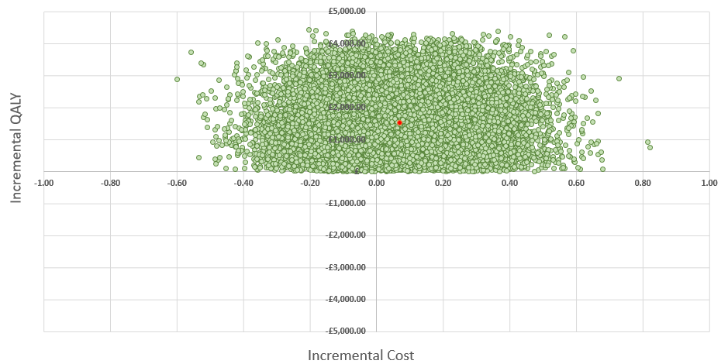

Appendix C: Practical Model ICER Scatter Plot
