Supplementary file 1. Diagnostic codes for low back pain and low back pain with neurological signs and symptoms
Diagnostic system | Diagnostic code | Frequency
Low back pain
SNOMED | Backache (finding) | 72199
SNOMED | Low back pain (finding) | 48212
ICD | M54.5 - Low back pain (Ed.1-Ed.9) | 22153
ICD | M54.99 - Unspecified dorsalgia, site unspecified (Ed.1-Ed.9) | 5919
SNOMED | Acute low back pain (finding) | 1582
ICD | 724.5 - Other and unspecified disorders of back, Backache, unspecified | 1540
SNOMED | Lower back injury (disorder) | 1403
SNOMED | Lumbar sprain (disorder) | 1237
SNOMED | Strain of back muscle (disorder) | 1137
SNOMED | Sacral back pain (finding) | 996
SNOMED | Spasm of back muscles (finding) | 971
ICD | 724.2 - Other and unspecified disorders of back, Low back pain | 531
ICD | S33.7 - Sprain and strain of other and unspecified parts of lumbar spine and pelvis (Ed.1-Ed.9) | 520
SNOMED | Sacroiliac joint pain (finding) | 502
SNOMED | Chronic low back pain (finding) | 481
SNOMED | Pain in the coccyx (finding) | 457
SNOMED | Injury of coccyx (disorder) | 433
SNOMED | Injury of back (disorder) | 405
SNOMED | Back pain complicating pregnancy (disorder) | 354
SNOMED | Mechanical low back pain (finding) | 345
SNOMED | Chronic back pain (finding) | 279
SNOMED | Sprain of sacroiliac ligament (disorder) | 227
ICD | M53.80 - Other specified dorsopathies, multiple sites in spine (Ed.1-Ed.9) | 159
SNOMED | Lumbar spondylosis (disorder) | 139
SNOMED | Complaining of low back pain (finding) | 132
SNOMED | Degeneration of lumbar intervertebral disc (disorder) | 122
SNOMED | Spondylosis (disorder) | 113
ICD | M51.2 - Other specified intervertebral disc displacement (Ed.1-Ed.9) | 107
SNOMED | Coccyx sprain (disorder) | 93
SNOMED | Sacrum sprain (disorder) | 92
SNOMED | Low back strain (disorder) | 88
ICD | M53.3 - Sacrococcygeal disorders, not elsewhere classified (Ed.1-Ed.9) | 88
ICD | 724.8 - Other and unspecified disorders of back, Other symptoms referable to back | 62
SNOMED | Sprain of ligament of lumbosacral joint (disorder) | 61
ICD | S33.50 - Sprain and strain of lumbar spine, unspecified (Ed.1) | 46
ICD | M47.99 - Unspecified spondylosis, site unspecified (Ed.1-Ed.9) | 45
SNOMED | Superficial injury of back (disorder) | 40
SNOMED | Displacement of lumbar intervertebral disc without myelopathy (disorder) | 37
SNOMED | Injury of muscle and tendon of abdomen, lower back and pelvis (disorder) | 31
ICD | 722.10 - Intervertebral disc disorders, Displacement of thoracic or lumbar intervertebral disc without myelopathy, Lumbar intervertebral disc without myelopathy | 25
ICD | 724.79 - Other and unspecified disorders of back, Disorders of coccyx, Disorders of coccyx, other | 25
SNOMED | Exacerbation of backache (finding) | 24
SNOMED | Stiff back (finding) | 24
ICD | M51.3 - Other specified intervertebral disc degeneration (Ed.1-Ed.9) | 23
ICD | 724.6 - Other and unspecified disorders of back, Disorders of sacrum | 17
ICD | 847.2 - Sprains and strains of other and unspecified parts of back, Lumbar | 15
ICD | M51.8 - Other specified intervertebral disc disorders (Ed.1-Ed.9) | 10
SNOMED | Sacral edema (disorder) | 7
ICD | 722.52 - Intervertebral disc disorders, Degeneration of thoracic or lumbar intervertebral disc, Degeneration of thoracic or lumbar intervertebral disc, lumbar or lumbosacral intervertebral disc | 6
SNOMED | Synovial cyst of sacrum (disorder) | 6
ICD | 722.90 - Intervertebral disc disorders, Other and unspecified disc disorder, Other and unspecified disc disorder, unspecified region | 4
SNOMED | Sprain of sacrococcygeal ligament (disorder) | 4
ICD | 847.4 - Sprains and strains of other and unspecified parts of back, Coccyx | 3
ICD | 722.2 - Intervertebral disc disorders, Displacement of intervertebral disc, site unspecified, without myelopathy | 2
ICD | 847.3 - Sprains and strains of other and unspecified parts of back, Sacrum | 2
ICD | 722.6 - Intervertebral disc disorders, Degeneration of intervertebral disc, site unspecified | 1
SNOMED | Back pain prevention education (regime/therapy) | 1
SNOMED | Entire sacroiliac joint (body structure) | 1
SNOMED | Lumbar facet joint pain (finding) | 1
SNOMED | Lumbar spine painful on movement (finding) | 1
SNOMED | Lumbar spine stiff (finding) | 1
SNOMED | Pain in lumbar spine (finding) | 1
SNOMED | Pain radiating to lumbar region of back (finding) | 1
Low back pain with neurological signs and symptoms
SNOMED | Sciatica (disorder) | 9738
ICD | M54.3 - Sciatica (Ed.1-Ed.9) | 1436
SNOMED | Lumbago with sciatica (finding) | 755
SNOMED | Acute back pain with sciatica (finding) | 260
SNOMED | Acute sciatica (disorder) | 218
SNOMED | Spinal stenosis of lumbar region (disorder) | 212
SNOMED | Lumbago-sciatica due to displacement of lumbar intervertebral disc (disorder) | 173
SNOMED | Injury of lumbar nerve roots (disorder) | 132
SNOMED | Lumbar radiculopathy (disorder) | 110
SNOMED | Lumbar disc prolapse with radiculopathy (disorder) | 51
SNOMED | Chronic sciatica (disorder) | 41
SNOMED | Injury of sciatic nerve (disorder) | 18
SNOMED | Injury of nerves and lumbar spinal cord at abdomen, lower back and pelvis level (disorder) | 14
SNOMED | Injury of sacral nerve roots (disorder) | 12
ICD | S74.0 - Injury of sciatic nerve at hip and thigh level (Ed.1-Ed.9) | 7
ICD | S34.2 - Injury of nerve root of lumbar and sacral spine (Ed.1-Ed.9) | 2
ICD | 953.5 - Injury to nerve roots and spinal plexus, Lumbosacral plexus | 1
ICD | 956.0 - Injury to peripheral nerve(s) of pelvic girdle and lower limb, Sciatic nerve | 1
SNOMED | Compression of sacral nerve root (disorder) | 1
SNOMED | Injury of lumbosacral plexus (disorder) | 1
SNOMED | Prolapsed lumbar intervertebral disc with sciatica (disorder) | 1
ICD | S34.5 - Injury of lumbar, sacral and pelvic sympathetic nerves (Ed.1-Ed.9) | 1
ICD | S346 - Injury of peripheral nerve(s) of abdomen, lower back and pelvis (Ed.1-Ed.9) | 1
ICD, International Classification of Diseases; SNOMED, Systematised Nomenclature of Medicine Clinical Terms
Supplementary file 2. Hospital peer groups
AIHW Criteria | Labels used in this study
Principal referral  Greater than 35,000 acute weighted separations AND offering highly specialised services (such as bone marrow and other specialised transplants, severe burn injury, major trauma) | Principal referral
Major hospitals group 1  35,000 or less but greater than 17,000 acute weighted separations AND availability of one or more specialist services requiring specific infrastructure (such as cardiac catheterisation, comprehensive cancer centre, in-centre dialysis and medical radiation imaging) OR average acute NWAU per separation of 1.25 or greater | Major
Major hospitals group 2  35,000 or less but greater than 10,000 acute weighted separations AND no specialist services requiring specific infrastructure OR average acute NWAU per separation less than 1.25 | Major
District group 1  10,000 or less but greater than 4,000 acute weighted separations | District
District group 2  4,000 or less acute weighted separations but greater than 2,000 acute separations | District
Community with surgery  2,000 or less acute separations but greater than 200 total separations AND more than 2 per cent surgery (based on DRG status) | Community
Community without surgery  2,000 or less acute separations AND less than 2 per cent surgery (based on DRG status), OR Less than 200 total separations | Community
Multi-purpose service  Multi-purpose service, including associated aged care entity | Multipurpose
Sub-acute  75 per cent or more general (mixed) sub- and nonacute Activity | Other
Other ungrouped  Other sub- and non-acute not able to be grouped to any other category | Other
Ungrouped acute – tertiary referral  Specialist acute role not suitable for any other rolebased group and tertiary referral status | Other
AIHW, Australian Institute of Health and Welfare; NWAU, National Weighted Activity Unit; DRG, Diagnosis-related group

Supplementary file 3. Multilevel model discrimination and goodness-of-fit
C-statistic: discrmination in relation to a fixed-effects model only
Model | Area under the curve (95% CI)
Fixed effects only | 0.781 (0.778 to 0.783)
Random effects (case-mix only) | 0.824 (0.821 to 0.806)
Random effects (case-mix + hospital) | 0.824 (0.821 to 0.826)

Goodness-of-fit of random effects models. Predicted versus observed number of admissions across deciles for model A.
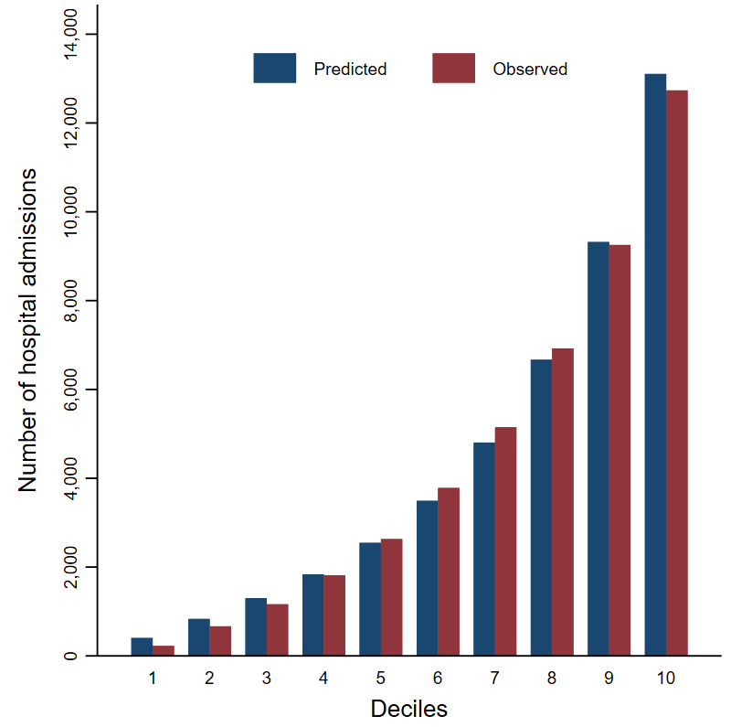

Supplementary file 4. Characteristics of presentations stratified by hospital peer-group
 | Principal referral  (n = 13) | Major  (n = 21) | District  (n = 40) | Community  (n = 34) | Multi-purpose  (n = 60) | Sub-acute  (n = 2) | Ungrouped  (n = 7)
Number of presentations | 56,533 | 54,798 | 44,954 | 8,977 | 6,521 | 1,532 | 3,414
Age, mean (SD) | 52 (19.9) | 51.8 (19.7) | 51.3 (19.1) | 52 (19.1) | 52.7 (18.8) | 55.8 (20.7) | 51.1 (19.1)
Age 65+, n (%) | 16,654 (29.4) | 15.789 (28.8) | 11,947 (26.58) | 2.539 (28.3) | 1.865 (28.6) | 555 (36.2) | 920 (26.9)
Sex, n (%)ª
Female | 29,141 (51.5) | 28,774 (52.5) | 23,189 (51.6) | 4,918 (54.8) | 3,403 (52.2) | 784 (51.2) | 1,697 (49.7)
Male | 27,389 (48.5) | 26,024 (47.5) | 21,765 (48.4) | 4,059 (45.2) | 3.118 (47.8) | 748 (48.8) | 1,715 (50.3)
Arrival at ED by ambulance, n (%)^{c} | 20,207 (35.8) | 18,570 (33.9) | 11,751 (26.1) | 2,029 (22.6) | 1,416 (21.8) | 489 (31.9) | 1,326 (38.9)
Triage category (ATS), n (%)^{d}
1 (Ressuciation) | 54 (0.1) | 7 (0.01) | 6 (0.01) | 2 (0.02) | 1 (0.02) | 0 | 0
2 (Emergency) | 1,896 (3.3) | 1,900 (3.5) | 1,248 (2,78) | 302 (3.4) | 200 (3.1) | 39 (2.5) | 2 (1.3)
3 (Urgent) | 22,230 (39.3) | 15,084 (27.5) | 14,650 (32.6) | 3,059 (34.1) | 2,358 (36.2) | 371 (24.2) | 553 (16.2)
4 (Semi-urgent) | 30,327 (53.7) | 24,071 (62.2) | 25,966 (57.8) | 4,489 (50.1) | 2,894 (44.5) | 993 (64.82) | 2,539 (74.37)
5 (Non-urgent) | 2,025 (3.6) | 3,735 (6.8) | 3,080 (6.9) | 1,117 (12.5) | 1,055 (16.2) | 129 (8.4) | 276 (8.1)
Type of low back pain, n (%)
Radicular | 4,041 (7.1) | 4,146 (7.6) | 3,782 (8.4) | 635 (7.1) | 288 (4.4) | 129 (8.4) | 165 (4.8)
Admitted to hospital, n (%) | 20,078 (35.5) | 14,377 (26.2) | 6,087 (13.5) | 1,528 (17) | 1,133 (17.4) | 520 (33.9) | 736 (21.6)
ED, emergency department; ATS, Australasian Triage Scale. Percentages might not add up to 100 due to rounding

