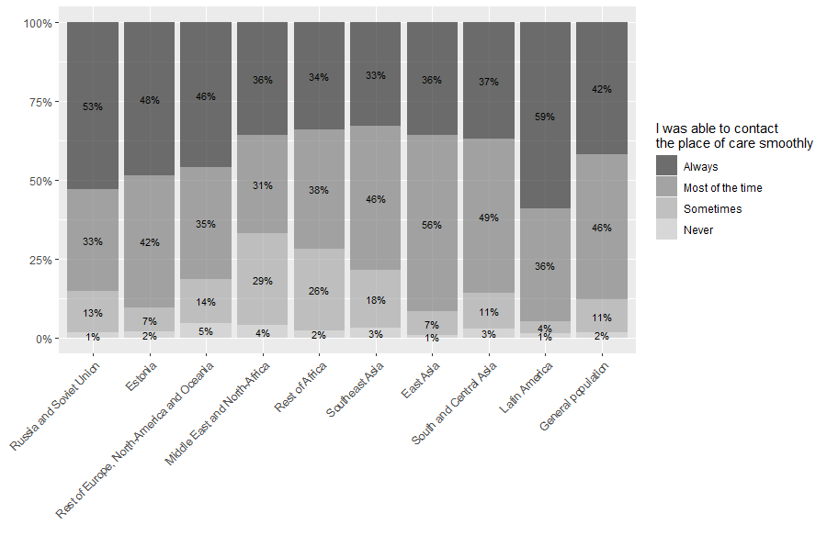
Supplementary figure 1. The distribution of responses to the item "I was able to contact the place of care smoothly" between migrants from different regions of origins and general population

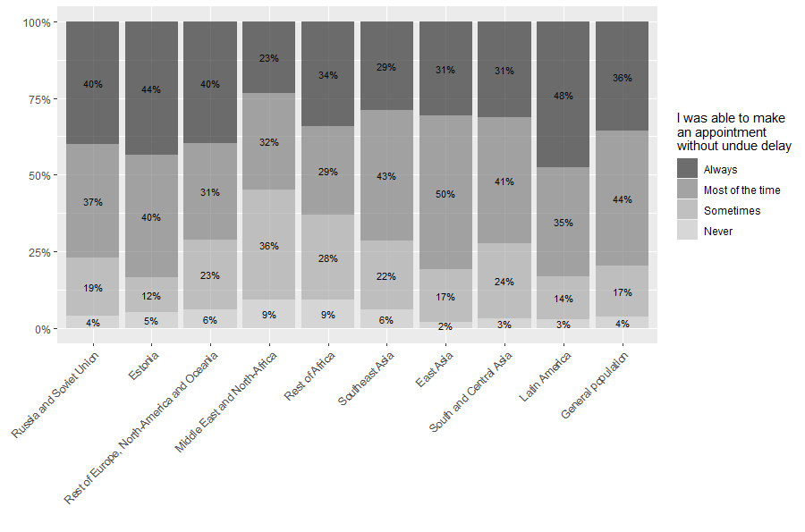
Supplementary figure 2. The distribution of responses to the item "I was able to make an appointment without undue delay" between migrants from different regions of origins and general population

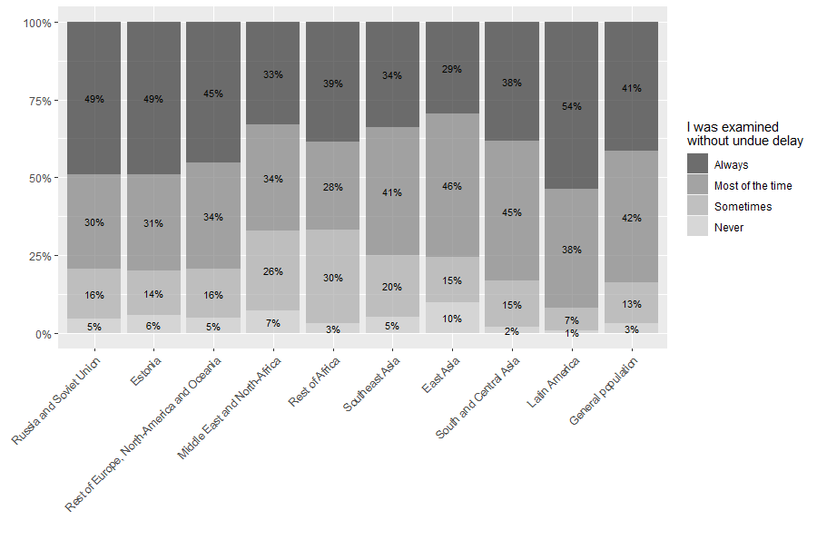
Supplementary figure 3. The distribution of responses to the item "I was examined without undue delay” between migrants from different regions of origin and general population.

