Supplement figures
Supplement figure 1 Overlap plot
Supplement figure 2 Covariate balance density
Supplement figure 3 Incremental cost-effectiveness (ICER) plane of utility improvement
Supplement figure 4 Incremental cost-effective (ICER) plane in hernia recurrence case prevented from cohort study.

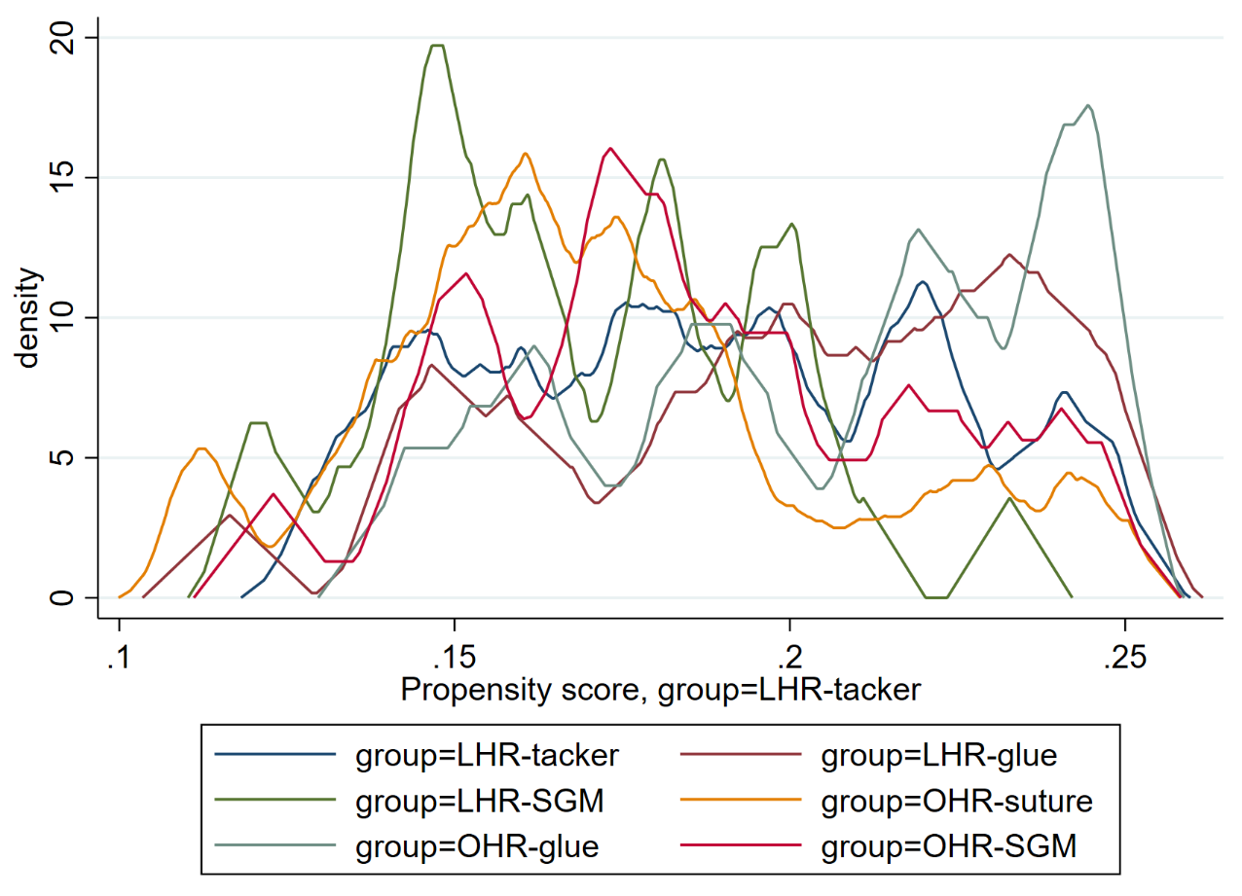
LT
LSG
OG
LG
OS
OSG

Supplement figure 1 Overlap plot
LT = laparoscopic inguinal hernia repair using tacker, LG = laparoscopic inguinal hernia repair using glue, LSG = laparoscopic inguinal hernia repair using self-gripping mesh, OS = open inguinal hernia repair using suture, OG = open inguinal hernia repair using glue, OSG = open inguinal hernia repair using self-gripping mesh

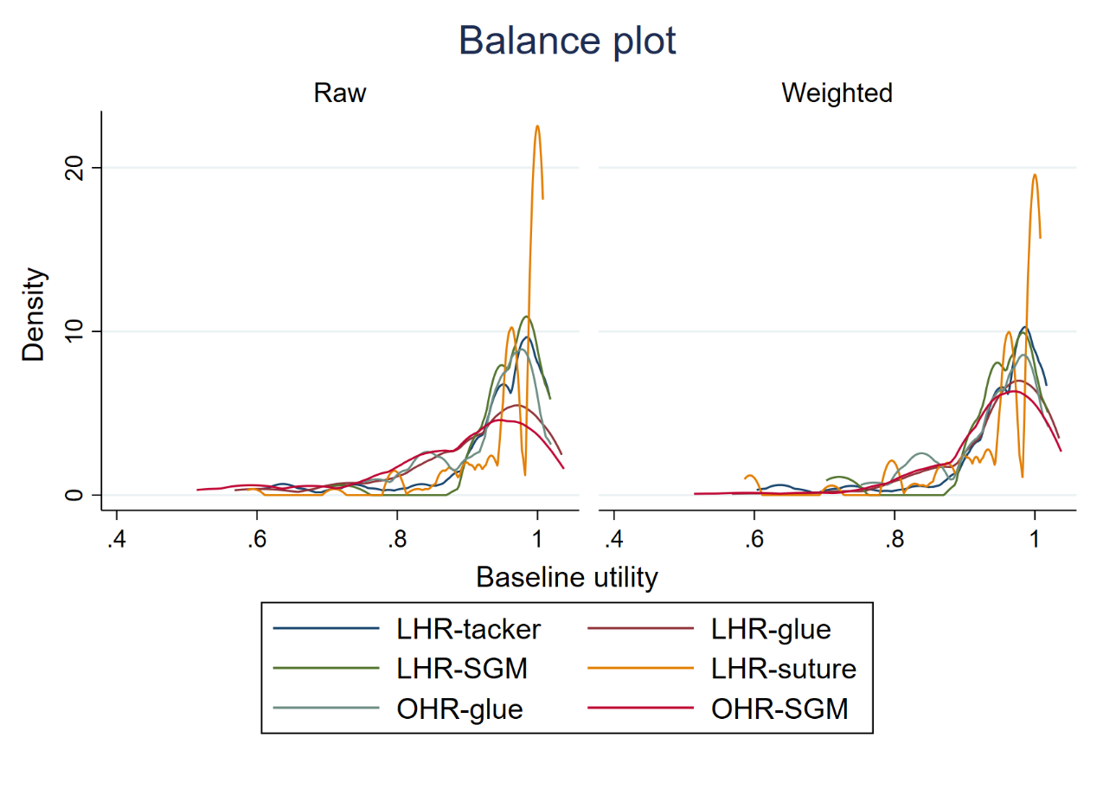
LT
LSG
OG
LG
OS
OSG
Supplement figure 2 Covariate balance density
LT = laparoscopic inguinal hernia repair using tacker, LG = laparoscopic inguinal hernia repair using glue, LSG = laparoscopic inguinal hernia repair using self-gripping mesh, OS = open inguinal hernia repair using suture, OG = open inguinal hernia repair using glue, OSG = open inguinal hernia repair using self-gripping mesh

LG
LSG
OG
OSG

- Short term with hospital perspective

LG
LSG
OG
OSG

- Long term with hospital perspective

LG
LSG
OG
OSG

- Short term with societal perspective

LG
LSG
OG
OSG

- Long term with societal perspective

Supplement figure 3 Incremental cost-effectiveness (ICER) plane of utility improvement

LG
LSG
OG
OSG

- Hospital perspective
LG
LSG
OG
OSG

- Societal perspective

Supplement figure 4 Incremental cost-effective (ICER) plane in hernia recurrence case prevented from cohort study

