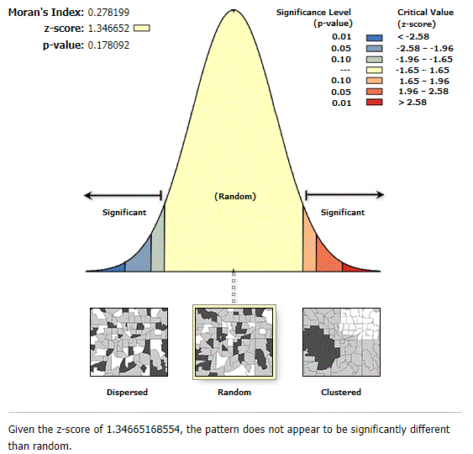  A | 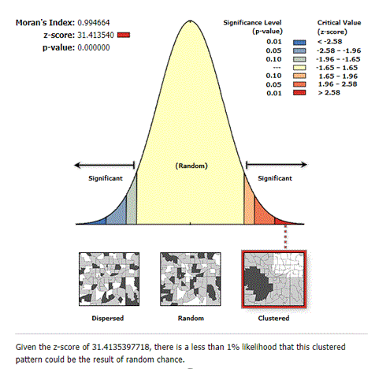  B
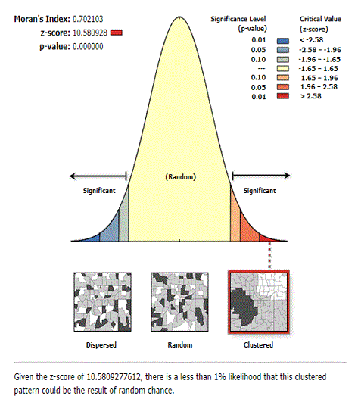  C | 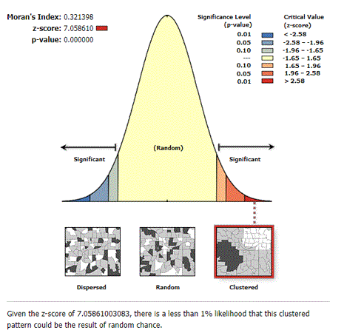  D
Supplementary figure 1: The global spatial autocorrelation of pregnant who received no antenatal care(ANC) service from a skilled provider in Ethiopia: 2005 (A), 2011 (B), 2016 (C), and 2019 (D)

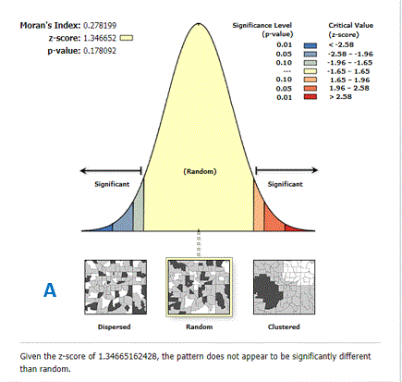  A | 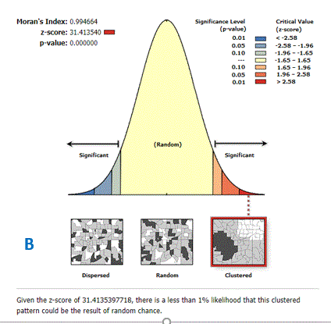  B
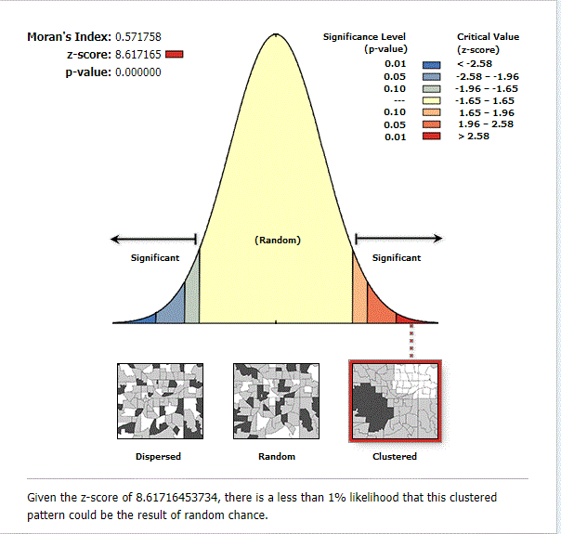  C | 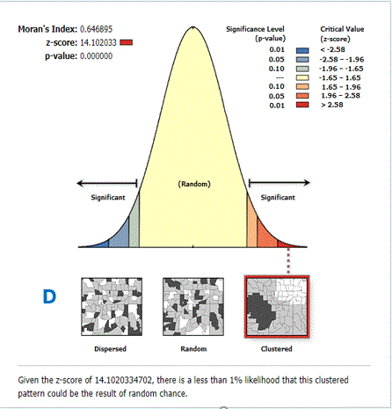  D
Supplementary figure 2: The global spatial autocorrelation of utilization of four or more antenatal care (ANC) visit among pregnant women in Ethiopia: 2005 (A), 2011 (B), 2016 (C), and 2019 (D)

Supplementary figure 3: The global spatial autocorrelation of birth attended in a health facility in Ethiopia: 2005 (A), 2011 (B), 2016 (C), and 2019 (D)

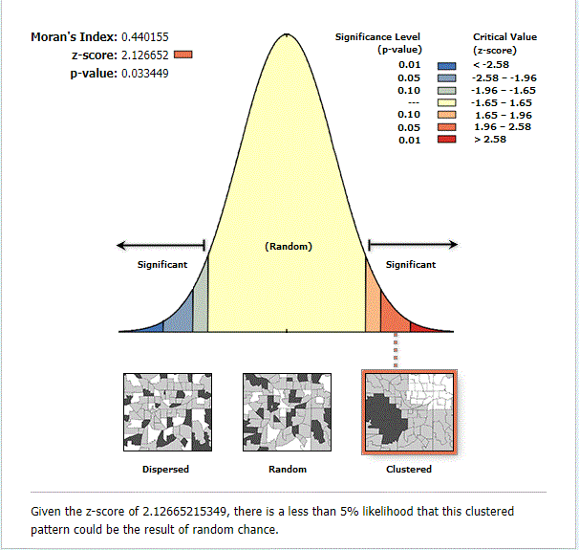  A  A) | 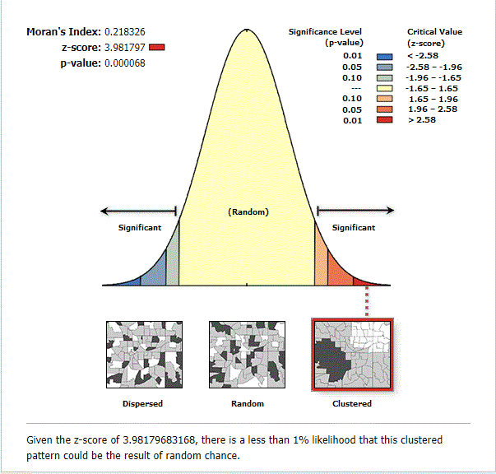  B
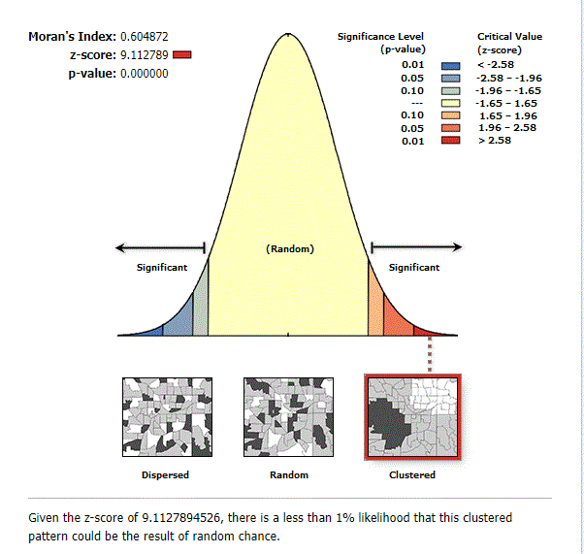  C | 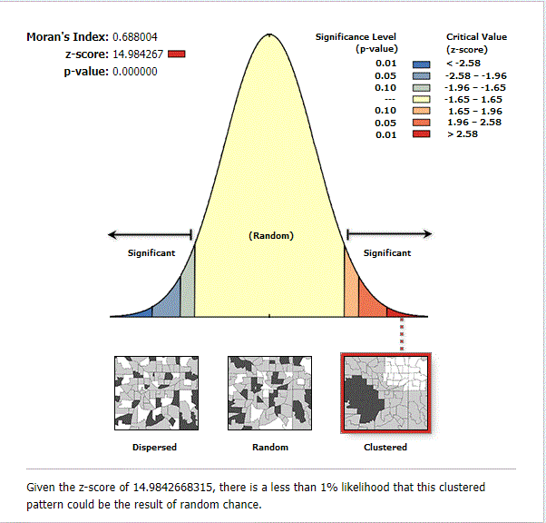  D

