Appendix
Supplementary table 1. Summary table of included studies
Supplementary table 2. Drug dose and costs
Supplementary table 3. Background mortality rate
Supplementary table 4. The results of scenario analyses
Supplementary table 5. The Rate of Adverse Events for Four Treatment Strategies.
Supplementary table 6. The results of survival analyses for all fitting curves
Supplementary table 7. The parameter values of survival analyses for all fitting curves

Supplementary figure 1. The Cost-Effective Frontier of 4 Different Competing Strategies
Supplementary figure 2. Tornado Diagrams Showing the Effect of Lower and Upper Values of Each Parameter on the ICERs of the Pembrolizumab-plus-Axitinib Versus Sunitinib Strategy
Supplementary figure 3. Tornado Diagrams Showing the Effect of Lower and Upper Values of Each Parameter on the ICERs of the Atezolizumab-Vemurafenib-Cobimetinib Versus Vemurafenib-plus-Cobimetinib Strategies
Supplementary figure 4: Parametric Distributions for First-Line Treatment (Atezolizumab + vemurafenib + cobimetinib strategy)
Supplementary figure 5: Parametric Distributions for First-Line Treatment (Vemurafenib + cobimetinib strategy)
Supplementary figure 6: Parametric Distributions for First-Line Treatment (Dabrafenib + trametinib strategy)
Supplementary figure 7: Parametric Distributions for First-Line Treatment (Encorafenib + binimetinib strategy)
Supplementary figure 8: Parametric Distributions for Second-Line Treatment
Supplementary figure 9: Parametric Distributions for Best Support Care State

The ISPOR CHEERs checklist

Supplementary table 1. Summary table of included studies.
 | Key characteristic
Study | Study design | Treatment | Sample size | Age (yrs) | Male (%) | ECOG performance status |  |  |  | BRAF mutation status (%)
 |  |  |  |  |  | 0 | 1 |  | Unknow | BRAF^{V600E} | BRAF^{V600K}
First-line treatment
IMspire150 | Phase III double-blind, placebo-controlled RCT | ATE-VEM-COB  VEM-COB | 256  258 | 54  53.5 | 59  58 | 76  77 | 24  22 | 0  2 |  | 77  71 |  | 11  11
COMBI-AD | Phase III double-blind, placebo-controlled RCT | DAB-TRA | 438 | 50 | 45 | 92 | 8 | 1 |  | 91 |  | 9
COLUMBUS | Phase III open-label RCT | ENC-BIN | 192 | 57 | 60 | 71 | 29 | - |  | 89 |  | 11
Second-line treatment
CheckMate 037 | Phase III open-label RCT | Nivolumab | 272 | 59 | 65 | 60 | 40 | - |  | 22
* ATE-VEM-COB = atezolizumab-vemurafenib-cobimetinib; VEM-COB = vemurafenib-plus-cobimetinib; DAB-TRA = dabrafenib-plus-trametinib; ENC-BIN = encorafenib-plus-binimetinib.

Supplementary table 2. Drug dose and costs
Drug | Dose | Route | Unit Price ($) | Cost for 1 model cycle ($, 28 days)
Atezolizumab + vemurafenib + cobimetinib strategy
Cycle 1
Atezolizumab | - | - | - | -
Vemurafenib | 960 mg twice-daily (for 21 day) followed by 720 mg vemurafenib twice-daily | Oral | 0.16 | 8064
Cobimetinib | 60 mg once-daily | Oral | 4.32 | 7257.6
From cycle 2 onwards
Atezolizumab | 840 mg on day 1 and 15 | IV | 7.82 | 13137.6
Vemurafenib | 720 mg twice daily | Oral | 0.16 | 6451.2
Cobimetinib | 60 mg once-daily (21 days on–7 days off) | Oral | 4.32 | 5443.2
vemurafenib + cobimetinib strategy
Cycle 1
Vemurafenib | 960 mg twice-daily (for 21 day) followed by vemurafenib 960 mg for 7 days | Oral | 0.16 | 7526.4
Cobimetinib | 60 mg once-daily | Oral | 4.32 | 7257.6
From cycle 2 onwards
Vemurafenib | 960 mg vemurafenib twice daily | Oral | 0.16 | 8601.6
Cobimetinib | 60 mg cobimetinib once-daily (21 days on–7 days off) | Oral | 4.32 | 5443.2
Dabrafenib + trametinib strategy
Dabrafenib | 150 mg twice daily for 12 months | Oral | 0.89 | 7476
Trametinib | 2 mg once daily for 12 months | Oral | 144.95 | 8117.2
Encorafenib + Binimetinib strategy
Encorafenib | 450 mg once daily | Oral | 0.89 | 11214
Binimetinib | 45 mg twice daily | Oral | 4.63 | 11667.6
Second-line treatment
Nivolumab | 3 mg/kg every 2 weeks | IV | 28.54 | 11986.8

Supplementary table 3. Background mortality rate
Estimates of background mortality rate for each age are provided in the US life table; Arias E, Heron M, Xu J. United States Life Tables, 2019. Natl Vital Stat Rep. 2019; 68:1-65.
Age (years) | Background | Age (years) | Background | Age (years) | Background
18 | 0.000603 | 54 | 0.007003 | 90 | 0.166829
19 | 0.000698 | 55 | 0.007607 | 91 | 0.185047
20 | 0.000795 | 56 | 0.008219 | 92 | 0.204441
21 | 0.000889 | 57 | 0.008857 | 93 | 0.224919
22 | 0.000970 | 58 | 0.009542 | 94 | 0.246354
23 | 0.001424 | 59 | 0.010285 | 95 | 0.26890
24 | 0.001497 | 60 | 0.011098 | 96 | 0.291442
25 | 0.001561 | 61 | 0.011952 | 97 | 0.314700
26 | 0.001624 | 62 | 0.012814 | 98 | 0.338142
27 | 0.001682 | 63 | 0.013657 | 99 | 0.361537
28 | 0.001737 | 64 | 0.014502 | 100 | 1
29 | 0.001792 | 65 | 0.015384
30 | 0.001847 | 66 | 0.016444
31 | 0.001900 | 67 | 0.017624
32 | 0.001952 | 68 | 0.018968
33 | 0.002003 | 69 | 0.029586
34 | 0.002053 | 70 | 0.022109
35 | 0.002111 | 71 | 0.024359
36 | 0.002174 | 72 | 0.026347
37 | 0.002233 | 73 | 0.028810
38 | 0.002285 | 74 | 0.031309
39 | 0.002340 | 75 | 0.034486
40 | 0.002413 | 76 | 0.038026
41 | 0.002516 | 77 | 0.042286
42 | 0.002649 | 78 | 0.046547
43 | 0.002811 | 79 | 0.051534
44 | 0.002999 | 80 | 0.057008
45 | 0.003203 | 81 | 0.062923
46 | 0.003433 | 82 | 0.069911
47 | 0.003709 | 83 | 0.078099
48 | 0.004047 | 84 | 0.086754
49 | 0.004445 | 85 | 0.096549
50 | 0.004874 | 86 | 0.106472
51 | 0.005331 | 87 | 0.119677
52 | 0.005844 | 88 | 0.134128
53 | 0.006408 | 89 | 0.149846

Supplementary table 4. The results of scenario analyses.
Strategy | Total cost | LY | QALY | ICER
Scenario 1
5 years
Vemurafenib + cobimetinib | 312875 | 1.99 | 1.65 | Dominate
Encorafenib + binimetinib | 517534 | 2.20 | 1.84 | Extend dominated
Dabrafenib + trametinib | 383970 | 2.18 | 1.82 | 402359
Atezolizumab + vemurafenib + cobimetinib | 577914 | 2.23 | 1.89 | 3201604
10 years
Vemurafenib + cobimetinib | 347548 | 2.24 | 1.88 | Dominate
Encorafenib + binimetinib | 578454 | 2.50 | 2.14 | Dominated
Dabrafenib + trametinib | 447242 | 2.56 | 2.18 | 335118
Atezolizumab + vemurafenib + cobimetinib | 670036 | 2.66 | 2.26 | 2829557
20 years
Vemurafenib + cobimetinib | 357053 | 2.33 | 1.99 | Dominate
Encorafenib + binimetinib | 596896 | 2.60 | 2.25 | Dominated
Dabrafenib + trametinib | 458757 | 2.66 | 2.30 | 325391
Atezolizumab + vemurafenib + cobimetinib | 683692 | 2.78 | 2.40 | 2340589
Scenario 2
10% patents switch to BSC
Vemurafenib + cobimetinib | 339320 | 2.27 | 1.89 | Domimate
Encorafenib + binimetinib | 578851 | 2.56 | 2.16 | Dominated
Dabrafenib + trametinib | 443650 | 2.62 | 2.21 | 325092
Atezolizumab + vemurafenib + cobimetinib | 670693 | 2.73 | 0.10 | 2225006
30% patents switch to BSC
Vemurafenib + cobimetinib | 317539 | 2.10 | 1.77 | Dominate
Encorafenib + binimetinib | 558446 | 2.41 | 2.06 | Dominated
Dabrafenib + trametinib | 424906 | 2.48 | 2.12 | 303800
Atezolizumab + vemurafenib + cobimetinib | 653105 | 2.61 | 2.22 | 2380948
Scenario 3
Adjust nivolumab 75% of its original price in the first-line setting.
Vemurafenib + cobimetinib | 357509 | 2.34 | 1.98 | -
Atezolizumab + vemurafenib + cobimetinib | 620446 | 2.82 | 2.41 | 611481
Adjust nivolumab 50% of its original price in the first-line setting.
Vemurafenib + cobimetinib | 353758 | 2.34 | 1.97 | -
Atezolizumab + vemurafenib + cobimetinib | 544589 | 2.82 | 2.40 | 443793
Adjust nivolumab 25% of its original price in the first-line setting.
Vemurafenib + cobimetinib | 358197 | 2.35 | 1.99 | -
Atezolizumab + vemurafenib + cobimetinib | 475322 | 2.80 | 2.43 | 266193

Supplementary table 5. The Rate of Adverse Events for Four Treatment Strategies.
Arms | The probability of AE caused discontinuation | The probability of AE caused death | References
Atezolizumab +vemurafenib + cobimetinib | 0.13 | 0 | 1
Vemurafenib + cobimetinib | 0.16 | 0 | 1
Dabrafenib +trametinib | 0.26 | 0.015 | 2
Encorafenib +binimetinib | 0.13 | 0 | 3
Nivolumab | 0.03 | 0 | 4

References:
1. Gutzmer R, Stroyakovskiy D, Gogas H, et al. Atezolizumab, vemurafenib, and cobimetinib as first-line treatment for unresectable advanced BRAF(V600) mutation-positive melanoma (IMspire150): primary analysis of the randomised, double-blind, placebo-controlled, phase 3 trial. Lancet (London, England). 2020;395(10240):1835-1844.
2. Long GV, Hauschild A, Santinami M, et al. Adjuvant Dabrafenib plus Trametinib in Stage III BRAF-Mutated Melanoma. N Engl J Med. 2017;377(19):1813-1823.
3. Dummer R, Ascierto PA, Gogas HJ, et al. Overall survival in patients with BRAF-mutant melanoma receiving encorafenib plus binimetinib versus vemurafenib or encorafenib (COLUMBUS): a multicentre, open-label, randomised, phase 3 trial. Lancet Oncol. 2018;19(10):1315-1327.
4. Weber JS, D'Angelo SP, Minor D, et al. Nivolumab versus chemotherapy in patients with advanced melanoma who progressed after anti-CTLA-4 treatment (CheckMate 037): a randomised, controlled, open-label, phase 3 trial. Lancet Oncol. 2015;16(4):375-384.

Supplementary table 6. The results of survival analyses for all fitting curves.
Distribution | Progressive-free survival |  |  |  |  | OS
Distribution | First-line |  |  |  | Second-line
Distribution | Atezolizumab+ vemurafenib+ cobimetinib | vemurafenib+ cobimetinib | Dabrafenib+ trametinib | Encorafenib+ binimetinib | Nivolumab | BSC
Exponential | 905.99 | 1087.11 | 2423.072 | 531.04 | 839.95 | 492.92
Weibull | 906.46 | 1080.49 | 2413.763 | 524.49 | 821.53 | 493.23
Log-logistic | 898.07 | 1067.13 | 2341.131 | 519.16 | 782.09 | 477.09
Lognormal | 895.47 | 1076.68 | 2333.435 | 516.14 | 778.96 | 476.49

PFS: Progressive-free survival; OS: Overall survival; BSC: Best support care.

Supplementary table 7. The parameter values of survival analyses for all fitting curves.
 | Exponential (SE) | Weibull (SE) | Lognormal (SE) | Log-logistic (SE)
Atezolizumab+ vemurafenib+ cobimetinib | Rate = 0.0463 (0.0044) | Shape = 1.1028 (0.0853)  Scale = 20.6978 (1.8859) | Mean = 2.6463 (0.1053)  Sd = 1.2683 (0.0886) | Shape = 1.375 (0.105)  Scale = 13.807 (1.363)
vemurafenib+ cobimetinib | Rate = 0.0596 (0.005) | Shape = 1.2275 (0.0822)  Scale = 16.3221 (1.1191) | Mean = 2.4028 (0.0824)  Sd = 1.0941 (0.0658) | Shape = 1.663 (0.113)  Scale = 10.926 (0.830)
Dabrafenib+ trametinib | Rate = 0.03659 (0.00218) | Shape = 0.8663 (0.0381)  Scale = 27.0674 (1.8639) | Mean = 2.6865 (0.0711)  Sd = 1.3105 (0.0553) | Shape = 1.307 (0.061)  Scale = 13.677 (0.979)
Encorafenib+ binimetinib | Rate = 0.04358 (0.00545) | Shape = 1.370 (0.139)  Scale = 19.271 (1.934) | Mean = 2.6668 (0.1142)  Sd = 1.0439 (0.0967) | Shape = 1.668 (0.167)  Scale = 14.080 (1.497)
Nivolumab | Rate = 0.09015 (0.00813) | Shape = 0.7683 (0.0477)  Scale = 10.8711 (1.2778) | Mean = 1.6439 (0.1178)  Sd = 1.4534 (0.0881) | Shape = 1.2021 (0.0829)  Scale = 4.6024 (0.5468)
BSC | Rate = 0.0857 (0.0102) | Shape = 1.1161 (0.0917)  Scale = 11.7287 (1.2504) | Mean = 1.9695 (0.1092)  Sd = 0.9994 (0.0816) | Shape = 1.757 (0.164)  Scale = 7.007 (0.753)

Supplementary figure 1. The Cost-Effective Frontier of 4 Different Competing Strategies.
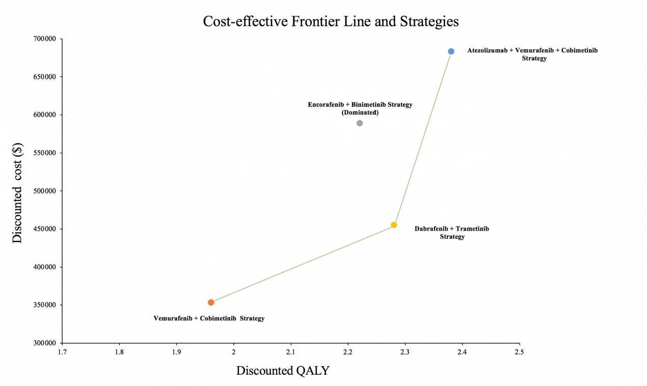
Supplementary figure 2. Tornado Diagrams Showing the Effect of Lower and Upper Values of Each Parameter on the ICERs of the Dabrafenib-plus-Trametinib and Vemurafenib-plus-Cobimetinib Strategies.
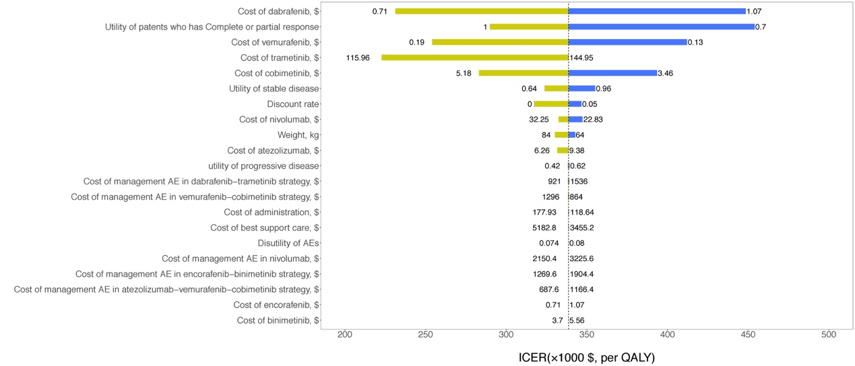

Supplementary figure 3. Tornado Diagrams Showing the Effect of Lower and Upper Values of Each Parameter on the ICERs of the Atezolizumab-Vemurafenib-Cobimetinib Versus Vemurafenib-plus-Cobimetinib Strategies

Supplementary figure 4: Parametric Distributions for First-Line Treatment (Atezolizumab + vemurafenib + cobimetinib strategy). KM = Kaplan-Meier.
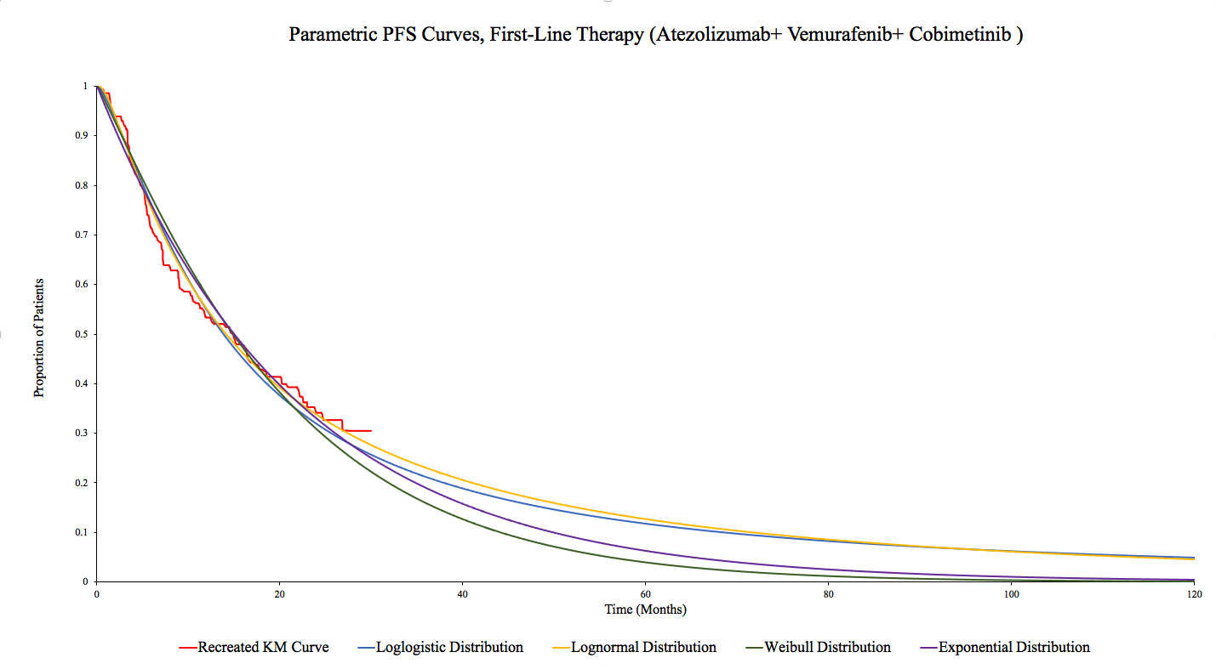

Supplementary figure 5: Parametric Distributions for First-Line Treatment (Vemurafenib + cobimetinib strategy). KM = Kaplan-Meier.
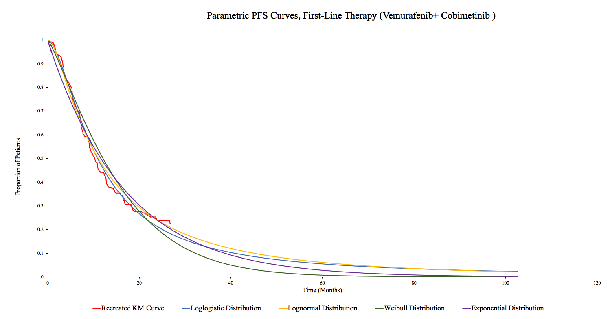

Supplementary figure 6: Parametric Distributions for First-Line Treatment (Dabrafenib + trametinib strategy). KM = Kaplan-Meier.
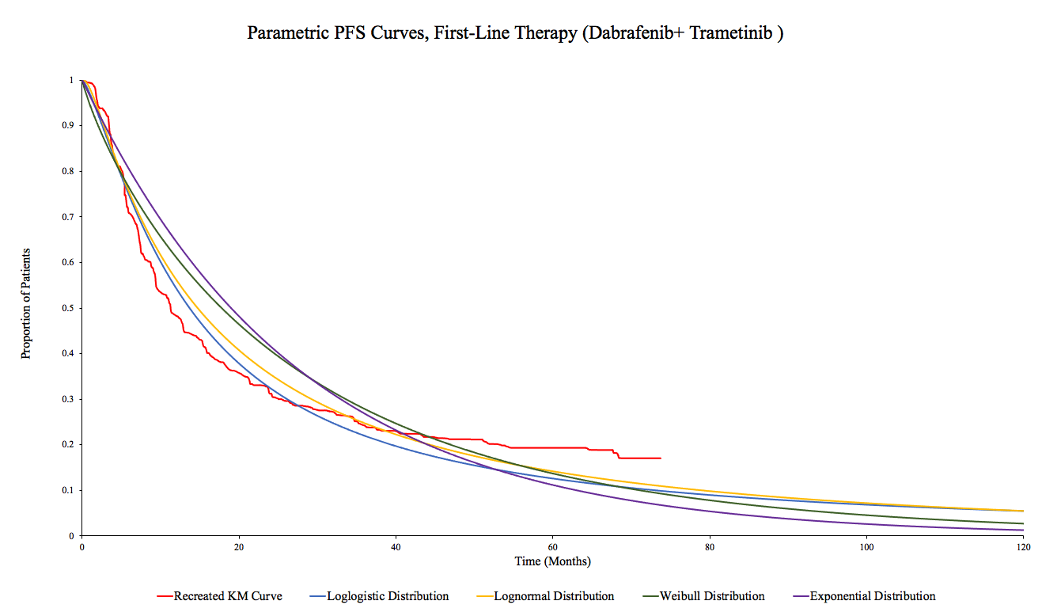

Supplementary figure 7: Parametric Distributions for First-Line Treatment (Encorafenib + binimetinib strategy). KM = Kaplan-Meier.
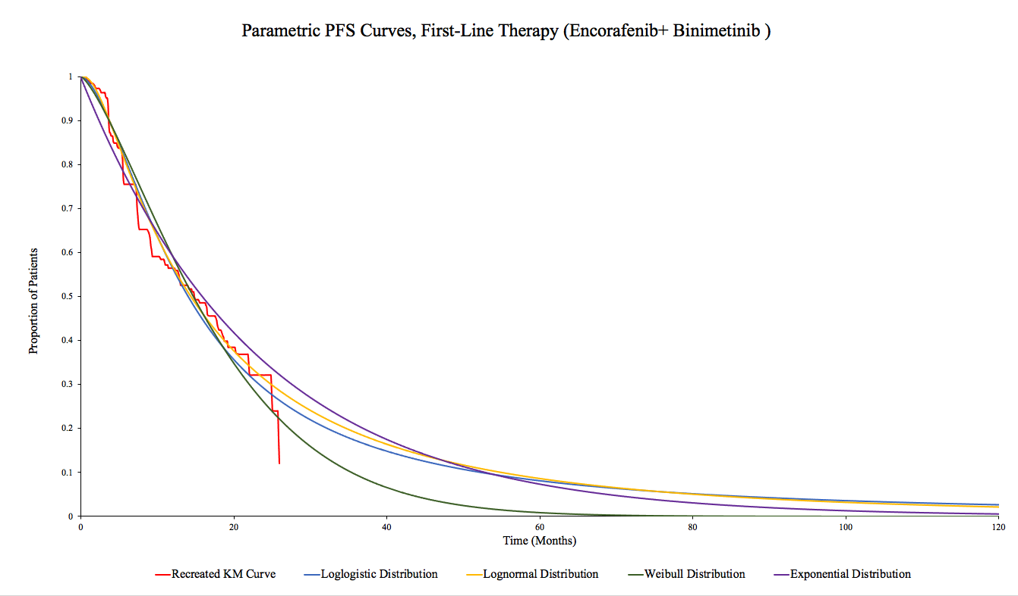

Supplementary figure 8: Parametric Distributions for Second-Line Treatment. KM = Kaplan-Meier.
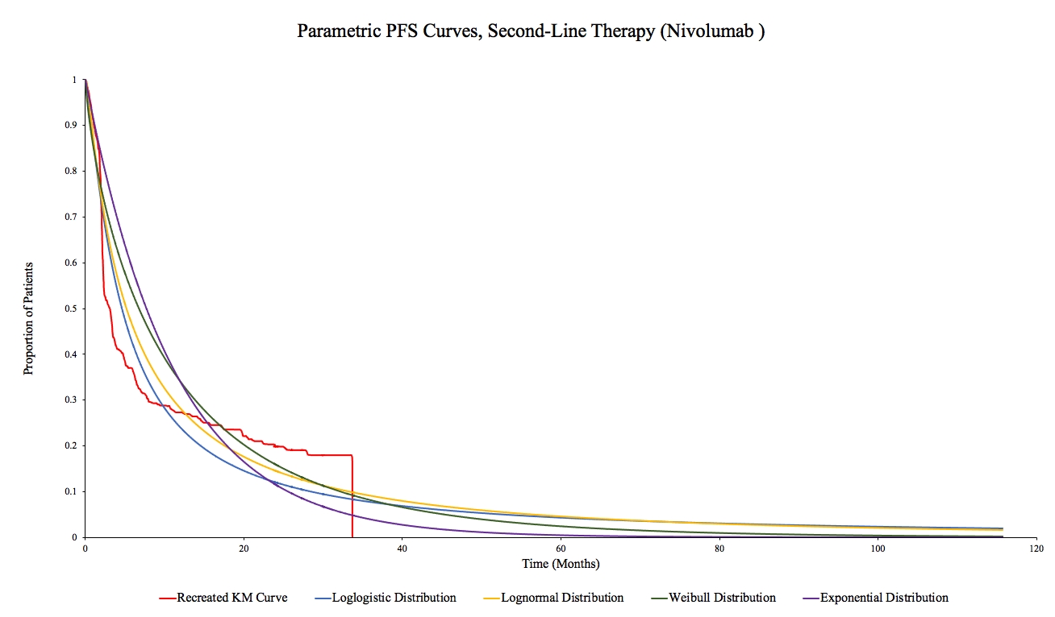

Supplementary figure 9: Parametric Distributions for Best Support Care State.
*BSC = Best support care.
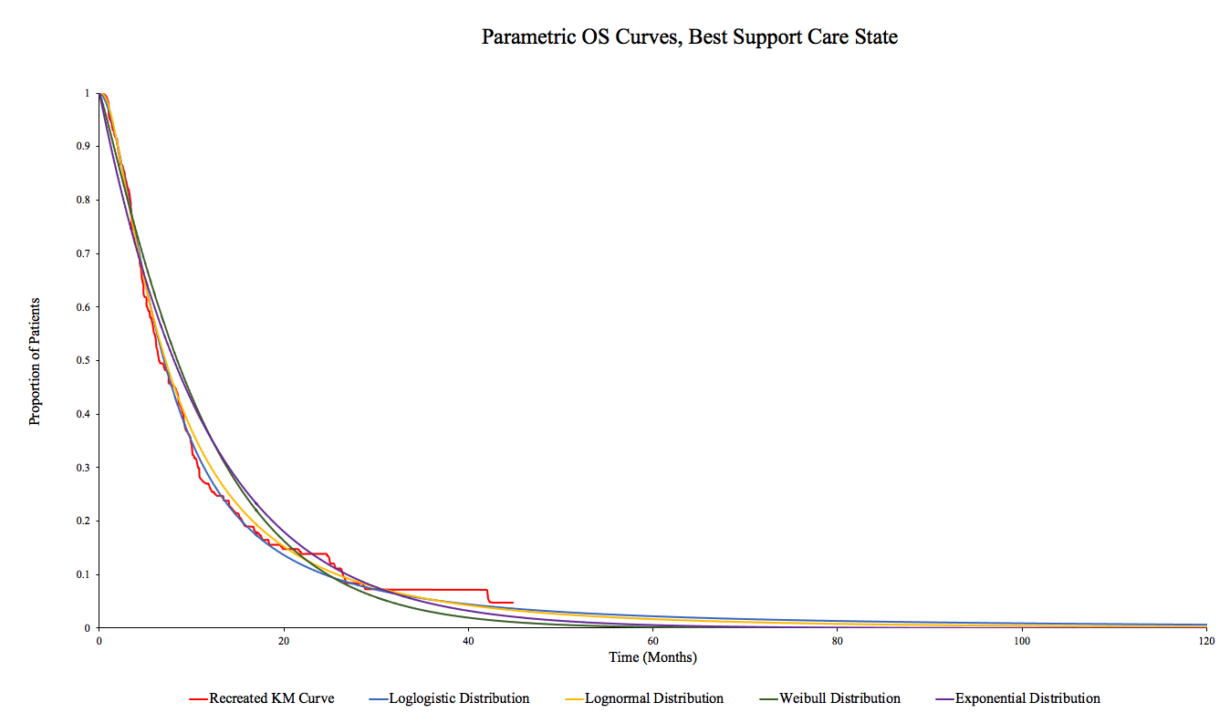



Consolidated Health Economic Evaluation Reporting Standards (CHEERS) 2022 Checklist

The CHEERS 2022 statement replaces the 2013 CHEERS statement, which should no longer be used. The CHEERS 2022 checklist contains 28 items with accompanying descriptions. Checklist users should indicate the section of the manuscript where relevant information can be found. The authors recommend using a section heading with a paragraph number. If an item does not apply to a particular economic evaluation, checklist users are encouraged to report “Not Applicable.” If information is otherwise not reported, checklist users are encouraged to write, “Not Reported.” Users should avoid the term “Not Conducted” as CHEERS is intended to guide and capture reporting. Additional information on CHEERS 2022 can be found here.

Title

Title
Identify the study as an economic evaluation and specify the interventions being compared.
Page 1 (title page)

Abstract

Abstract
Provide a structured summary that highlights context, key methods, results, and alternative analyses.
Pages 2-3, lines 1-27.

Introduction

Introduction: Background and Objectives
Give the context for the study, the study question, and its practical relevance for decision making in policy or practice.
Background: pages 3-4, lines 28-60; objectives: page 4, lines 61-63.

Methods

Health economic analysis plan

Indicate whether a health economic analysis plan was developed and where available.
Pages 4-5, lines 65-82.

Study population
Describe characteristics of the study population (such as age range, demographics, socioeconomic, or clinical characteristics).
Pages 5-6, lines 82-93.

Setting and location
Provide relevant contextual information that may influence findings.
Page 4, lines 58-63

Comparators
Describe the interventions or strategies being compared and why chosen.
Page 6, lines 71-76

Perspective
State the perspective(s) adopted by the study and why chosen.
Page 4, line 63

Time horizon
State the time horizon for the study and why appropriate.
Page 5, lines 66-68

Discount rate
Report the discount rate(s) and reason chosen.
Page 5, line 80

Selection of outcomes
Describe what outcomes were used as the measure(s) of benefit(s) and harm(s).
Page 5, lines 77-78

Measurement of outcomes
Describe how outcomes used to capture benefit(s) and harm(s) were measured.
Page 5, lines 77-78

Valuation of outcomes
Describe the population and methods used to measure and value outcomes.
Page 7, lines 113-130

Measurement and valuation of resources and costs
Describe how costs were valued.
Page 8, lines 132-151

Currency, price date, and conversion

Page 8, lines 132-151

- Rationale and description of model
If modeling is used, describe in detail and why used. Report if the model is publicly available and where it can be accessed.
Pages 12-13, lines 233-236

Analytics and assumptions
Describe any methods for analyzing or statistically transforming data, any extrapolation methods, and approaches for validating any model used.
Page 9, lines 154-169

Characterizing heterogeneity
Describe any methods used for estimating how the results of the study vary for subgroups.
Page 9, lines 154-169

Characterizing distributional effects
Describe how impacts are distributed across different individuals or adjustments made to reflect priority populations.
Page 9, lines 161-162

Characterizing uncertainty
Describe methods to characterize any sources of uncertainty in the analysis.
Page 9, lines 154-169

Approach to engagement with patients and others affected by the study

Describe any approaches to engage patients or service recipients, the general public, communities, or stakeholders (eg, clinicians or payers) in the design of the study.
Not applicable

Results

Study parameters
Report all analytic inputs (eg, values, ranges, references) including uncertainty or distributional assumptions.
Pages 9-11, lines 170-208

Summary of main results
Report the mean values for the main categories of costs and outcomes of interest and summarize them in the most appropriate overall measure.
Pages 9-11, lines 170-208

Effect of uncertainty
Describe how uncertainty about analytic judgments, inputs, or projections affects findings. Report the effect of choice of discount rate and time horizon, if applicable.
Pages 9-11, lines 170-208

Effect of engagement with patients and others affected by the study
Report on any difference patient/service recipient, general public, community, or stakeholder involvement made to the approach or findings of the study.
Not applicable

Discussion

Study findings, limitations, generalizability, and current knowledge
Report key findings, limitations, ethical, or equity considerations not captured and how these could impact patients, policy, or practice.
Pages 11-13, lines 209-255

Other Relevant Information

- Source of funding
Describe how the study was funded and any role of the funder in the identification, design, conduct, and reporting of the analysis.
Page 14, lines 276-278

- Conflicts of interest
Report authors’ conflicts of interest according to journal or International Committee of Medical Journal Editors requirements.
Page 14, line 275

1. Gutzmer R, Stroyakovskiy D, Gogas H, et al. Atezolizumab, vemurafenib, and cobimetinib as first-line treatment for unresectable advanced BRAF(V600) mutation-positive melanoma (IMspire150): primary analysis of the randomised, double-blind, placebo-controlled, phase 3 trial. Lancet (London, England). 2020;395(10240):1835-1844.
2. Long GV, Hauschild A, Santinami M, et al. Adjuvant Dabrafenib plus Trametinib in Stage III BRAF-Mutated Melanoma. N Engl J Med. 2017;377(19):1813-1823.
3. Dummer R, Ascierto PA, Gogas HJ, et al. Overall survival in patients with BRAF-mutant melanoma receiving encorafenib plus binimetinib versus vemurafenib or encorafenib (COLUMBUS): a multicentre, open-label, randomised, phase 3 trial. Lancet Oncol. 2018;19(10):1315-1327.
4. Weber JS, D'Angelo SP, Minor D, et al. Nivolumab versus chemotherapy in patients with advanced melanoma who progressed after anti-CTLA-4 treatment (CheckMate 037): a randomised, controlled, open-label, phase 3 trial. Lancet Oncol. 2015;16(4):375-384.

