Supplementary file 1: Clinical bundle definition

Bundle name | Bundle definition
Admission management | Danger sign assessment
Admission management | Partograph initiated when cervical dilation at least 4 cm
Admission management | Availability of soap, water, alcohol hand rub, and gloves
Admission management | Birth companion encouraged to be present during labour and at birth
Admission management | Mothers privacy maintained during labor and delivery
2nd stage of labour | Availability of gloves, soap/savlon and clean water
2nd stage of labour | Preparation of 10 IU IV/IM Oxytocin in syringe
2nd stage of labour | Availability of two clean, dry, warm towels and suction device
2nd stage of labour | Availability of bag and mask (size 0 and 1)
2nd stage of labour | Helper/Assistant identified and informed for resuscitation
Post-delivery | Newborn assessment
Post-delivery | Immediate skin to skin and initiate breastfeeding within the 1st hour
Post-delivery | Baby weighed and recorded
Post-delivery | Administer Vitamin K
Post-delivery | Administer tetracycline eye ointment

Supplementary file 2 Control charts for four core improvement indicators for the study facilities

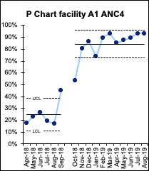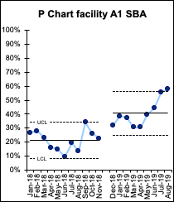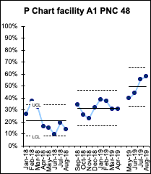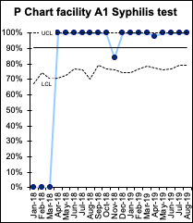

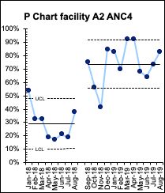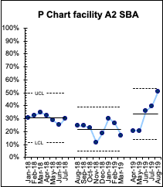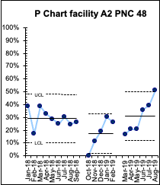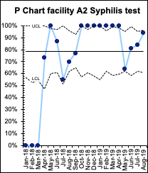

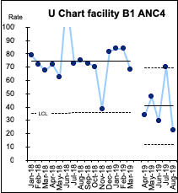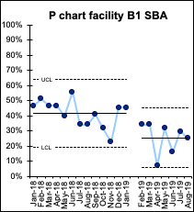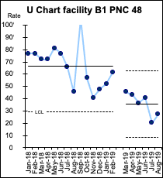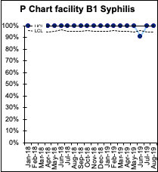

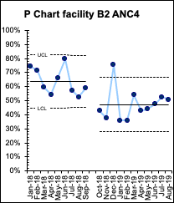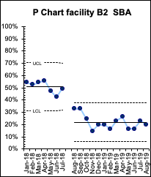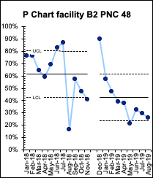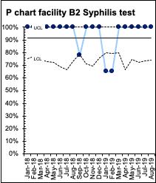

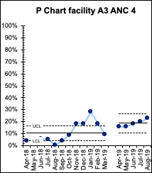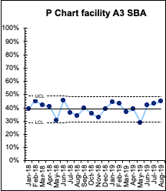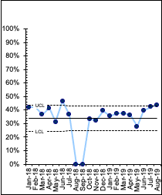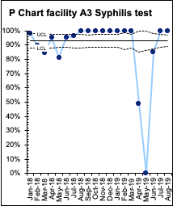
P Chart facility A3 PNC 48

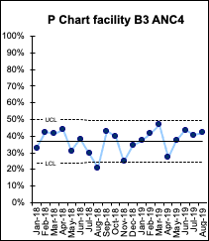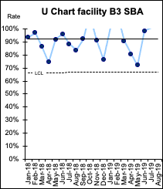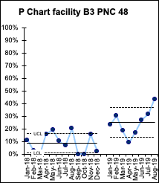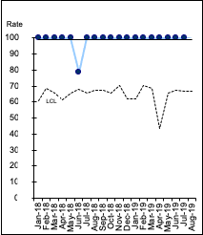
U Chart facility B3 Syphilis test
Supplementary file 3: Summary of the QI core indicator P charts in relation to observed special cause changes*
 | Health centres |  |  |  | Hospitals
 | A1: High performing | A2: Low performing | B1: High performing | B2: Low performing | A3 | B3
Coverage of ANC-4 | Improvement (Rule 4) | Improvement (Rule 4): outliers suggest instability (Rule 1) | Degradation after LS3 (small shift) outliers suggest instability (Rule 1) | Degradation after LS2 (Rule 3) outliers suggest instability (Rule 1) | Improvement after LS3 (Rule 2) | No change
Coverage of SBA | Improvement after LS3 (Rule 4) | Degradation after LS1 (Rule 3) and improvement after LS3 (Rule 2) | Degradation after LS3 (Rule 2) | Degradation after LS1 (Rule 3) | No change | No change
Coverage of PNC-48 | Improvement (Rule 3) | Degradation after LS1 (Rule 2) and improvement after LS3 (Rule 5) | Degradation after LS3 (Rule 2) outliers suggest instability | Degradation after LS2 (Rule 5) outliers suggest instability (Rule 1) | No change, outliers suggest continued instability (Rule 1) | Improvement (Rule 3) outliers suggest instability (Rule 1)
ANC attendees tested for syphilis | High levels at baseline maintained | Improvement (Rule 4) outliers suggest continued instability (Rule 1) | High levels at baseline maintained | High levels at baseline maintained, outliers suggest instability (Rule 1) | High levels at baseline maintained, outliers suggest instability (Rule 1) | High levels at baseline maintained

* Rule 1: Single data point outside the control limits, Rule 2: Four of five points above or below the central line, Rule 3: Eight or more data points above or below the central line, Rule 4: Two out of three consecutive points near the outer control limit, Rule 5: Six or more points increasing or decreasing

