Additional file 1. Treatment sequence

Treatment sequence for RA patients with inadequate response

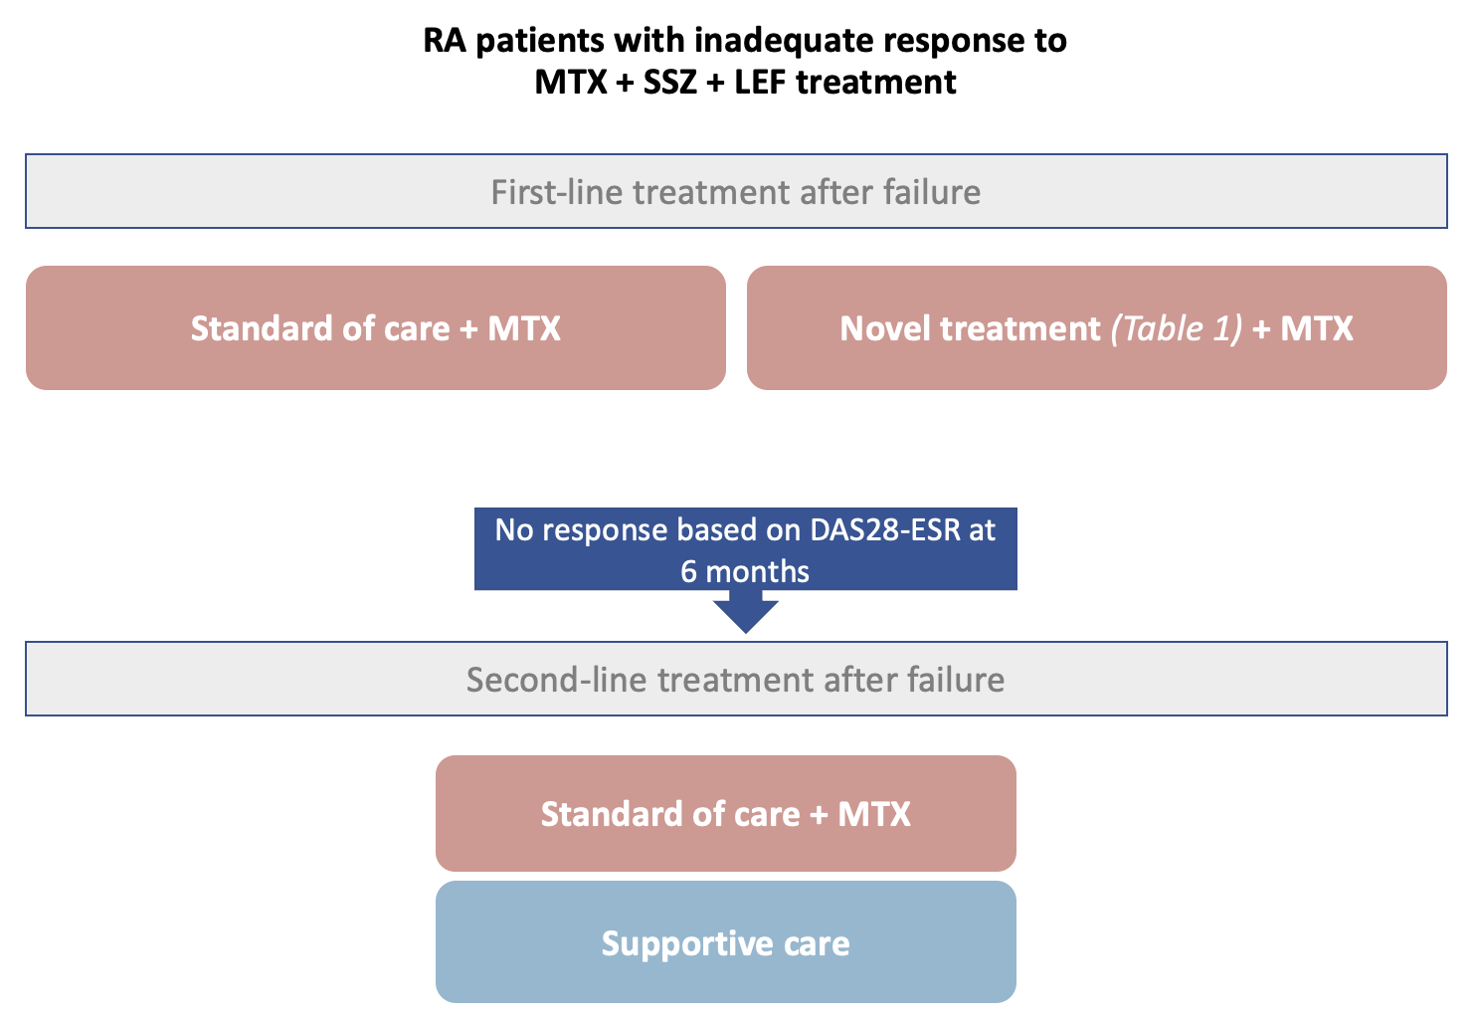
Treatment sequence of RA patients with inadequate response to MTX + SSZ + LEF treatment proceeds as follows:
Intervention arm
First-line therapy: Novel treatment + MTX Second-line therapy: SoC + MTX + Supportive care

Comparator arm
First-line therapy: SoC + MTX Second-line therapy: SoC + MTX + Supportive care

Supportive care includes the use of corticosteroids or non-steroidal anti-inflammatory drugs (NSAIDs).

