S1: P. 1
S2: P. 2
S3: P.3-6
S4: P.6 L15-20
S5: P.6-8
S6: P.7
L3-4
S7: P.7 L12-14
S8: P.7 L16-22
S9: P.9
L8-11
S10: P.8, P.9 L1-6
S11: P.8, L5-9
S12: P.7-8, P.10, L2-6
S13: P.9, L10-22
S14: P.9-10
S15: P.9
S16: P.10-14, 16-17
S17: P.10-14, 16-17
S18: P.14-18
S19: P.18
S20: P.19
S20: P.19
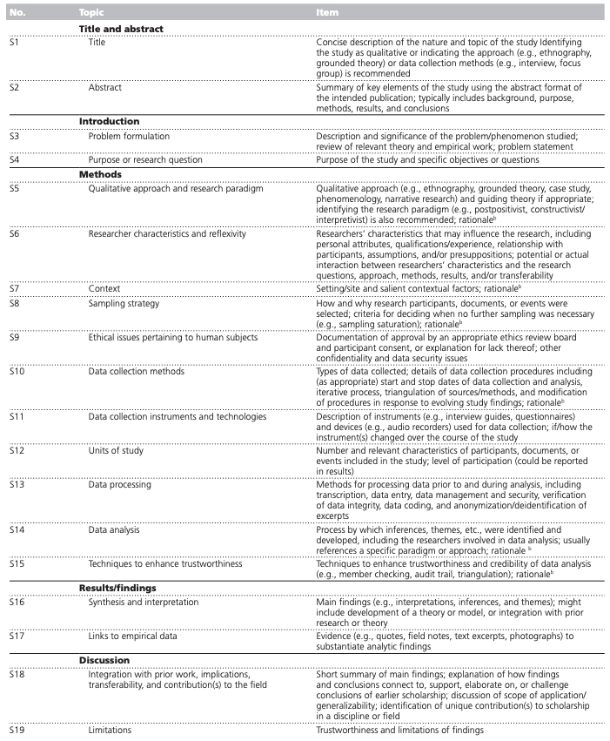
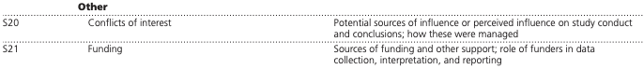
Appendix 1. Checklist for the Standards for Reporting Qualitative Research (SRQR)
References:
O’Brien BC, Harris IB, Beckman TJ, Reed DA, Cook DA. Standards for reporting qualitative research: A synthesis of recommendations. Academic Medicine [Internet]. 2014 [cited 2022 Jul 18];89(9):1245–51. Available from: https://journals.lww.com/academicmedicine/Fulltext/2014/09000/Standards_for_Reporting_Qualitative_Research__A.21.aspx

