Supplementary file 2: Maps visualising travel time from all locations to the nearest TB diagnosis site Ahafo, Upper West, North East, Northern, Savannah, and Upper East Regions of Ghana
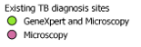
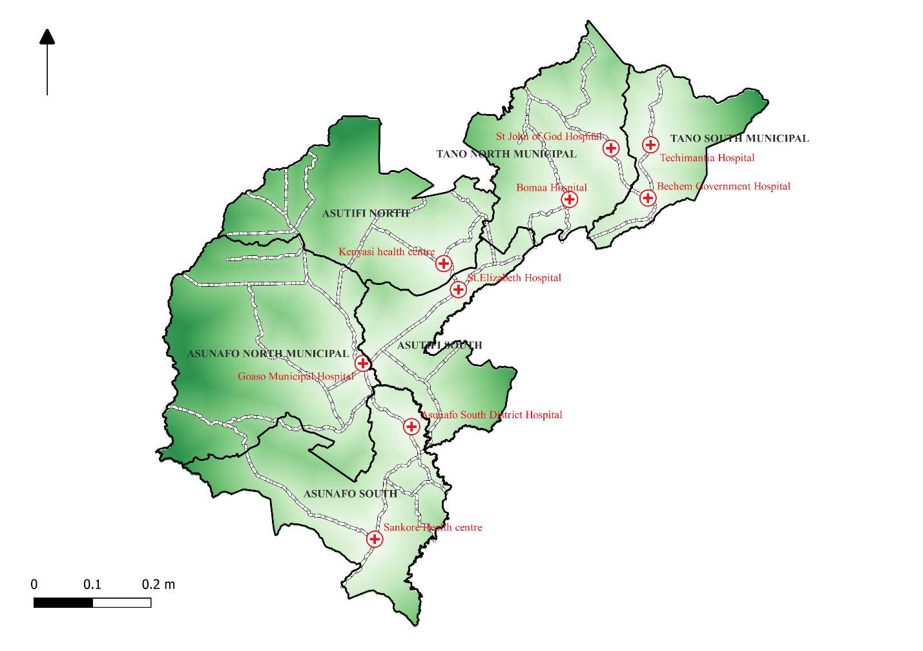Figure S1: A map visualising travel time from all locations to the nearest TB diagnosis site in the Ahafo Region
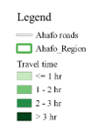

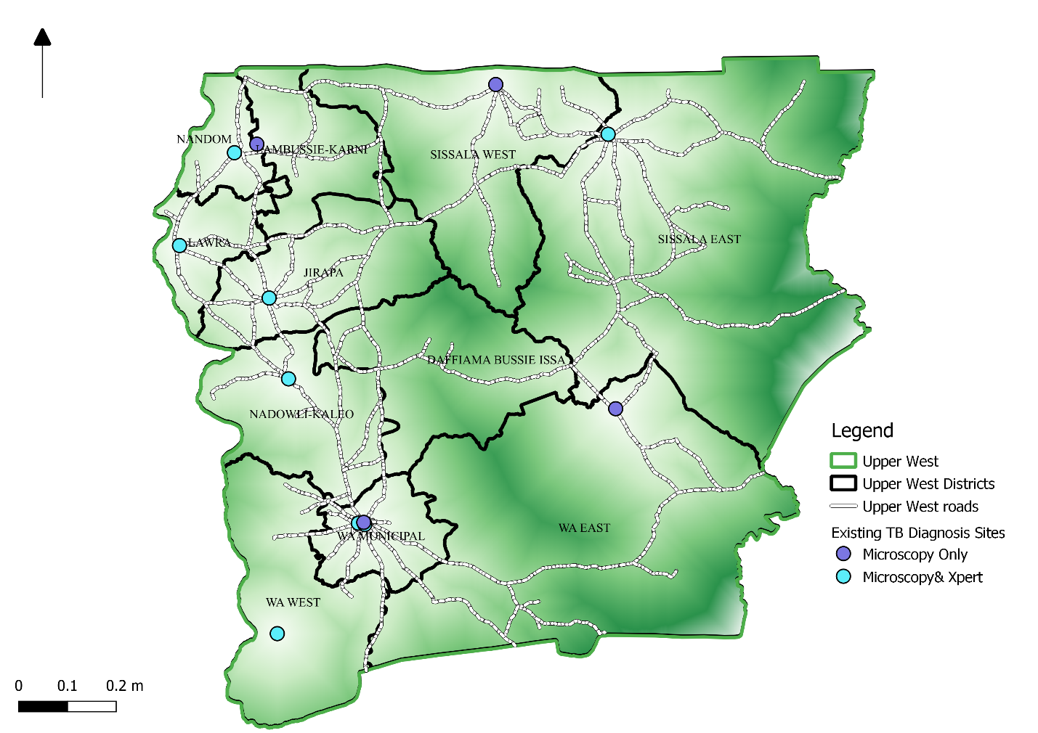Figure S2: A map visualising travel time from all locations to the nearest TB diagnostic site in the Upper West Region
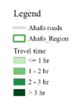

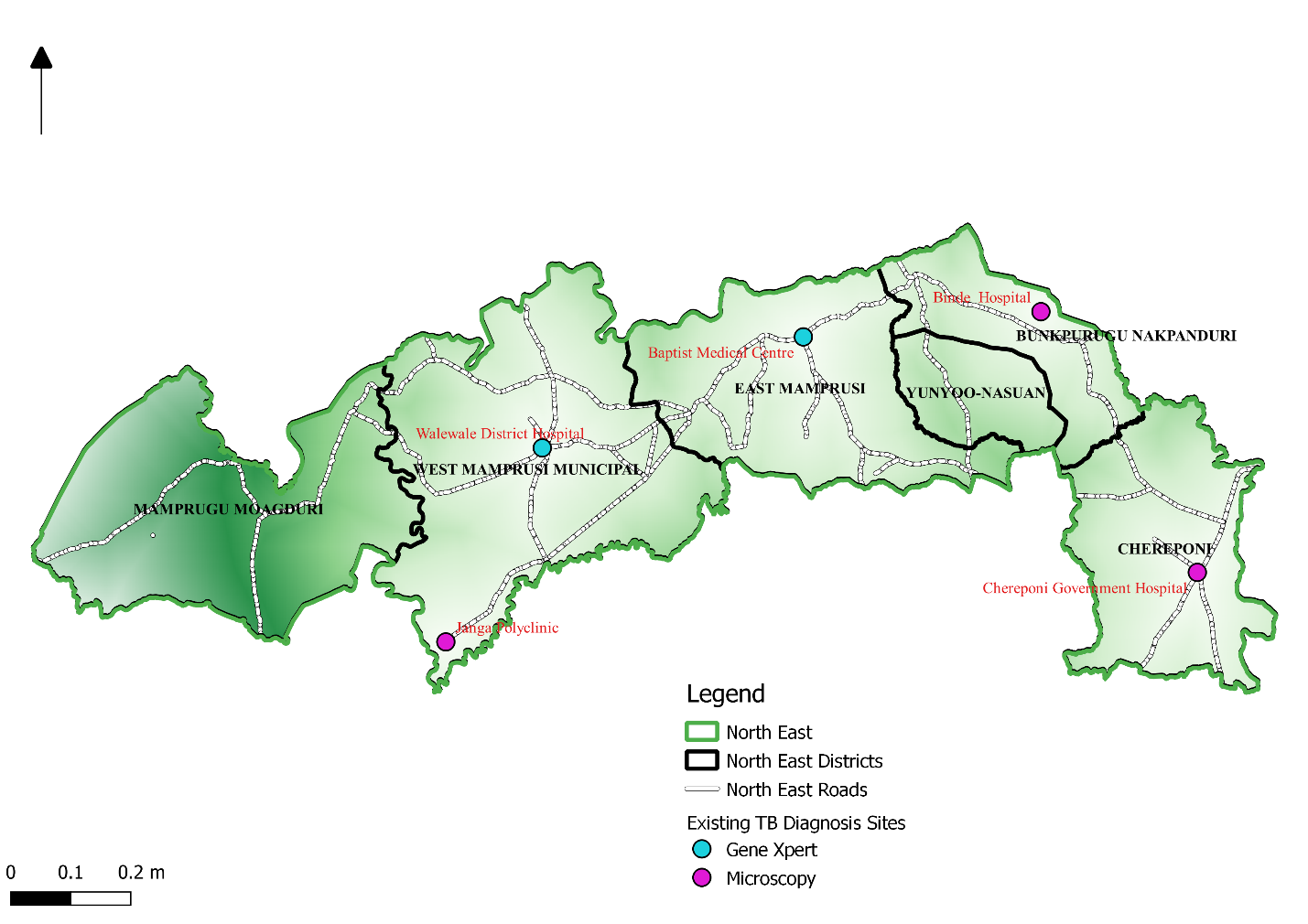Figure S3: A map visualising travel time from all locations to the nearest TB diagnostic site in the North-East Region
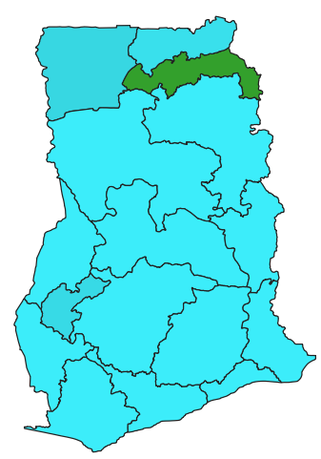

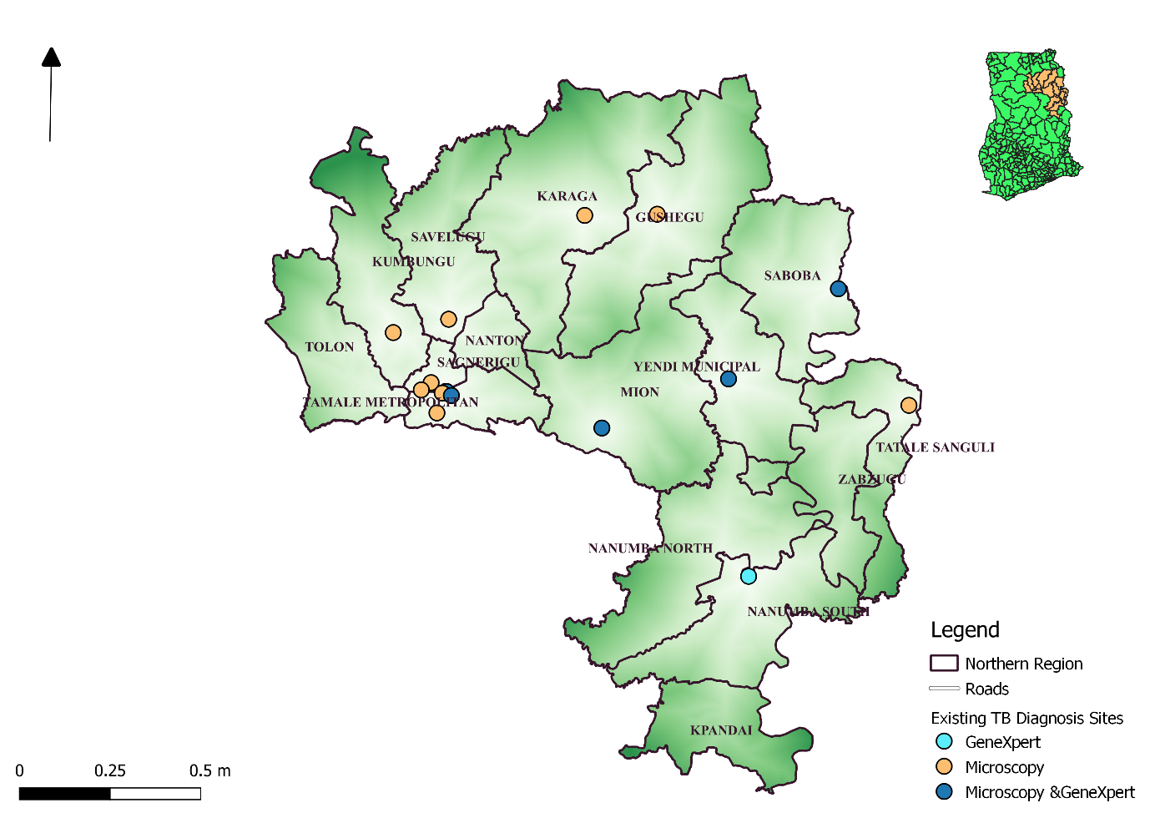Figure S4: A map visualising travel time from all locations to the nearest TB testing site in the Northern Region
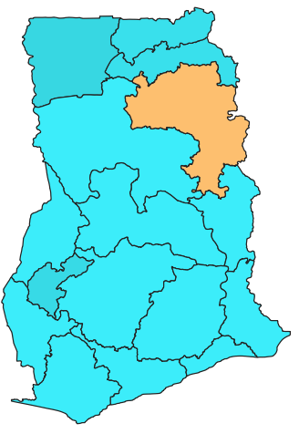

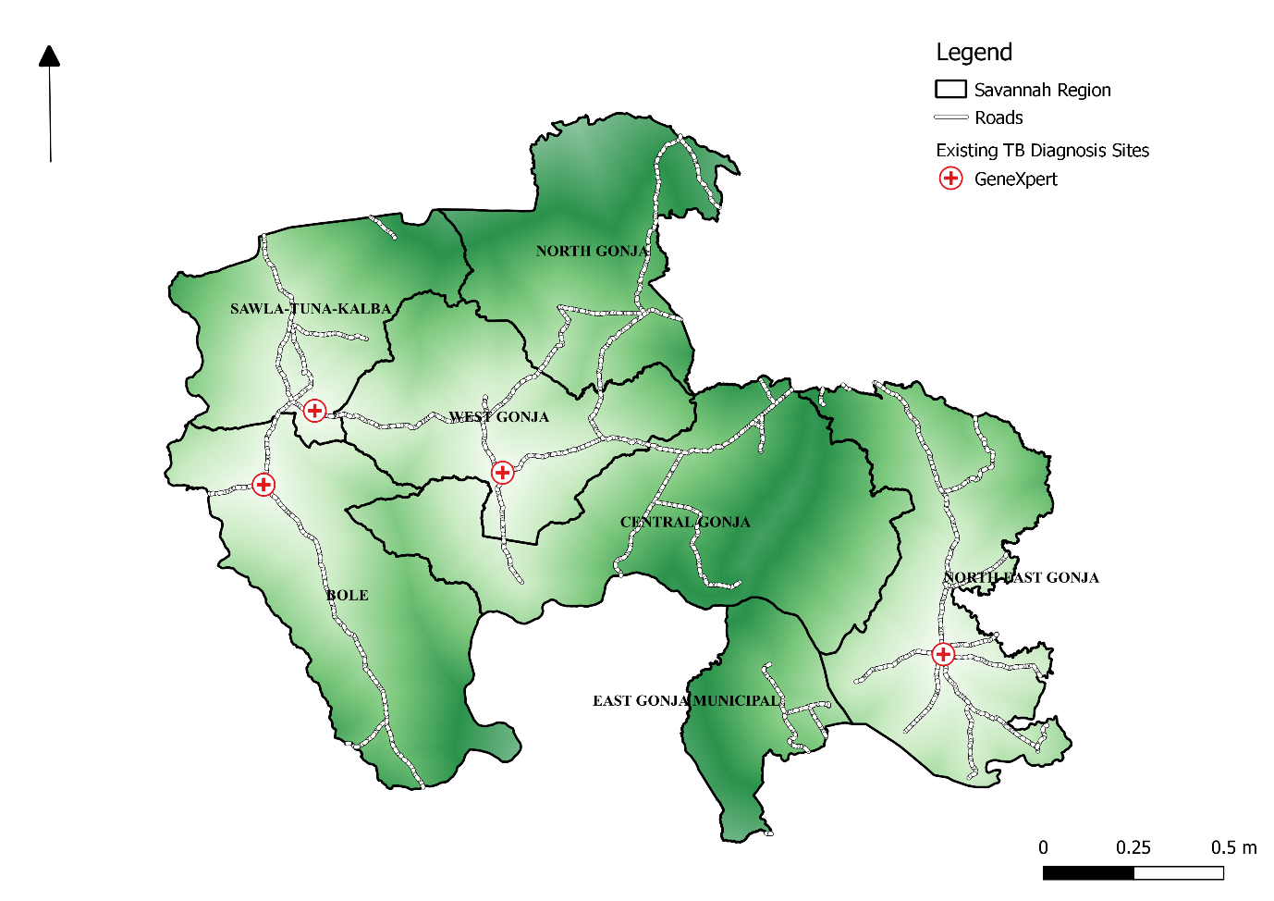
Figure S5: A map visualising travel time from all locations to the nearest TB diagnosis site in the Savannah Region

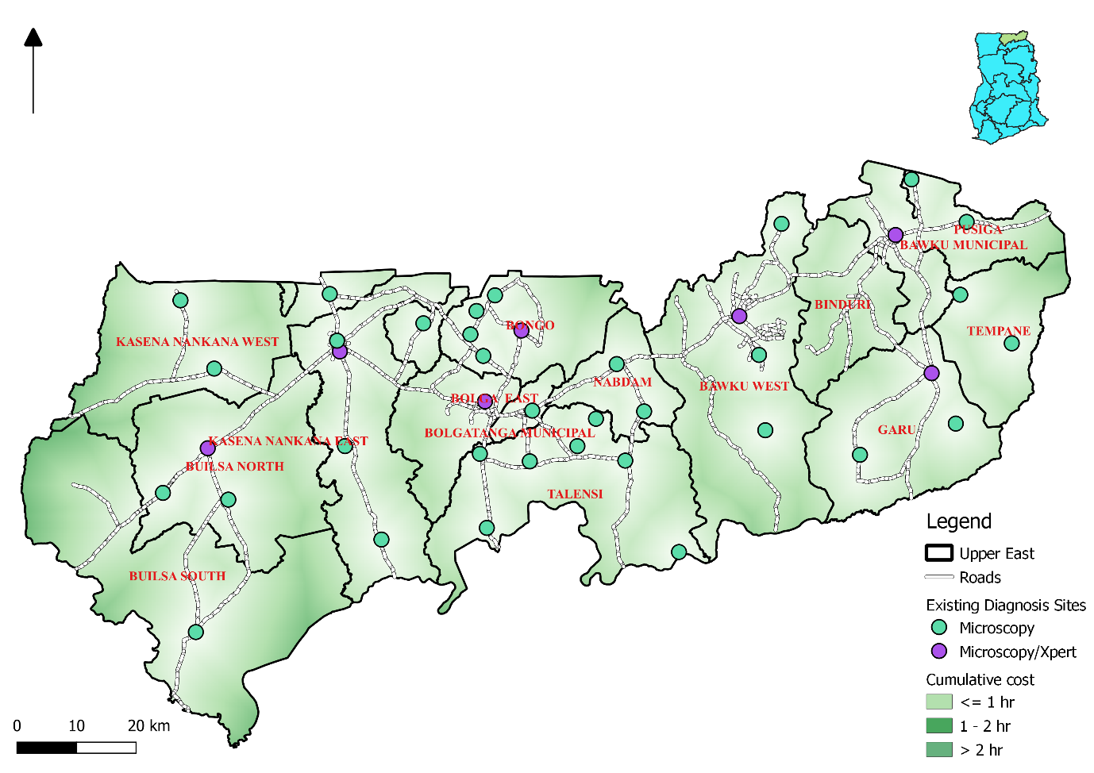
Figure S6: A map visualising travel time from all locations to the nearest TB diagnosis site in the Upper East Region

