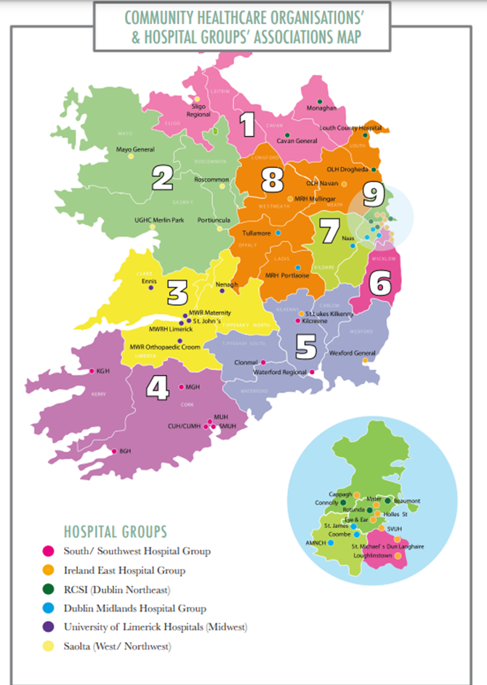
Figure S1., Community healthcare organisations and hospital groups associations map. Available at: https://www.hse.ie/eng/services/publications/corporate/cho-chapter-1.pdf

Table S1. Community Health Organisation and area it covers
Community Health Organisation (CHO) Number | Area
1 | Donegal, Sligo/Leitrim/West Cavan, Cavan/Monaghan
2 | Galway, Roscommon, Mayo
3 | Clare, Limerick, North Tipperary / East Limerick
4 | Kerry, North Cork, North Lee, South Lee, West Cork
5 | South Tipperary, Carlow / Kilkenny, Waterford, Wexford
6 | Wicklow, Dun Laoghaire, Dublin South East
7 | Kildare / West Wicklow, Dublin West, Dublin South City, Dublin South West
8 | Laois / Offaly, Longford / Westmeath, Louth, Meath
9 | Dublin North Central, Dublin North West

Table S2, Reasons for doing certain clinical activities
Treat non-diabetic foot pathologies
Hospital only based podiatrists.
- “Only patients with diabetes active ulcerations are referred to the hospital service here” (ID# 1)
- “Diabetic only service. Terms of contract” (ID# 3)
- “not part of my job description” (ID# 32)
- I work in a level 4 acute hospital (ID# 5)
- Don't see non diabetic patients. Do treat diabetic patients with these problems (ID# 6)
- in model 4 hospital, active and high risk diabetic patients only (ID# 7)
- Often managed by the community Podiatry Team (ID# 8)
- we only treat diabetic foot pathologies (ID# 9)
- the service is for diabetes pateints with high active foot disease (ID# 10)
- not appropriate (ID# 11)

Community only based podiatrists
- do not treat non-diabetic - non active feet (ID# 38)

Refer patients with non-diabetic foot pathologies to community podiatry

Hospital only based podiatrists:
- There is no public community podiatrist in my area (ID# 5)
- Don't see non diabetic patients. Do treat diabetic patients with these problems (ID# 6)
- we only treat diabetic foot pathologies - non pathologies would be referred to community podiatry by the team members in OPD via their GP's (ID# 9)

Annual review of low-risk patients

Community only based podiatrists.
- understaffed - not seen in department (ID# 13)
- Completed by practise nurses (ID# 14)
- Low risk screening is to be done by Nursing Staff (ID# 16)
- Low risk referrals not accepted (ID# 17)
- do not see Low Risk patients (ID# 38)
- do not accept low risk patient referrals (ID# 21)
- we do not see low risk patients (ID# 48)
- Do Not See as Screened by GP/PN/PHN (ID# 49)

Annual review of moderate risk patients

Hospital only based podiatrists.
- Too many active wounds for this. (ID# 3)
- only deal with active and high risk (ID# 4)
- I work in a level 4 acute hospital (ID# 5)
- Do on assessment but then transfer to community Podiatry (ID# 6)
- moderate risk seen in community not model 4 hospital (ID# 7)
- we don't perform annual review - these happen in the diabetes OPD with onward referral to us for acute conditions (ID# 9)
Community only based podiatrists.
- Cannot meet the annual review target based on caseload and staff levels (ID# 17)
- we do not see moderate risk patients (ID# 48)
- Insufficient staff at present due to non filled posts and suspension of service for Moderates (ID# 49)

Annual review of high-risk patients
Hospital only based podiatrists.
- Where possible (ID# 3)
- we don't perform annual review - these happen in the diabetes OPD with onward referral to us for acute conditions (ID# 9)
- Often managed by the community Podiatry Team (ID# 8)
- should be carried out in community podiatry (ID# 11)

Refer high risk pts to hospital podiatrist
Community only based podiatrists.
- Only refer active foot disease patients to Hospital Podiatrist as per HSE Model of Care of Diabetic Foot (ID# 15)
- Generally do not refer high risk pts unless they have ulcer (ID# 16)
- The hospital podiatrist will not accept high risk referrals. (ID# 17)
- If not ulcerated do not refer these patients to DFPS (ID# 18)
- only those with active foot disease (ID# 20)
- High risk patients kept in community in my area (ID# 38)
- Patients easily managed in community (ID# 22)
- the hospital podiatrist only accepts patients with active foot ulcerations (ID#48)

Weekly review of AFD until healed.

Hospital only based podiatrist.
- Review of active foot disease may not be weekly - review based on clinical need (ID# 11)

Record activity statistics

Hospital only based podiatrist.
- Not set up yet but starting (ID# 3)
- Currently only recording numbers of patient contacts under each risk level. Cannot afford to give needed time to gathering/manipulating statistics as it would negatively impact the running of our clinics and the number of clients we would be able to see. (ID# 28)

Table S3, Responses to questions on screening tools used
 | Hospital (n=23)  N (%) | Community (n=19)  N (%) | Hospital and Community (n=8)  N (%)
National Diabetic Foot Screening Tool | 12 (52) | 9 (47) | 4 (50)
Locally Developed Tools | 2 (9) | 2 (11) | 2 (25)
Does not use a specific tool | 1 (4) | 0 | 0
Do not provide diabetic foot screening | 3 (13) | 0 | 0
Missing | 5 (22) | 8 (42) | 2 (25)

Table S4, Satisfaction with community and hospital based services
Parameter | Respondent work setting | Satisfied | Neither satisfied nor unsatisfied | Dissatisfied | I don’t know if this happens | No response
Appropriate screening by GPª/PN^{b} | Hospital (N=23)  Community(N=19)  Hospital/Community (N=8) | 13% (n=3)  5% (n=1)  25% (n=2) | 26% (n=6)  21% (n=4)  12.5% (n=1) | 17% (n=4)  48% (n=9)  0 | 26% (n=6)  10% (n=2)  25% (n=2) | 22% (n=5)  16% (n=5)  37.50% (n=3)
Low risk patients managed by GP | Hospital  Community  Hospital/Community | 17% (n=4)  11% (n=2)  25% (n=2) | 13% (n=3)  21% (n=4)  0 | 22% (n=5)  47% (n=9)  0 | 30% (n=7)  5% (n=1)  25% (n=2) | 22% (n=5)  16% (n=3)  50% (n=4)
PN uses the national screening tool | Hospital  Community  Hospital  /Community | 35% (n=8)  16% (n=3)  12.5% (n=1) | 9% (n=2)  11% (n=2)  0 | 26% (n=6)  26% (n=5)  25% (n=2) | 13% (n=3)  5% (n=1)  0 | 22% (n=5)  42% (n=8)  62.5% (n=5)
PHNs^{c} use the national screening tool | Hospital  Community  Hospital  /Community | 17% (n=4)  5% (n=1) | 0  21% (n=4) | 0  43% (n=10) | 0  11% (n=2) | 87% (n=20)  11% (n=2)  100% (n=8)
Appropriate referral pathways by GP/PNs | Hospital  Community  Hospital  /Community | 44% (n=10)  Not asked  25% (n=2) | 17% (n=4)  Not asked  0 | 22% (n=5)  Not asked  12.5% (n=1) | 0  Not asked | 22% (n=5)  Not asked  62.5% (n=5)
Appropriate screening by community podiatrists | Hospital  Community  Hospital  /Community | 52% (n=12)  Not asked  37% (n=3) | 4% (n=1)  Not asked  0 | 17% (n=4)  Not asked  12% (n=1) | 9% (n=2)  Not asked  0 | 22% (n=5)  Not asked  50% (n=4)
Appropriate referral pathways by community podiatrists | Hospital  Community  Hospital  /Community | 65% (n=15)  Not asked  37% (n=3) | 4% (n=1)  Not asked  0 | 13% (n=3)  Not asked  12% (n=1) | 0  Not asked  0 | 22% (n=5)  Not asked  50% (n=4)
Annual review of moderate risk pts completed by community podiatrists | Hospital  Community  Hospital  /Community | 35% (n=8)  Not asked  38% (n=3) | 0  Not asked  0 | 35% (n=8)  Not asked  12.5% (n=1) | 22% (n=5)  Not asked  12.5% (N=1) | 26% (n=6)  Not asked  38% (n=3)
High risk foot patients are reviewed by hospital podiatrist | Hospital  Community  Hospital  /Community | Not asked  16% (n=3)  0 | Not asked  32% (n=6)  0 | Not asked  32% (n=6)  0 | Not asked  5% (n=1)  0 | Not asked  16% (n=3)  100% (n=8)
Active foot disease patients are seen by a hospital podiatrist within 24hours | Hospital  Community  Hospital  /Community | Not asked  52% (N=8)  0 | Not asked  11% (n=2)  0 | Not asked  22% (n=6)  0 | Not asked  0  0 | Not asked  16% (n=3)  100% (n=8)
ªGP – General Practitioner; ^{b}PN – Practice nurse; ^{c}PHNs – Public Health Nurses

Table S5., Continuous professional activities
 | Hospital (n=23)  N (%) | Community (n=19)  N (%) | Hospital & Community (n=8)  N (%)
Protected Budget for CPD | 5 (22) | 0 | 0
Protected time for CPD | 6 (16) | 3 (16) | 0
Activities engaged in:
Conference attendance | 11 (48) | 12 (63) | 0
Attend national CPD days organised by NCPD | 7 (30) | 3 (16) | 0
Attend national CPD days (not facilitated by NCPD) | 2 (9) | 3 (16) | 0
Educate other professionals about podiatry | 8 (35) | 7 (37) | 0
Educational/upskilling courses | 12 (52) | 5 (26) | 0
Educational/upskilling workshop | 9 (39) | 6 (32) | 0
None | 0 | 0 | 0
Self-directed CPD activities
Review journal articles/literature | 12 (52) | 11 (58) | 0
Watch webinars | 4 (14) | 3 (16) | 0
Undertake learning on HSELand | 8 (35) | 9 (47) | 0
Reflective practice | 7 (30) | 6 (32) | 0
I do not engage in these activities | 1 (4) | 0 | 0

