Supplementary material for: Economic burden of cardiac arrest in Spain: Analyzing healthcare costs drivers and treatment strategies cost-effectivenes

Supplementary Table 1
CAPAC Questionnaire

GENERAL INFORMATION
Name of the hospital: ___________________(deductive drop-down) the drop-down menu needs to be added
Autonomous Community ________________(deductive drop-down)
City: ___________________ (predictive drop-down)
What is your unit? _______________
o Cardiac
o Intensive/multi-purpose
Number of beds in your Unit: ________
Number of admissions of comatose patients for out-of-hospital cardiac arrest per year: _________
CARE OF COMATOSE PATIENTS AFTER OUT-OF-HOSPITAL CARDIAC ARREST (CRA) WITH RETURN OF SPONTANEOUS CIRCULATION (ROSC)
1. Do you have a post-cardiac arrest protocol?
a. Yes
b. No
2. Please indicate which protocols you have in place in your Unit: (Multiple answers)
a. Referral protocols
b. Diagnostic approach protocol
c. Temperature control
d. Neurological prognosis
e. Organ donation
Rank the selected options from most to least important: __________
3. Which hospital department receives comatose patients recovered from suspected non-cardiac out-of-hospital cardiac arrest (OHCA)?
a. Emergency service
b. Cardiac catheterisation laboratory
c. ICU/Critical Unit
d. Other: _______________
4. Which hospital service receives comatose patients recovered from suspected cardiac OHCA?
a. Emergency service
b. Cardiac catheterisation laboratory
c. ICU/Critical Unit
d. Other: ______________
5. In which patient populations do you perform coronary angiography and emergent percutaneous coronary intervention (PCI)?
a. None
b. All
c. Some
Which ones? (Multiple answers)
a. Elevated ST only
b. Any suspicion of acute coronary syndrome
c. Unexplained CRA
d. Refractory cardiac arrest
e. Clinical instability
6. Is there an age limit for not performing coronary angiography and emergent PCI in comatose patients?
a. Yes
b. No
If yes, please indicate what are: __________
7. In ST-elevation acute coronary syndrome (STEACS), do you have a time target for PCI?
a. Yes
b. No
If yes, is it routinely measured?
a. Yes
b. No
If so, what is the time? ____h_____min
8. In actual clinical practice, what is the average time for PCI?
a. 60 minutes
b. 120 minutes
c. 180 minutes
d. 240 minutes
e. 300 minutes
f. 360 minutes
9. Do you carry out regular quality audits?
a. Yes
b. No
10. Do you have a screening protocol for arrhythmogenic diseases?
a. Yes, electrophysiological/pharmacological study
b. Yes, genetic study
c. Both
d. No
STRUCTURE
11. Do you have a PCI service in your centre?
a. Yes, 24 Hours, 7 days a week
b. Yes, but with restricted shift
c. I do not have this service
If you select B, please answer the following question:
Please indicate which:__________________
12. Do you have an ultrasound service in your centre?
a. Yes, 24 Hours, 7 days a week
b. Yes, but with restricted shift
c. I do not have this service
If you select B, please answer the following question:
Please indicate which:__________________
13. Do you have a CT service in your centre?
a. Yes, 24 Hours, 7 days a week
b. Yes, but with restricted shift
c. I do not have this service
If you select B, please answer the following question:
Please indicate which:__________________
14. Do you have an EEG service in your centre?
a. Yes, 24 Hours, 7 days a week
b. Yes, but with restricted shift
c. I do not have this service
If you select B, please answer the following question:
Please indicate which:__________________
15. Do you have a neurophysiology service in your centre?
a. Yes, 24 Hours, 7 days a week
b. Yes, but with restricted shift
c. I do not have this service
If you select B, please answer the following question:
Please indicate which:__________________
16. Do you have a cardiology service in your centre?
a. Yes, 24 Hours, 7 days a week
b. Yes, but with restricted shift
c. I do not have this service
If you select B, please answer the following question:
Please indicate which:__________________
TEMPERATURE CONTROL MANAGEMENT
17. Do you actively monitor the temperature of comatose patients after out-of-hospital cardiac arrest with ROSC?
a. Yes, for all patients
b. Yes, only in patients with shockable rhythm.
c. No
18. Where does temperature control (TTM) start?
a. Emergency service
b. Cardiac catheterisation laboratory
c. ICU
d. Other: _______________
19. Is TTM initiated before or after PCI?
a. Before PCI
b. During PCI
a. After PCI
20. Do you have a time target for the start of TTM?
a. Yes
b. No
If so, what is the time? ____h_____min
If yes, is it routinely measured?
a. Yes
b. No
21. How do you monitor the temperature? (Multiple answers)
a. It is not generally monitored
b. Antipyretic medication
c. Cold fluids/crystalloids
d. Physical measures: cold compresses, fans/wet towels
e. Non-feedback sheet/water mattress (without servo-control)
f. Hydrogel catheters/patches with advanced servo-control devices
22. Do you perform temperature recovery after TTM?
a. Yes
b. No
If so, what is the time? (Drop-down)
a. <0.1oC/hour
b. 0.1 – 0.25oC/hour
c. 0.26 – 0.5oC/hour
23. Do you have a written TTM protocol?
a. Yes
b. No
24. Does it have a target temperature?
a. Yes
b. No
If yes:
a. It is a fixed temperature: _______
b. It operates in a range: minimum____ maximum____
PROGNOSIS
25. Do you apply prognostic scales in the first 72 hours?
a. Yes
b. No
If yes, please indicate which: __________
26. When is neuroprognosis performed? (Multiple answers)
a. 72 hours after the arrest
b. Immediately after rewarming
c. 72 hours after rewarming
d. I don't have a set time
27. Do you have a protocol to limit therapeutic effort?
a. Yes
b. No
If yes, do you consider donation in end-of-life care?
a. Yes
b. No
28. Indicate which prognostic method you use (Multiple answers)
a. Neurological examination
b. Neuro-specific enolase
c. MRI
d. CT
e. EEG
f. Somatosensory evoked potentials
g. Others: _____________
29. Indicate which assessments are made in the neurological assessment upon discharge (Multiple answers)
a. mRS (Modified Rankin Scale)
b. CPC (cerebral performance category)
c. GOS (Glasgow Outcome Scale)
d. Pupillary reflex
e. Corneal reflex
30. Is there long-term follow-up of patients?
a. Yes
b. No
If yes, where is it done? (Hospital/Health Centre) _______
If yes, how often? (months) _______
31. Do you have a rehabilitation protocol for patients?
a. Yes
b. No
If yes, please indicate which: (Multiple answers)
a. Locomotive rehabilitation
What is the average number of sessions you perform? ______
What is the average duration of rehabilitation? (months)_____
b. Neuro-rehabilitation
What is the average number of sessions you perform?______
What is the average duration of rehabilitation? (months)_____
c. Occupational therapy
What is the average number of sessions you perform?______
What is the average duration of rehabilitation? (months)_____
32. Indicate the percentage of patients per year according to neurological damage on discharge:
a. CPC1 (without sequelae)___________
b. CPC2 (mild disability, is independent, does not require institutionalisation)__________
c. CPC3 (severe disability, not independent, requires institutionalisation) ________
d. CPC4 (persistent vegetative state)___________
e. CPC5 (death)________
33. Indicate, in days, the average length of stay:
a. In the ICU/CU _________
b. In the hospital ________
34. Would you be interested in participating in a prospective register of cardiac arrest management?
a. Yes
b. No

Supplementary Table 2. Explanatory variables used in the multivariate models
Explanatory variable | Definition
Coronarography and PCI | A value of 1 is given if all patients undergo coronary angiography and PCI and a 0 in all other cases.
Time objective for PCI | A value of 1 is given if the procedure anticipates a time objective for performing the PCI and it is normally measured, and a 0 if otherwise.
PCI execution time | Average time in which PCI is performed. Precoded into one hour periods in the survey. A value of 1 is given if the average time during which PCI is performed is 60 minutes, 2 if it is 120 minutes, 3 if it is 180 minutes, 4 if it is 240 minutes, 5 if it is 300 minutes and 6 if it is 360 minutes.
PCI availability | A value of 1 is given if there is a 24 hour PCI service, and a 0 for all other options of the reference question.
TTM active control | A value of 1 is given if the temperature is controlled actively and a 0 if it is not.
Time objective for commencement of TTM | A value of 1 is given if there is a TTM commencement objective and 0 if there is not
Servo-control use | A value of 1 is given if the temperature control is performed through catheters/hydrogel patches with advanced servo-control devices, and a 0 if the control is carried out by any of the other alternative methods provided in the survey.
Thermal recovery | A value of 1 is given if there is a recovery of the temperature after the TTM and 0 if there is not.
The aim is to reach a temperature | A value of 1 is given if there is a target temperature and 0 if there is not.
Use of 72-hour prognostic scales | A value of 1 is given if prognosis scales are applied during the first 72 hours and a 0 if they are not.
Long-term monitoring | A value of 1 is given if the patients are monitored in the long term and a 0 if they are not.
Rehabilitation program | A value of 1 is given if there is a rehabilitation protocol and 0 if there is not.
PCI, percutaneous coronary intervention; TTM, targeted-temperature management
Supplementary Table 3. Normalized proportion of patients in each neurological state at discharge according to the use of servo-control for temperature management
 | CPC1 | CPC2 | CPC3 | CPC4
Without servo-control | 0.379 | 0.248 | 0.217 | 0.156
With servo-control | 0.471 | 0.251 | 0.143 | 0.135

Supplementary Table 4. Average total cost per patient admitted with cardiac arrest according to the neurological outcome at discharge
Neurological outcome | Average cost per patient (2020 Euros)
CPC1 | 28,332.7
CPC2 | 52,950.3
CPC3 | 71,207.9
CPC4 | 97,953.1
CPC, Cerebral Performance Category

Supplementary Table 5. Average direct and indirect costs per hospital for patients admitted with cardiac arrest
Average cost | 2020 Euros | % of the  direct cost | % of the total cost
Average ICU cost | 155,324 | 33.4
Average cost for hospital stay | 131,975 | 28.4
Average prognostication cost | 2,975 | 0.6
Average rehabilitation cost | 141,026 | 30.3
Average TTM cost | 33,581 | 7.2
Average direct cost | 464,881 | 100 | 60.5
Average indirect cost | 303,592 |  | 39.5
Average total cost | 768,474 |  | 100
ICU, intensive care unit; TTM, targeted-temperature management

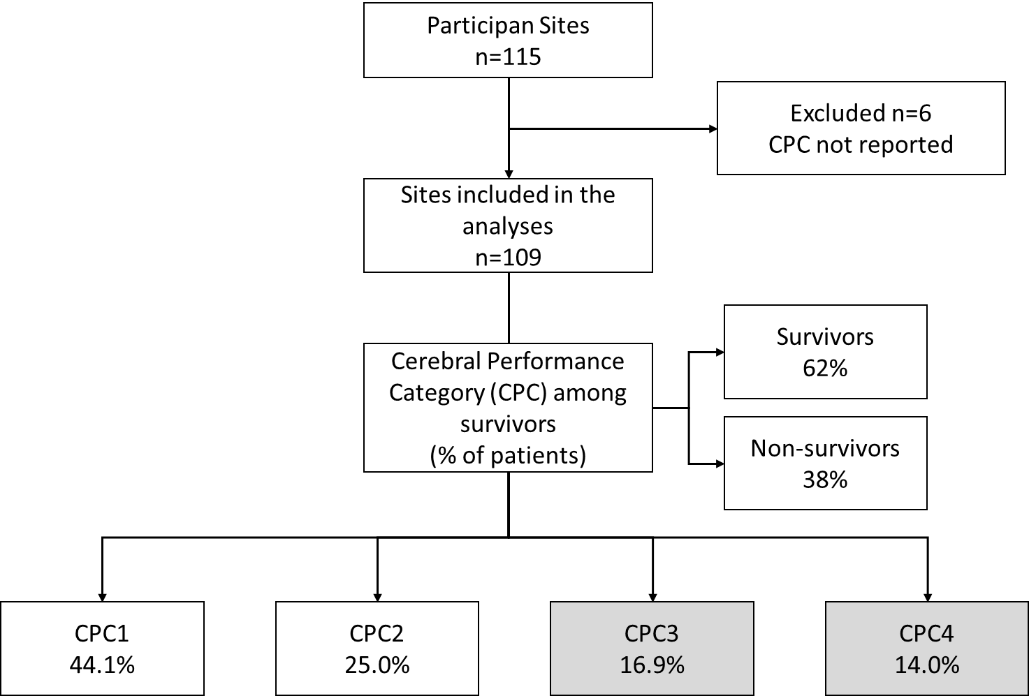Supplementary Figure 1. Patient disposition

Supplementary Table 6. Results of variability analysis regarding the care of comatose patients after out-of-hospital cardiac arrest (OHCA) and return of spontaneous circulation (ROSC)
PROTOCOLS | Reply | % (n)
Existence of post cardiac arrest protocol | Yes | 75.7 (87)
Protocols in your Unit | Organ donation | 91.3 (105)
Major importance protocol | Diagnostic approach protocol  Temperature control | 39.1 (45)  27.8 (32)
Hospital department receiving comatose patients recovering from out-of-hospital cardiac arrest (OHCA)  Presumed non-cardiac  Presumed cardiac | ICU/Critical Unit  ICU/Critical Unit | 67.0 (77)  52.2 (60)
Populations undergoing coronary angiography and emergent percutaneous coronary intervention (PCI) | Some  Any suspected of acute coronary syndrome | 76.5 (88)  71.6 (63)
Age limit for not performing coronary angiography and emergent PCI in comatose patients | Does not exist | 97.4 (112)
Time target for PCI | Yes  It is usually measured 61-120 minutes | 77.4 (89)  79.7 (71)  67.6 (48)
Average time PCI is performed | 120 minutes | 45.2 (52)
Conducting of regular audits | No | 51.3 (59)
Screening protocol for arrhythmogenic diseases | No | 43.5 (50)

Supplementary Table 7. Results of variability analysis on the structure of healthcare units (staff and tests available in the units).
UNIT STRUCTURES | REPLAY | % (n)
PCI service in your centre Shift | Yes, 24 Hours, 7 days a week  Morning shifts from Monday to Friday | 66.1 (76)  40.0 (4)
Ultrasound service in your centre Shift | Yes, 24 Hours, 7 days a week  Morning shifts from Monday to Friday | 84.3 (97)  62.5 (10)
CT service in your centre Shift | Yes, 24 Hours, 7 days a week  Morning shifts from Monday to Friday | 99.1 (114)  100 (1)
EEG service in your centre Shift | Yes, but with restricted shift  Morning shifts | 70.4 (81)  36.4 (28)
Neurophysiology service in your centre Shift | Yes, but with restricted shift  Morning shifts from Monday to Friday | 75.7 (87)  29.7 (25)
Cardiology service in your centre Shift | Yes, 24 Hours, 7 days a week  Morning shifts | 65.2 (75)  39.4 (15)

Supplementary Table 8. Results of variability analysis on temperature control (temperature control management and protocols)
TEMPERATURE CONTROL | Reply | % (n)
Active control of the temperature of comatose patients after out-of-hospital cardiac arrest with ROSC | Yes, for all patients | 67.8 (78)
Where does temperature control (TTM) start? | ICU | 70.4 (81)
Is TTM initiated before or after PCI | After PCI | 50.4 (58)
Time target for the start of TTM | No  It is usually measured  2h- 12h | 65.2 (75)  77.5 (31)  51.2 (20)
Means of temperature control | Hydrogel catheters/patches with advanced servo-control devices  Physical measures: cold compresses, fans/wet towels | 53.0 (61)  51.3 (59)
Temperature recovery after TTM | Yes  0.1 – 0.25oC/hour | 68.7 (79)  52.2 (60)
Written TTM protocol | Yes | 58.3 (67)
Target temperature | Yes  Fixed temperature  Fixed temperature 33ºC  Range 34-36ºC | 75.7 (87)  54.0 (47)  36.1 (17)  27.5 (11)

Supplementary Table 9. Results of variability analysis on prognosis (assessment of patients’ condition and follow-up)
PROGNOSIS | Reply | % (n)
Application of prognostic scales in the first 72 hours | No | 67.8 (78)
Timing of the neuroprognosis | 72 hours after the arrest | 55,6 (64)
Protocol to limit therapeutic effort | Yes  Donation in end-of-life care | 80.0 (92)  100 (92)
Method of prognosis | Neurological examination  EEG | 96.5 (111)  92.2 (106)
Assessments performed in the neurological evaluation upon discharge | GOS (Glasgow Outcome Scale) | 61.7 (71)
Long-term follow-up of patients | No  Performed at the hospital  Every 6 months | 71.3 (82)  90.9 (30)  63.6 (21)
Rehabilitation protocol for patients | No locomotive rehabilitation  6 sessions on average, average duration of sessions 8 months | 58.3 (67)  95.4 (42)
Average percentage of patients per year according to neurological damage on discharge | CPC1 (without sequelae)  CPC2 (mild disability, is independent, does not require institutionalisation)  CPC3 (severe disability, not independent, requires institutionalisation)  CPC4 (persistent vegetative state)  CPC5 (death) | 26%  16%  13%  9%  36%
Average patient length of stay | In the ICU/CU  In the hospital | 10 days  25 days

