Supplementary File 3: ACE and PACE-IT MOC flowchart
ACE Flowchart

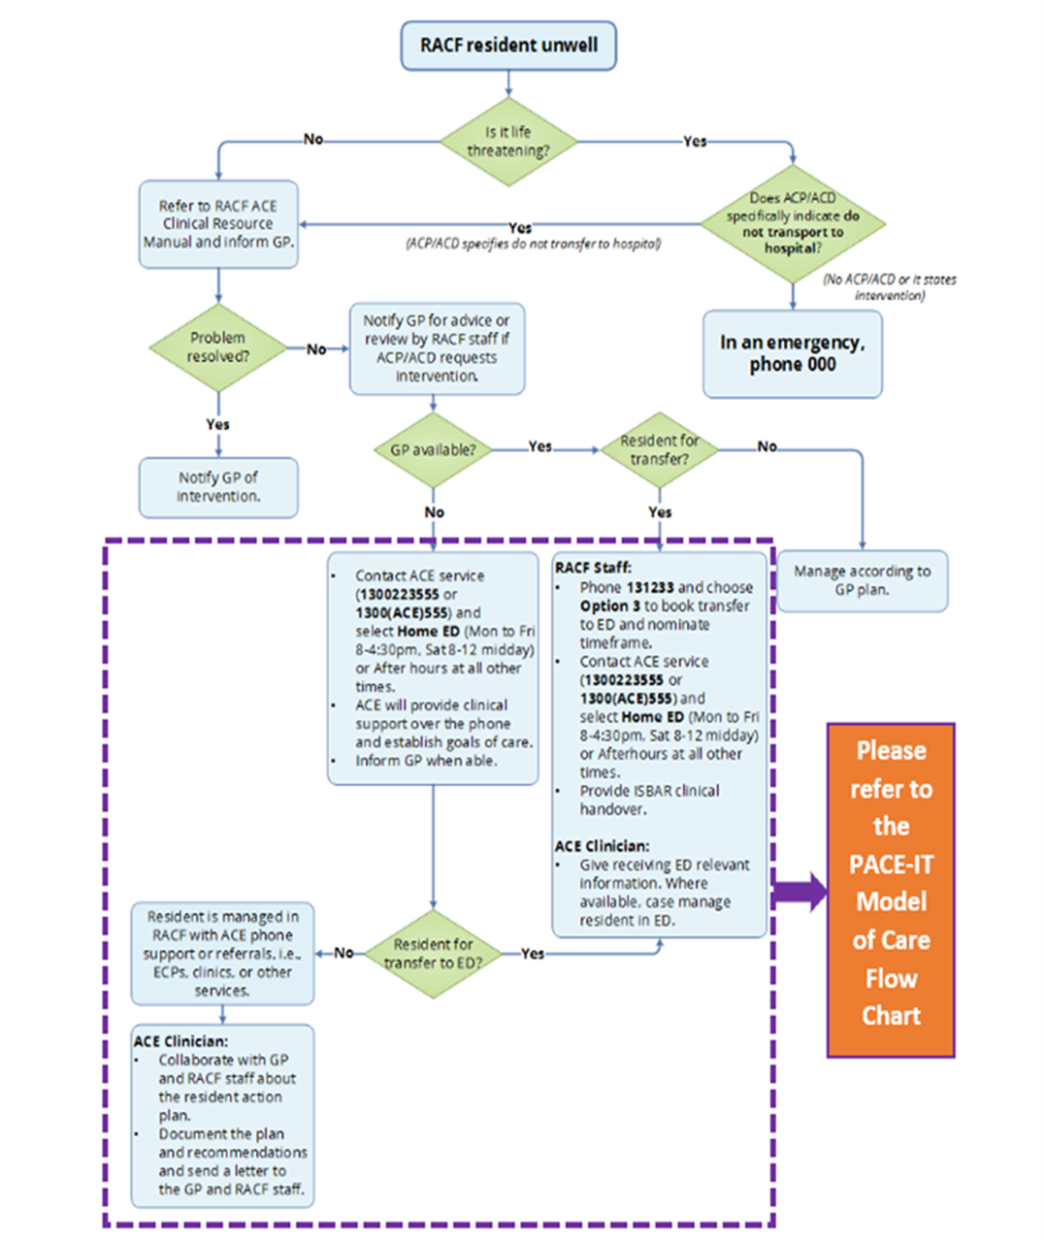

PACE-IT Model of Care Flow Chart

