ANNEX I: Kirckpatrick levels of effective simulation training (Niemann, L. & Thielsch, M. (2020). Evaluation of Basic Trainings for Rescue Forces)

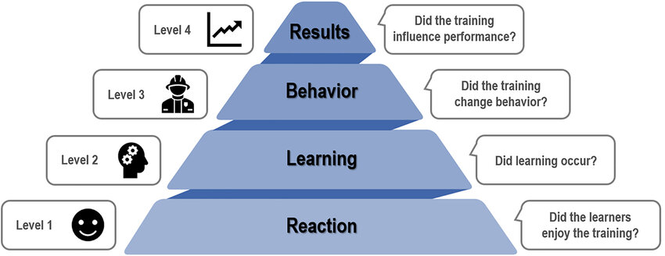

ANNEX II: TIMETABLE FOR THE MCI COURSE SUMMA PROCEDURE
DAY 1
SCHEDULE | WORKSHOP | CONTENTS
9:30-9:45 | Presentation of the course | Reception of students.  Welcome.
9:45-10:45 | MCI SUMMA procedure | Technical instruction  Annex Barajas  Other institutions
10:45-11:00 | Questions
11:00-12:00 | Roles & Vests | Location and legends  Role functions  Supporting documentation
12:00-12:30 | BREAK
12:30-13:30 | Triage and backpack | Definition of out-of-hospital triage.  Triage in the different phases of MCI: DUAL, START/ Jump Start.  Triage backpack: location and content.  Triage card.  Assistance backpack: location and contents.  Support documentation.
13:30-14:15 | Communications | Communications procedure  Channel management and operation  Broadcast priority and radio language
14:15-14:30 | Course closure | Questions and Answers  Post-test  DPost-testion and links  Closing and farewell

DAY 2
SCHEDULE | WORKSHOP | CONTENTS
9:00-9:30 | Introduction to the SELF-EFFICACY STUDY | Consent and pretest instructions
9:30-10:30 | Table-top simulation | Case studies will be carried out in small groups using blackboards and magnets.
10:30-12:00 | Students will be divided into two stations | Triage card workshop  Communications and roles
12:00-12:30 | BREAK
12:30-13:15 | Brief Simulation | MCI activation (students only)
13:15-13:30 | Briefing
13:30-14:15 | Brief Simulation | MCI activation (students only)
14:15-14:45 | SELF-EFFICACY STUDY | Postest
14:45-15:00 | QR code signature | END OF COURSE

