Graphical representation of explanatory power of UTAUT-2, UTAUT-3, extended UTAUT-3, and the confirmed paths using Extended UTAUT-3

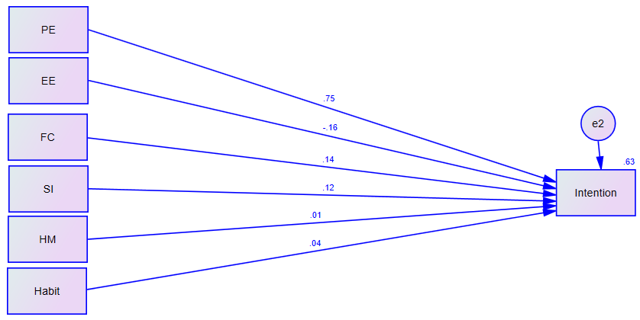
Figure 1: Explanatory Power of UTAUT-2

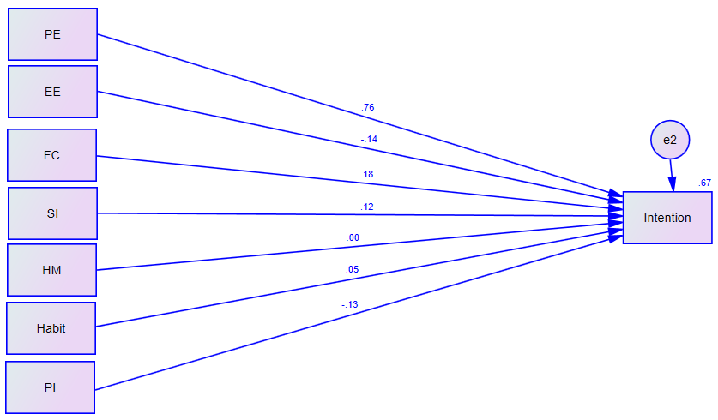
Figure 2: Figure 1: Explanatory Power of UTAUT-3
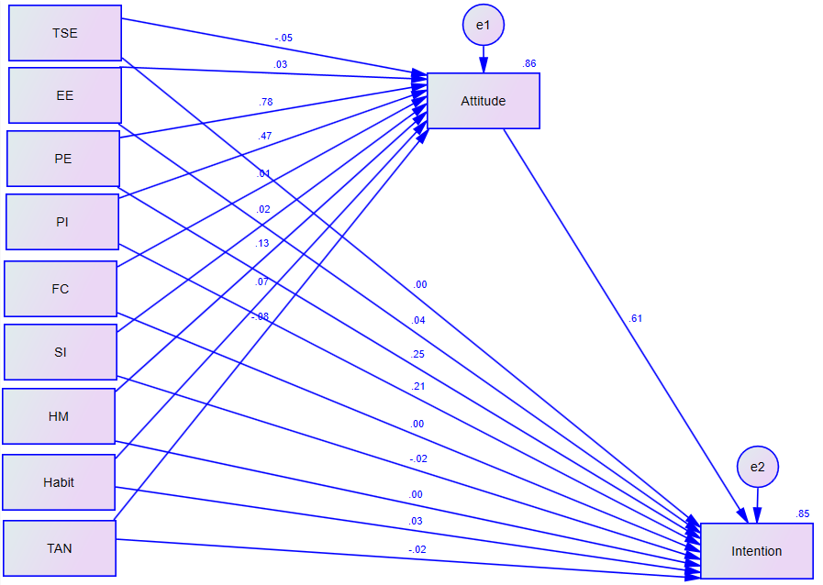
Figure 3: Explanatory Power of the Proposed Model (Extended UTAUT-3)
NB: TSE= technology self-efficacy, EE= effort expectancy, PE= performance expectancy, PI=personal innovativeness, FC= facilitating condition, SI=social influence, HM=Hedonic motivation, TAN=technology anxiety

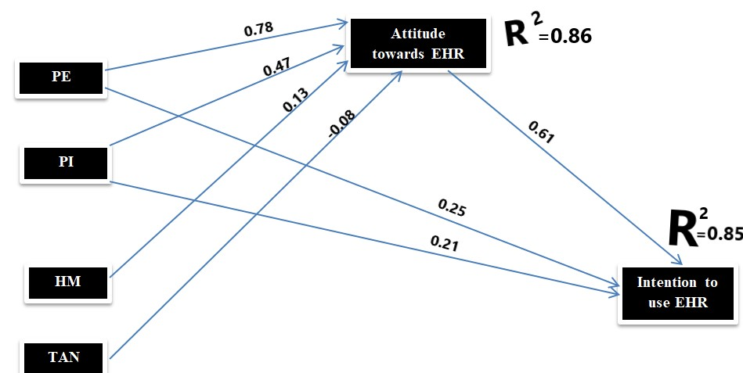
Figure 4: Confirmed paths from structural equation modeling

