Supplementary Table 1 Summary of process evaluation data sources by components of HRW

 | Component of HRW
Data source | Trial Processes | CST | ABIC
Project Log | x | x | x
Surveys:  CST attendee surveys (face-to-face and online)  Participant ‘Hospital Experience’ survey  (Participant ‘ABIC’ survey) |  | x  x | x  (x)
Semi-structured interviews:  Chief Investigator  Project Manager  Data Operations Manager  ABIC Coordinator  ABICs  Research Site Contacts  Assessors (baseline and blinded) | x  x  x  x  x  x  x | x  x | x  x  x  x  x  x
Observations | x | x | x
Review of meeting minutes (project and partner meetings) | x | x | x

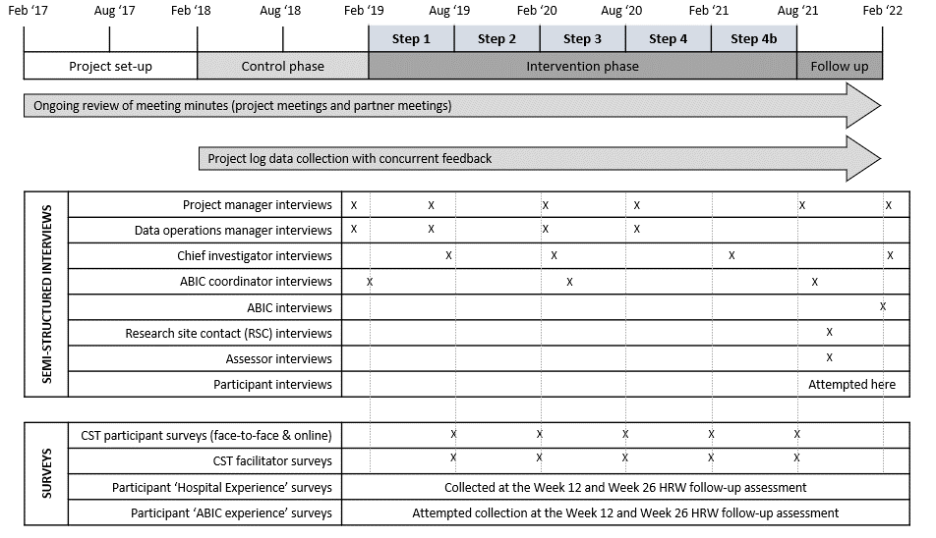
Supplementary Figure 1. Overview of process evaluation data sources and exact time of collection
Supplementary Table 2: Summary of process evaluation findings in relation to HRW trial processes*
*As the following focused on general research trial processes and research project management rather than the intervention itself, the heading of ‘Intervention’ in comparison CFIR tables has been altered to ‘Research component’ representing the typical research components of an RCT.
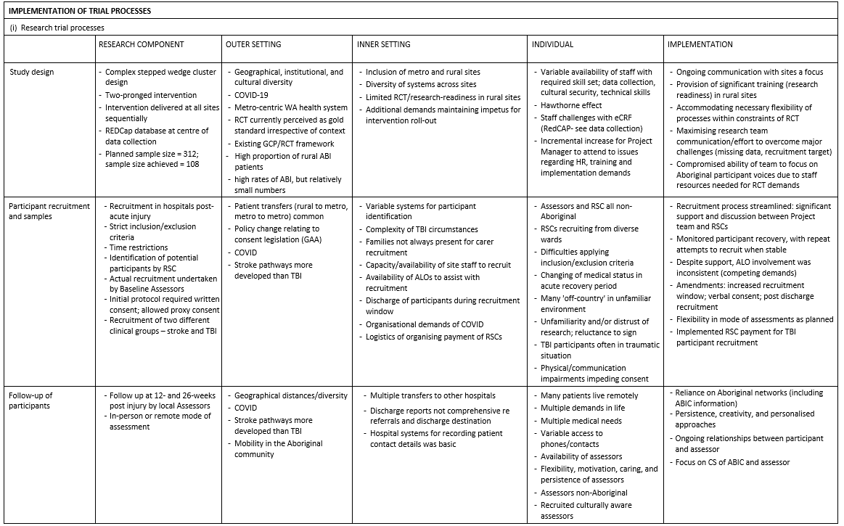

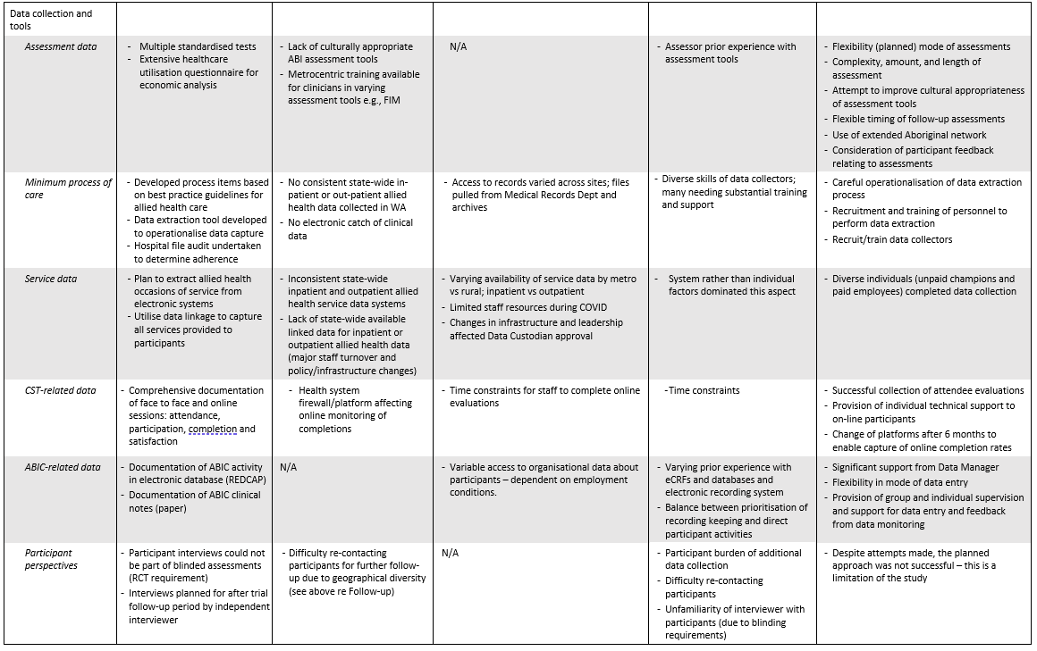

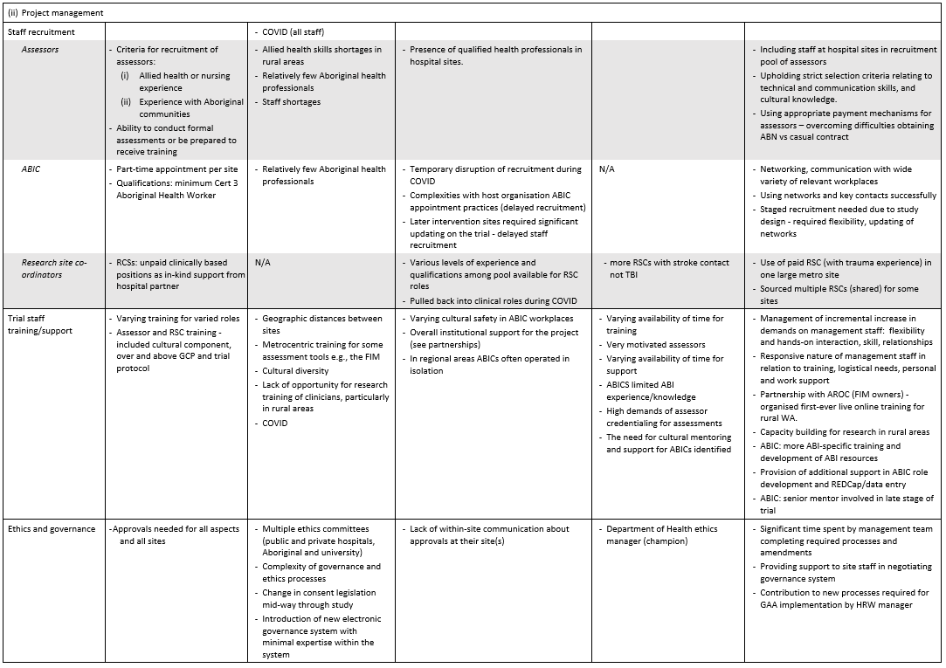

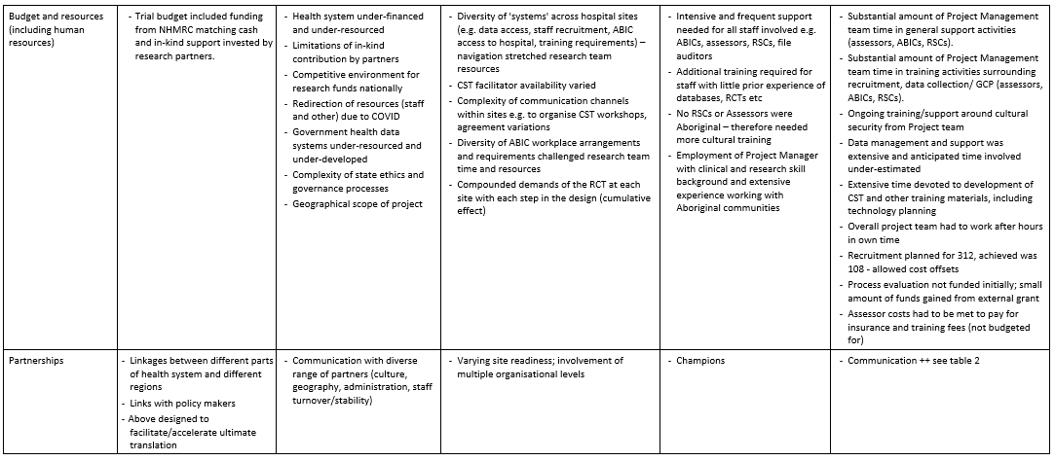

Supplementary Table 3: Summary of process evaluation findings in relation to HRW interventions
